Big Project 2

Mary Floren

Friday, May 5, 2017

ECE 430: Electromagnetics in Wireless Sensing and Communications

**I. SAR History**

Synthetic Aperture Radar (SAR) is a type of radar that was invented in 1951 by a mathematician named Carl Wiley. He observed relationships between the coordinates of an object reflecting a moving radar beam and the Doppler shift of the antenna’s signal returned to the radar. After working with a group at the University of Illinois, this concept was improved and SAR was developed.

SAR was further enhanced as it was used in military applications. Until the 1970’s SAR was mostly used for land applications. The first SAR satellite for civilian use was SEASAT, which was sent to space in June 1978. SEASAT was created to gather information about the Earth’s oceans and worked successfully for several months.

Over the next decades Synthetic Aperture Radar has been researched and used by multiple countries including Russia, Japan and Canada. It is used in military applications, tracks data about land, and other particular applications. Nowadays many of the SARs are in space and viewing Earth from a far. Along with the progress and research in SAR through the years, they now have varying characteristics depending on the setting and application.

**II. SAR Fundamentals**

SAR stands for Synthetic Aperture Radar. It is a method of radar detection often used on spacecraft or airplanes to analyze the area below. The movement of the carrier provides a way for the SAR to simulate multiple antennas and calculate positioning of objects or characteristics below. The antenna sends signals and stores information about the returned signals for a period of time. By using information such as the signal speed, transmitted signal pattern, time differences between transmissions.

Information from the numerous antenna positions along the trajectory is pooled and processed. This is where the term *synthetic aperture* comes from: through the synthesis of multiple positions of the SAR, a large antenna is simulated.

There are two main types of Synthetic Aperture Radar: spotlight SAR and strip map SAR. The difference between these two types is the positioning of the antenna aboard the aircraft. Spotlight SAR consists of an antenna that is constantly moving so it is pointing towards the specific spot is it imaging while strip map SAR involves an antenna that remains stationary on the aircraft.

Since the strip map SAR does not orient itself towards a specified spot, once a segment is out of view it can no longer be imaged. Therefore, in the case of a strip map SAR the resolution is limited by the field of view of the antenna. The time a target is within view of the antenna also impacts resolution because it affects how many times it will be sent signals from the SAR.

The transmitted signal plays a role in the quality of the received signal. Some tactics used in wireless communications and radar are to use specific signal patterns, such as a Frank Code, Barker Code or Costas Code. Each are a series of high and low signals that have different advantages and disadvantages when it comes to the return of the sent signal.

When processing the received signals, many algorithms can be used. In this simulation Back projection is used. Matched filtering helps improve the Signal-to-Noise Ratio, as it eliminates some of the noise that distracts from the important part of the signal. It allows for an impulse response to be found in the received signal.

**III. Setup Outline**

The dimensions of the overall grid area are 1000 by 1000. This refers to the length and width of the SAR’s field of examination. The target to find is made up of 13 points creating the letter “M”. The points have the coordinates listed in *Figure 1*, the layout is shown in *Figure 2*, and the zoomed in image is in *Figure 3*.

|  |  |
| --- | --- |
| x | y |
| 722 | 264 |
| 722 | 265 |
| 722 | 266 |
| 722 | 267 |
| 722 | 268 |
| 723 | 267 |
| 724 | 266 |
| 725 | 267 |
| 726 | 268 |
| 726 | 267 |
| 726 | 266 |
| 726 | 265 |
| 726 | 264 |

Figure 1: Coordinates of target object.

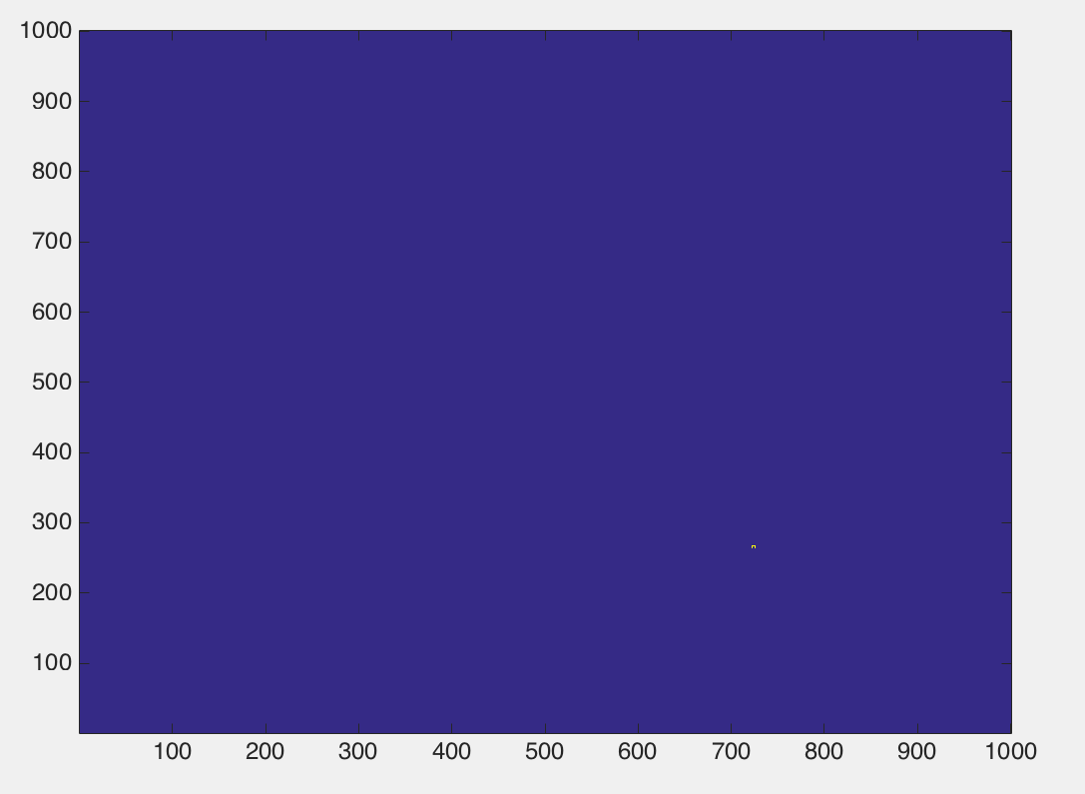

Figure 2: Target location on original 2-D 1000x1000 grid.

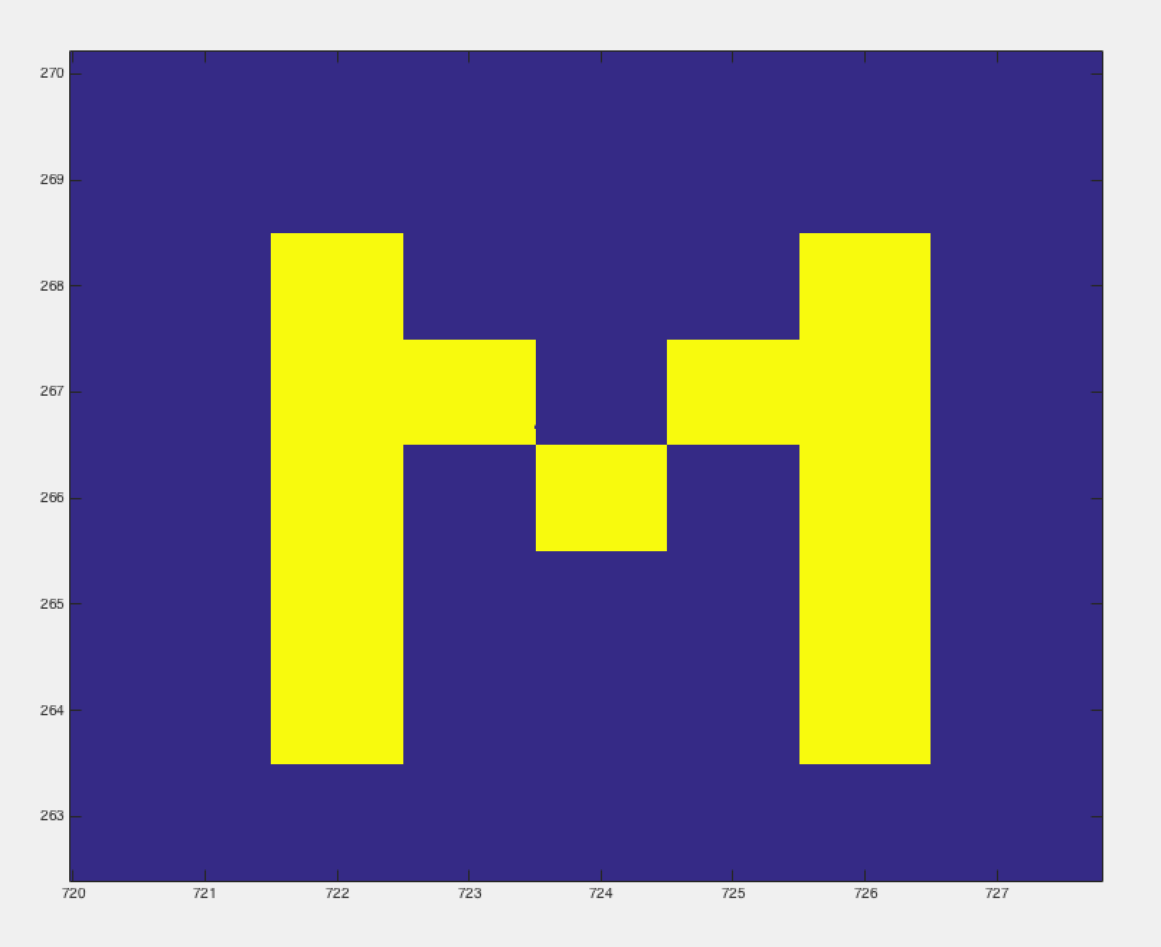

Figure 3: Close-up view of the target.

The selected antenna pattern is sin(). The polar plot of this pattern is shown in *Figure 4*.

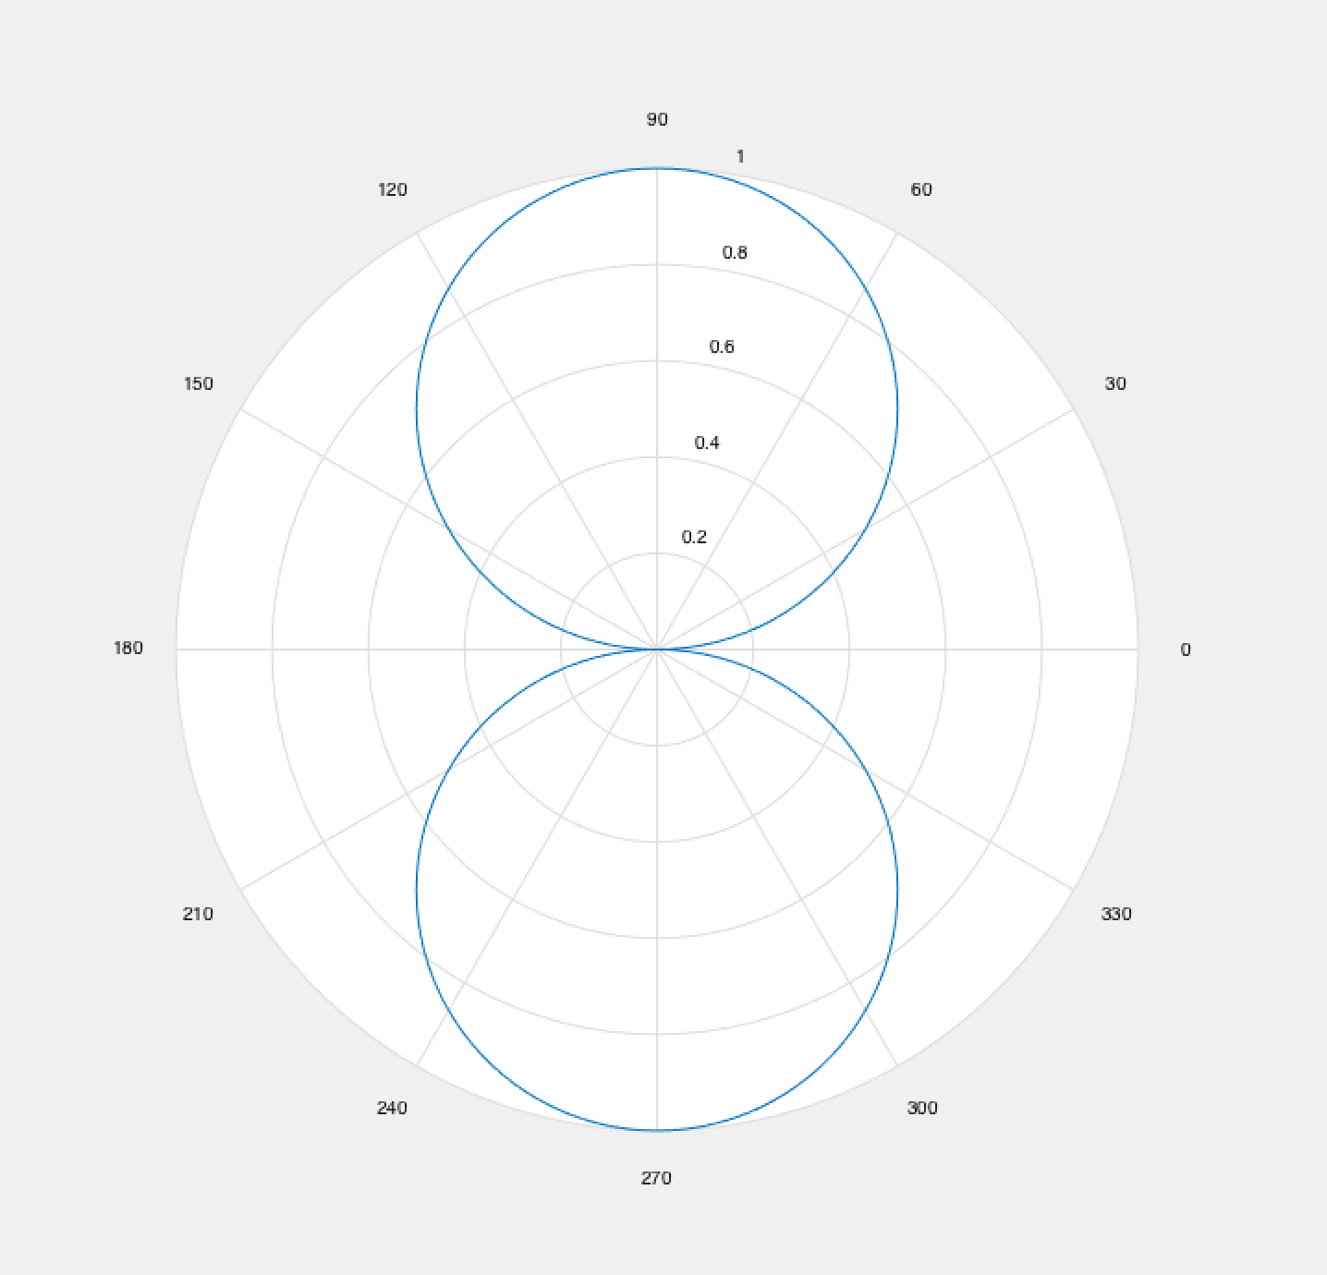

Figure 4: Polar plot of sin( antenna radiation pattern.

Since the SAR only scans below the plane, it only reaches a 180-degree area. In this case the antenna is assumed to be pointing straight down, therefore is from and the radiation pattern found in this simulation is more realistically shown in *Figure 5*.

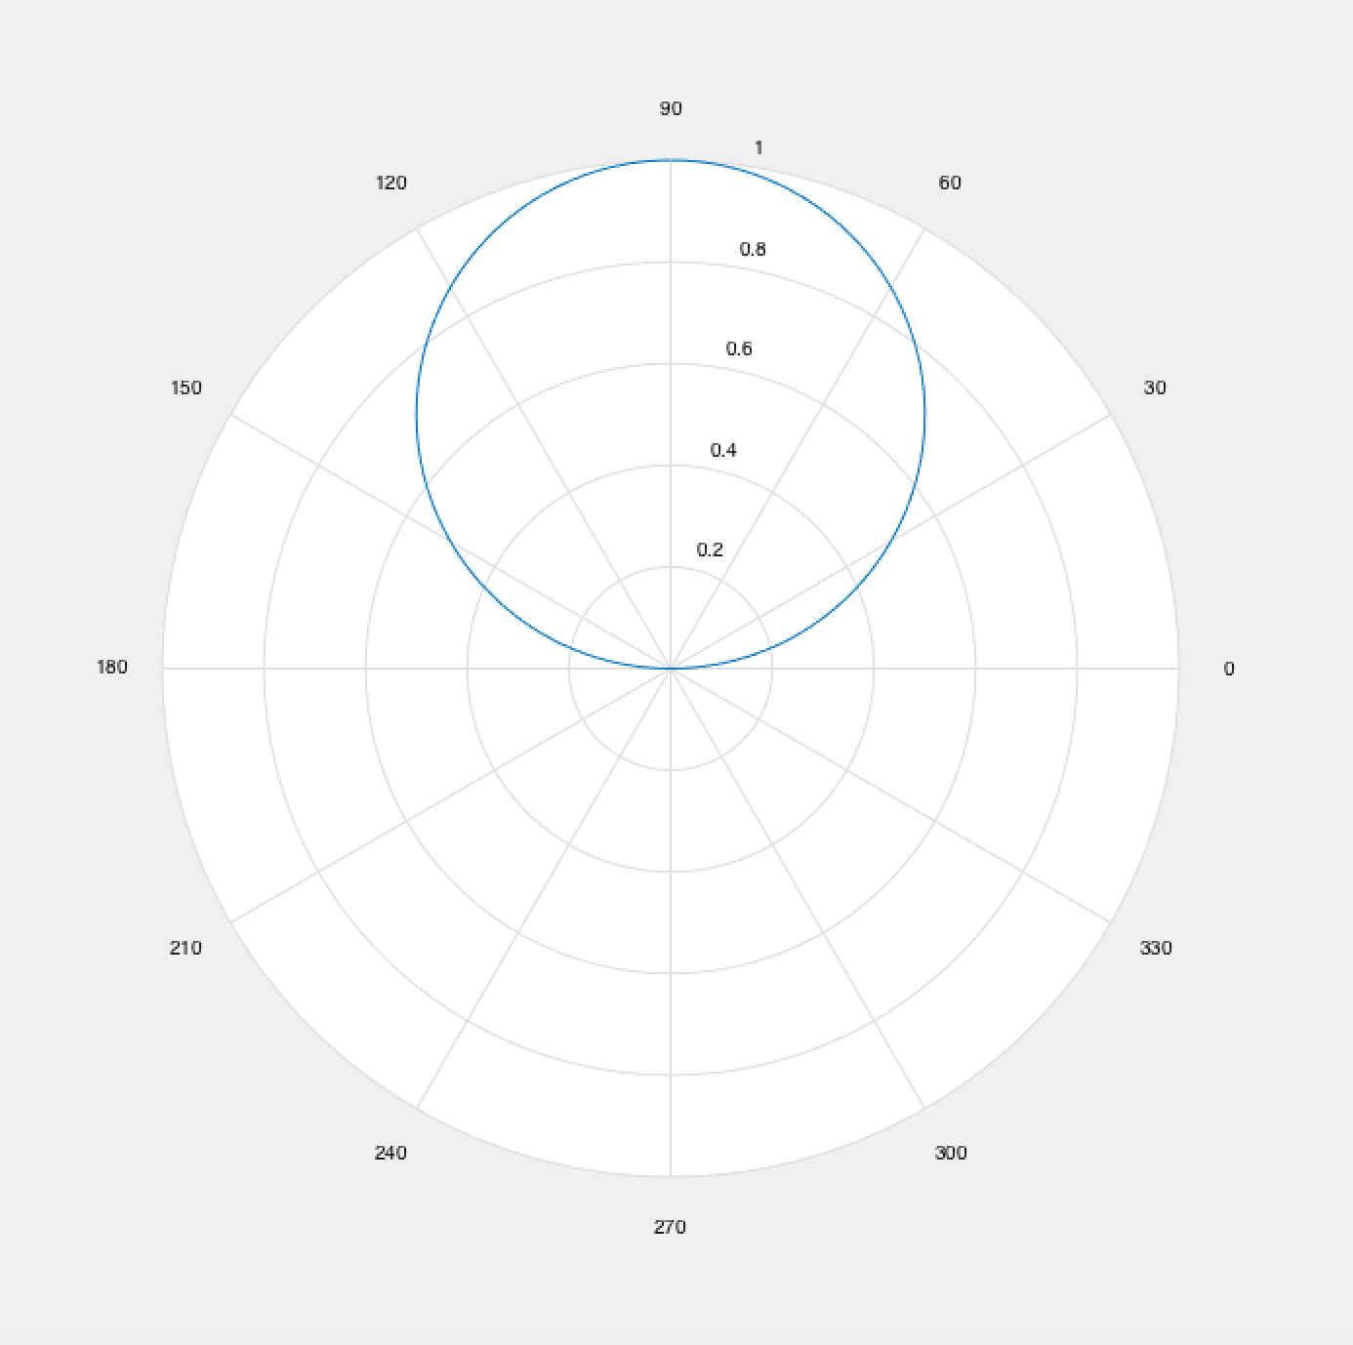

Figure 5: Simulation’s SAR antenna radiation pattern.

**IV. Signal Design for Correlation**

In this simulation, a Barker sequence is transmitted from the simulated SAR antenna because it has a high autocorrelation when the offset is minimal. Therefore the side lobes are tiny and the waveform is symmetrical. This way the range profiles are clear for the system to interpret and the resolution is good.

The autocorrelation function is plotted in *Figure 5* and displays the symmetry of the signal and the distinctive peak in the middle. This does not display the perfect result of the autocorrelation of Barker Code because a true Barker Code cannot exceed the length of 13. This transmit signal is 16 points, therefore it is not a true Barker Code, some points were added. The range profiles in the cases of no noise, low noise, strong noise, and overwhelming noise are shown in *Figure 6-10*. *Figure 6*, the plot of the range profiles of the simulation with no noise, shows the clarity of the received signal when the Barker Code was transmitted. When low noise is present, as seen in *Figure 7*, the range profiles are still clear with a few that are unclear.

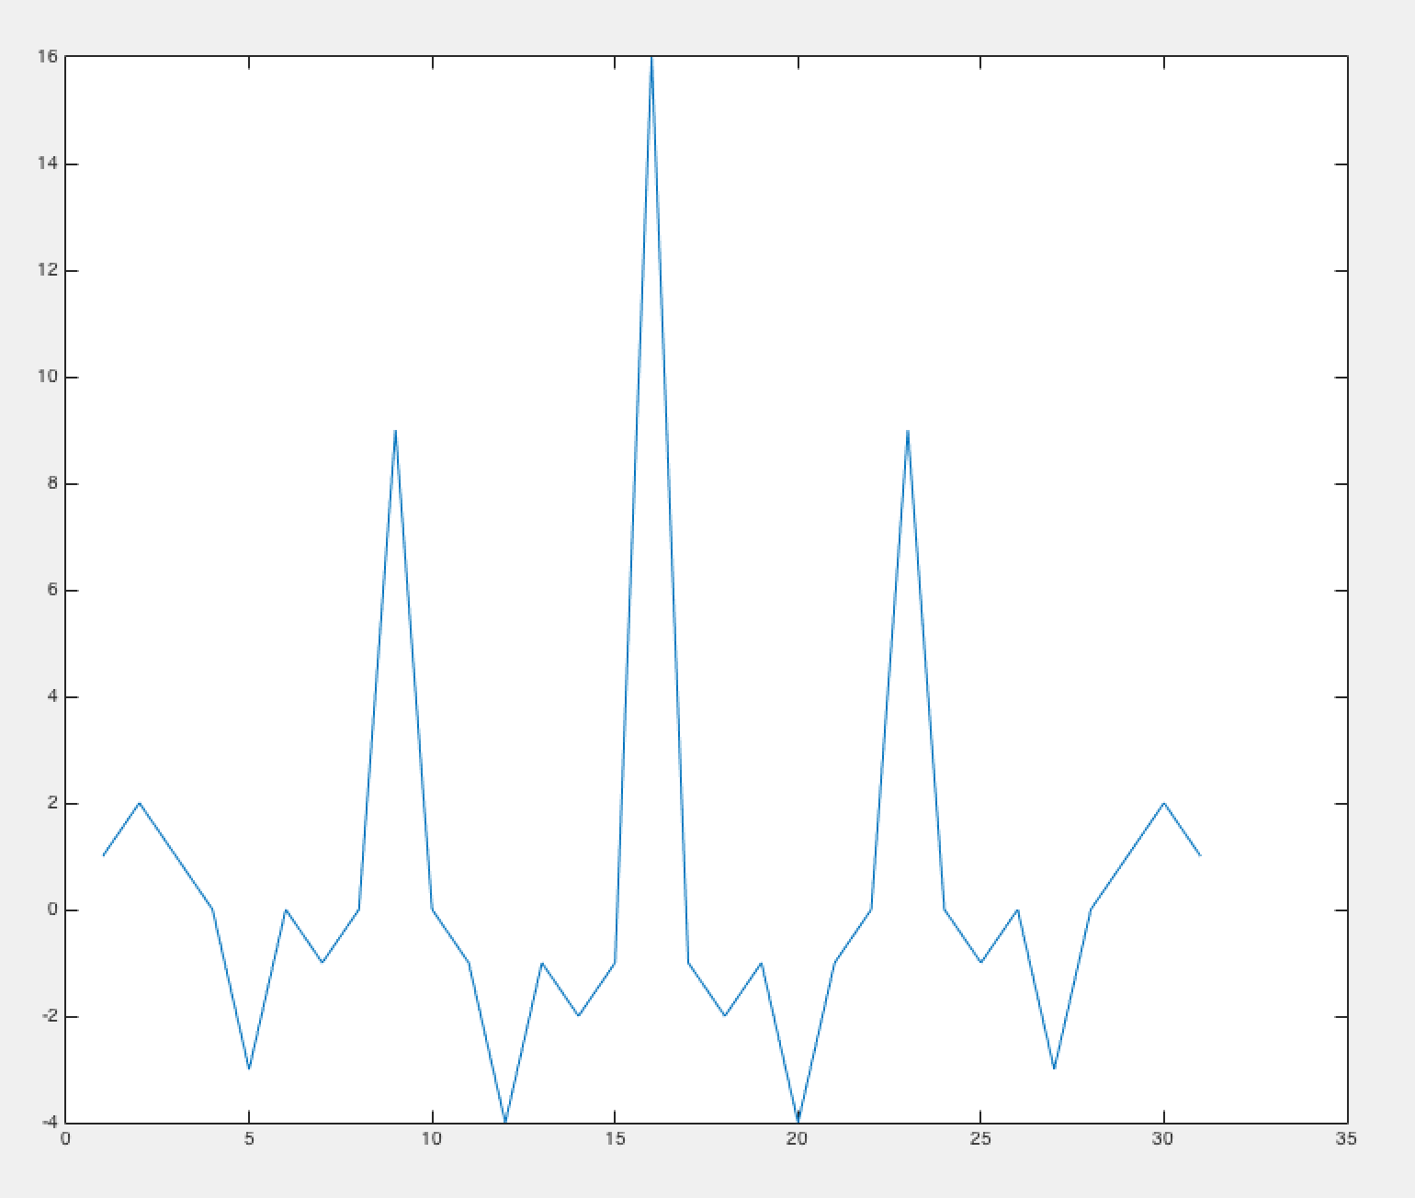

Figure 6: Plot of the autocorrelation function (ACF).

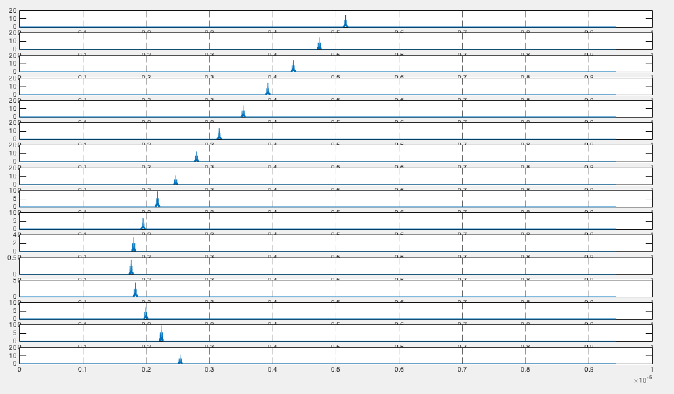

Figure 7: Plot of range profiles when no noise is present.

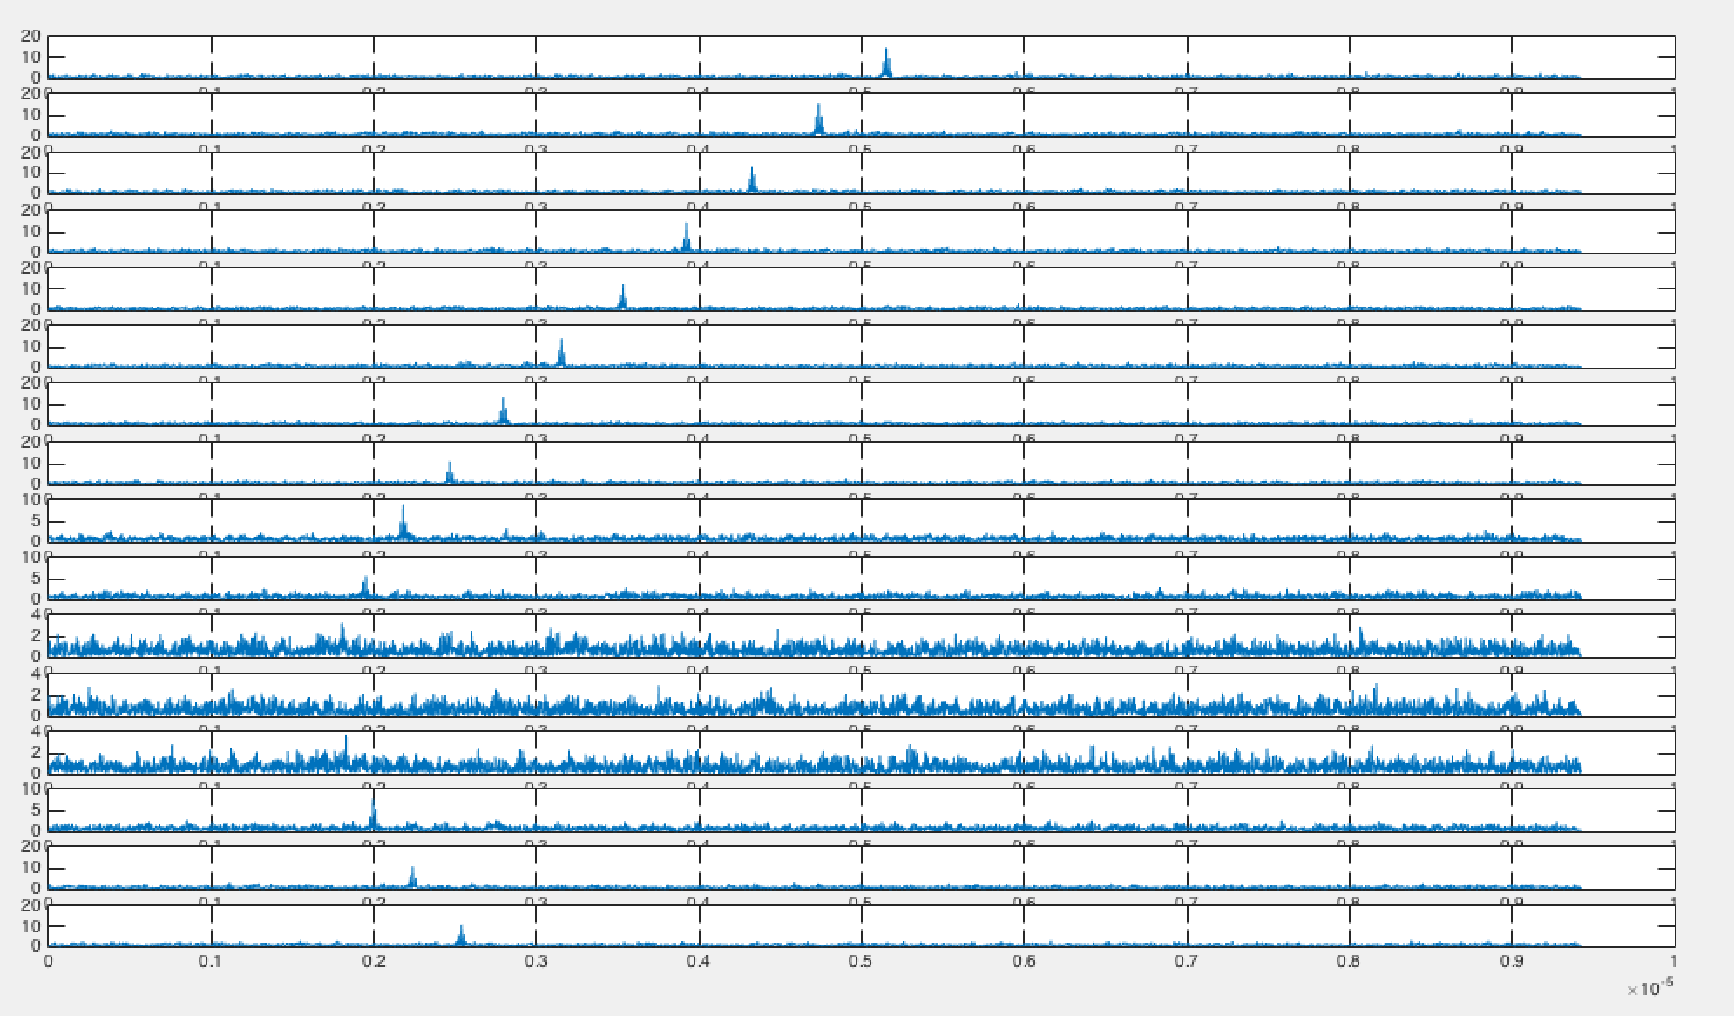

Figure 8: Plot of range profiles when low noise is present.

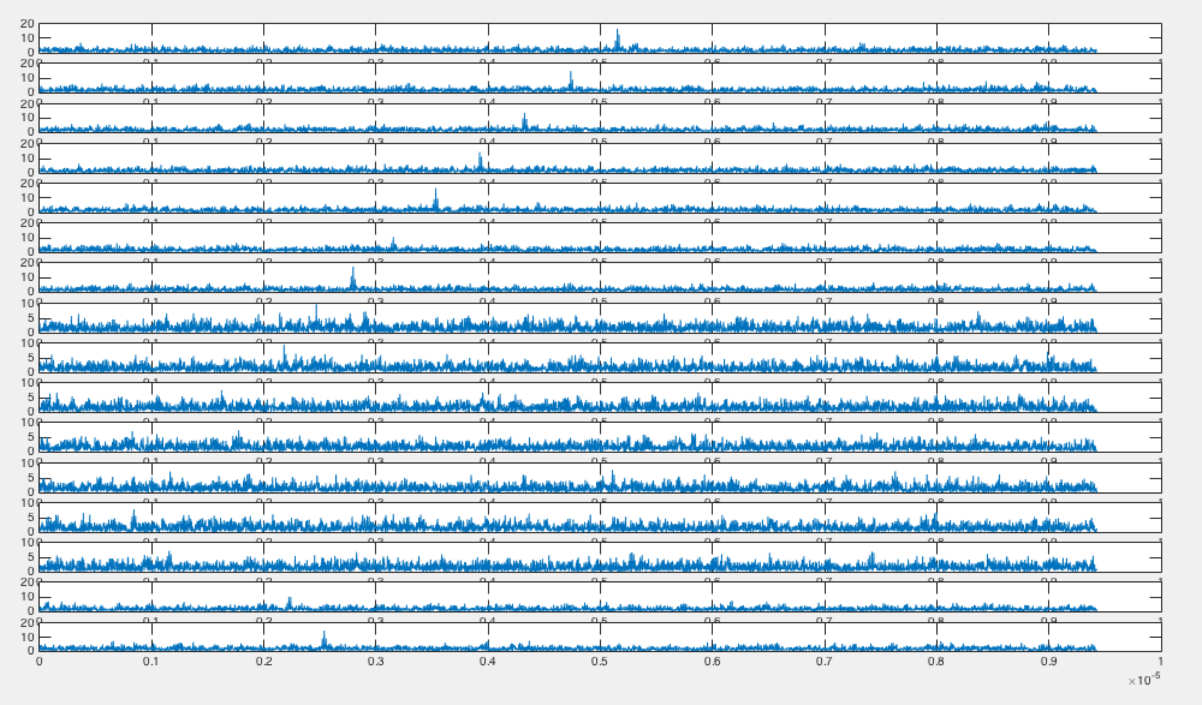

Figure 9: Plot of range profiles when strong noise is present.

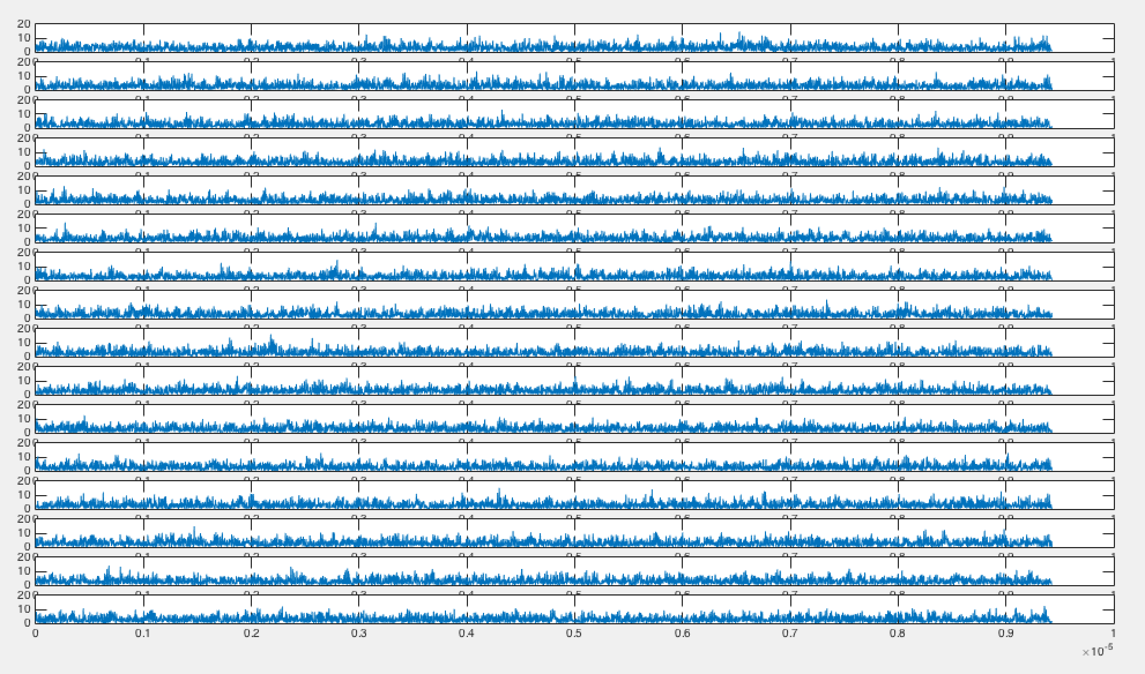

Figure 10: Plot of range profiles when overwhelming noise is present.

**V. Backprojection Algorithm**

The backprojection algorithm takes the timing delays at every single point on the grid from each of the 16 samples and compresses these. As it goes through, the target points produce higher magnitudes as everything is added up. After going through the entire grid like this, an image can be created by flagging the locations with the highest magnitudes.

A(x’,y’)=

Create grid of MxN grid of zeros

Plot the reconstructed image

This algorithm often provides accurate results, however since so many signals are added together a threshold may need to be added to filter out the spots on the image grid that are in a radiation path with a target, and therefore flagging that a target is in the path, but are not the location of the target so the magnitude at these points will not be quite as high as that of the target itself. By filtering out magnitudes below a certain threshold, the integrity of the response is improved.

**VI. Simulation Results**

The reconstructed images in the case of no noise, low noise, strong noise, and overwhelming noise can be observes in *Figure 11-19*. When noise is low, the system does a good job of interpreting the general location and vague shape of the target. *Figure 11* shows that the location of the target is correctly represented and a shape begins to take form. More points are present in the path of the antenna’s radiation pattern due to the backprojection algorithm.

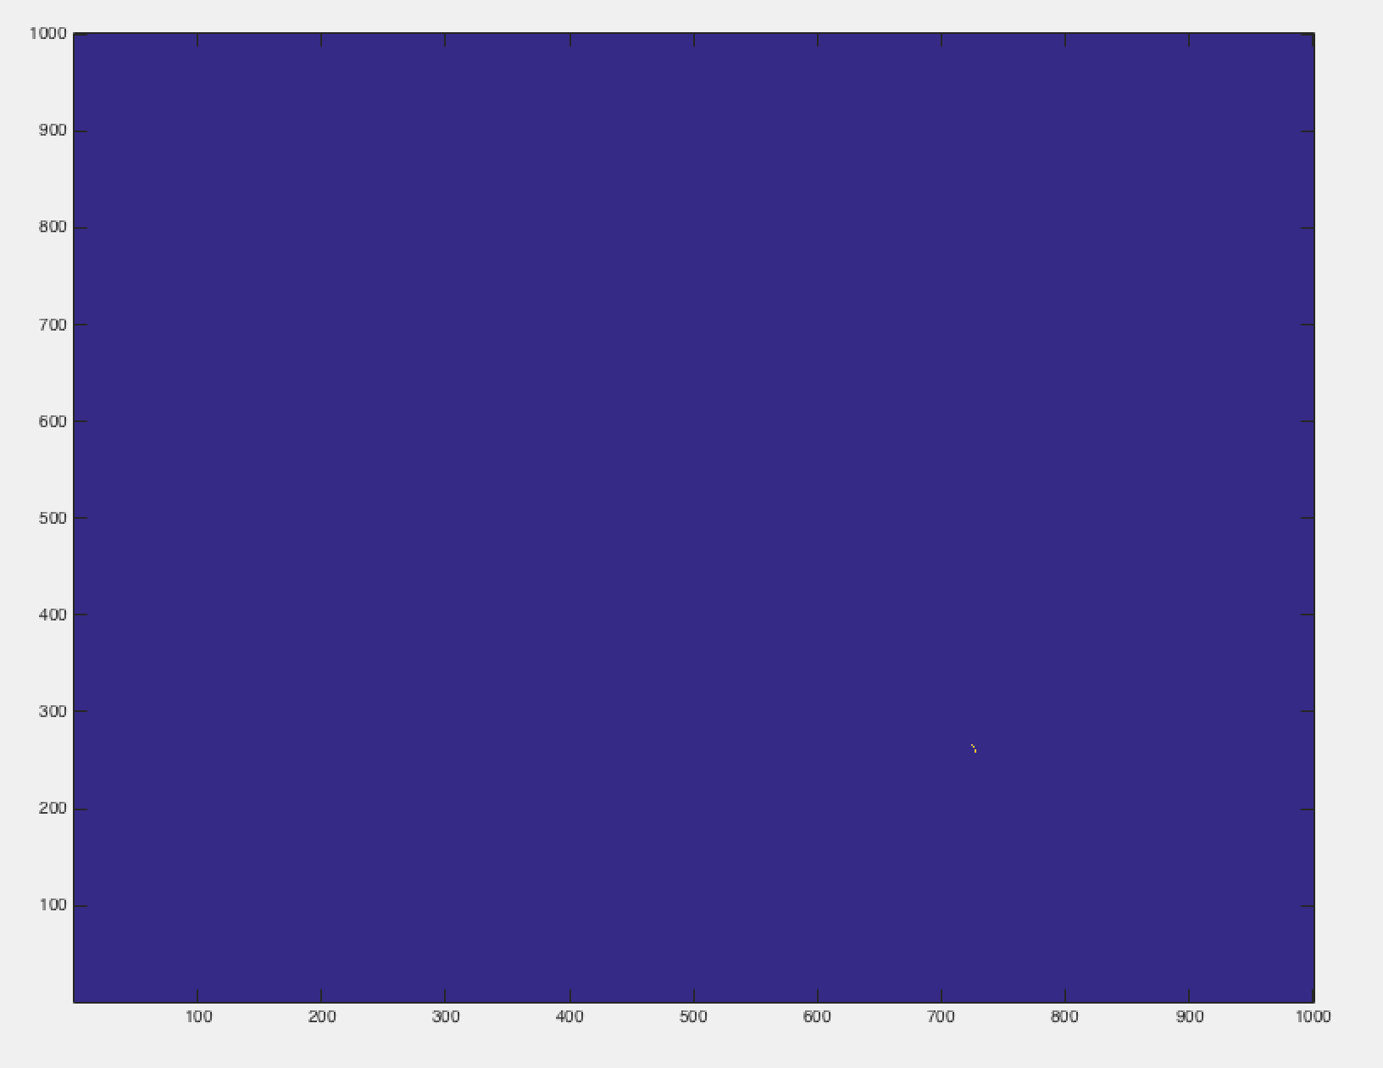

Figure 11: Reconstructed image when no noise is present.

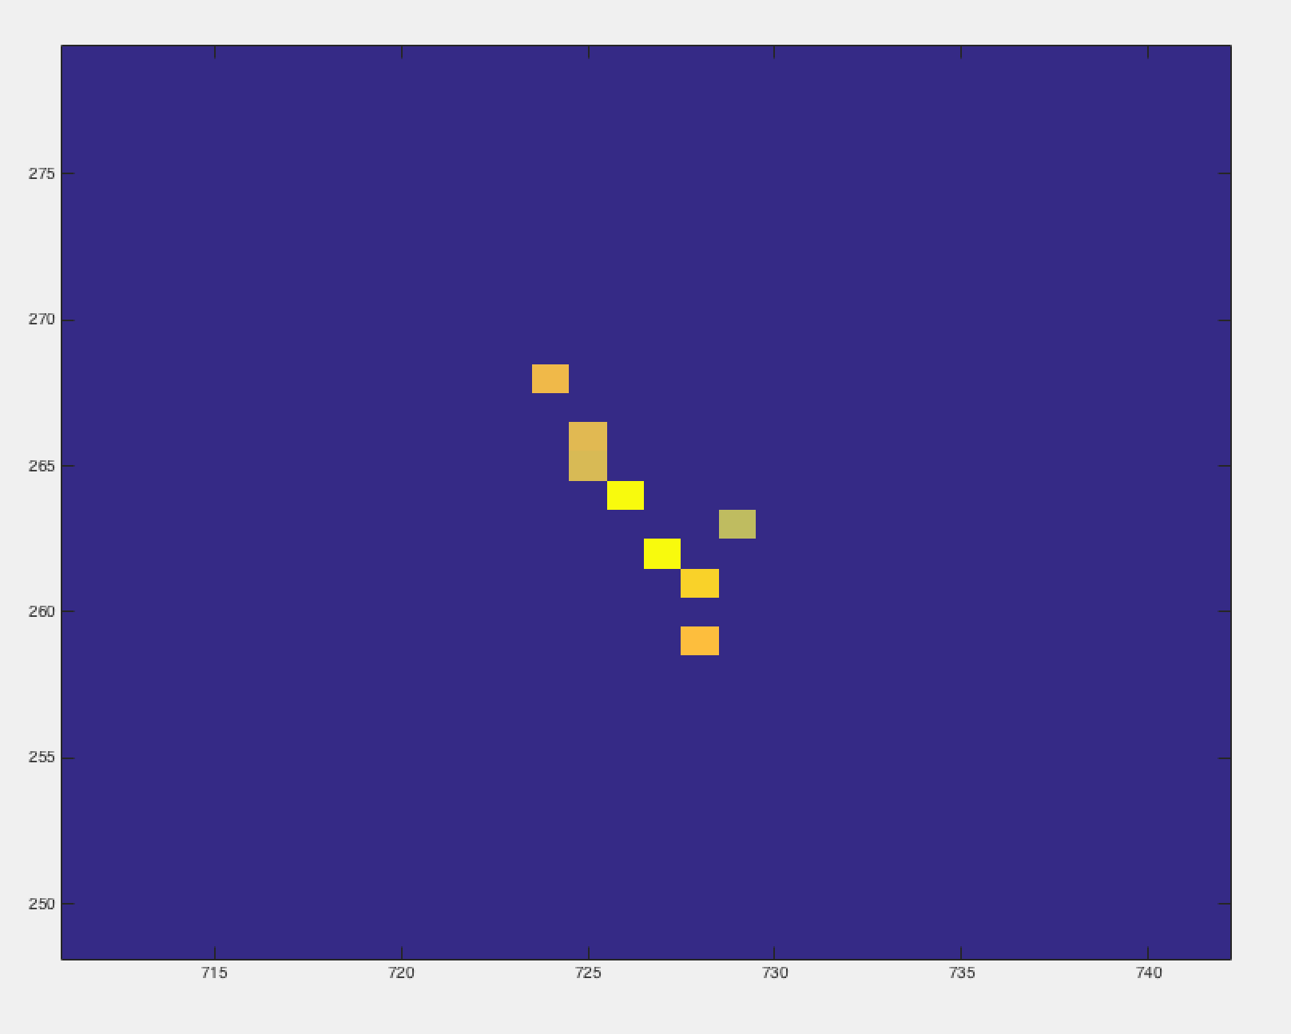

Figure 12: Close-up of reconstructed image when no noise is present.

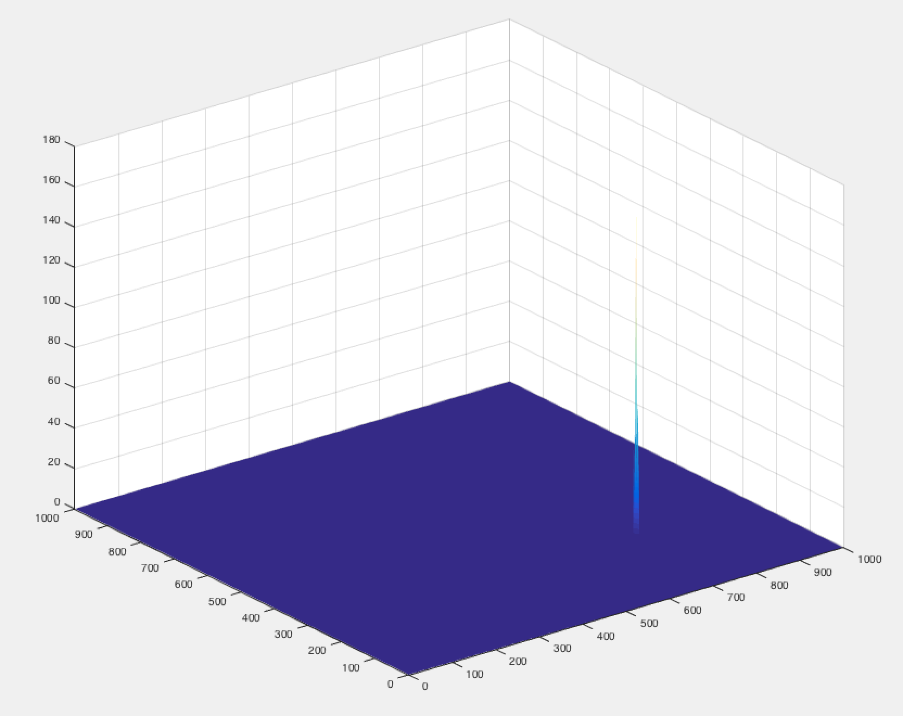

Figure 13: 3-dimensional view of reconstructed image when no noise is present.

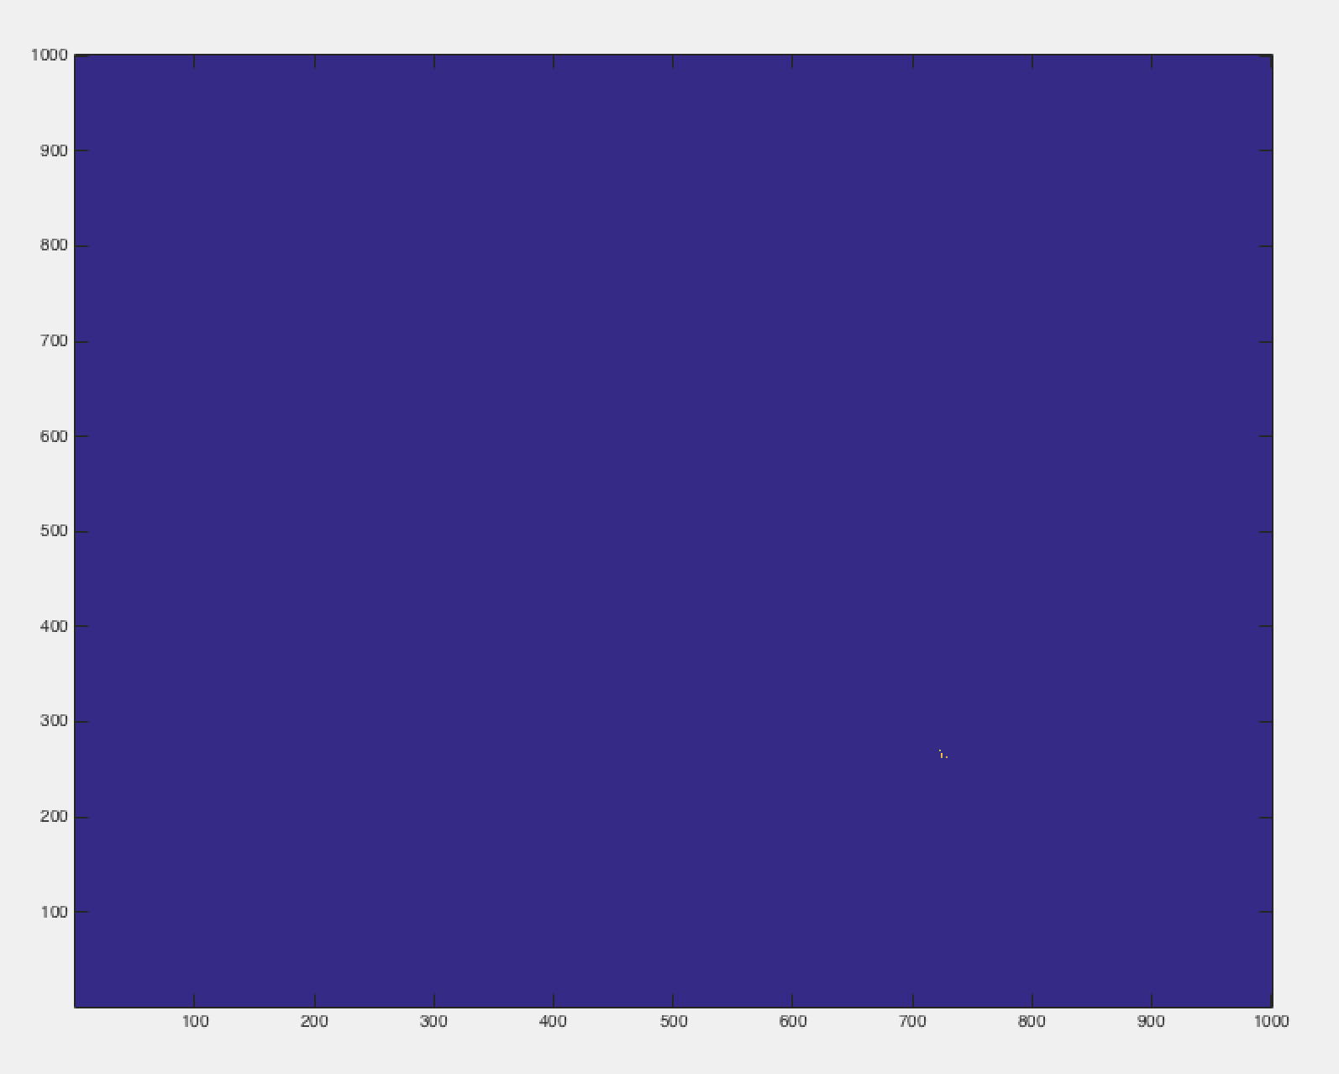

Figure 14: Reconstructed image when low noise is present.

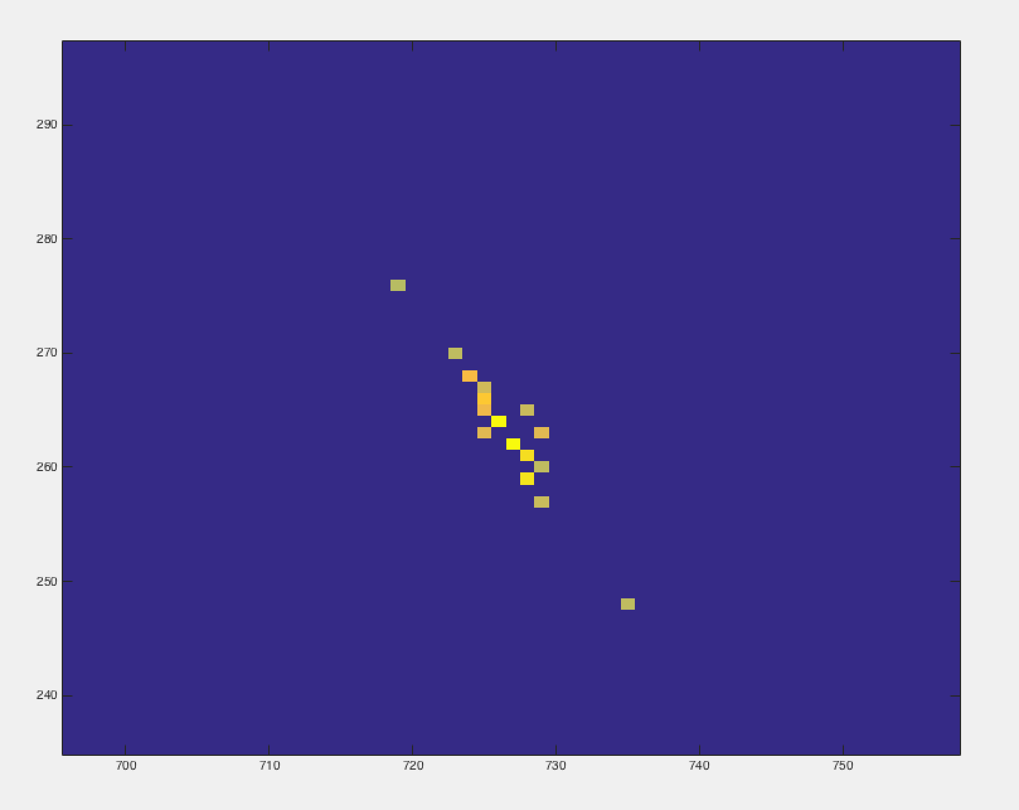

Figure 15: Close-up of reconstructed image when low noise is present.

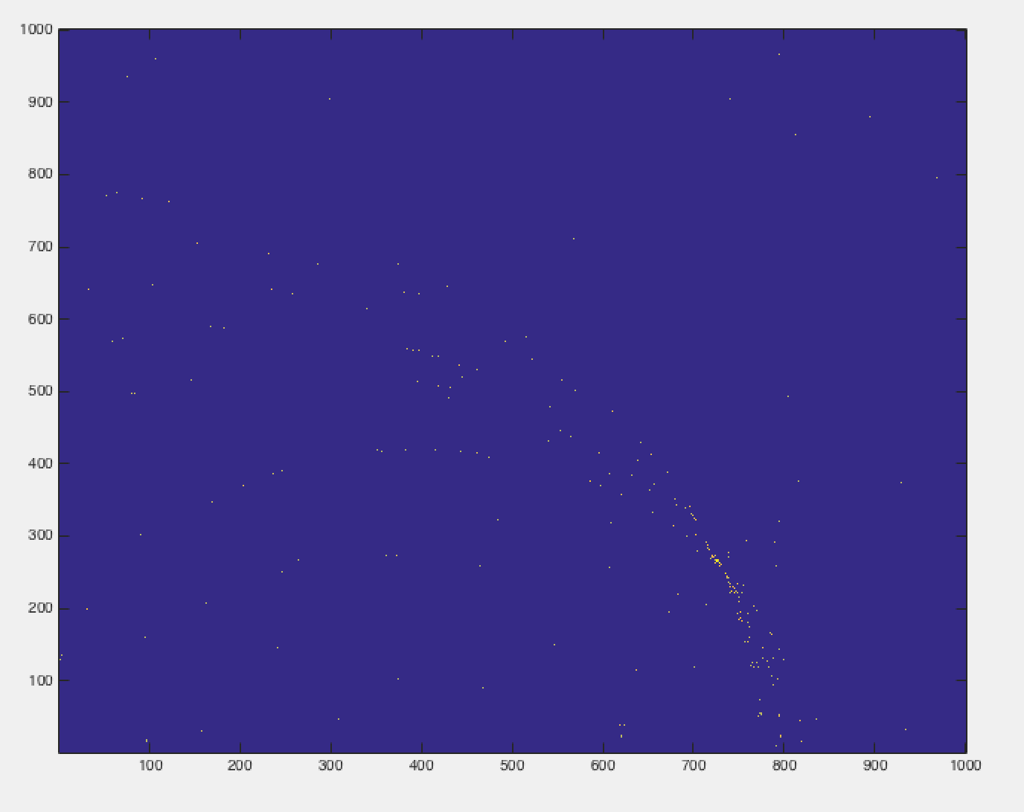

Figure 16: Reconstructed image when strong noise is present.

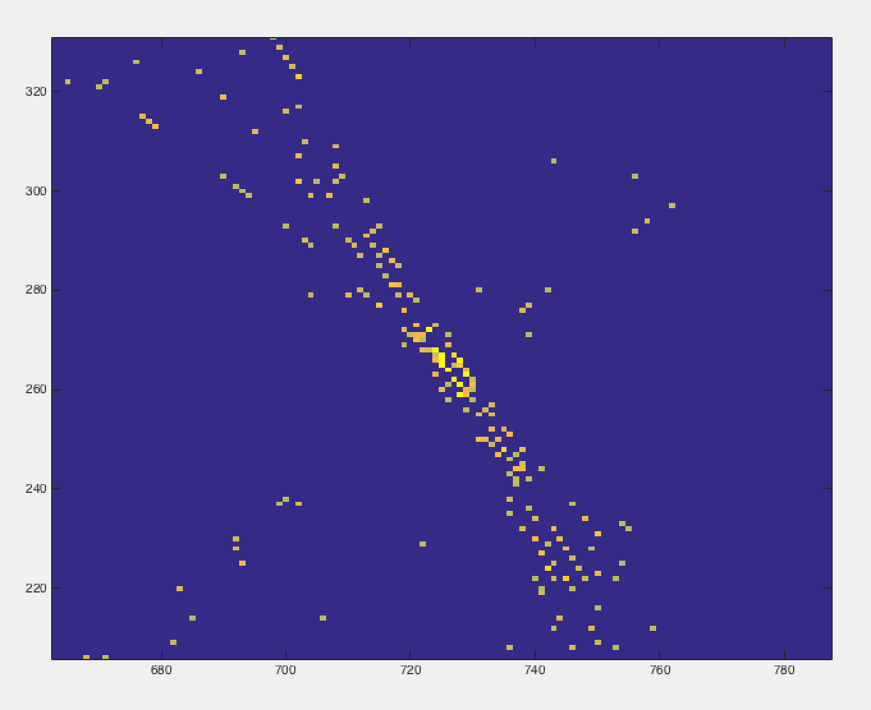

Figure 17: Close-up of reconstructed image when strong noise is present.

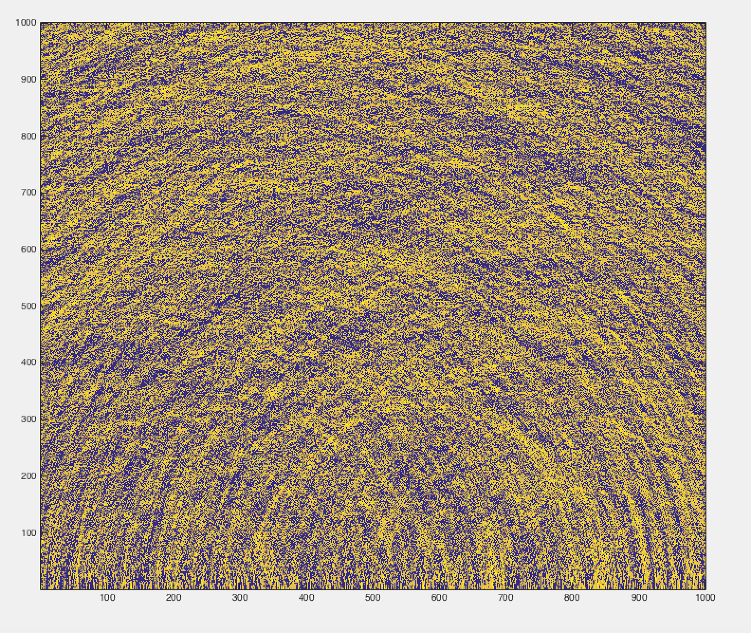

Figure 18: Reconstructed image when overwhelming noise is present.

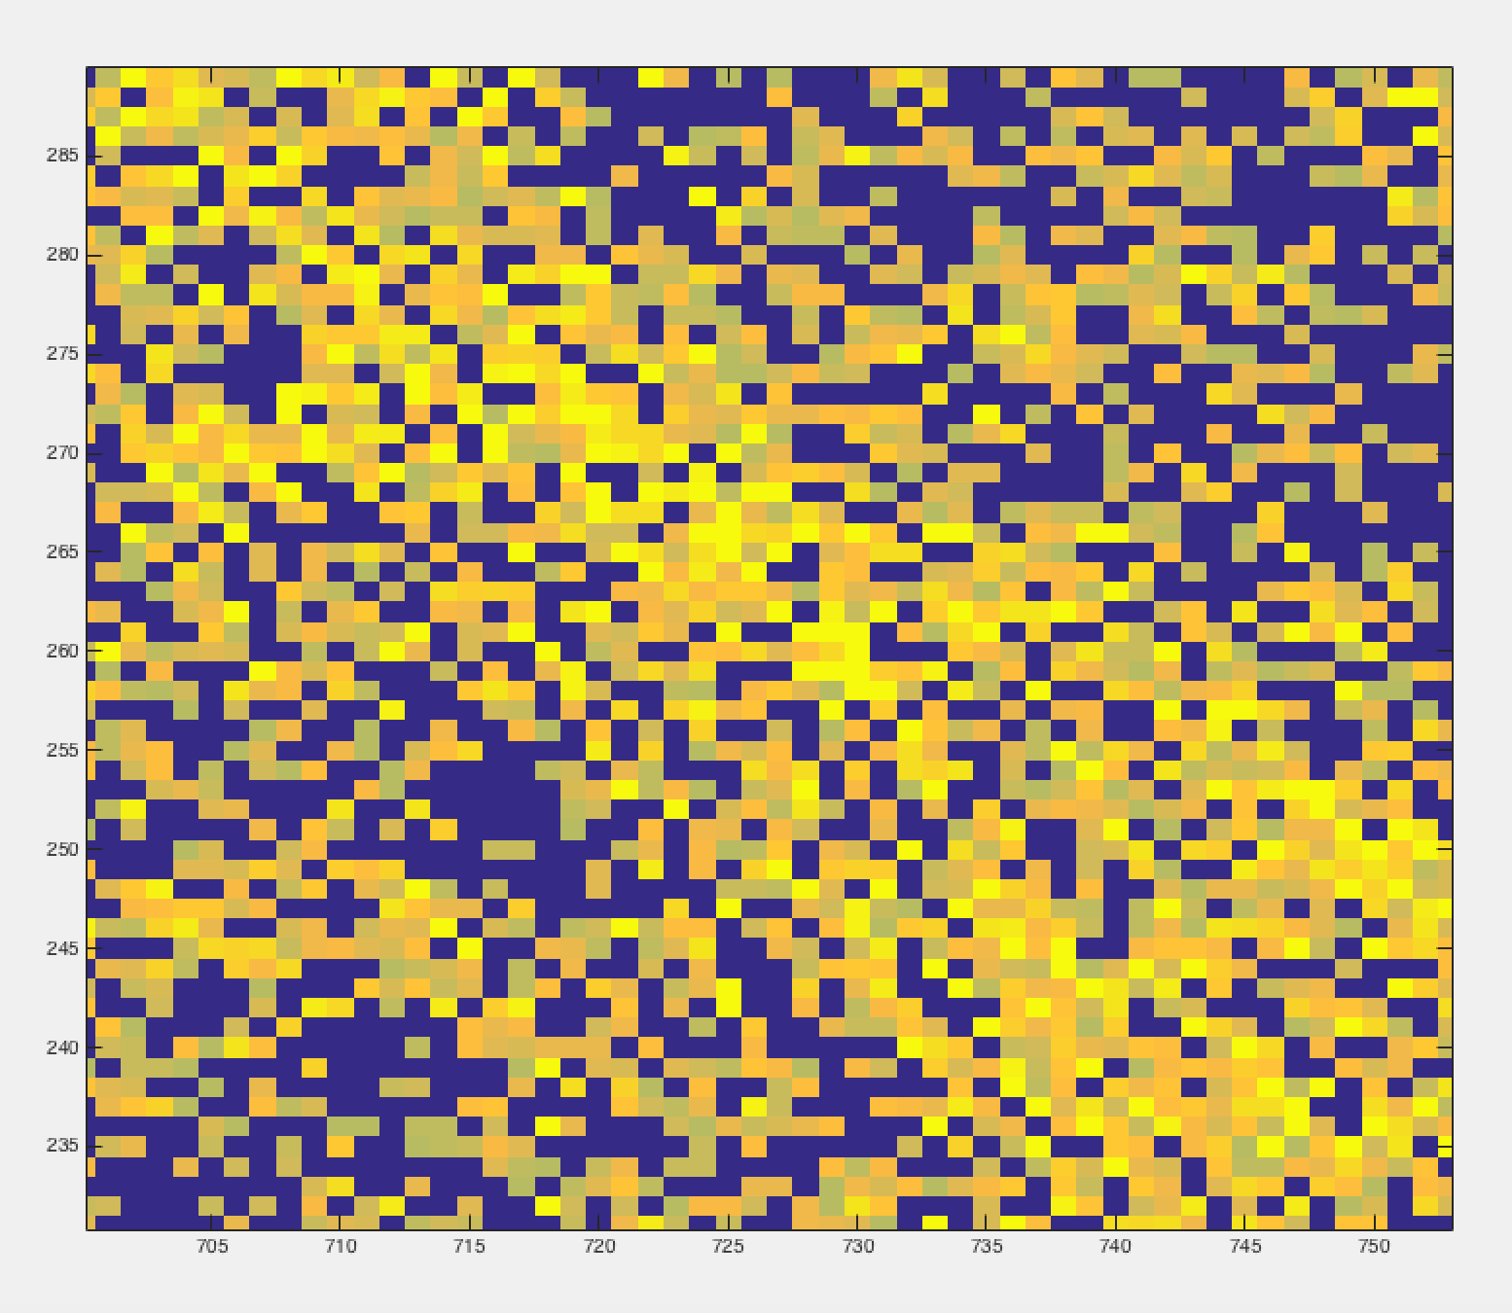

Figure 19: Close-up of reconstructed image when overwhelming noise is present.

Naturally, the signals that had less noise produced much better reconstructed images and the images got progressively more difficult to distinguish as noise was added because accuracy was lost. The system could not distinguish the impulse signal that indicated a target from the noise in the rest of the signals.

1. **Conclusion and discussion**

Synthetic Aperture Radar is a useful way to detect objects, land patterns or characteristics from a moving object above because it acts as a large antenna gathering vast amounts of information. It can detect a lot for its size, however a lot of computing power and logic is necessary because of the signal processing and backprojection algorithm. Noise gets in the way or adequate detection, however match filtering helps combat a lot of this noise. In this simulation we analyzed strip map Synthetic Aperture Radar which surveys the entire ground in sight and to do a full analysis of the system’s behavior it would be helpful to also study spotlight Synthetic Aperture Radar which focuses on a specific spot on the ground. It’ll be interesting to see the applications of SAR and improvements of the processing algorithms as it improves with time.

Works Cited

Budge, Merg, Dr. "Synthetic Aperture Radar (SAR)." *AccessScience* (2011): n. pag. Web.

Wolff, Dipl.-Ing. (FH) Christian. "Radar Basics." Radar Basics - Synthetic Aperture Radar. N.p., n.d. Web. 05 May 2017.

"Principles of Synthetic Array (Aperture) Radar." Introduction to Airborne Radar (n.d.): 403-24. Web.

"The Scientist and Engineer's Guide ToDigital Signal ProcessingBy Steven W. Smith, Ph.D." Computed Tomography. N.p., n.d. Web. 05 May 2017.