Mary Floren

Adam Benjamin

Spring 2017

**ECE 461 Mini Project 2**

**Simulation and Analysis of a Circuit-Switched Optical Network with Wavelength-Division Multiplexing**

**Part A**

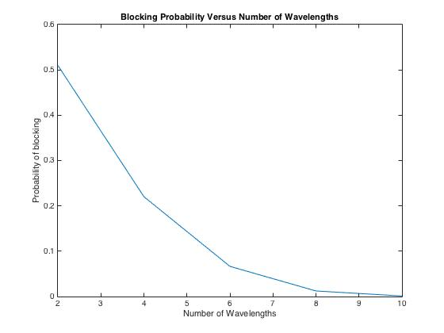

*Fig 1. Blocking probability for optical bus network with wavelengths ranging from 2 to 10 by increments of 2 using 10,000 connection requests and 8 simulation instances*

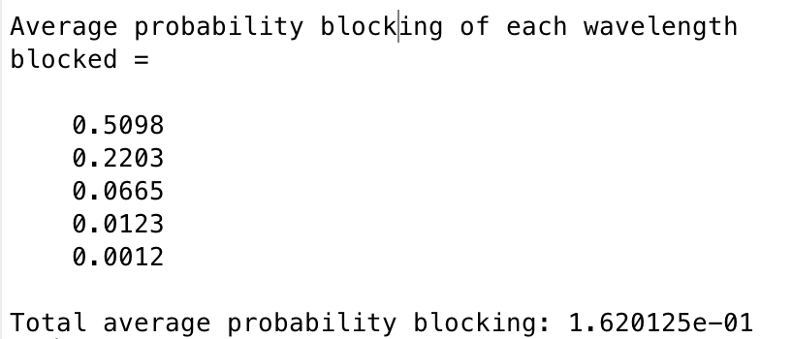

*Fig 2. Average blocking probability for wavelength numbers, w, of 2, 4, 6, 8, 10 respectively using 10,000 connection requests and 8 simulation instances*

Part A simulates a simple optical network consisting of 10 nodes interconnected in a bus topology. Connection requests are equally likely between any two nodes in the network. One way to think about this is that a connection between a New York node and Chicago node is equally as likely as a New York and Los Angeles node or any other city combinations.

In an optical network, transmissions are sent over a wavelength. As the number of wavelengths increases, the average blocking probability decreases in an exponential fashion, as seen in Fig 1. Simply put, this is because more wavelengths means more possible connections.

**Part B**

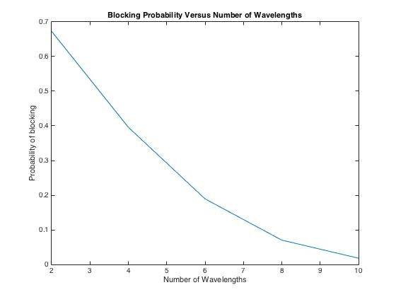

*Fig 3. Blocking probability for optical bus network with wavelengths ranging from 2 to 10 by increments of 2 using 10,000 connection requests (assuming all connections are between nodes 1 and 10) and 8 simulation instances.*

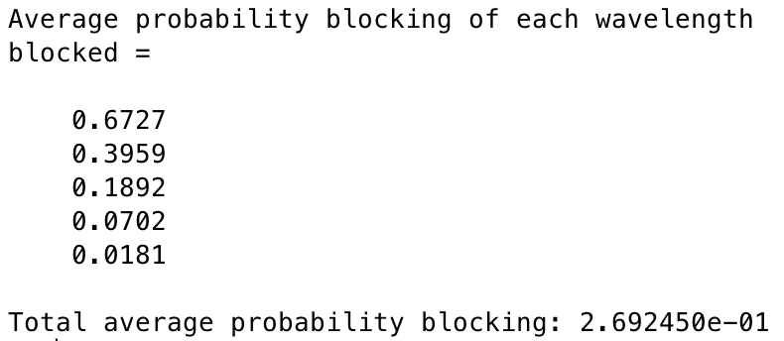

*Fig 4. Average blocking probability for wavelength numbers, w, of 2, 4, 6, 8, 10 respectively using 10,000 connection requests (assuming all connections are between nodes 1 and 10) and 8 simulation instances.*

Part B is identical to Part A except for the fact that all connection requests are between nodes 1 and 10. An example of this is that all connections are between the New York node and the Los Angeles node.

As expected, this increases blocking at every value of w. This is because one wavelength can only handle one connection now. In Part A, a wavelength could handle multiple connections if connections were made at different node links (e.g. node 1 to node 3 and node 5 to node 10).

**Part C**

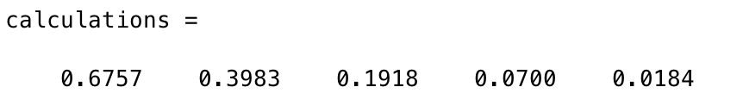

*Fig 5. Theoretical blocking probability for wavelength numbers, w, of 2, 4, 6, 8, 10 respectively using 10,000 connection requests (assuming all connections are between nodes 1 and 10) and 8 simulation instances.*

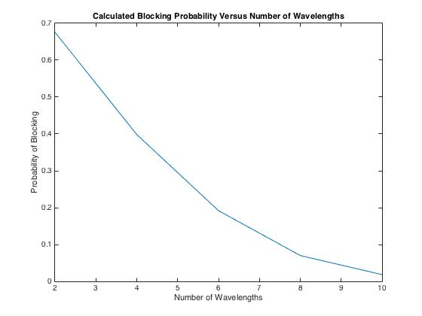

*Fig 6. Theoretical blocking probability for optical bus network with wavelengths ranging from 2 to 10 by increments of 2 using 10,000 connection requests (assuming all connections are between nodes 1 and 10) and 8 simulation instances.*

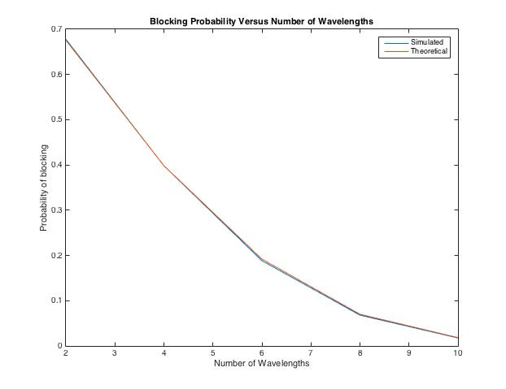

*Fig 7. Theoretical (red) vs simulated (blue) blocking probability for optical bus network with wavelengths ranging from 2 to 10 by increments of 2 using 10,000 connection requests (assuming all connections are between nodes 1 and 10) and 8 simulation instances.*

The changes made in Part B (all connections made between node 1 and node 10) turn the system into an M/M/c/c system. This means that it is fairly simple to calculate the blocking probability for different values of w. You use the equation for Erlang-B, as seen below:

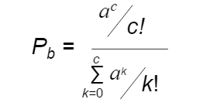

In this equation, a=lambda/mu and c=w(number of wavelengths). This is how the values are calculated in Fig 5. When these values are graphed versus the simulated blocking probabilities, they are almost identical, as seen in Fig 7. It can be concluded that our simulation captures the theoretical behavior of the optical network very effectively.

**Part D**

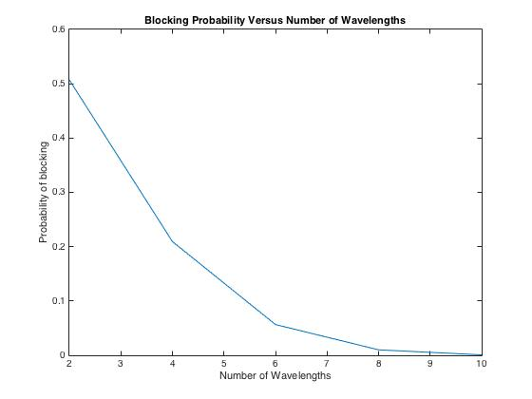

*Fig 8. Blocking probability for optical bus network with wavelength conversion capability with wavelengths ranging from 2 to 10 by increments of 2 using 10,000 connection requests and 8 simulation instances*

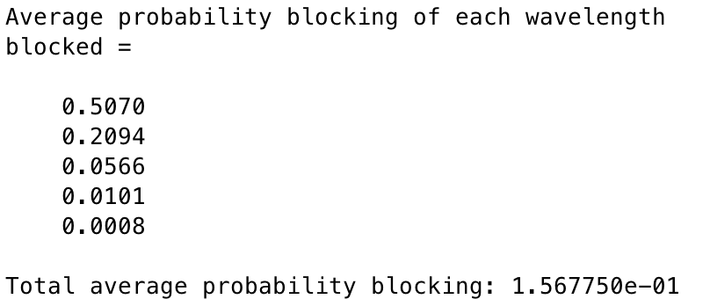

*Fig 9. Average blocking probability for wavelength numbers, w, of 2, 4, 6, 8, 10 respectively using 10,000 connection requests and 8 simulation instances (with wavelength conversion capability)*

Part D corresponded to adding wavelength conversion capability to the system. This capability decreases blocking probability for each value of w.

However, these decreases are very small. Wavelength conversion is very expensive. Therefore, it does not seem practical to implement in all but the most extreme cases. The added cost only results in minimal performance increase. The only cases where wavelength conversion may be justified is when transmitting extremely time sensitive data.