Building the semantic tree

Introduction

The semantic pattern takes place in the beginning of the transformation process, it has to search the information needed for output language semantic definition in the input language formalism.
Then this information has to be organised so that the syntactic pattern can easily generate code in the output formalism.

First, we will quickly explain the input language formalism, then we will talk about the organisation of our semantic tree, and finally we will show how the semantic pattern has been implemented.

1) Description of the input language formalism

The input language formalism we are dealing with describes a petri net partitionning. It has a global attribute called NAME which contains the name of the petri net model and owns some entities which are subdivided into two categories : links and nodes.

a) Here is a list of the nodes we can find in this formalism :

- node PROCESS
A process has a NAME, a list of INSTANCES, and can have non-oriented arcs BELONG
- node STT_PLACE
This is a local place for a process.
A local place has a NAME, a non-oriented arc BELONG and two oriented arcs in and out to be connected to the in and out transitions of this place with none maximum count
- node COMM_PLACE
This is communication place.
A communication place has a NAME, a number of tokens NB_IN_TOKENS and two oriented arcs in and out as the local place do.
- node LOC_TRANS
This is a local transition.
A local transition has a NAME, a non-oriented arc BELONG, two oriented arcs (directions in and out), and oriented communication arcs with none maximum count (directions in and out).
- node SYNC_TRANS
This is a synchronized transition between many processes.
A synchronized transition has a NAME, non-oriented arcs BELONG and oriented arcs (directions in and out)

b) We describe below the different links available in the formalism :

- link BELONG
Allows a group of node entities to be associated to the same process.

- link ARC
Links two node entities if they are local to the process.

- link COMM_ARC
Links a local node entity to an external COMM_PLACE.
A communication arc has an integer attribute called VALUE which contains the arc valuation.

There are some limitations we can see when looking at this formalism, for example a synchronized transition can not be connected to a communication place and a communication can not belong to a process.

2) Organisation of the semantic tree

As we said before, the semantic pattern is placed between the input formalism and the syntactic pattern in the transformation process. This means that the organisation of the generated code has to be taken into account in the design of the semantic tree.
A first partitionning of the data can be done between processes, synchronized transitions and communication places, indeed there will be a state machine per process, a manager for the synchronized transitions and another manager for the communication places.
These datas are distributed into three subtrees of the root node : the « PN-Processes » subtree, the « Synchronized transitions » subtree and the « Communication places » subtree.

In our case, processes will be generated as state machines, so every local state should know its successor. This implies some specific structuration of the tree at the process level to make the code generation during the syntactic phase easier.

We will describe below how the semantic tree has been organised, and the reasons why it has been designed like this.

The starting point of our tree is a node called C_MPI, all important datas are stored in subtrees of this node. The C_MPI node has four sons which match to the first partionning of our input datas, theses sons will be described in the same order they appear in the root node, so that it can be reused in the syntactic pattern when applying rules on the semantic tree.

To summarize, we first distribute the datas into four different subtrees, the first one contains all informations needed by processes, the second one contains all informations needed by synchronized transitions management, the third one contains all informations about communication places management and the last one contains all datas needed for the prototype manager :

C_MPI (root) node has four sons :
- LIST_PROCESS : datas needed for state machine generation
- LIST_SYNC_TRANS : datas needed for synchronized transitions management
- LIST_COMM_PLACE : datas needed for communication places management
- LIST_INSTANCE : datas needed for prototype manager

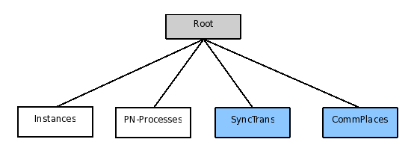

We explain below the structure of each subtree in details :

- LIST_PROCESS
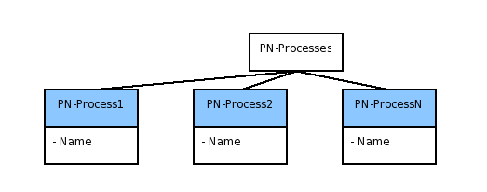
This node contains a list of all different processes of the application, each process is a node of type PNPROCESS with the process name and its id (node position in the list).
To build a state machine which represent a PNPROCESS, syntactic rules will need to access datas which are included in a process, that's why we choose to store every element concerned by a process in the PNPROCESS tree.
The input formalism implies that only local places, local transitions and synchronized transitions take place inside a PN-Process. Therefore each PNPROCESS tree has three subtrees which store elements contained in a process.
PNPROCESS node has three sons :
- LOCAL_PLACES : contains a list of places owned by a PN-Process
- LOCAL_TRANSITIONS : contains a list of transitions owned by a PN-Process
- LOC_SYNC_TRANSITION : contains a list of synchronized transitions owned by a PN-Process

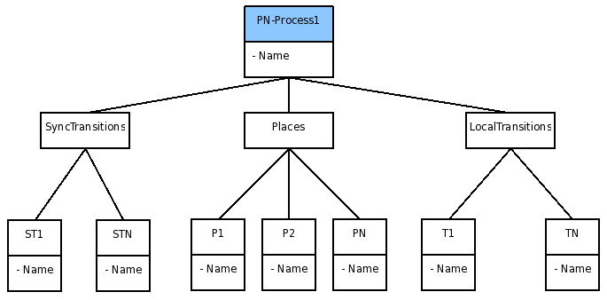

Each of theses nodes is in fact a list of entities with corresponding names and ids. They are designed with the same structure in order to match a state machine behavior, therefore we will explain the general organisation of these subtrees and then give an example for one of them.
In our implementation, places and transitions share the same state status, a transition is then a state in which conditions are tested to know if the transition can be crossed.
As we said before, each state of a state machine has to know its successor because the current state will jump to the next one after processing its job.

Each transition (local or synchronized) contains a list of output local places, and each local place contains a list of output transitions.
After creating the list of output local places, the work is done for the synchronized transitions nodes, but there are informations missing for local places and transitions because local places can have input or/and output synchronized transitions and local transitions can have input or/and output communication places.
We need to store incoming synchronized transitions and communication places because there will be some work at the syntactic level to manage these synchronisations.
That's why local place elements have two more nodes than synchronized transition elements, which are a list of input synchronized transitions and a second list of output synchronized transitions. Same for local transitions elements which contains a list of input communication places and a list of output communication places.

To sum up the organisation of elements inside a PN-Process :

Each PNPROCESS has three subtrees of types LOCAL_PLACES, LOCAL_TRANSITIONS and LOC_SYNC_TRANSITION composed as follow :

a) LOCAL_PLACES is a list of LOCAL_PLACE with corresponding names
LOCAL_PLACE contains three subtrees :
- SYNC_TRANS_IN is a list of input synchronized transition names
- SYNC_TRANS_OUT is a list of output synchronized transition names
- LOC_TRANS_OUT is a list of output local transition names
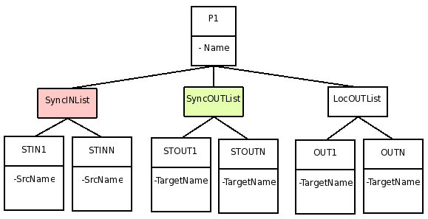
b) LOCAL_TRANSITIONS is list of LOCAL_TRANS with corresponding names
LOCAL_TRANS contains three subtrees :
- COMM_PLACE_IN is a list of input communication place names
- COMM_PLACE_OUT is a list of output communication place names
- LOC_PLACE_OUT is a list of output local place names
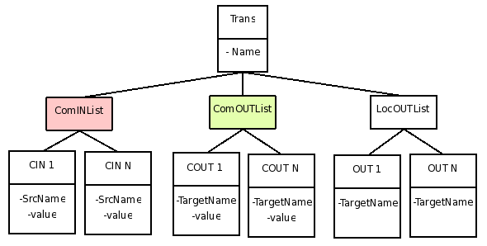
c) LOC_SYNC_TRANSITION is a list of LOC_SYNC_TRANSITION with corresponding names
LOC_SYNC_TRANSITION contains one subtree :
- ST_LOC_PLACE_OUT is a list of output local place names

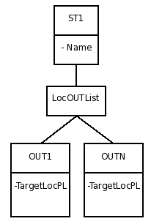

The organisation we choose allows to access directly the state following the current state, therefore a syntactic rule working on a process element can easily generate the relation between two successive states.
LIST_SYNC_TRANS
The behaviour of a synchronized transition is to wait for a number of input processes, when all these processes have called the synchronized transition, it releases all output processes waiting on this transition.
This behaviour reveals important datas to be stored inside a synchronized transition node, these datas are input and output process names, but also names of places where each synchronized transition arrives.

This leads to the following structure for each synchronized transition :

SYNC_TRANSITION has two sons :
- PROC_IN is a list of input process and place names, the type of list elements is ONE_SYNC_TRANS_PROC_IN
- PROC_OUT is a list of output process and place names, the type of list elements is ONE_SYNC_TRANS_PROC_OUT

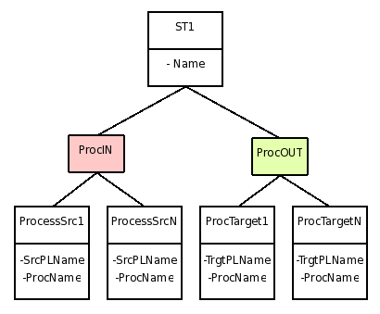
LIST_COMM_PLACE
The structure of a communication place is almost similar to the synchronized transition. A communication place has input and output process names, source and target transition names, but also a number of required tokens and a valuation for input and output communication arcs.
Therefore, the organisation of the LIST_COMM_PLACE subtree is the same as the LIST_SYNC_TRANS, but we have added a number of tokens available in each communication place node and a valuation in each input and output process.

This leads to the following structure for each communication place :

COMM_PLACE is described by a name, a number of required tokens.It has two sons :
- PROC_IN is a list of input process names, input place names and valuations, the type of list elements is ONE_COMM_PLACE_PROC_IN
- PROC_OUT is a list of output process names, output place names and valuations, the type of list elements is ONE_COMM_PLACE_PROC_OUT
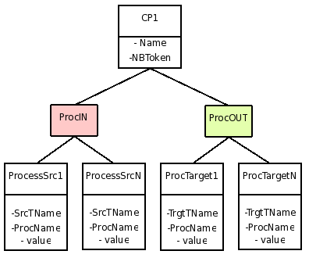

LIST_INSTANCE
The last subtree of the root node was initially placed under the PNPROCESS subtree, because a group of instances is related to a PN-Process, but we realised that it was not easy to look through all PN-Process nodes for the prototype manager, so we stored informations about instances directly under the root node.
We had problems with the prototype manager because instance datas were distributed between all processes (each instance was under its corresponding PN-Process node) and the manager had to look through every PN-Process nodes to collect informations about instances.
The new structure with a list of all instances under the root node makes the prototype manager generation easier.

The subtree LIST_INSTANCE is not really complicated, it only contains the list of all instances with the name of the PN-Process to be instanciated and the name of starting place for this process.
The type of list elements is ONE_INSTANCE.

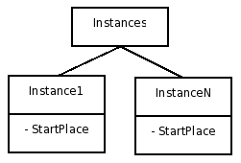
3) Building the semantic tree (.mssm)

To implement the code generator, we used the Metascribe tool which accept three types of files, the input formalism (.msm), the semantic pattern (.mssm) and the syntactic pattern (.msst). We explain in this section how the semantic pattern has been implemented in order to generate the semantic tree described above.

The semantic pattern is subdivided in three .mssm files, the main file (generator-main.mssm) declares all prototypes for semantic rules, semantic trees and constructors. These prototypes are implemented in the rule file (generator-rule.mssm) for semantic rules and in the tree file (generator-tree.mssm) for semantic trees. Each constructor of the list match a syntactic rule of the syntactic pattern, this allows us to link both patterns together.

Our general process to build the semantic tree is to use a semantic rule when we want to create a tree and to use a semantic tree when we want to create a leaf. Semantic rules can contain other semantic rules if the tree has subtrees.

Matching our semantic tree organisation, the root node is composed of four sons, each one is created with a semantic rule :

- WORK_ON_PROCESS : creates LIST_PROCESS son
- WORK_ON_SYNC_TRANS : creates LIST_SYNC_TRANS son
- WORK_ON_COMM_PLACE : creates LIST_COMM_PLACE son
- WORK_ON_INSTANCES : creates LIST_INSTANCE son

We describe below the implementation of each main rules.

rule WORK_ON_PROCESS
This rule creates a main node of type LIST_PROCESS called « PN_Processes » containing the number of processes, and for each instance of node type PROCESS found in the input model, it creates a subtree by calling the semantic rule CREATE_PROCESS.

rule CREATE_PROCESS
This rule creates a main node of type PNPROCESS with the name and id of the process, then three sons are added by calling CREATE_PLACES, CREATE_TRANSITIONS and CREATE_LOC_SYNC_TRANSITIONS

rule CREATE_PLACES
This rule creates a main node of type LOCAL_PLACES, it first recover the process name from the process ID given in parameter, then for each instance of node type BELONG found in the input model, we check if the process name linked to that instance match to our process name.
If names are equals, we go through all places of the BELONG node and create a son for each of them by calling the semantic rule CREATE_PLACE.

rule CREATE_PLACE
This rule creates a main node of type LOCAL_PLACE and three sons of types SYNC_TRANS_IN, SYNC_TRANS_OUT and LOC_TRANS_OUT.
For each instance of node type ARC found in the input model, we check if the place name is either the input or output name of the ARC, if the name matches we add the second name (at the other side of the ARC) in the right son depending of the type of the second entity.
Leafs with names are added to sons by calling the matching semantic tree : ONE_SYNC_TRANS_IN for input synchronized transitions, ONE_SYNC_TRANS_OUT for output synchronized transitions and ONE_LOC_TRANS_OUT for output local transitions.

rule CREATE_TRANSITIONS
This rule creates a main node of type LOCAL_TRANSITIONS, it first recover the process name from the process ID given in parameter, then for each instance of node type BELONG found in the input model, we check if the process name linked to that instance match to our process name.
If names are equals, we go through all transitions of the BELONG node and create a son for each of them by calling the semantic rule CREATE_TRANS.

rule CREATE_TRANS
This rule creates a main node of type LOCAL_TRANS and three sons of types COMM_PLACE_IN, COMM_PLACE_OUT and LOC_PLACE_OUT.
For each instance of node type ARC found in the input model, we check if the transition name is the input name of the ARC, if the name matches and if the output entity is a local place, we add the output name to the list of output local places by calling the semantic tree ONE_LOC_PLACE_OUT.
For each instance of node type COMM_ARC found in the input model, we check if the transition name is respectively the input or output name of the COMM_ARC, if the name matches and if the output (resp. input) entity is a communication place, we check the valuation of the COMM_ARC (default is 1 if none defined) and add the output (resp. input) name to the list of output (resp. input) communication places by calling the semantic tree ONE_COMM_PLACE_OUT (resp. ONE_COMM_PLACE_IN).

rule CREATE_LOC_SYNC_TRANSITIONS
This rule creates a main node of type LOC_SYNC_TRANSITIONS, it first recover the process name from the process ID given in parameter, then for each instance of node type BELONG found in the input model, we check if the process name linked to that instance match to our process name.
If names are equals, we go through all synchronized transitions of the BELONG node and create a son for each of them by calling the semantic rule CREATE_LOC_SYNC_TRANS.

rule CREATE_LOC_SYNC_TRANS
This rule creates a main node of type LOC_SYNC_TRANSITION and one son of type ST_LOC_PLACE_OUT.
For each instance of node type ARC found in the input model, we check if the synchronized transition name is the input name of the ARC, if the name matches and if the output entity is a local place, we add the output name to the list of output local places by calling the semantic tree ONE_LOC_PLACE_OUT.

rule WORK_ON_SYNC_TRANS
This rule creates a main node of type LIST_SYNC_TRANS called « SyncTrans » containing the number of synchronized transitions, and for each instance of node type SYNC_TRANS found in the input model, it creates a subtree by calling the semantic rule CREATE_SYNC_TRANS.

rule CREATE_SYNC_TRANS
This rule creates a main node of type SYNC_TRANSITIONS and two sons of types PROC_IN and PROC_OUT.
For each instance of node type ARC found in the input model, we check if the synchronized transition name is respectively the input or output name of the ARC, if the name matches and if the output (resp. input) entity is a local place, we add the output (resp. input) place name and process name to the list of output (resp. input) processes by calling the semantic tree ONE_SYNC_TRANS_PROC_OUT (resp. ONE_SYNC_TRANS_PROC_IN).
rule WORK_ON_COMM_PLACE
This rule creates a main node of type LIST_COMM_PLACE called « CommPlaces » containing the number of communication places, and for each instance of node type COMM_PLACE found in the input model, it creates a subtree by calling the semantic rule CREATE_COMM_PLACE.

rule CREATE_COMM_PLACE
This rule creates a main node of type COMM_PLACES and two sons of types PROC_IN and PROC_OUT.
For each instance of node type COMM_ARC found in the input model, we check if the synchronized transition name is respectively the input or output name of the COMM_ARC, if the name matches and if the output (resp. input) entity is a local transition, we check the valuation of the COMM_ARC (default is 1 if none defined) and add the output (resp. input) transition name and process name to the list of output (resp. input) processes by calling the semantic tree ONE_COMM_PLACE_PROC_OUT (resp. ONE_COMM_PLACE_PROC_IN).

rule WORK_ON_INSTANCES
This rule creates a main node of type LIST_INSTANCE called « Instances » .
For each instance of node type PROCESS found in the input model, we recover the number of attribute INSTANCES from the current process and create a subtree for each instance found by calling the semantic tree ONE_INSTANCE.

As said before semantic trees are used to create leaves for the global semantic tree, leaves are mostly built on the same scheme. Leaves can only have : a type, a string and an integer. We will explain the few different types of leaves we can find in our semantic tree.

Leaves which contains one string :
the string is passed in parameter of the semantic tree, it returns a leaf node with a type and a string.

Leaves which contains one string and one integer :
both are given in parameter of the semantic tree, it returns a leaf node with a type, the given string and integer.

Leaves which contains more than one string and/or more than one integer :
a semantic leaf has only one string and one integer so we return a node composed by as many leaves as the number of different string or integer.

OBJECT_NAME is the unique type for leaves, if a node is needed to regroup leaves, it has the same name as the semantic tree that created it.

4) Reflexions about designing the semantic tree

Designing a semantic pattern is a difficult task because it is directly dependant of the way the software will be implemented, designers must have an idea of this implementation to avoid a lot of problems which only appear at the end of the transformation process. And because there are different ways to organise the semantic tree, designers should choose a structure which is convenient for making syntactic rules but also for importing datas from the input formalism.

