**AI DECLARATION FORM FOR STUDENT ACTIVITIES**

**Student name:** ________________________________

**Program:** _____________________________________

**Course Code/Subject:** ______________________________________

**Date:** ________________________________________

**Title of the Activity:** ___________________________

**Instructor:** Kenneth Mar A. Ico, LPT

**AI DECLARATION**

I hereby declare that I have used **_____________** for **____________________________**. I understand that the use of AI in activities is limited only for:

* Proofreading
* Generating ideas
* Plagiarism checking
* Improving formatting
* Other ethical uses of Artificial Intelligence.

Additionally, the prompts I used with the AI tools were as follows:

I hereby affirm that the content of the document is originally created and adheres to the ethical standards of using Artificial Intelligence in student activities. I acknowledge that I am accountable for my own paper and understand that any violation of this AI declaration form will result from a 0/100 of my output.

Threshold of Generative AI content and sanction;

1% - 100 % = 0 points

**________________________**

Student’s signature

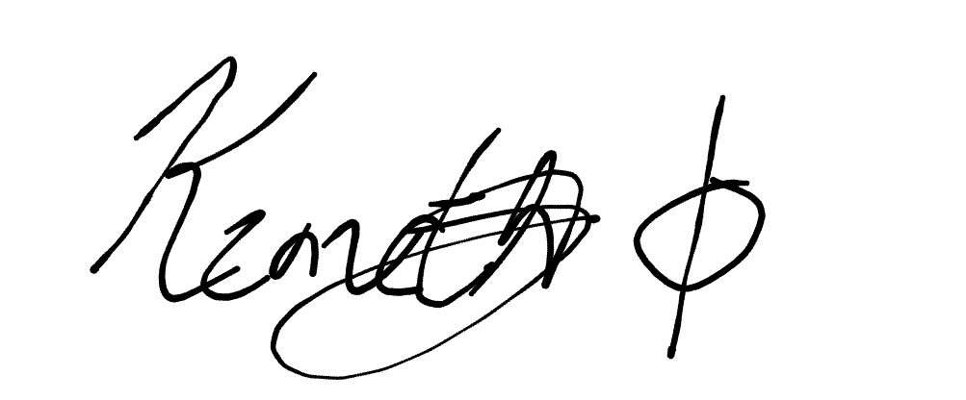Reviewed:

Kenneth Mar A. Ico, LPT

Feedback:

______________________________________________________________________________________________________________________________________________________________________________________________________________________________________________________

***EXAMPLE COPY (DO NOT SUBMIT THIS PART)***

**AI DECLARATION FORM FOR STUDENT ACTIVITIES**

**Student name:** Robin Padilla

**Program:** BSCS 2A

**Course Code/Subject:** GEC 108 (Ethics)

**Date:** April 1, 2025

**Title of the Activity:** Performance Task #1

**Instructor:** Kenneth Mar A. Ico, LPT

**AI DECLARATION**

I hereby declare that I have used **ChatGPT** for **Generating Ideas and Proofreading.** I understand that the use of AI in activities is limited only for:

* Proofreading
* Generating ideas
* Plagiarism checking
* Improving formatting
* Other ethical uses of Artificial Intelligence.

Additionally, the prompts I used with the AI tools were as follows:

1. **Can you check my output if it is correct?**
2. **Can you give me ideas about the importance of the subject Ethics?**

I hereby affirm that the content of the document is originally created and adheres to the ethical standards of using Artificial Intelligence in student activities. I acknowledge that I am accountable for my own paper and understand that any violation of this AI declaration form will result from a 0/100 of my output.

Threshold of Generative AI content and sanction;

1% - 100 % = 0 points

**________________________**

Student’s signature

Reviewed:

Kenneth Mar A. Ico, LPT

Feedback:

______________________________________________________________________________________________________________________________________________________________________________________________________________________________________________________