EIS testing on bench
4 miguel
Spring 2024

1) Purpose:
To have a battery model that can effectively capture the internal dynamics of a battery cell and give insights as to what transients will be present in response to a load change attached to the cell, we need a way to stimulate the battery cell to probe these internal parameters, which are otherwise unobservable when conducting static tests (constant current, constant power, etc.). To briefly reiterate, we care about these transients because the simple IR model of a cell (an ideal voltage source in series with a resistor representing the internal resistance) provides a lower bound for what the cell voltage will be when a step load is applied to the cell. For a given current demanded, a higher predicted voltage implies more power for the same amount of current. For a given power demanded, a higher predicted voltage implies less current. Being able to model these battery transients elevates us from the simple IR model, being able to accurately predict the battery voltage given any load condition, not just a step load, and to appropriately ride the limits of the battery in a load transient.
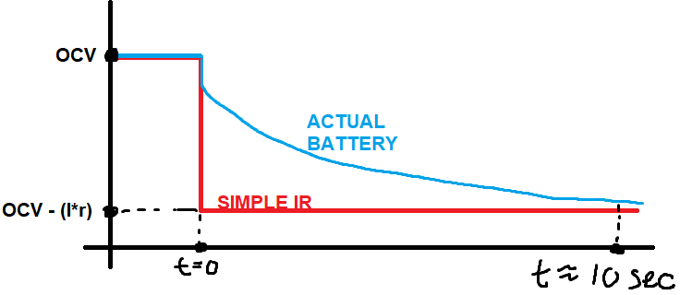
X axis: time
Y axis: voltage
Load step at t=0 seconds

OCV → open circuit voltage of cell at rest
I → current drawn in step load
r → modeled internal battery resistance for simple IR model

In order to find these internal parameters, we need a way to excite the battery cell so that it is not in equilibrium. In the general case, the load a battery cell experiences can be equated to the instantaneous current out of the cell. A case can be made that instantaneous power is a better metric for the load demanded of the cell, but for modeling and simulation purposes thinking of the current drawn from the battery cell as the load will be easier to work with since current itself is a system state variable, while power is a product of system state variables (V x I). Backing out what V and I would need to be given a cell output power can get very ugly (in the simple IR model, you would need to solve a quadratic equation. If your model is more complex… good luck).
Understanding the current in the battery cell as the demanded load of the cell, we would like a way to draw changing currents from the cell using an external circuit. What should this current waveform look like? The answer is a sinusoid. This is because driving an LTI (linear time invariant) system with an external force that is purely sinusoidal causes all system variables of that system to also be sinusoids, making analysis in the frequency domain equivalent to solving for state variables (V and I) of a resistor network. This is the basis of how we analyze circuit containing components that are linear time invariant, like resistors, capacitors, and inductors. We will make the assumption that the internals of a battery cell can be accurately modeled using resistors, capacitors, and inductors, as well as possibly ideal voltage or current sources, an assumption that may not be entirely valid. The internals of a battery cell do exhibit behaviors such as hysteresis, nonlinearities with respect to system state variables (current dependent RLC values for example), temperature dependence (an unmodeled system variable that we are not directly measuring), among other things. These effects will undermine our ability to model the internal dynamics of a cell using LTI components, but it has been shown in academic papers that the Randles model, a circuit containing only ideal voltage sources, resistors, and capacitors, is an adequate model for a battery cell. The effectiveness of an LTI system for our case in legged robots is still unknown, and is the topic of this research.
A problem with creating such a driver to push a sinusoid into the battery (applying a sinusoidal voltage or current across the battery terminals), is that one half of the sinusoid will have to apply positive power and the other half will have to apply negative power. This means the driver circuit will need to be able to both sink and source power. This difficulty is only exacerbated when going to lower frequencies as the amount of power sourced or sinked in each half cycle increases.
A simple solution could be to leverage economies of scale and buy a product that does something similar for a low price to experiment with, such as a car audio amplifier. Empirically, I found the car amplifier can only go to as low as 5-10Hz with no load and I’m not sure what the upper bound for current will be, but your job will be to find the limits of our test bench setup. At some point, when driving a sufficiently high current and low frequency, I suspect the car amp to fail to produce a usable sinusoidal driving voltage. You will need to write a script to sweep current amplitudes and frequencies, starting at a high frequency and backing down until the voltage signal is no longer sinusoidal looking. I can help you with detecting this.

2) The Theory:
We need to apply voltage waveforms across the cell and measure the corresponding current waveforms produced (typically use Potentiostat), or we need to do the opposite and send a current waveform into the cell and measure the voltage waveform across the cell (typically use Galvanostat). In either case, whether we have a driver circuit that can control the voltage across the cell or the current into the cell, we will be able to measure the other, dependent waveform which is related to our input signal by the impedance of the cell.

(Z = V∠0 / I∠Φ) if we are driving the voltage and measuring amplitude and phase of current
(Z = V∠Φ / I∠0) if we are driving the current and measuring amplitude and phase of voltage

Phasor Recap: Remember that we are representing the voltage and current values with phasors here, since we are operating in the frequency domain. Remember that a phasor only encodes two properties: the amplitude of the sine wave (just like you would quantify the voltage of a DC voltage), and the phase shift. The driving sinusoid which is typically assigned a phase shift of 0 radians, so you can think of the phase shift of the dependent signal to be a phase shift relative to the driving sinusoid (you could always take every signal present in a circuit and add on a constant phase shift and the solution would still be perfectly valid. You are just changing the zero crossing time of the voltages and currents, equivalent to a time domain time offset. Thus the convention is to assign your driving circuit a phase offset of 0 radians to keep it simple). Phasors do not explicitly encode the frequency because it is redundant to do so. All waveforms in an LTI circuit, which are driven by a single frequency input sinusoid, will all have the same frequency as the driving sinusoid but potentially have a different amplitude and phase. ALSO REMEMBER THAT ALL PHASOR MATH REPRESENTS FREQUENCY IN RAD/S AND NOT HERTZ! DO NOT ACCIDENTALLY DO MATH WITH THE FREQUENCY IN HERTZ! 2*π*f = ω

Once we have the current and voltage phasors for a specific driving frequency, dividing them gives the impedance of the cell. This impedance is a complex number, and if we take multiple impedance measurements while sweeping the driving frequency we can make one of those Nyquist plots you read about in the EIS readings. The goal of EIS is to produce one of those Nyquist plots. Then you can fit a model to the data in the Nyquist plot in a least squares sense for a fairly good estimate for the frequency dependent internal impedance of the battery cell.

One subtlety here is recognizing how our assumption of the linearity of the system is going to affect how well our model will reflect the actual behavior of the battery cell which is an inherently nonlinear system. Our original protocol to divide the voltage and current phasors to obtain impedance needs to be inspected further. The impedance is given as the ratio of the voltage and current phasors: whatever their values may be does not matter, only their ratio.
Example ideal resistor with AC driving signals:
2V∠0 / 1A∠0 = 2Ohms
4V∠0 / 2A∠0 = 2Ohms
600V∠0 / 300A∠0 = 2Ohms
Despite the voltage and current waveforms across this imaginary ideal resistor being wildly different, the ideal resistor will always present itself as an ideal resistance, with zero phase shift. In reality, components present some sort of non linearity to input driving signals, especially that of the internal impedance of a battery cell. In the case of a battery cell, you might measure something like this:
Battery cell responding to AC voltage driving signal:
200mV∠0 / 1A∠0.13 = 200 mOhms
400mV∠0 / 1.9A∠0.24 = 211 mOhms
1V∠0 / 4.1A∠0.38 = 244 mOhms
In this case, a doubling of our input voltage amplitude did not lead to a doubling of our measured current amplitude. There also might be phase shift that changes with input voltage amplitude, which should not be affected in an ideal LTI system. Batteries are nonlinear systems. To account for such effects, we will need to capture multiple Nyquist plots.

A Nyquist plot encodes the real and imaginary parts of the impedance of a system as you sweep through frequency. The driving signal amplitude does not matter because the system is assumed to be linear. Since we actually do care about the driving signal amplitude, we will need multiple Nyquist plots, each controlling and specifying the input signal amplitude. In our case, we would like to conduct each frequency sweep with a driven input current waveform that we can control with our driving circuitry and measure the corresponding voltage drop. We will conduct frequency sweeps for a list of current values, making a Nyquist plot that corresponds to a specific current amplitude for every amplitude we specify. This will make a 2D lookup table to find the impedance of the battery cell, indexed by both the driving frequency and the driving signal amplitude. Your objective to generate this table, so that I can use it to fit a frequency and amplitude dependent equivalent circuit model for use as a constraint in the robot trajectory optimizer.

3) Test setup:

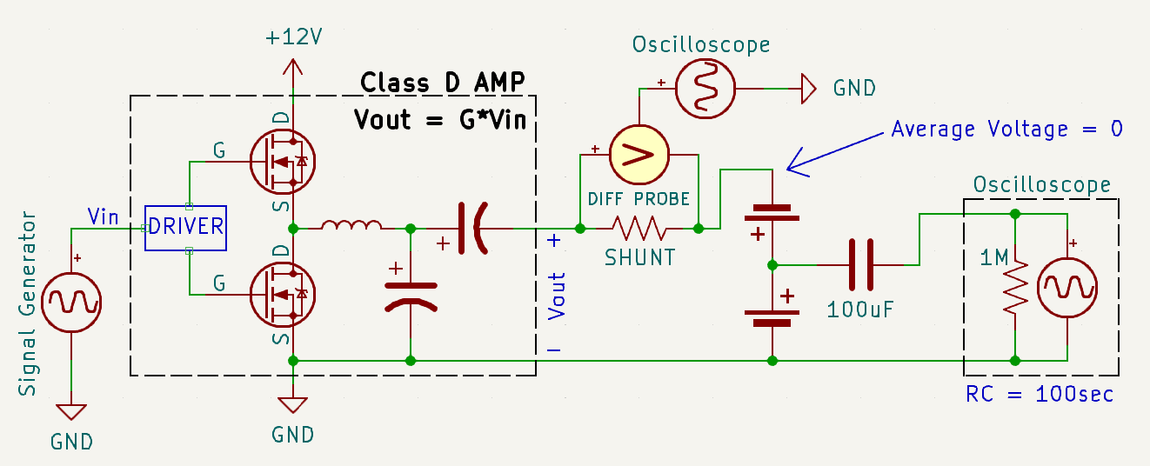
The idea is that we use an arbitrary waveform generator whose output impedance is relatively high to command a sinusoid to a much lower impedance car audio amplifier which has the strength and might to move large currents into and out of the cell. Since car speakers themselves (the thing car audio amplifiers are typically attached to) cannot supply power, the amp is not designed to drive a sinusoid with an output voltage that is not on average zero volts. The proposed circuit will place two cells back to back to cancel each other’s voltage. One of the cells will have its voltage measured with an oscilloscope and have its DC value removed using an external RC circuit (the C is the 100uF cap, the R is the 1Megaohm impedance of the oscilloscope probe itself) with a time constant of 100seconds, much larger than the largest time constant we are going to be driving (remember around 10ms) and honestly could be a bit smaller. Maybe make it 2-10 seconds (remember tau = R*C). Removing the DC voltage at the scope probe is important because we can get more resolution from the ADC if the input signal doesn’t have to be divided down internally, and the small signal voltage produced from these large currents will be quite small. You could do this by switching the oscilloscope to AC coupling mode, but you cannot explicitly control the time constant this way and we need it to be much larger than the smallest time constant present in the load signal.
The current is measured with a high side shunt resistor and the common mode voltage is subtracted using a differential probe which presents only the difference in voltage to the oscilloscope. This is already hooked up at the bench. The shunt I am using does 75mV / 20A which is a resistance of 375 uOhms.
Ideally, the amplifier shown in the dotted black rectangle would take the input signal and amplify it by a constant factor “G” at all frequencies. In reality, this is not true and an unknown transfer function G(s) exists which reveals this frequency dependent gain which probably also depends on output current magnitude. If you write a controller to modulate the input voltage amplitude using a PI controller, you can just ignore this unknown transfer function and rely on your controller to get the desired sinusoidal current in the cell.
I also found that this car amp does have a slight DC output voltage when not connected to anything, and applying a 4.5 Ohm load dropped this DC voltage but did not eliminate it. This could be a problem since a steady state DC output voltage with two cells back to back would drive a steady state current, causing one cell to charge while the other would discharge. This would cause the cell voltages to no longer exactly cancel, but it should eventually equalize such that the sum of voltages in the loop would sum to zero. I’m not sure what effects this would cause, but maybe this is tolerable since we only care about measuring one of the cells. I think placing a large series output cap is a non-elegant solution, maybe just let the cells go slightly out of balance into equilibrium and we will see how it goes from there.

4) The Controller:
You will need to write a controller to control the current in the cell while conducting your frequency sweeps. I’ve written some python code that can interface with the signal generator and oscilloscope. The interface with the signal generator allows you to set the amplitude of the output signal from the signal generator, the frequency, and the output state, on or off. The interface with the oscilloscope allows you to measure the cell voltage amplitude, cell voltage phase shift, circuit current amplitude, and circuit current phase using the built in measurement function. Super useful. You can get the complex impedance of the cell using these quantities.
The controller you need to write will take feedback from the oscilloscope, specifically the circuit current amplitude, and drive it to the desired Nyquist plot current you are trying to hold. Your controller will need to constantly do work as you sweep frequency, since impedance will be changing with frequency and a constant voltage would cause a changing current through the frequency sweep. You may need to include a divider circuit between the signal generator and the car amp if the generator cannot make signals with small enough resolution for the current to smoothly approach the target current. Your controller does not need to be fast, and a simple PI controller should do the job.
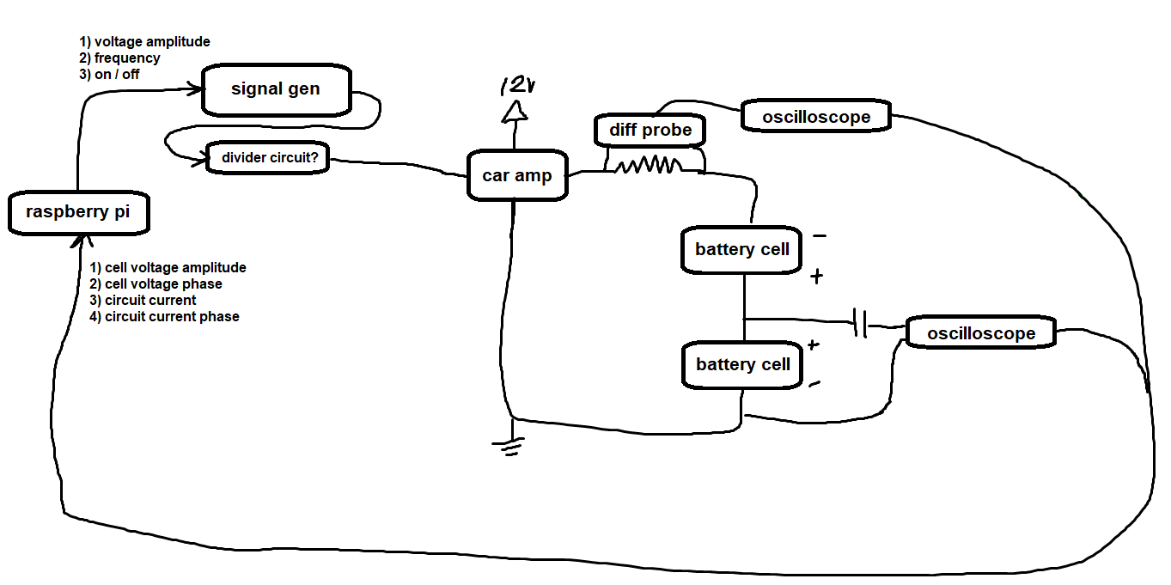
5) EIS testing:
Before you know it you will be ready to test the setup and attempt to run your controller. Please let me know ahead of time so I can inspect your circuit and code. I have not attempted to attach cells to the output of the amplifier, and I don’t know if it will blow up for some unknown reason but I don’t think it will. Time will tell.

Unorganized Chris Ramblings that got deleted:
To drive sinusoids into the battery cell, we will need a circuit to drive the very small impedance of the cell. A small impedance load implies a large current for a relatively small voltage. The impedance of the battery cell in the case of the P45B is around .008 Ohms to .015 Ohms. To drive a current of 15A we would only need about 120mV to 225mV. Such a driver might be difficult to find.

We are looking to drive signals on the timescale of 10ms-500ms which we can observe on the humanoid, which corresponds to 1/2Hz – 100Hz in frequency. We also need currents on the scale of 50A per cell peak to represent what the humanoid will demand of the battery. Driving a 50A amplitude sin wave at 10Hz at around 4V equates to 6.4J of energy pushed in during the first half cycle and 6.4J pulled out during the second cycle. This is an enormous amount of energy that would be stored in a capacitor, you’d need a capacitor rated for at least 4-6V to be ~.8F (Farads). Fitting this energy into a capacitor would requires a large capacitor. This implies that the driver circuit would need to be able to discretely be both a supply and a load depending on which half cycle it is in, which is not an easy circuit to design for.

