7.1)

a) The point contact model uses a box and 8 points slighty protruding at each vertex while the hydroelastic contact simply defines a box with a modulus of elasticity. The hydroelastic contact is enabled with the drake:proximity_properties tag.

b) The sugar box is very well approximated by a box, so using a mesh file would be a waste of computation.

c) The object I added is a pencil. The reason it is much larger than the table is probably because of a unit mismatch from the model on TurboSquid, so I could downsize it another program or just find another model that isn’t so enourmous. The physics still worked fine.

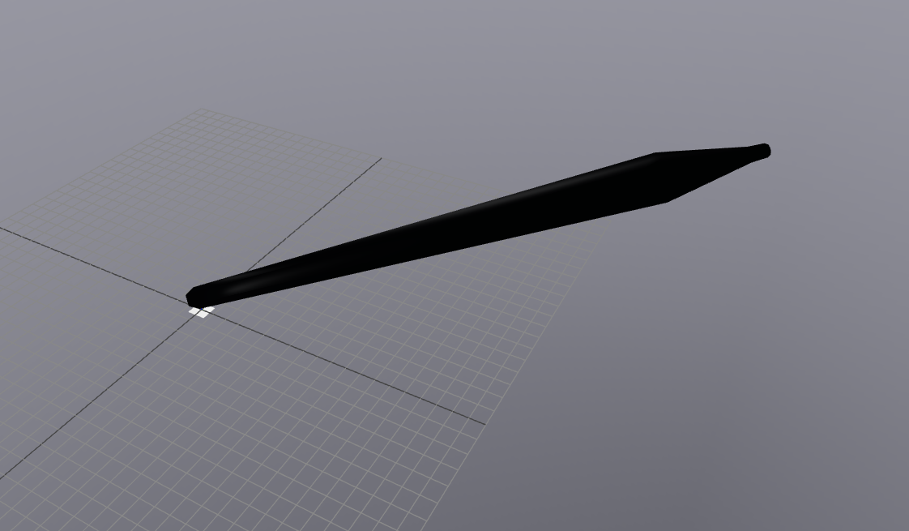

8.2)

a) f_BcFinger_Cz > m*g / (2 * (1 + mu_C))

b) f_BcFinger_Cz < m*g*mu_A / (2 * (1 + mu_A))

c) 1 <= mu_A * mu_C

for mu_A = 0.25, mu_C would need to be at least 4

for mu_A = 1, mu_C would need to be at least 1

Survey) Mobile Base = Less Constraints