Lab 1_1 Button

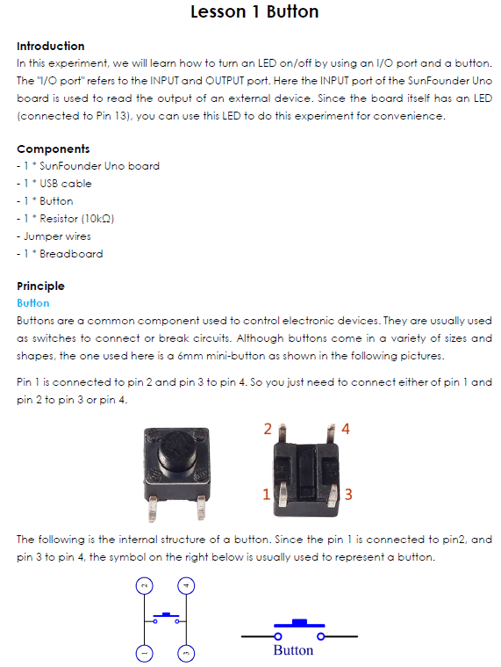

A) Design and implement
  - Hardware implementation with the arduino board and the bread board

B) Program
  - Write Arduino program for the Button operation
  - Verify the program
  - Upload the program to Arduino

C) Test
- Make the circuit correction with Arduino and breadboard
- Test the hardware implementation
Deliverables
- IDE project folder containing the code and a photo of the circuit.

