Reddit Sentiment Analysis Instructions

- Create an API here: https://old.reddit.com/prefs/apps/

- Select ‘script’ and put http://localhost:8080 as the redirect uri (or any valid url, like https://www.google.com). This allows web apps to redirect users to a URI after an API request happens. In our case, we don’t really need it, but it’s required to create the app. Then click ‘create app’.

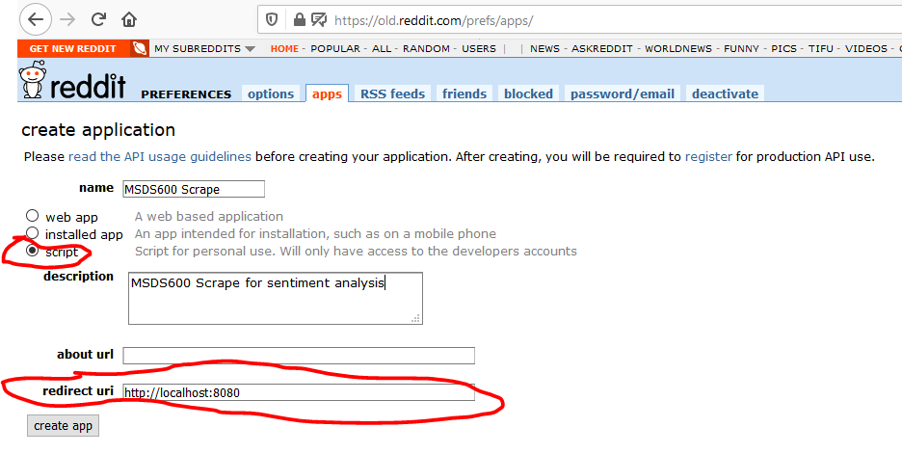

- This screen has the User agent, Client_ID, and Client_secret for using PRAW.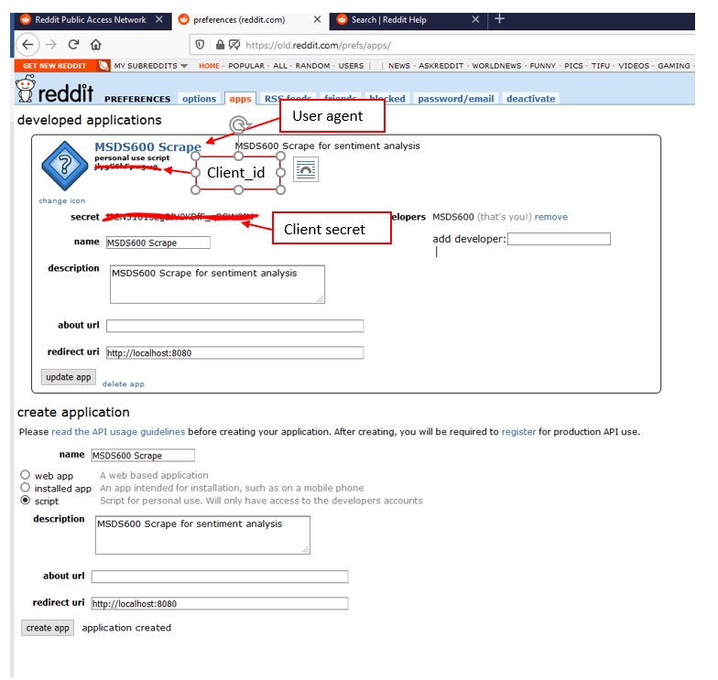

- Open a Terminal or command prompt (assuming Anaconda is in your Path, otherwise open the Anaconda Prompt, or run from within Jupyter) and type:

conda install praw -y

This installs the PRAW package. If a library does not install via conda for whatever reason, you can also try pip:

pip install praw

