ComplaintPro: Complaint Management System of Barangay Kingking



A Propose Presented to the Integrated Programming and Technology of the Information Technology Department, Institute of ICT, ACES Tagum College, Inc., Pioneer Avenue, Tagum City

FLORES , RACHELLE ANN A.

JANUARY 2026

- OVERVIEW

As the global environment ages, the emerging trend for Information Technology has risen above the surface of development initiatives (Carpio, 2020). The ComplaintPro is a console-based mini information system designed to help barangay offices manage complaints from residents. Currently, most submissions are handled manually using logbooks or paper forms, which can lead to delayed responses, misplaced records, and difficulty tracking officer assignments.

The proposed system addresses these challenges by organizing resident information, urgency level, assigned officers, request histories, and request statuses using Kotlin, which allows for fast development, easy maintenance, and reliable automation of system processes.

By automating tasks such as complaint submission, officer assignment, and status updates, the system improves efficiency, accuracy, and organization, enabling barangay operations to run more smoothly and systematically.
General Objective
To develop a console-based mini-system that helps the barangay manage complaints efficiently, allowing residents to report issues and officers to track, assign, and resolve them in an organized and timely manner, improving complaints request and communication within the community.

Specific Objectives
The system aims to efficiently manage barangay complaints by:
- Managing submission of complaints with resident details.
- Determining urgency and seriousness of each complaint.
- Scheduling meetings only if required (Informal or Hearing).
- Allowing immediate resolution of minor complaints without meetings.
- Escalating unresolved minor complaints to hearings automatically.
- Assigning officers to complaints and tracking their availability.
- Updating complaint status (Pending, In Progress, Resolved).
- Maintaining a history of resolved complaints for record-keeping.

- SIGNIFICANCE OF THE STUDY

To Residents. They benefit from an organized and transparent process for submitting complaints, where urgent and serious complaints are tracked, minor complaints can be resolved immediately, and unresolved issues are escalated to meetings or hearings to ensure proper resolution.
To Barangay Officers. They benefit from a structured system that ensures complaints are properly assigned and avoids double assignments, which helps officers focus on resolving issues efficiently without conflicts or overlapping tasks.
To Barangay Administrators. They benefit from improved efficiency, reduced manual workload, and better organization of records, including complaint histories, meeting schedules, and status updates, which makes overseeing barangay operations easier and more systematic.
To Communities. The system benefits the community through faster response times, improved accountability, and systematic handling of complaints, fostering trust and a more responsive and organized barangay operation.

- FLOWCHART

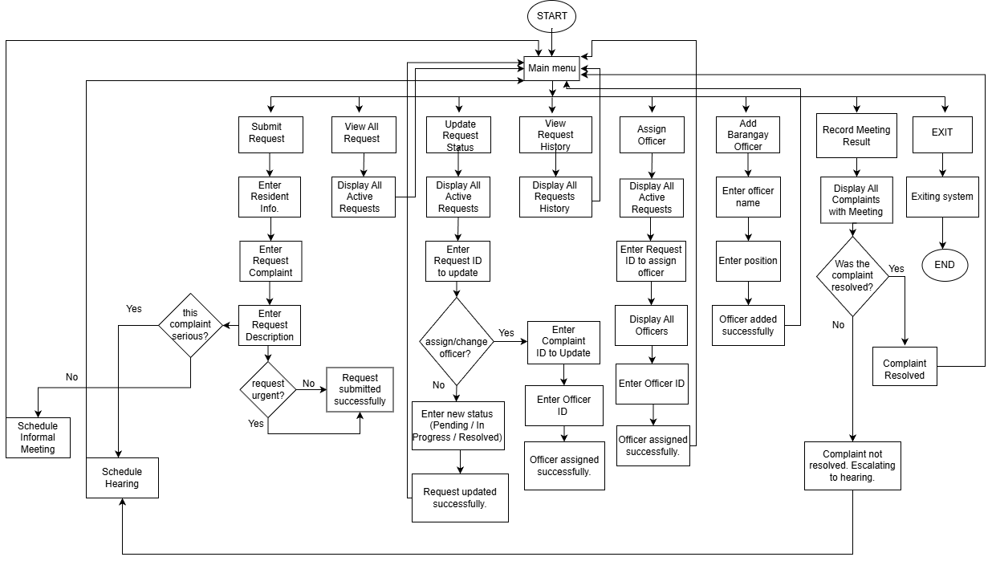

References:
Claire Ong Carpio, ―Barangay Management System,‖ International Journal of Multidisciplinary Research and Publications (IJMRAP), Volume 3, Issue 2, pp. 26-32, 2020.

