IPT 1 – Integrative Programming Technology
Project: ComplaintPro: Complaint Management System of Barangay Kingking
Student: Rachelle Ann A. Flores

A. Instructor Minutes and Resolutions
Suggestion #1: Tracking of Complaints for Transparency
Issue:
Residents need a way to track their complaints for transparency.
Solution:
Added auto-generated tracking code (CMP-XXXXXX-YYYY) displayed after submission so if the resident want to track their complaint, they can present the tracking code given to them when their complaint was filed.

System Screenshots:
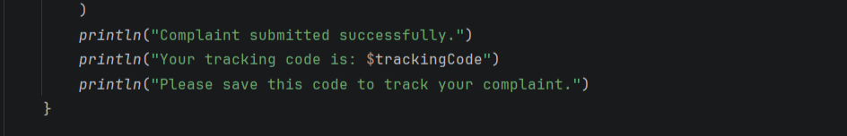

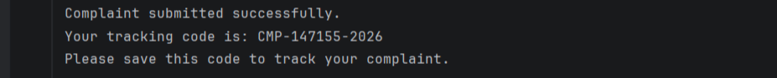

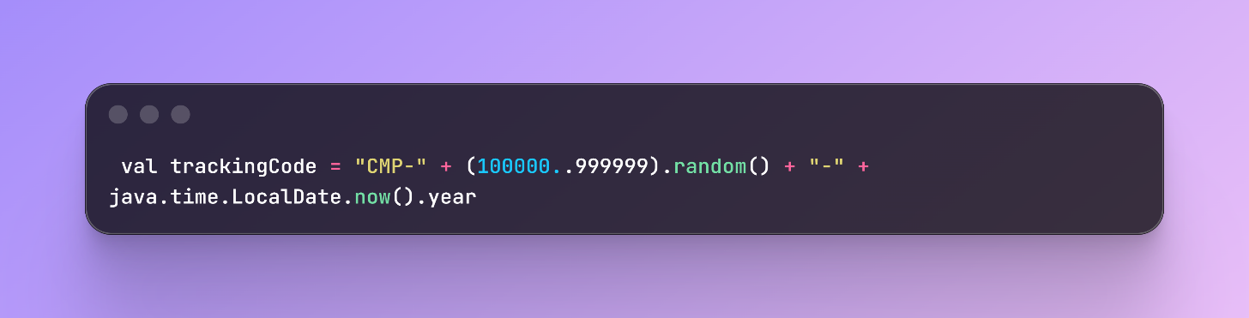
Code Snapshot:

Suggestion #2: Date of When Complaint is Filed
Issue:
No record of when the complaint was filed
Solution:
Added submissionDate field captured automatically when complaint is submitted so that the user can see when the complaint is submitted.

System Screenshot:

Code Snapshot:

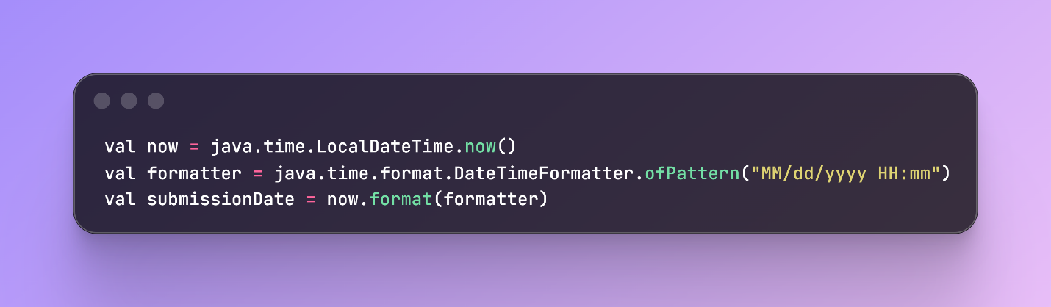

B. Self-Identified Project Recommendations

Suggestion #1: Days Counter for Pending and In Progress Complaints
Issue:
Need to show how long complaints have been pending or in progress
Solution:
The system shows how long each complaint has been pending, holding the barangay accountable for quick responses. Added days counter calculated from submission date.

System Screenshot:

Code Snapshot:
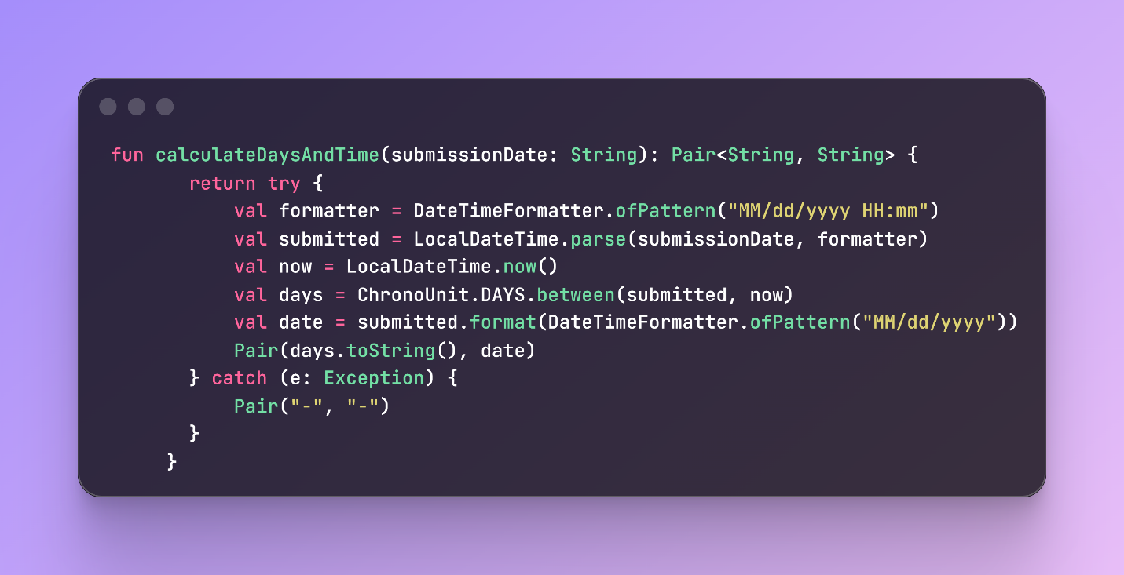

Suggestion #2: Multiple Search Options
Issue:
Tracking should not only be by tracking code but also by ID, contact number, and resident name.
Solution:
- Search by Complaint ID
- Search by Contact Number
- Search by Tracking Code
- Search by Resident Name
This allows residents to search using any information they have available.
System Screenshot:
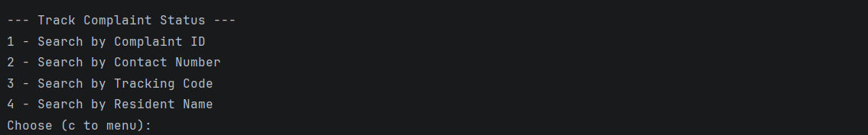

Code Snapshot:
