

**Faculty of Computing and Informatics (FCI)**

**Multimedia University**

**Cyberjaya**

**TCP 1201 Object-Oriented Programming and Data Structures**

TRIMESTER 1 2019/2020

**Group Assignment**

**Lecture Section : TC02**

**Tutorial Section : TT04**

**INSTRUCTOR’S NAME: Sharaf Horani**

|  |  |  |  |
| --- | --- | --- | --- |
| **Student ID** | **Name** | **Email Address** | **Phone No.** |
| **1171100655** | **Ong Pei Yong** | [kiong_99@hotmail.my](mailto:kiong_99@hotmail.my) | **011-35325387** |
| **1171101429** | **Rishidharan A/L Rajagopal** | [1171101429@student.mmu.edu.my](mailto:1171101429@student.mmu.edu.my) | **013-8041150** |

Table of Contents

PROBLEM DEFINITION 1

SOLUTION ALGORITHM 2

APPENDIX A 3

LIMITATION OF YOUR PROGRAM 6

CONCLUSION 7

# PROBLEM DEFINITION

The purpose of this assignment is to create a flight management system that manage customer booking , generate flight with information such as flight number, number of seat for each class ,airplane name , time and date, travelling distance , depature and destination airport.The system also will update total travel distance for each customer for each complete booking and boarding without any cancellation on the flight.The system also only let customer to check in 14 days before travelling and stop the check in time 30 minutes before departure date and time.The information of customer , flight , airplane and etc will be store in the database of the system.

## SOLUTION ALGORITHM

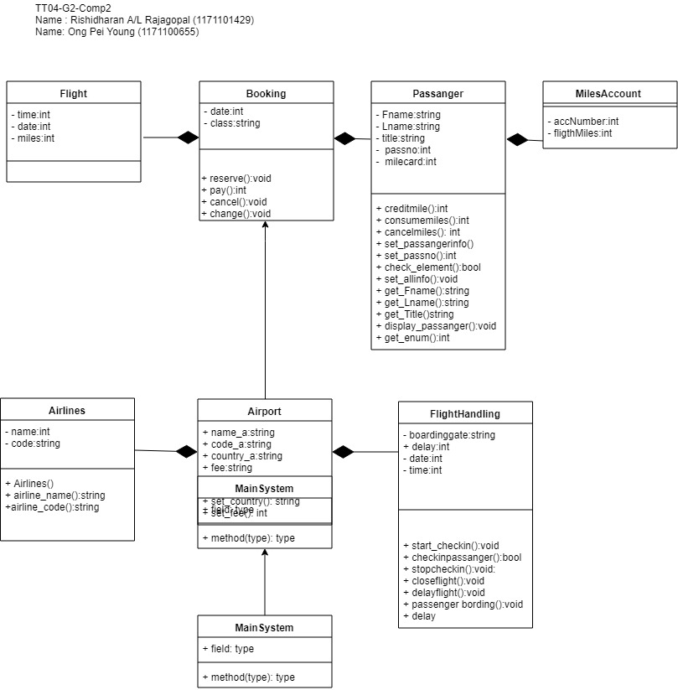

### APPENDIX A

When the program is first run it will generate a file call Flight.txt which contain all details of flight such as flight number , aircraft number,total seat , total seat for first class, total seat for economy class , total seat for business class , depature airport , arival airport and total travel distance 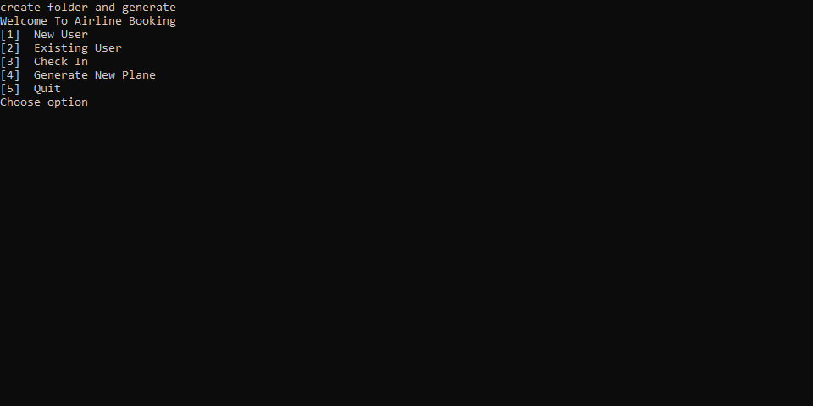

^First time run the program

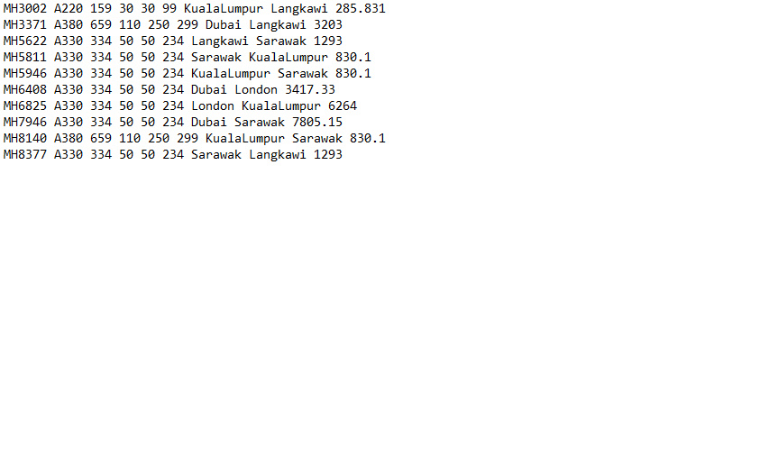

^Flight.txt file

For first time login , passanger need to register under new user .

Info need such as Passport number, first name, last name, title,and their milecard.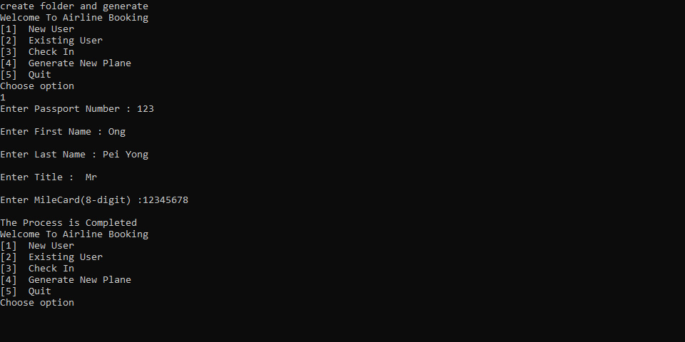

Upon register , passanger is allow to login with their registed passport number .

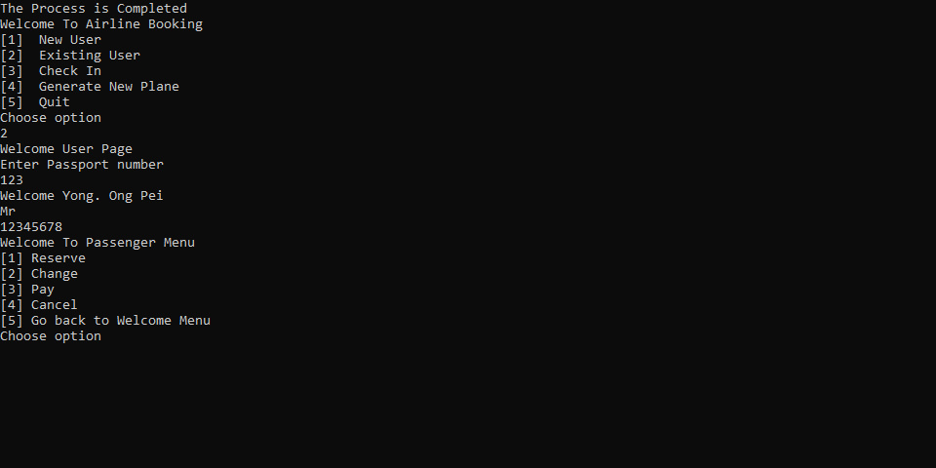

Passanger can reserve the seat by press 1 and choose which airline they want to take follow by the time date and which class.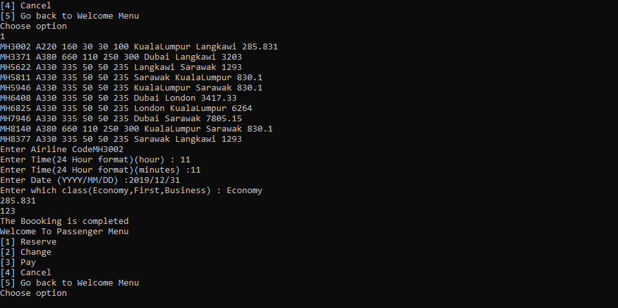

### LIMITATION OF YOUR PROGRAM

Our program is not fully completed as the program cannot change the time and date . It also cannot pay nor cancel the booking. Cannot generate any new flight after the flight.txt is created. The program also cannot let the passanger check in .

### CONCLUSION

As a nutshell , the assignment is aimed at creating a real life Flight Management Systems that can help to solve nowadays Flight Management System . The program also use to enhancing the relationship between passanger and airline provider agencies to ease their traveling and handling.