Station A
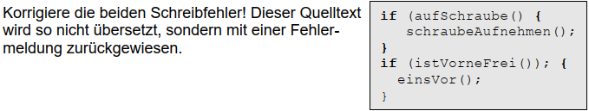

Station B
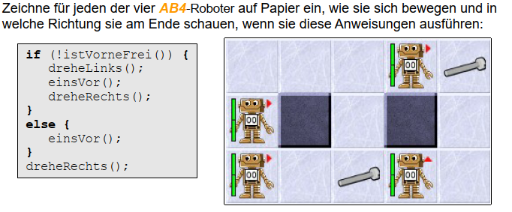

Station C
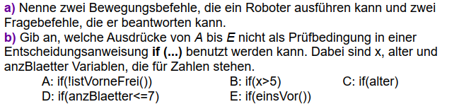
a)___________________________________________________
b)___________________________________________________

