Cheese in the world

From production to consumption
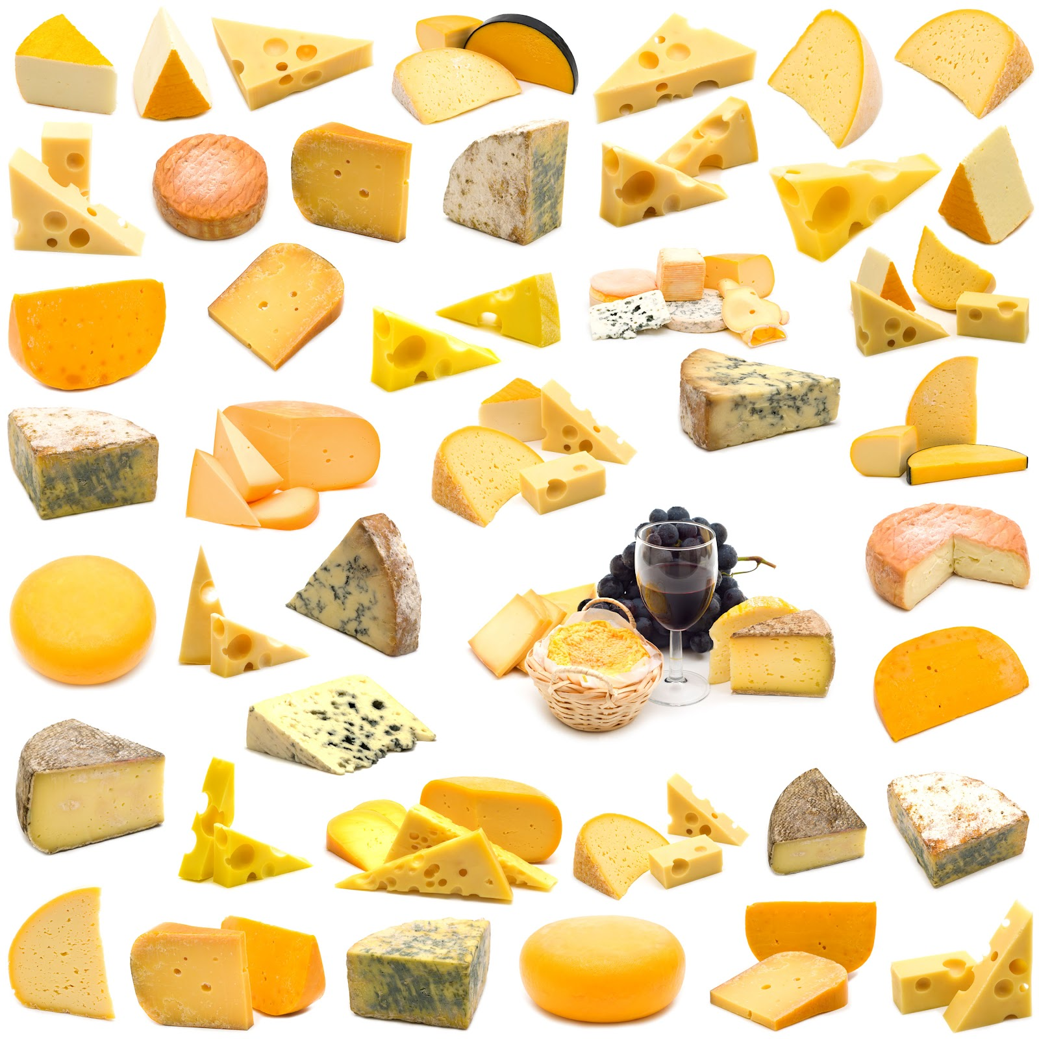http://3.bp.blogspot.com/-qoqcs4um4nQ/UHCXGVlysBI/AAAAAAAADOA/6RqptxoeELw/s1600/cheese-world.jpg

Table of content
Introduction 3
I History of cheese 4
II Cheese production 5
a) Coagulation 5
b) Scalding 6
c) Draining 6
d) Mould & ripening 7
III Cheese impacts 8
a) Economic impact 8
b) Social impact 9
Bibliography 11

Introduction

Cheese definition : the curd of milk separated from the whey and prepared in many ways as a food.³
The cheese is a food derived from milk that is produced in a wide rang of flavors, textures, and forms by coagulation of milk protein casein.

The cheese has a very long history and a very rich diversity. There are more than 900 varieties of cheeses.
We can make cheese from cows, goats, sheeps and buffalos.
In order to make cheesse, we must have a good milk in order to get the best organoleptic cheese quality.. The physical makeup of this milk is primarily :
- Water (88%)
- Lactose (4.5-5.5%) : the milk sugar which serves as fuel for the lactic bacteria
- Protein (3.5% to 8 %) : primarily the Casein for cheese structure
- Fat (3.5-5% in cows up to 9% for ewes) : providing flavor, aroma, and texture in cheese
- Minerals : Calcium, Sodium, Phosphorus
- Enzymes : Lipase and Plasmin which aid in the ripening of cheese
The protein content and fat content depends of the breed and the type of animal (cows, ewes, goats)
The sources will be in the footnote and in the alphabetical order in the Bibliography.

I History of cheese

The origins of the cheese starts around 7000 BCE in the « Fertile Crescent ». There is two story about the beginning of the cheeseamking.

The first theory : The cheese was probably discovered when a nomad filled his saddlebag, made of a dried sheep’s stomack, with milk. A few hours later, there were a solid part (the curd) and a liquid part (the whey) .

The second theory : When men wanted to offer some milk to Gods, they noticed that the milk became thick because of the heat and the milk was sperated with the curd and the whey in order to make a very soft cheese¹.

In the Greece time, Hommer in his Iliad refered to cheese with « Fig rennet coagulating the milk quickly ».¹ Homer refered to cheese « being made in the mountain caves of Greec form the milk of sheep and goats ».² Maybe, the Feta comes from that period.

The Roman Empire considered Cheesemaker as a « mature craft » and cheesemakers did drier cheeses which travelled easier. Just before the Roman Empire fall, the cheesemaking was sread all over ythe Roman Empire and the using of milk from goats and sheeps.

In the Middle Ages, some new cheeses were created such as the Cheddar (1500), Gouda (1697) and the Camembert in 1791¹. Monks were innovators in cheesemaking and the creation of a lot of cheeses type such as Roquefort (1070), Parmesan (1579)².

France is known for its cheeses diversity with more than 400 cheeses. The geographic origin defined the type of cheese.

II Cheese production

There is several steps to make cheese.
We can use milk from cows, buffalos, goats, cheeps or a mix of these milk.²
The milk can be raw or pasturised, it will not give litteraly the same cheese and not the same flavours.

a) Coagulation

« The type of coagulant used depends on the type of cheese desired. For acid cheeses, an acid source […]. For rennet cheeses, […] a rennet produced through microbial bioprocessing is used»¹
We can add some flavours, such as herbs, spicies, peppers, horseardish directly in the curd.

The microbial process use bacteries called lactic acid Bacteria (LAB) because they « eat » the lactose in milk then they produce lactic acid. « There is a wide variety of bacterial cultures that provide distinct flavor and textural characteristics to cheeses. »¹
« Yeasts are used in some cheeses to provides the characteristic colors and flavors of some cheeses varieties »¹. The combinaison of bacteries used and yeasts can make a very typical cheese with a special process.

b) Scalding

The curd, when there is not anymore whey, is « cut into small cubes and the temperature is raised to approximately 39°C »

c) Draining

When the cheese curd is jusdge to be ready, the cheesemaker must separate the curd from the whey.
Otherwise, the curd is going to be decomposed by bacterias. So the cheesemaker must stop the process by removing the whey.
We can drain the curd with draining bags or moulds to give a shape to the future cheese.
The whey is separated of the curd, in order to tranform the curd to cheese.

d) Mould & ripening
We hav to eleminate the rest of whey by gravity. To make cheese, the curd must be dry, so it put in mould, in order to form the cheese. The ripening allows cheese to take its flavour. It ripen almost in cave with hygrometrics constant value, constant temperature.

We try to have a cheese composition like :
- Proteins : 31.23%
- Fat : 34.39%
- Water : 30.17%
- Minerals : 4.31%
The cheese is mainly composed of fat and proteins so the milk is concentrated to be conserved longer.

III Cheese impacts

a) Economic impact
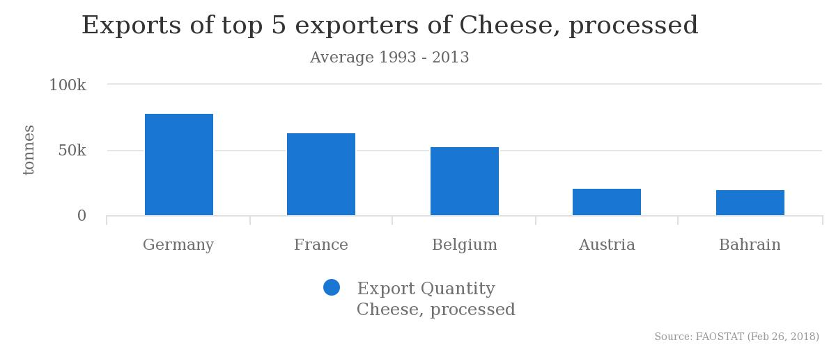FAOSTAT, 2018
On this barchart, we can see the main exporters of cheese to the world.
The four first countries are in Europe.

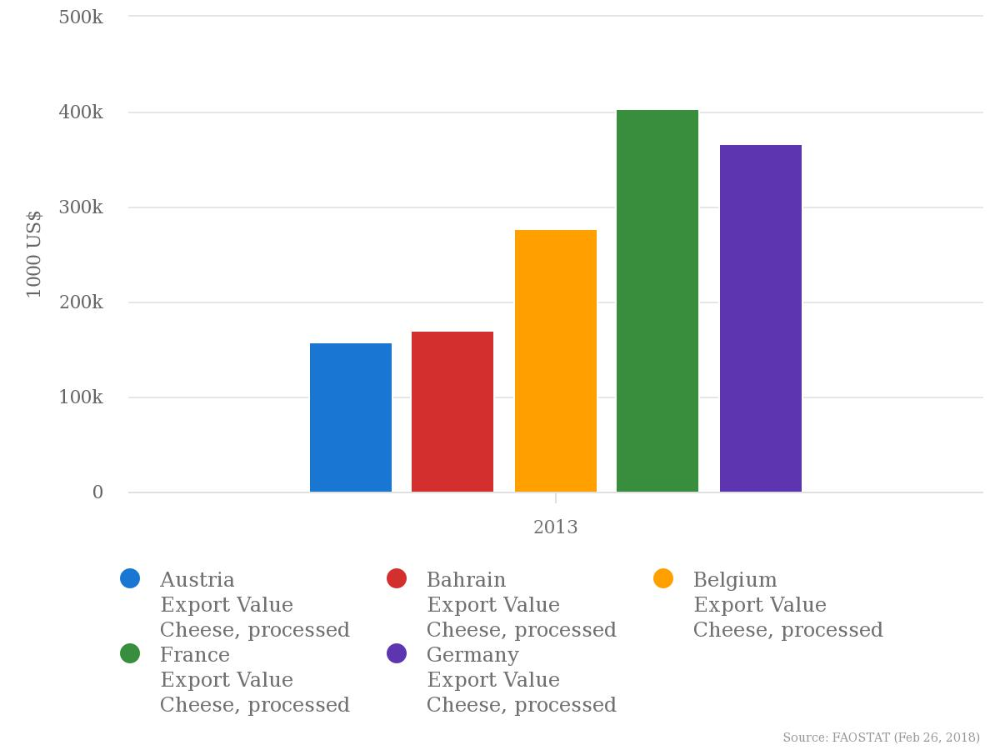FAOSTAT, 2018

On this barchart, we can see the same contries as above, and now France has the most exporting value for cheese processed.

France and Germay are the main exporters in quantity and in cheese value. In that countries, the cheese is important, because of the cheese history in that countries.

On this barchart, we can see the importers of cheese in the world. UK is the biggest importer but there is also Saudi Arabia, not a European country, that import a lot of processed cheese.
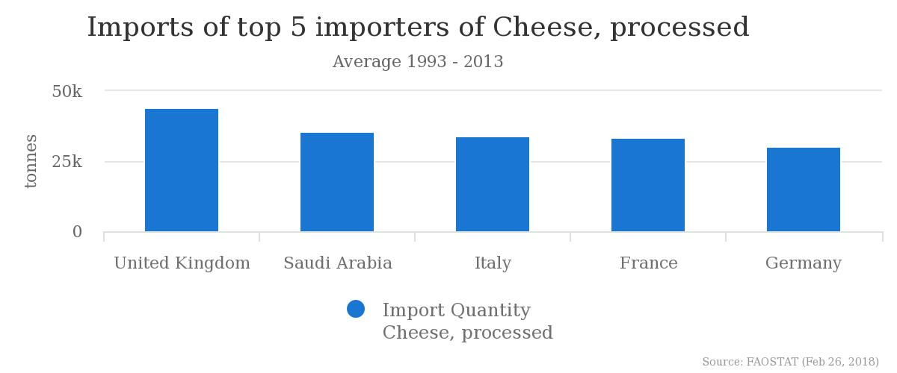FAOSTAT, 2018

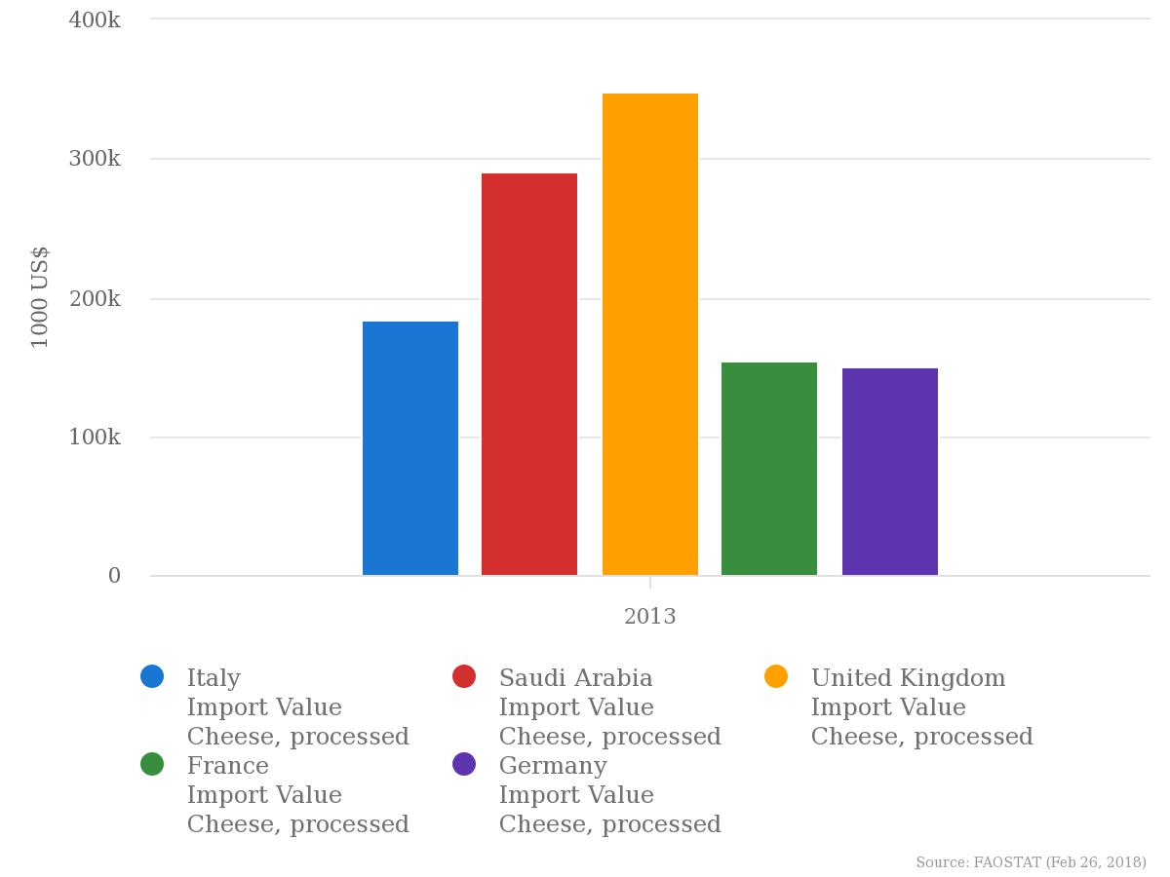FAOSTAT, 2018
On this barchart, we can that United Kingdom is the main importer of cheese and also the main cheese value importer.

As importers, or exporters, European countries lead the exchange in the world because of the history and also for an other reason : a lot of people are intolerant lactose in most of countries, so there is no more cheese consumption in that countries.

b) Social impact

The cheese allow the metting of producteur with protected designation of origin cheese (AOP in France). The AOP allow a limit of production and specifications. The limit production refers to the soil or geographic limit in order to produce a local cheese. Somme cheese are made everywhere in the world (cheddar) because they do not need to have a special taste.

Bibliography

1 - All About Milk.... at cheesemaking.com, [sans date]. [en ligne]. [Consulté le 3 mars 2018]. Disponible à l’adresse : http://www.cheesemaking.com/includes/modules/jWallace/OnLineNews/NewsFiles/MilkAbout.html

2 - Cheese | Define Cheese at Dictionary.com, [sans date]. [en ligne]. [Consulté le 21 février 2018]. Disponible à l’adresse : http://www.dictionary.com/browse/cheese

3 - Cheese Composition, [sans date]. [en ligne]. [Consulté le 3 mars 2018]. Disponible à l’adresse : http://chestofbooks.com/food/recipes/Boston-Cooking-School/Cheese-Composition.html

4 - Cheese Production | MilkFacts.info, [sans date]. [en ligne]. [Consulté le 25 février 2018]. Disponible à l’adresse : http://www.milkfacts.info/Milk%20Processing/Cheese%20Production.htm

5 - Cheese, 2018. Wikipedia [en ligne]. [Consulté le 25 février 2018]. Disponible à l’adresse : https://en.wikipedia.org/w/index.php?title=Cheese&oldid=827350128

6 - FAOSTAT, [sans date]. [en ligne]. [Consulté le 21 février 2018 a]. Disponible à l’adresse : http://www.fao.org/faostat/en/#data/QP/visualize

7 - FAOSTAT, [sans date]. [en ligne]. [Consulté le 26 février 2018 b]. Disponible à l’adresse : http://www.fao.org/faostat/en/#compare

8 - LGOL27 : History of Cheese, [sans date]. [en ligne]. [Consulté le 25 février 2018]. Disponible à l’adresse : http://www.gol27.com/HistoryCheese.html

9 - Milk and milk product statistics - Statistics Explained, [sans date]. [en ligne]. [Consulté le 21 février 2018]. Disponible à l’adresse : http://ec.europa.eu/eurostat/statistics-explained/index.php/Milk_and_milk_product_statistics

10 - The History of Cheese - An Ancient Tradition - Today An Artisan Industry..., [sans date]. [en ligne]. [Consulté le 24 février 2018]. Disponible à l’adresse : http://www.gourmetcheesedetective.com/History-of-Cheese.html

. All About Milk.... at cheesemaking.com, [sans date]. [en ligne]. [Consulté le 3 mars 2018]. Disponible à l’adresse : http://www.cheesemaking.com/includes/modules/jWallace/OnLineNews/NewsFiles/MilkAbout.html
. Cheese Production | MilkFacts.info, [sans date]. [en ligne]. [Consulté le 25 février 2018]. Disponible à l’adresse : http://www.milkfacts.info/Milk%20Processing/Cheese%20Production.htm 2. The History of Cheese - An Ancient Tradition - Today An Artisan Industry... [en ligne]. Disponible sur : http://www.gourmetcheesedetective.com/History-of-Cheese.html [Consulté le 24 février 2018].
. Cheese Production | MilkFacts.info, [sans date]. [en ligne]. [Consulté le 25 février 2018]. Disponible à l’adresse : http://www.milkfacts.info/Milk%20Processing/Cheese%20Production.htm 2. LGOL27 : History of Cheese. [en ligne]. Disponible sur : http://www.gol27.com/HistoryCheese.html [Consulté le 25 février 2018]. 3. Cheese | Define Cheese at Dictionary.com, [sans date]. [en ligne]. [Consulté le 21 février 2018]. Disponible à l’adresse : http://www.dictionary.com/browse/cheese
. Cheesemaking, 2018. Wikipedia [en ligne]. [Consulté le 25 février 2018]. Disponible à l’adresse : https://en.wikipedia.org/w/index.php?title=Cheesemaking&oldid=825695030
. Cheesemaking, 2018. Wikipedia [en ligne]. [Consulté le 25 février 2018]. Disponible à l’adresse : https://en.wikipedia.org/w/index.php?title=Cheesemaking&oldid=825695030
. Cheese Composition, [sans date]. [en ligne]. [Consulté le 3 mars 2018]. Disponible à l’adresse : http://chestofbooks.com/food/recipes/Boston-Cooking-School/Cheese-Composition.html
. FAOSTAT, [sans date]. [en ligne]. [Consulté le 26 février 2018]. Disponible à l’adresse :http://www.fao.org/faostat/en/#compare

