Template
Florian Bouchet
2025-05-14
Table of Contents
1. Title 1

1. Title

1. Subtitle
This is a word template for generating good looking R markdown files.
An embedded R code chunk looks like this:
summary(cars)
## speed dist
## Min. : 4.0 Min. : 2.00
## 1st Qu.:12.0 1st Qu.: 26.00
## Median :15.0 Median : 36.00
## Mean :15.4 Mean : 42.98
## 3rd Qu.:19.0 3rd Qu.: 56.00
## Max. :25.0 Max. :120.00
An embedded table looks like this:

 | Bacterial vs. healthy | COVID_19 vs. healthy
Down | 2588 | 181
NotSig | 16033 | 20544
Up | 2129 | 25

An embedded figure with caption looks like this:

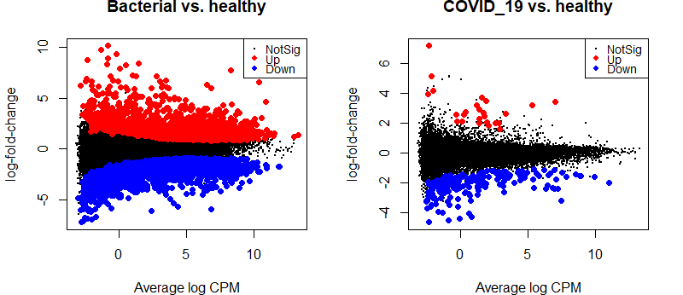
Fig. 5. MD plot for each contrast.

