Practical Graphics in R (ca. 1h)

We will work in RStudio, but as a demonstration, let’s have a look at the RGui first. Start up the program R from your programs in Windows, look at the window that popping up, and try writing 2+2 in the main window

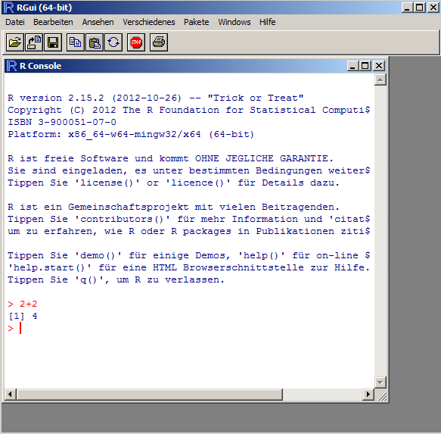

This main window, called the R Console, is how you interact with the core R program that does all the communcation. Let’s write something else

R has a few standard datasets that are already loaded to try out stuff. Before we go to RStudio, let’s try out plotting one of those. Type

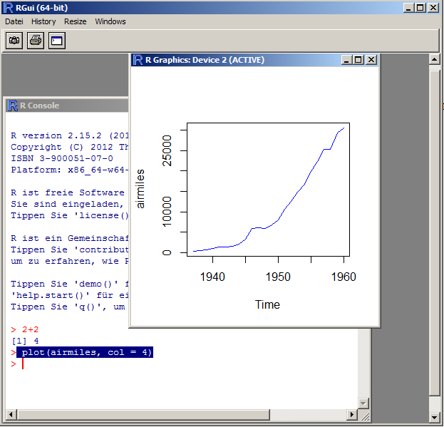
plot(airmiles, col = 4)

The result should look like that
OK, let’s move to RStudio … RStudio basically offers the same functions as the RGui, but a few things can be done easier or are handled more comfortable for you. This is how it looks like

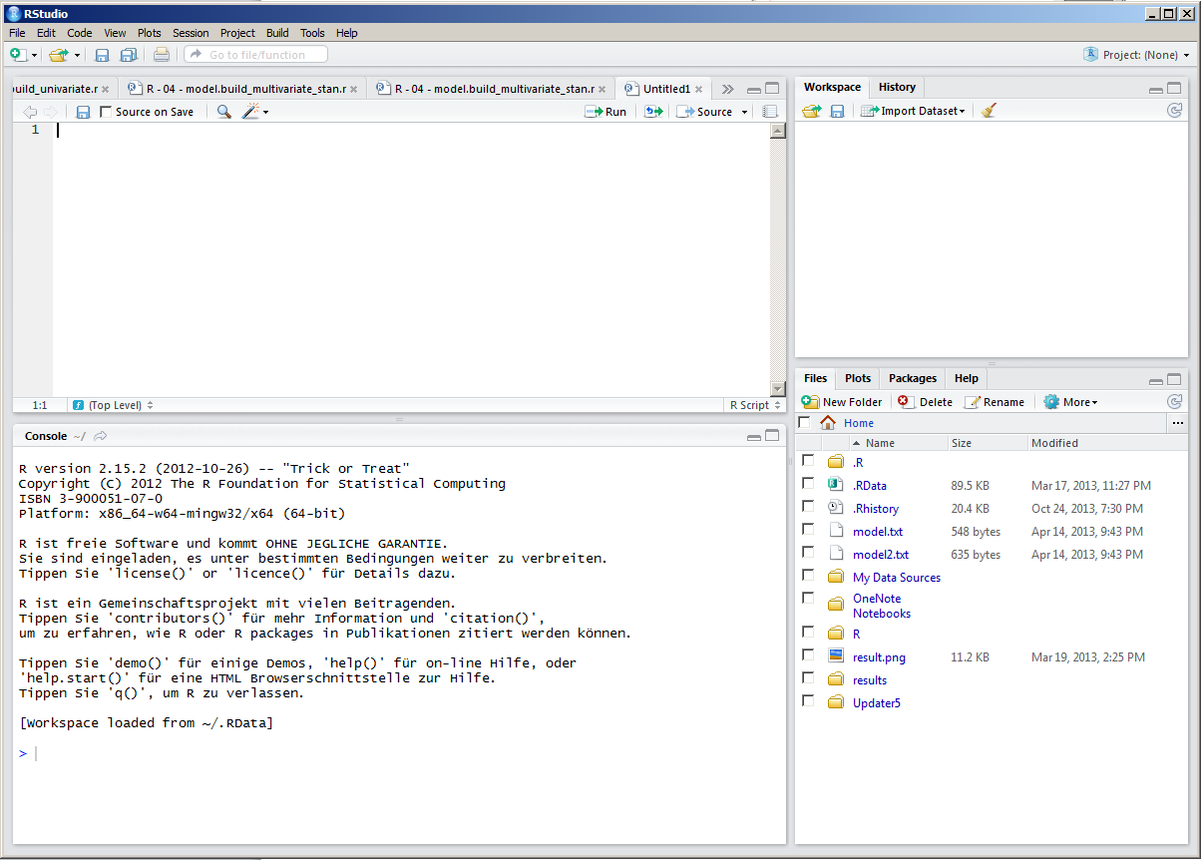

The console is in the bottom left … try to put in the same commands as we did before, i.e. 2+2, and plotting the graph

On the top of the console, r script files that are open are displayed … you can work of course in the console, typing everything in directly, but typically you work in the script and then send the stuff you were writing to the console. Typical script

# the hash means this is treated as a comment
# this file is written by FH, 25.10.13

rm(list=ls(all=TRUE)) # this command means all variables in the memory are erase

# load some data

# do some plots

How to load data?

Load the airquality.txt file with RStudio, or with hand with read.table()

Variables / Objects

Who has ever worked with a programming language? In a programming language, data is stored in variables / objects

VariableX = read.table(datafile)

Now the content of datafile is in the computer, and it is stored in variable X

Different variable types / objects in R:
- atomic: numeric, factor, data …
- Structures: vector, list, dataframe

If we read in data, we have to check that it is in the right structure / format

Checking data and structure

str() gives you the structure of a variable / object
summary() tries to give you a summary, depending on the type you have
plot() tries to make a plot, depending on the type you have

Try this out with the airquality. If a column would have the wrong type, we have to change this, e.g. as.factor(x) or as.numeric(x)

The data frame

Most common structure in r, basically columns are stored as a list of vectors, so each column can be a different data type

You can select columns in a number of ways

By name: airquality$Ozone
By index: airquality[,1]

Slicing: try out airquality[,1:2], airquality[4:6,1], airquality[c(1,2,3,4,7,8),1] … what do you get?

Plotting

OK, now you know how to select data from your dataframe

Lets do some standard plots

plot(airquality) automatically chooses a particular plot, namely pairs(airquality)

Lets plot only two variables against each other

plot(airquality$Ozone, airquality$Temp) … or should it rather be the other way around? plot(airquality$Temp , airquality$Ozone)

hist(airquality$Ozone)

Getting help and modifying functions

Functions in R have typically a lot of options … you get them by looking at the help of a function, either on it and F1, or ?functionname, try ?hist

Default values can be overwritten

hist(airquality$Ozone, breaks = 30, col = "darkred")

Colors at http://research.stowers-institute.org/efg/R/Color/Chart/

Can also modify

plot(airquality$Ozone, airquality$Temp, pch = 5)

plot(airquality$Ozone, airquality$Temp, pch = 3, cex = airquality$Wind / 10, col = "darkred")

Some more plotting functions

# Simple Bar Plot
counts <- table(mtcars$gear)
barplot(counts, main="Car Distribution",
xlab="Number of Gears")

# Grouped Bar Plot
counts <- table(mtcars$vs, mtcars$gear)
barplot(counts, main="Car Distribution by Gears and VS",
xlab="Number of Gears", col=c("darkblue","red"),
legend = rownames(counts), beside=TRUE)

# Boxplot of MPG by Car Cylinders
boxplot(mpg~cyl,data=mtcars, main="Car Milage Data",
xlab="Number of Cylinders", ylab="Miles Per Gallon")

# Notched Boxplot of Tooth Growth Against 2 Crossed Factors
# boxes colored for ease of interpretation
boxplot(len~supp*dose, data=ToothGrowth, notch=TRUE,
col=(c("gold","darkgreen")),
main="Tooth Growth", xlab="Suppliment and Dose")

Modifying a function afterwards with inkscape

Short demonstration, you can try this later: Save as a pdf, open with inkscape, modify e.g. colors of the figure, but a different background, etc.

Fitting a model

fit = lm(airquality$Temp~airquality$Ozone)
abline(fit, col = "blue")

fit2 = lm(airquality$Temp~airquality$Ozone + I(airquality$Ozone^2))

check out ?formula to understand how to put in formulas

Websites with examples / tutorials

Start with http://www.statmethods.net/index.html

More examples here:

http://rgm3.lab.nig.ac.jp/RGM/R_image_list?navi_idx=0

https://www.stat.auckland.ac.nz/~paul/RGraphics/rgraphics.html

http://rgraphgallery.blogspot.de/search/label/heatmap

google is your friend!

