Software Evolution – Practical Session:

Building a GitHub Bot

<https://github.com/florianilaurence/umons-bot-tutorial.git>

1. **Say thanks when a pull request has been merged.**

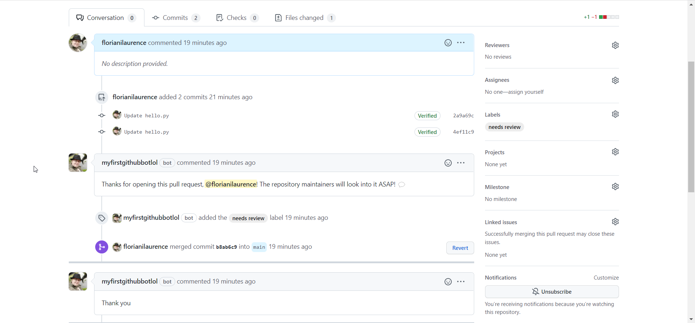

1. **Automatically delete a merged branch.**

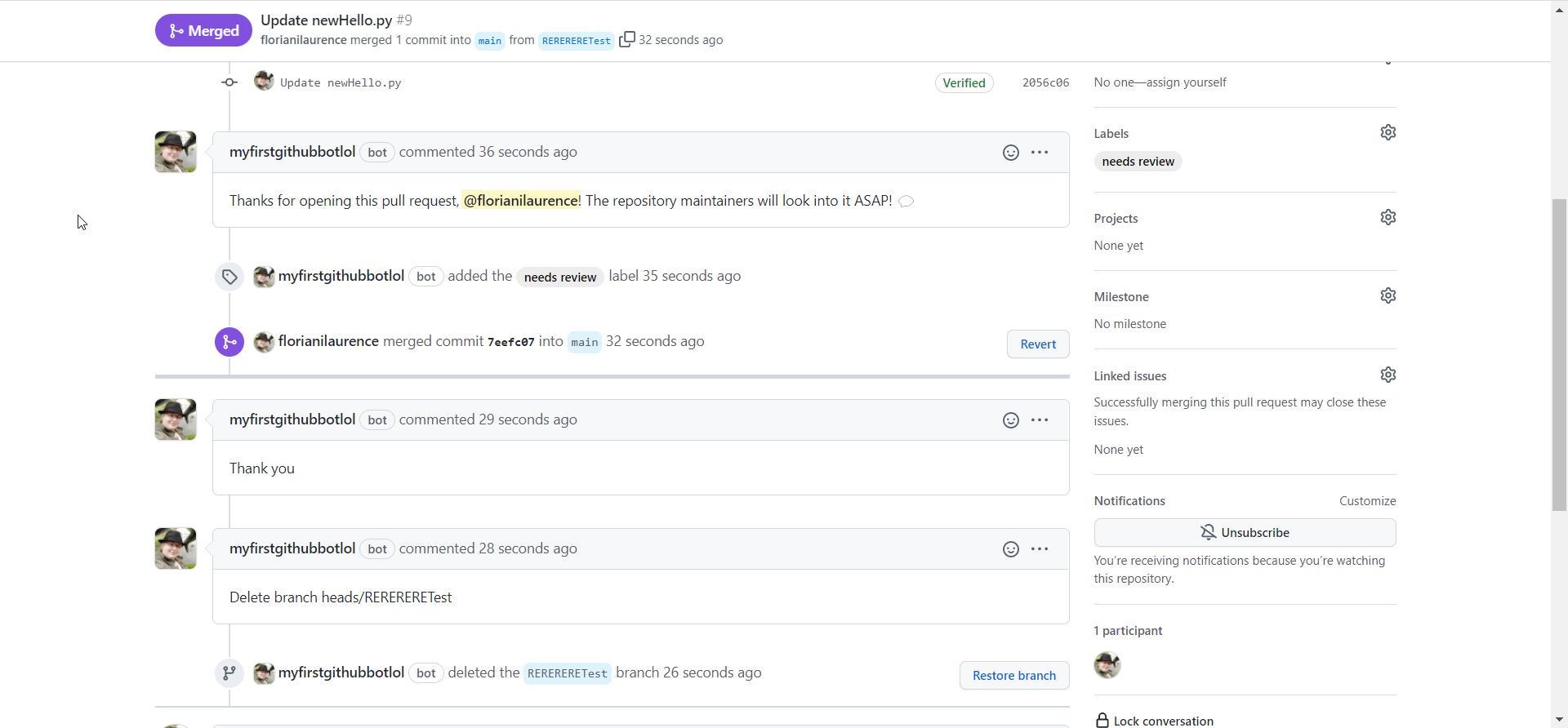

1. **Prevent merging of pull requests with "WIP" in the title.**

***Part 1:***

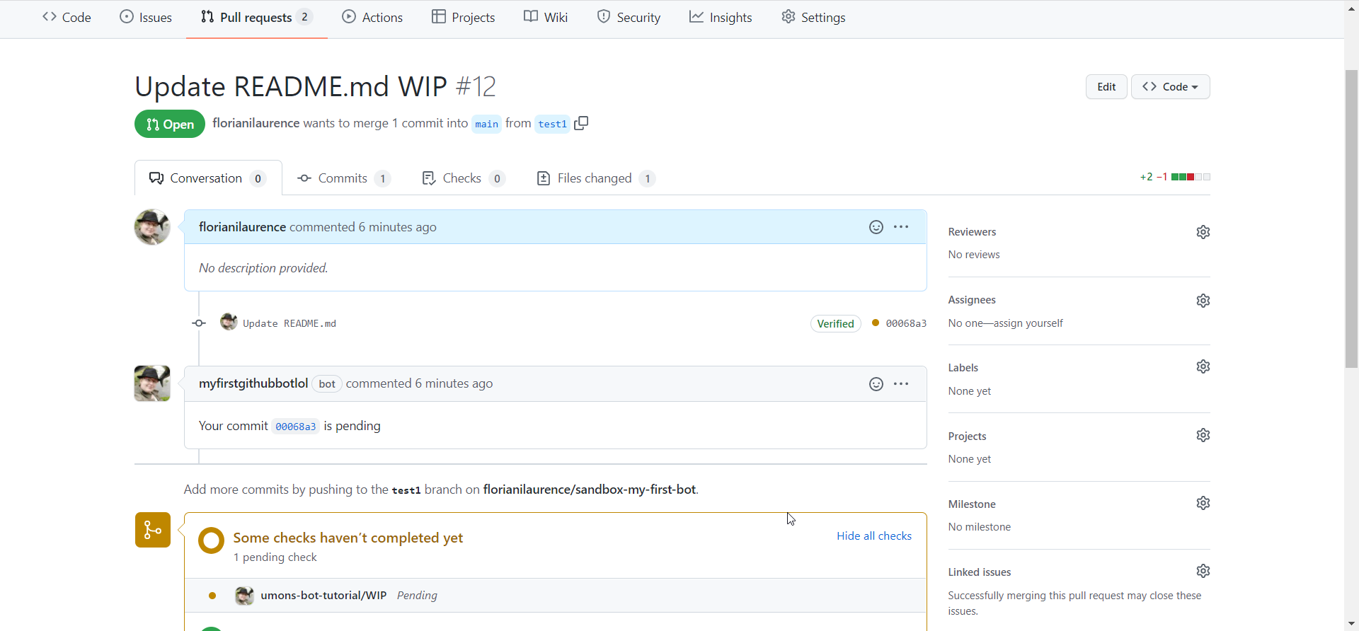

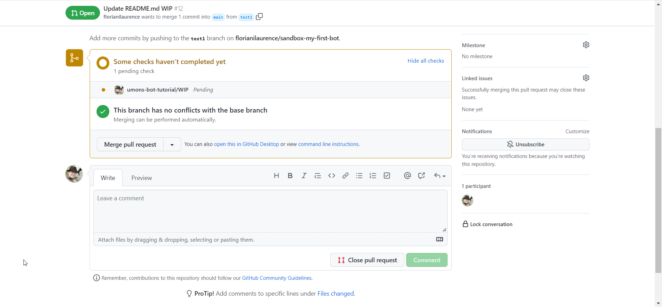

***Part 2:***

