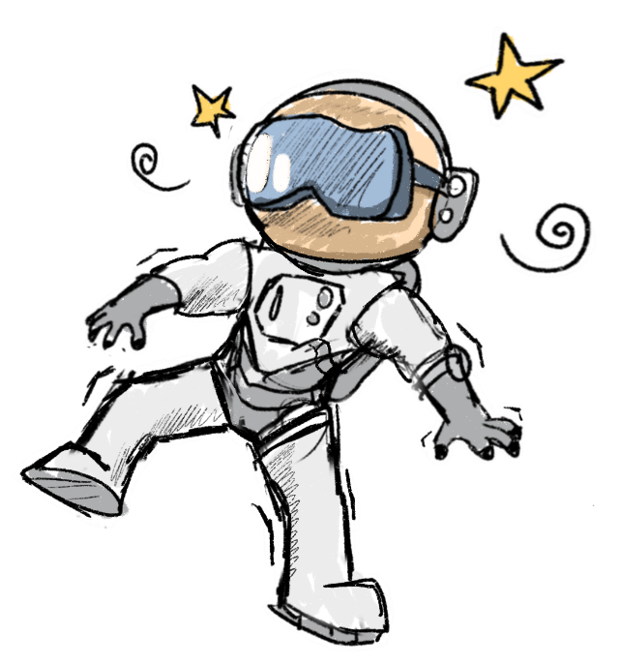
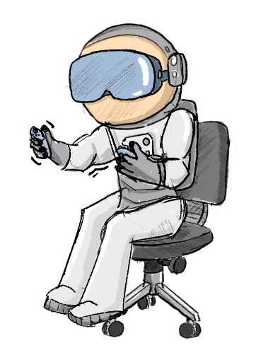
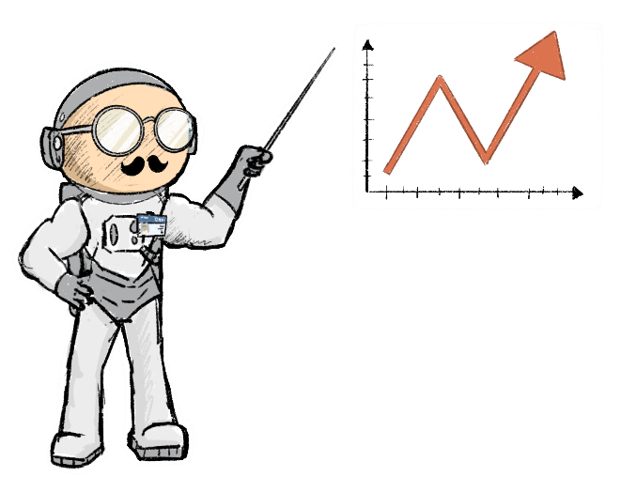
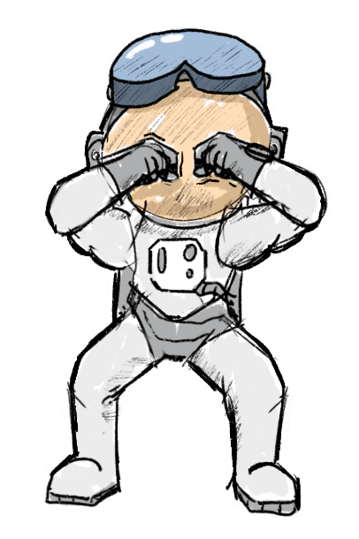
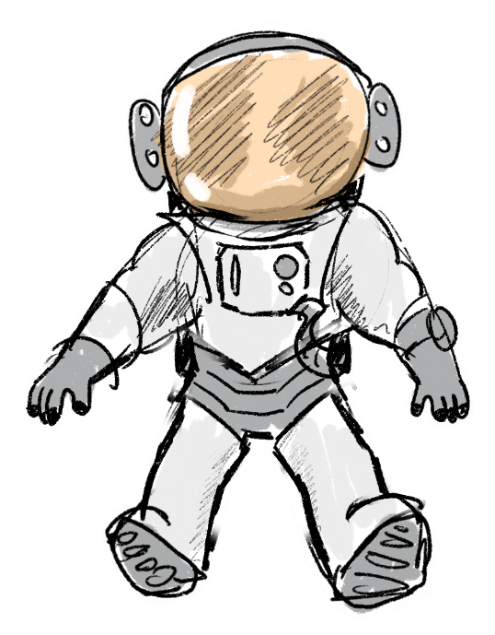
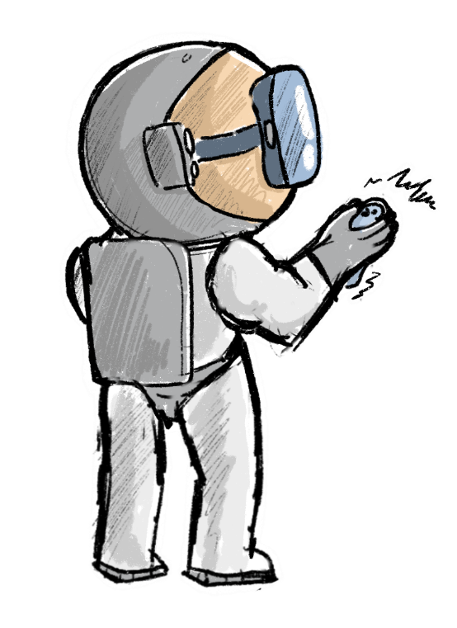
Visual Fatigue
☐Use dark mode and reduce overall brightness to minimise eye strain
☐Maintain consistent brightness and avoid sudden or frequent colour changes
☐Prefer low-saturated and low-luminescent colours for large or persistent elements
☐Apply natural depth cues and subtle motion parallax to support visual comfort
☐Reduce cognitive load with clear guidance and simple visual structures
Colours
☐Low-saturation and low-luminosity colours are used for comfortable long-term viewing
☐High-intensity colours are used sparingly and only to guide attention
☐The colour palette is limited and visually cohesive
☐Variations of a single hue are used to create depth without clutter
☐Colour contrast supports readability without causing visual fatigue
Outside Manipulation
☐Provide consistent instructor tools and workflows across applications
☐Ensure instructors always have clear, easily accessible guidance and reference material
☐Keep instructor interactions simple and avoid complex inputs or confusing hotkeys
☐Provide shared visual context (e.g., mirrored or multiple viewpoints)
☐Enable real-time support and intervention without disrupting the user experience
Motion Sickness
☐Align virtual movement with physical motion to reduce sensory conflict
☐Keep movement smooth and predictable; avoid sudden accelerations or rotations
☐Use teleportation and controller-based rotation to minimise discomfort
☐Give users control over movement, rotation, and comfort settings
☐Apply subtle FOV restriction (e.g., vignette) during movement where appropriate
☐Support seated experiences and adaptable interaction setups
☐Encourage breaks and provide a comfortable real-world environment
Lighting conditions for environments without an atmosphere (e.g. the Moon, outside the ISS)?
☐Lighting can be adjusted (e.g. sun position, time of day) to suit the scenario
☐Important objects are well-lit and remain clearly visible at all times
☐Additional light sources support visibility in dark or shadowed areas
☐Objects are spaced to prevent shadows from hiding smaller items
Accessibility
Design for diverse users (e.g., left-handed, colourblind, limited mobility, situational constraints)
☐Support flexible interaction (e.g., seated/standing use, adjustable reach, alternative inputs)
☐Use multimodal communication (visual, audio, haptic) instead of relying on a single sense
☐Provide adjustable difficulty and allow undo/redo to support different skill levels
☐Ensure accessibility features are visible, easy to activate, and introduced during onboarding
☐Avoid placing critical interactions out of reach or requiring precise physical ability
XR Guidelines Cheat Sheet
While it is encourage to check as many boxes as possible, it is not always possible for each application. For more information check out the guidelines via this link: https://floriansaling.github.io/eac-ux-guidelines/Guidelines/

What format of onboarding is the application using?
☐General
☐Ensure instructions are always accessible and easy to revisit
☐Use clear visual cues, diagrams, or tooltips; choose colours carefully to avoid fatigue
☐Keep instructions simple and readable, matching the user’s environment
☐Tutorials
☐Make tutorials interactive and let users progress at their own pace; include redo/skip options
☐Provide immediate, specific feedback on user actions to confirm success or guide corrections
☐Highlight current instructions clearly, e.g., with positioning, arrows, or sound cues
☐Keep content concise and manageable to avoid overwhelming users
☐Controller Diagram
☐Keep diagrams simple and easy to understand, avoiding excessive text
☐Make diagrams easily accessible or always visible at startup
☐Virtual Controller with Tooltips
☐Keep tooltip texts short and clear (ideally ≤2 words)
☐Provide flexible access—allow hiding or showing tooltips to avoid blocking the view

Super Soldier Syndrome
☐Restrict unnecessary interactions to reduce overconfidence and unrealistic behaviour
☐Structure tasks into clear, guided steps to discourage skipping or experimentation
☐Use clear, simple instructions to prevent users from inventing their own procedures
☐Provide explicit, immediate feedback to reinforce correct behaviour and outcomes
☐Enhance realism through multisensory cues to reduce the feeling of “no consequences”
Interaction Feedback
☐Provide Feedback letting the user know their interaction is working
☐Provide Feedback letting the user know what they can do
☐Provide Feedback letting the user know what they just did
☐Maintain consistent, predictable feedback patterns across the experience
☐Combine visual, auditory, and haptic cues to reinforce interactions and immersion
☐Ensure feedback is unambiguous and easy to interpret; highlight cause-and-effect relationships
☐Use colour thoughtfully and pair with other modalities; employ billboarding for 2D markers where needed
What kind of interface does my application have?
☐Diegetic Interfaces
☐Interactions feel intuitive and mirror real-world behaviour
☐Actions are simple and low in cognitive effort
☐Interactive objects are clearly distinguishable and well placed
☐Users receive clear guidance when needed (onboarding or contextual cues)
☐Every interaction provides clear, appropriate feedback
☐Non-diegetic Interfaces
☐UI is simple, symmetrical, and free of clutter
☐Elements are clearly grouped and visually distinct (no “floating” confusion)
☐Text, buttons, and spacing are readable and comfortable to interact with
☐Key UI is placed within the comfortable viewing zone and at a suitable distance
☐Feedback and colour use are consistent, readable, and not overwhelming
How does the user interact with the application?
☐Controllers
☐Controls are simple, intuitive, and consistent across the application
☐Core actions (move, rotate, grab, select) are easy to learn and clearly mapped
☐Multiple movement and rotation options are available (e.g. teleport, steering)
☐Controls support different users (e.g. left-/right-handed use or remapping)
☐Menu access is easy, consistent, and always available
☐ Voice
☐Commands are short, simple, and easy to pronounce and remember
☐Commands are distinct, consistent, and avoid similar-sounding phrases
☐Voice actions are safe, reversible, and context-aware (only active when needed)
☐System voice commands are respected and not overridden
☐Users can access a clear overview of available commands
☐Voice input is supported by other interaction methods where needed
☐Gaze
☐Provide subtle feedback and slightly delayed visuals to confirm gaze selection
☐Combine gaze with other inputs (gesture, voice, controller) for accuracy and control
☐Use comfortably sized targets and avoid forcing unnatural eye or head movements
☐Avoid attaching UI elements directly to eye gaze (cursors or overlays)
☐Gestures
☐Use intuitive, real-world gestures that are simple and easy to remember
☐Design UI cues that naturally suggest how to interact with objects
☐Limit gesture variety to reduce errors and cognitive load
☐Combine gestures with tools like eye tracking or hand rays for precision and reach

