# Manual for the code used in the following publication:

# Välkki IA, Lenk K, Mikkonen JE, Kapucu FE and Hyttinen JAK (2017) Network-Wide Adaptive Burst Detection Depicts Neuronal Activity with Improved Accuracy. Front. Comput. Neurosci. 11:40. doi: 10.3389/fncom.2017.00040

As **input** the user needs a cell array called DataCell saved as .mat file as indicated in Figure 1.

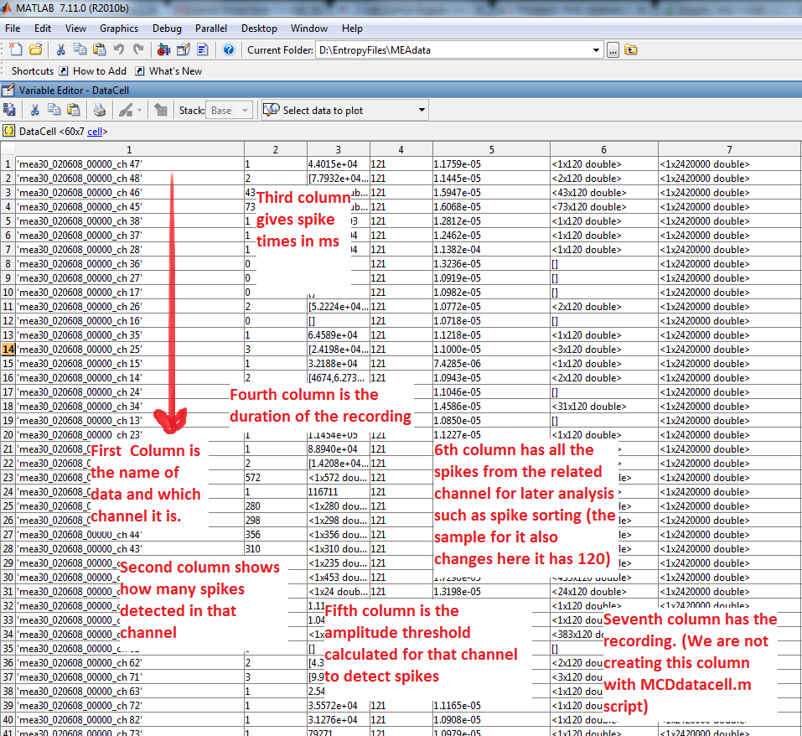

Figure : Outline of the input cell array called DataCell.

As **output** the user gets BurstInfoO (results with original CMA algorithm, DOI: 10.3389/fncom.2012.00038) and BurstInfoN (results of the modified network-wide CMA algorithm).