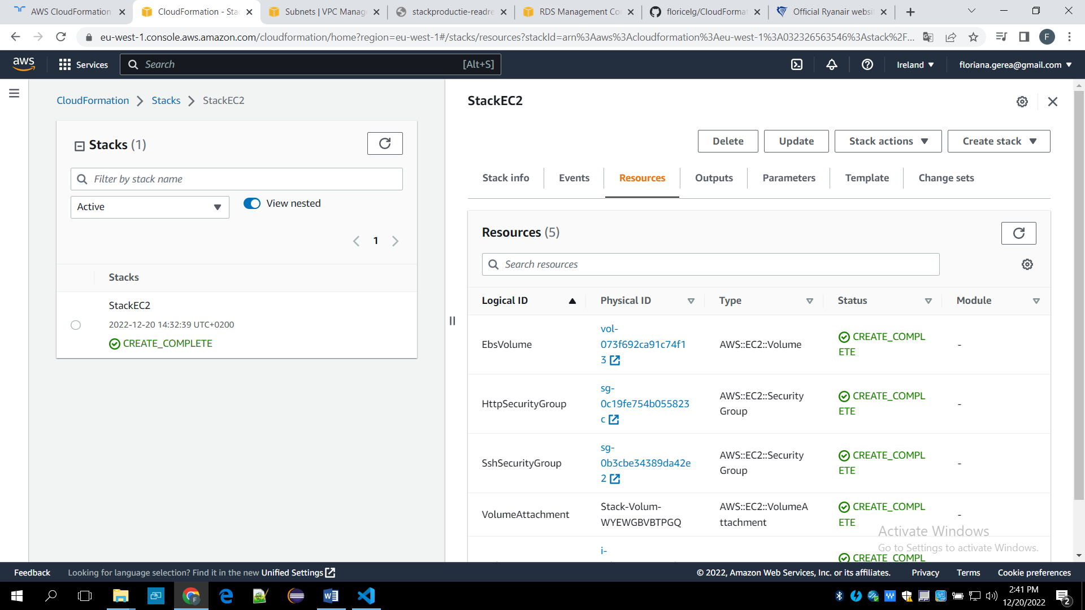

 Section 5 Activity template.

  It launches a web server EC2 instance with separate security groups for HTTP and SSH access.

  It creates an EBS volume and attaches it to the EC2 instance.

