Copper Metabolism 1995–2024
Where the world's copper is mined, processed, traded and used: a reconciled supply–use view
Florian Huber · 2 November 2026 · pySUTO run opt_20261022_112855_928da10c · all quantities in contained copper

What pySUTO does and how to read its results
Copper statistics are plentiful but do not add up. The International Copper Study Group (ICSG) reports mine, smelter and refinery output, scrap use and stock changes; national customs offices report trade, compiled in CEPII's BACI database; the materialflows.net series reports the tonnage of ore extracted. Each source has its own gaps, definitions and errors. pySUTO fuses them into one supply–use system for copper: who produces which copper product, who uses it and where it goes, for 46 countries and regions plus a rest of the world, in every year from 1995 to 2024. It follows copper from ore in the ground through concentrate, matte, anode and cathode to the fabricators that first use it, and requires that every tonne entering a process leaves it as a product or a loss. Where sources disagree, it adjusts each reported number as little as possible, weighted by how reliable that number is.
Five points matter when reading the results. First, they are reconciled estimates, not observations, and are described here, not explained: well-reported flows such as national mine output stay close to their sources, thinly reported ones move more, and in Chapter 3 the reconciliation lifts some regions' scrap ratios above their statistics. Second, the system ends at refined cathode: final use means cathode delivered to fabricators, not copper in finished goods, and scrap that fabricators melt directly lies outside it, which is why direct-melt users such as the United States show little scrap. Third, all quantities are contained copper, in Mt Cu or kt Cu, not the mass of ore or product. Fourth, trade comes from customs records with reporting errors; those detected were corrected, but bilateral flows remain the least certain part of the picture. Fifth, each year is reconciled on its own and the figures show central estimates: a one-year jump may come from the data, and the uncertainty ranges the model computes are not drawn.

1 · System size: 35 Mt of copper a year cross the system boundary, 2.3 times as much as in 1995
The system takes in copper from two sources, ore in the ground and scrap returned from use, and releases it as cathode to its users, as stock changes and as losses to tailings and slag. Between 1995 and 2024 inputs, final use and losses all grew, but not at the same pace.
Figure 1. Process outputs along the chain, 1995–2024
World output of each step of the copper chain in Mt Cu, from ore mined (lightest) to refined cathode (darkest). The dashed line is cathode from the solvent-extraction electrowinning (SX‑EW) route, which leaches ore and bypasses the smelters. The lines are successive stages of one chain and are not additive.
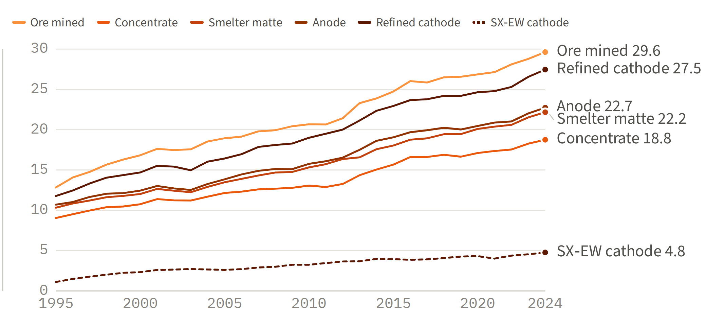
- Mined copper grew faster than concentrate. Ore output rose ×2.31 (12.8 → 29.6 Mt Cu) but concentrate only ×2.07 (9.0 → 18.8 Mt), because a growing share of ore is leached rather than milled, 22 % in 2024 against 12 % in 1995: SX‑EW cathode rose ×4.30, from 1.1 to 4.8 Mt Cu.
- The smelting core grew in step. Matte, anode and electrorefined copper all grew ×2.12–2.15, as a mass-balanced chain requires; refined cathode grew faster (×2.33, to 27.5 Mt Cu) because SX‑EW cathode joins it without passing the smelters.
Figure 2. Inputs across the system boundary, 1995–2024
Copper entering the system each year in Mt Cu, stacked: ore in the ground (in situ) and scrap delivered to smelters and fire refineries. Scrap melted directly by fabricators enters outside this boundary and is not shown.
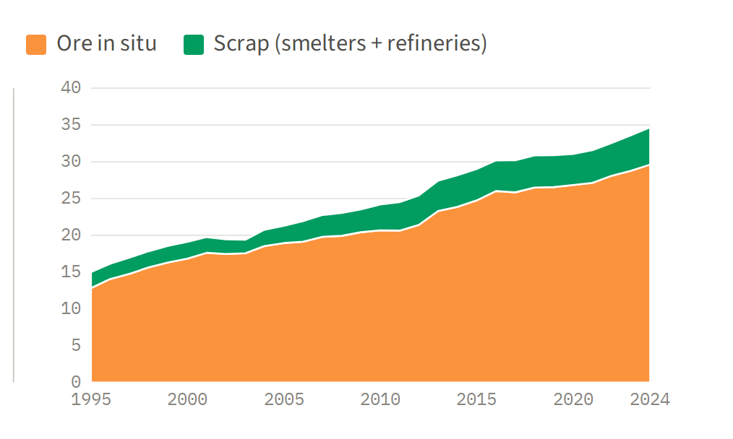
- Inputs grew 2.3-fold. From 15.0 Mt Cu in 1995 to 34.7 Mt Cu in 2024, of which ore supplied 12.8 and 29.6 Mt.
- Scrap held its share. Scrap to smelters and refineries rose from 2.2 to 5.1 Mt Cu, 14.5 % of the input in 1995 and 14.6 % in 2024.
Figure 3. Outputs across the system boundary, 1995–2024
Copper leaving the system each year in Mt Cu, stacked: cathode to final use, stock changes (exchange, user and producer stocks) and losses to tailings and slag, on the same vertical scale as Figure 2.
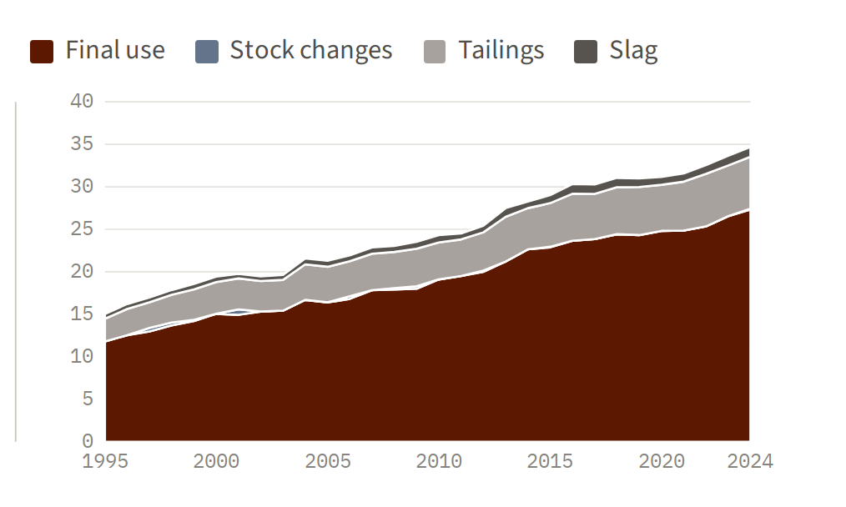
- Four fifths of the input reaches users. Final use took 78.6 % of the boundary input in 1995 and 78.8 % in 2024 (11.8 and 27.3 Mt Cu).
- Losses grew slightly slower than final use. Tailings rose ×2.27 and slag ×2.09 while final use rose ×2.32, so losses fell from 21.5 % to 20.9 % of the input.
Table 1. Boundary ledger, 1995 and 2024
Each world copper flow across the system boundary in Mt Cu in the first and the last year, with its growth factor. Stock changes are booked on the output side and can be negative (a draw-down).
Boundary flow, Mt Cu | 1995 | 2024 | 2024 / 1995
Inputs
Ore in situ, from nature | 12.84 | 29.62 | ×2.31
Scrap to smelters | 1.65 | 4.12 | ×2.49
Scrap to fire refineries | 0.52 | 0.95 | ×1.82
Total in | 15.02 | 34.69 | ×2.31
Outputs
Final use | 11.80 | 27.33 | ×2.32
Tailings (mill and SX‑EW) | 2.68 | 6.10 | ×2.27
Slag (smelting, fire refining and electrorefining) | 0.55 | 1.15 | ×2.09
Stock changes (exchange, user and producer) | -0.01 | 0.11 | –
Total out | 15.02 | 34.69 | ×2.31

- The ledger closes by construction. The reconciliation requires it, and inputs equal outputs to within 0.2 kt Cu in every year from 1995 to 2024; the processing chain itself holds no stock.
- Stock changes are small but volatile. They never exceed 0.81 Mt Cu in a year (a draw-down of 807 kt in 2004, a build-up of 645 kt in 2001), against 15–35 Mt of input.

2 · The chain in one picture: 30 Mt Cu in from the ground, 27 Mt of cathode to final use
The Sankey diagrams follow the world's copper through every process in the first and the last year. Each band runs from the process that makes a commodity to the process that uses it; its colour names the commodity, and full colour marks the part that crosses a border.
Figure 4. World copper system, 1995 and 2024
Reconciled world flows; node labels in Mt Cu. Dark bars are processes, coloured bars are sources and sinks at the system boundary, and band width is proportional to the flow, on one scale for both panels. Pale bands stay within the region that made them; full-colour bands cross a border between two of the model's 47 regions.
(a) 1995
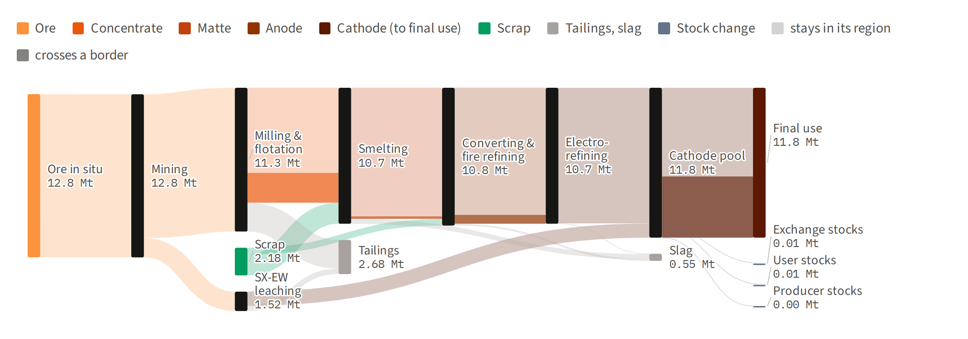
(b) 2024
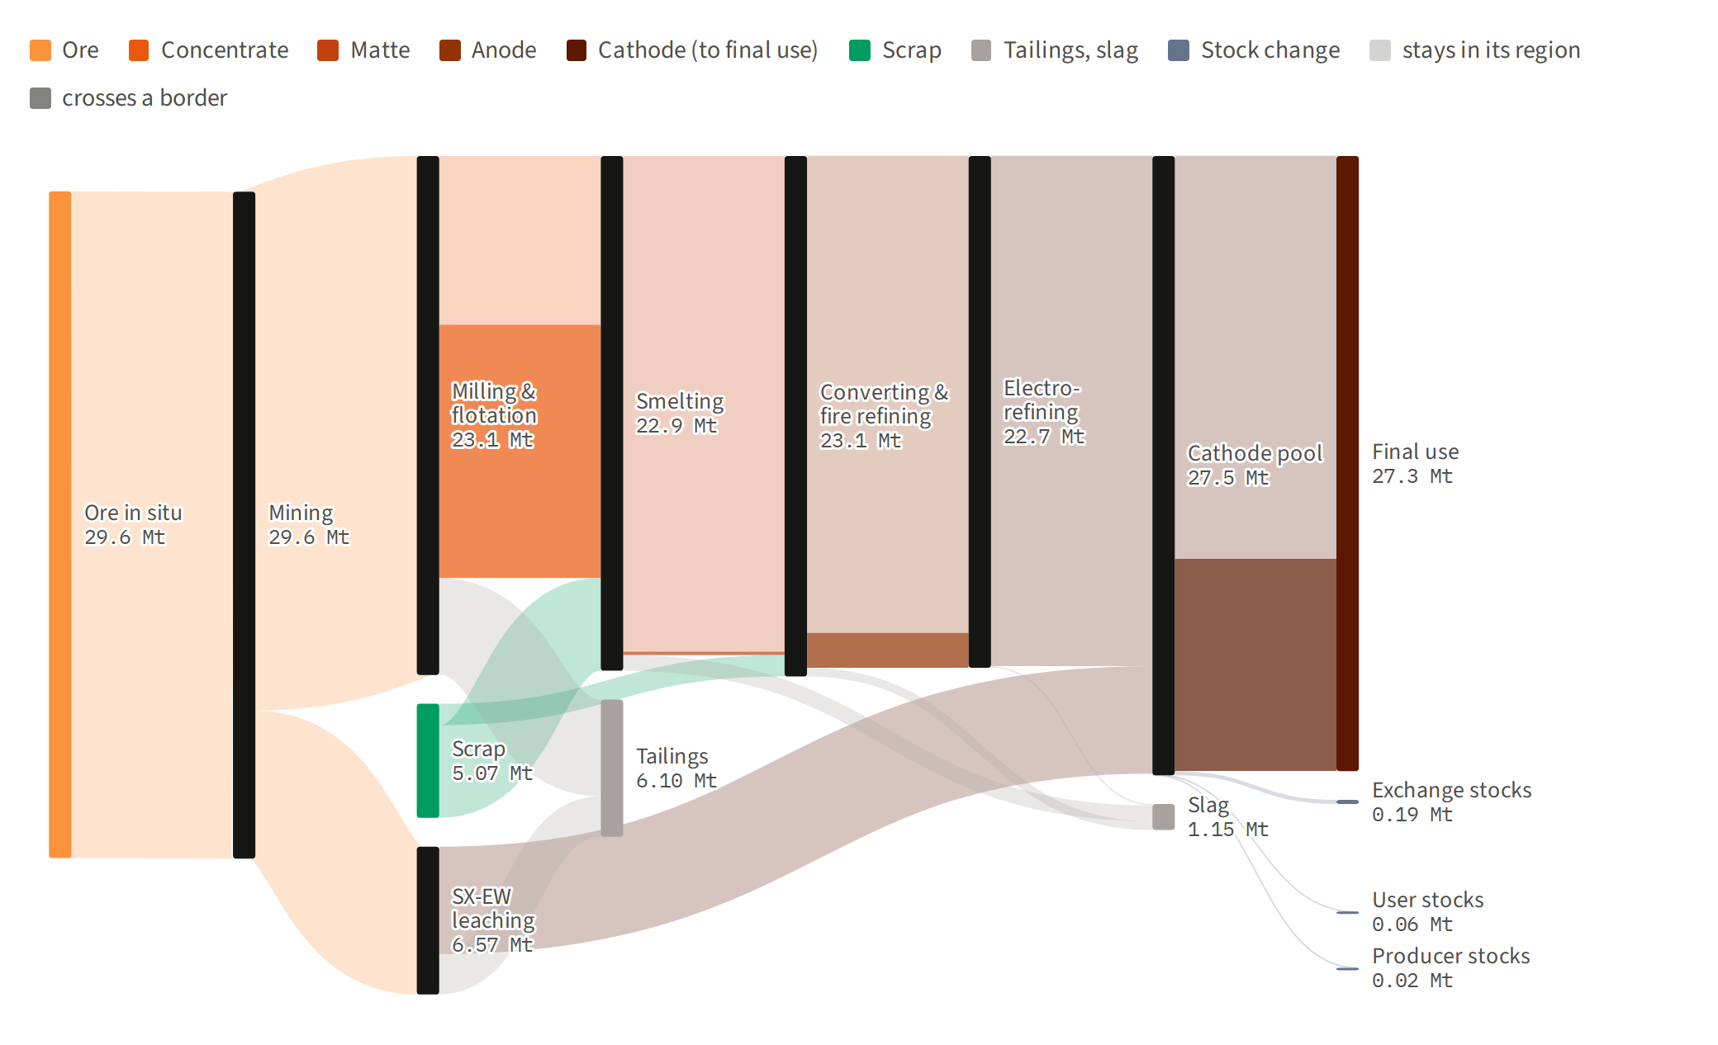
- Concentrate became the traded form of copper. In 1995, 26 % of the world's concentrate (2.3 of 9.0 Mt Cu) was smelted outside the region that mined it; in 2024, 60 % (11.3 of 18.8 Mt). The share of cathode used abroad fell from 41 % to 35 %, and matte (under 2 %) and anode (7 %) mostly stay where they are made.
- Most copper is lost at the mine. In 2024 milling and flotation lost 4.3 of 23.1 Mt Cu (19 %) to tailings and leaching 1.8 of 6.6 Mt (27 %), against 1.2 Mt lost to slag in smelting, converting and electrorefining together.

3 · Scrap versus primary input: 0.22 kt of scrap per kt of primary feed in 2024, back at the 1995 level
Smelters and refineries are fed either with primary material (concentrate and SX‑EW cathode) or with scrap. The ratio of the two shows how much of the refined copper supply is recycled within the modelled boundary. The EU‑14 are the 14 EU member states the model resolves, listed under Data and sources.
Figure 5. Scrap feed per unit of primary feed, 1995–2024
Ratio of scrap to primary feed at smelters and refineries for the world and five regions, in kt Cu per kt Cu. Scrap is scrap to smelters and fire refineries; primary is concentrate to smelters plus SX‑EW cathode. The dashed grey line is the world ratio implied by ICSG statistics before reconciliation.
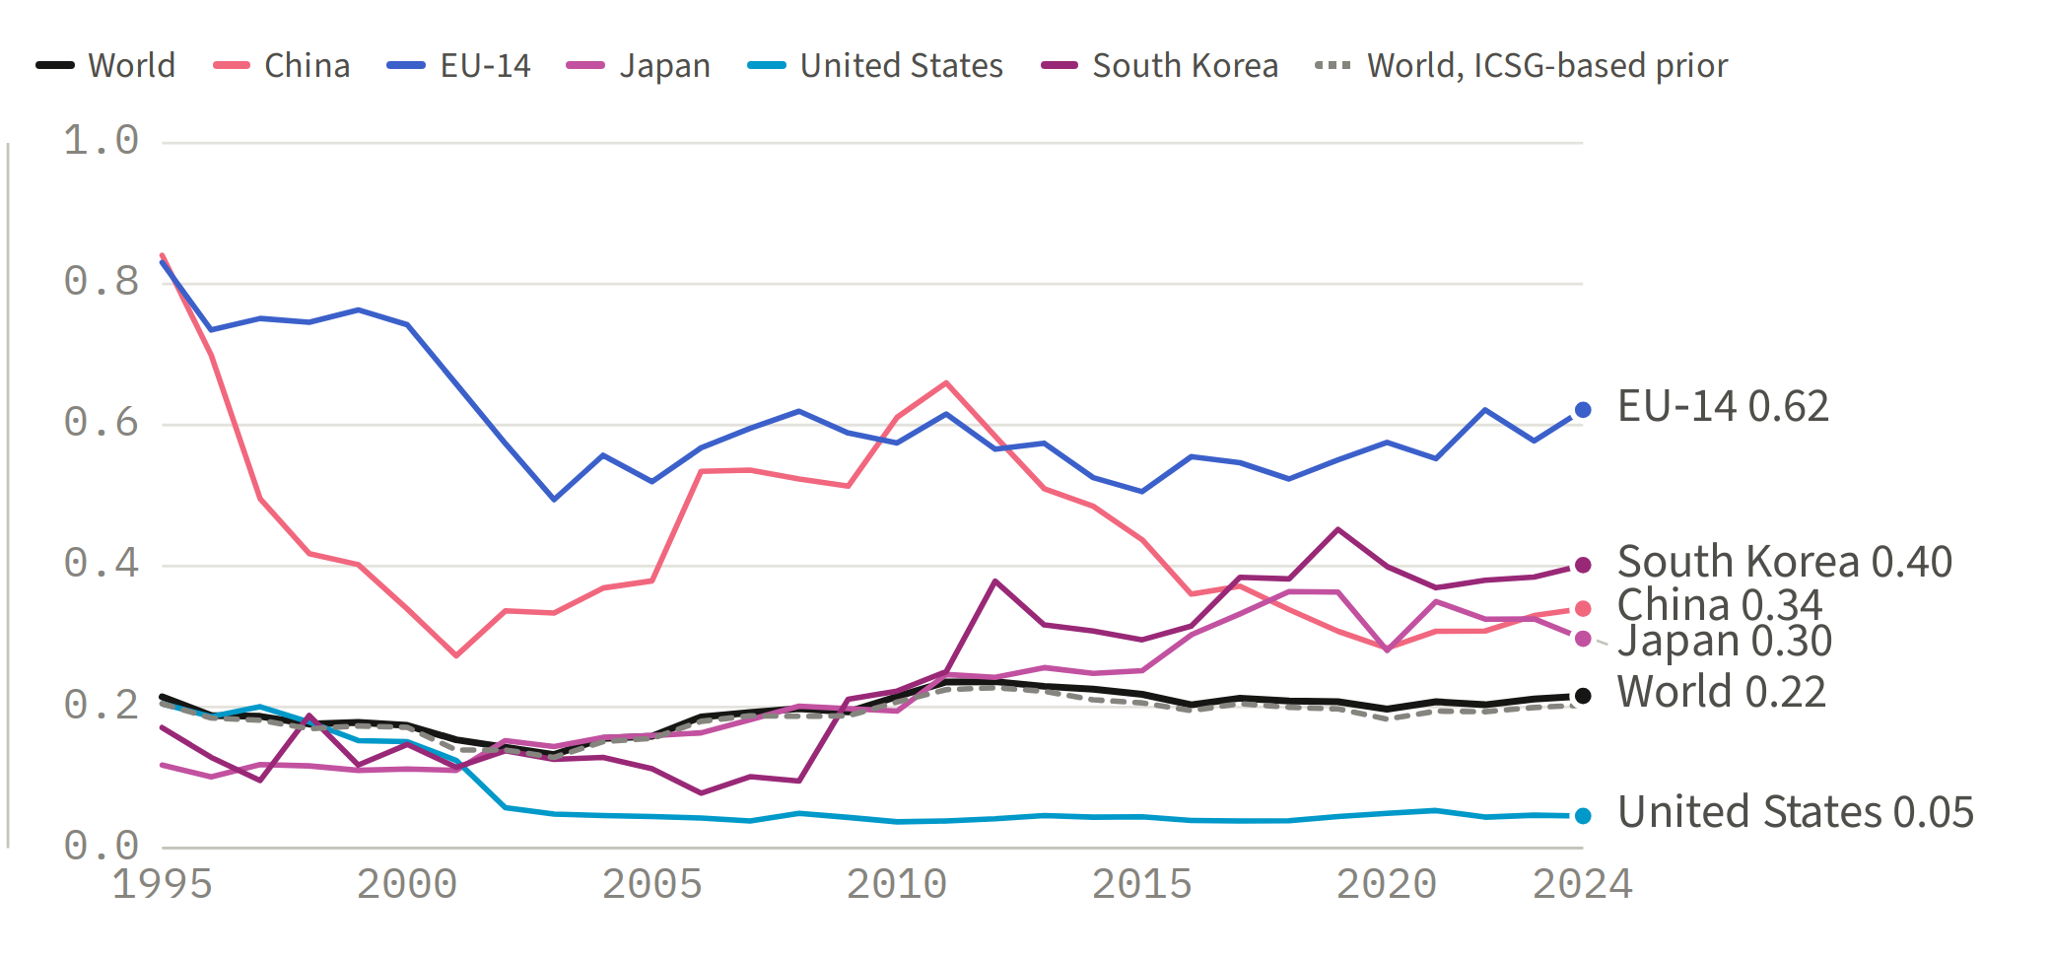
- A trough, then recovery. The world ratio fell from 0.21 in 1995 to 0.13 in 2003, as primary feed grew 37 % while scrap feed fell 15 %, and returned to 0.22 by 2024, close to the ICSG-based 0.20.
- The regions diverged. The EU‑14 stayed scrap-heavy (0.83 → 0.62), China fell from 0.84 to 0.34 while its scrap volume rose 6.5-fold, South Korea rose from 0.17 to 0.40 and Japan from 0.12 to 0.30, and the United States dropped from 0.20 to 0.05.
Figure 6. Scrap share of smelter and refinery feed by region, 2024
Scrap as a share of total smelter and refinery feed (scrap plus primary) in 2024, for the 20 regions whose feed exceeds 300 kt Cu; EU‑14 members carry the EU‑14 colour.
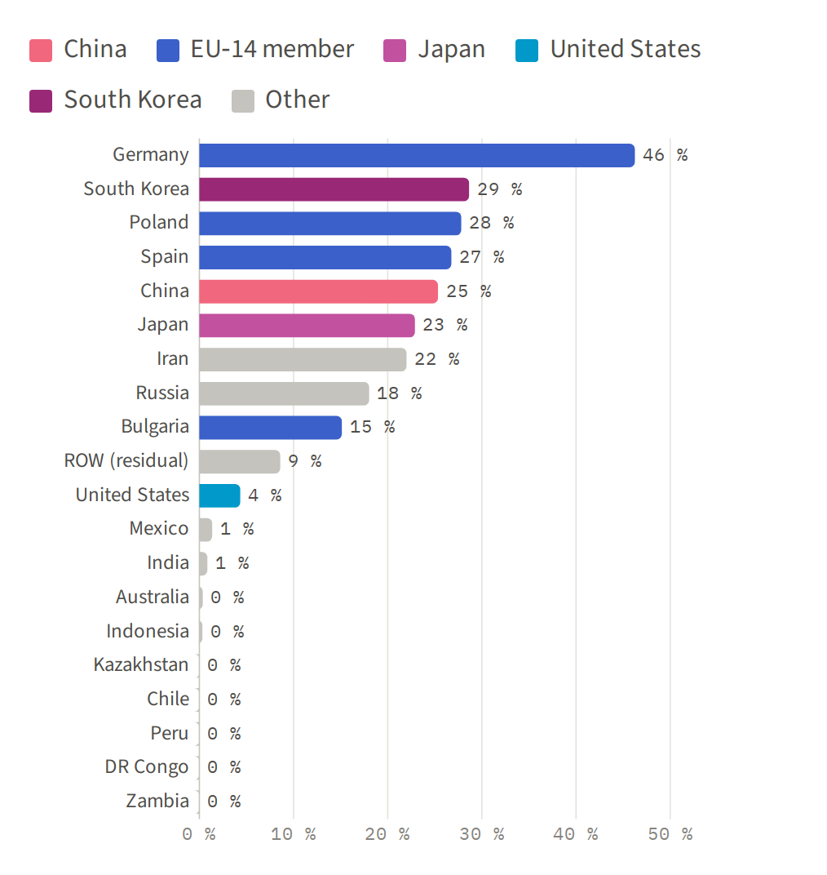
- Germany leads. Close to half of German smelter and refinery feed is scrap (46 %), followed by South Korea (29 %), Poland (28 %), Spain (27 %), China (25 %) and Japan (23 %).
- In the reconciled accounts the mining countries refine primary metal only. Chile, Peru, the DR Congo and Zambia feed no scrap and the United States only 4 %, consistent with US scrap going to direct melt or export, outside this boundary.
Figure 7. Scrap feed volume by region, 1995–2024
Scrap delivered to smelters and fire refineries each year in kt Cu, stacked by region in the order and colours of Figure 5.
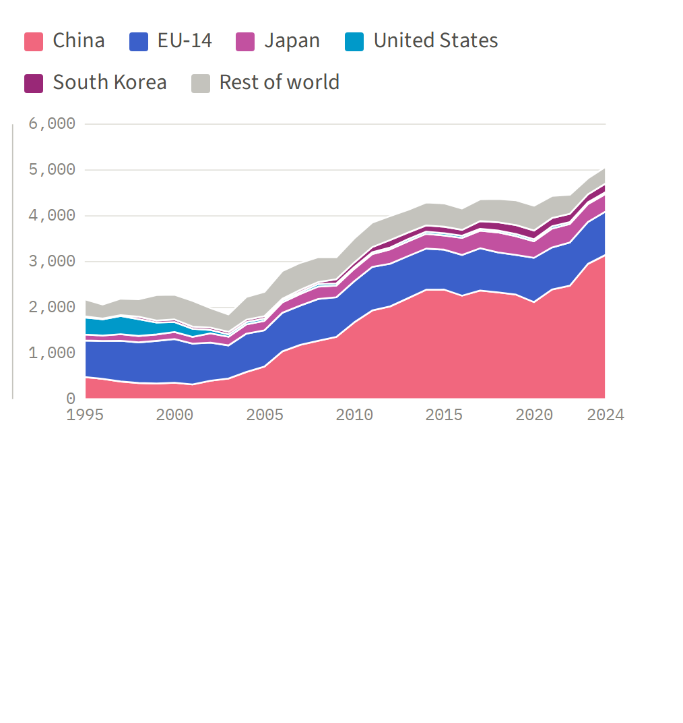
- The growth landed in China. World scrap feed rose from 2.2 to 5.1 Mt Cu, and China's part of it from 22 % to 62 % (0.5 → 3.1 Mt), more than three times the EU‑14's 0.95 Mt.
- Read the regional split with care. In 2024 China's ratio (0.34) and South Korea's (0.40) sit above their ICSG-based priors (0.31 and 0.34), so the reconciliation, not the statistics, set part of their scrap feed; the EU‑14's ratio (0.62) matches its prior.

4 · Supply concentration: mining spread out a little, everything downstream concentrated in China
For each step of the chain, the regions' shares of world output show how concentrated supply is. In 1995 the United States led smelting, refining and final use; by 2024 China led all three.
Figure 8. Share of world output by region, per chain step, 1995–2024
Six panels, one per step, each stacked to 100 %: mining and concentrate by producing region, smelting and refined cathode by processing region, final use and scrap feed by consuming region. The rest of the world pools every region not named, the DR Congo included.
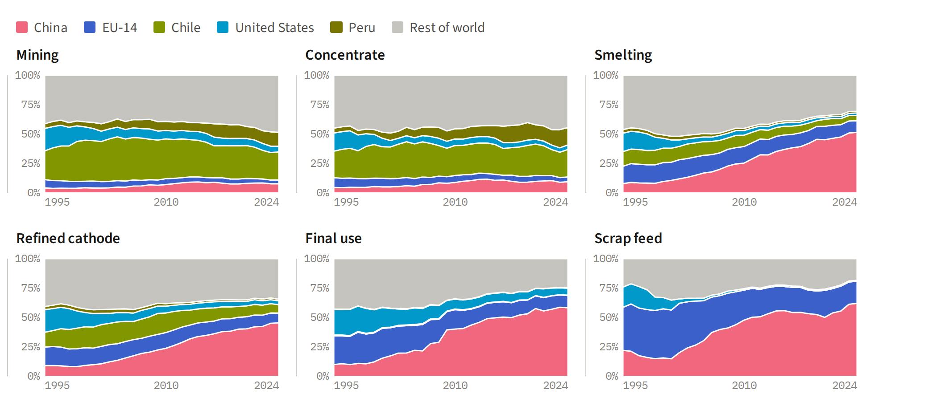
- China's rise is downstream. Between 1995 and 2024 China went from 8 % to 52 % of smelting, from 9 % to 45 % of refined cathode and from 10 % to 58 % of final use, but only from 4 % to 8 % of mining.
- Mining spread out. Chile held 24 % of mining in both years, Peru rose from 4 % to 12 % and the DR Congo reached 14 %, while the United States fell from 19 % to 5 %.
Figure 9. Concentration index by chain step, 1995 and 2024
Herfindahl–Hirschman index (the sum of squared shares of the 47 regions, rest of the world included) for each step: open circle 1995, filled circle 2024. Shaded bands mark moderate (0.15–0.25) and high (above 0.25) concentration.
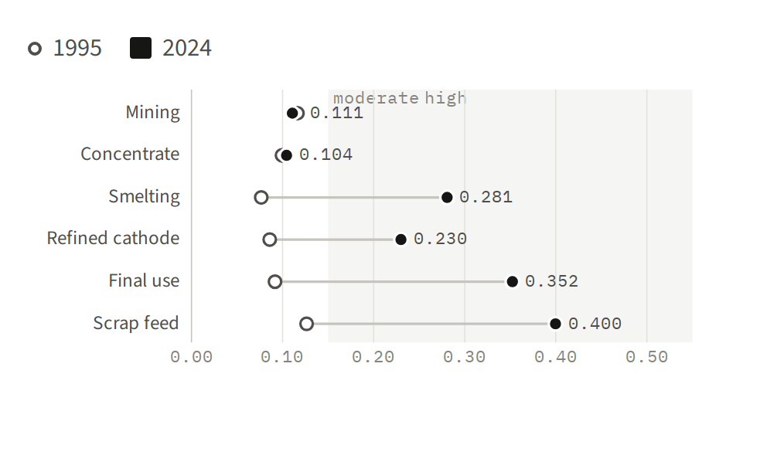
- Concentration moved downstream. In 1995 mining (0.116) was more concentrated than smelting (0.077) or final use (0.092); by 2024 smelting (0.281) and final use (0.352) had overtaken it, while mining eased slightly (0.111).
- Scrap feed is the most concentrated step. Its index reached 0.400 in 2024, with China taking 62 % of the world's scrap feed.
Figure 10. Imported share of smelter concentrate intake, 1995–2024
Share in % of the concentrate smelted in China, the EU‑14 and the United States that comes from outside the region (for the EU‑14, from outside the EU‑14 as a whole).
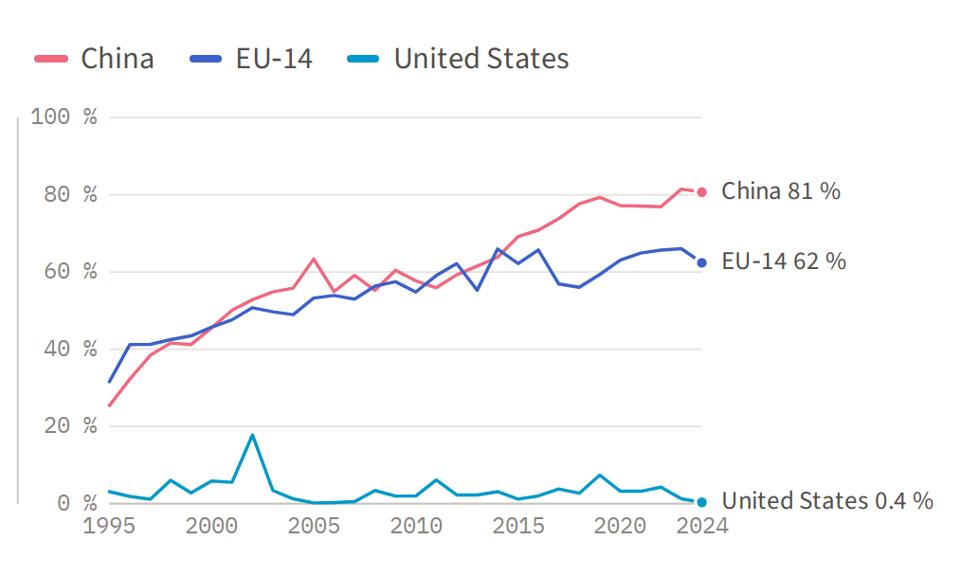
- China's smelters run on imports. Their import share rose from 25 % to 81 %: 7.4 of the 9.2 Mt Cu of concentrate they smelted in 2024 came from abroad.
- The EU‑14 imports three fifths, the United States almost nothing. The EU‑14's share doubled from 32 % to 62 %, while US smelters, their intake down from 1.3 to 0.5 Mt Cu, run on domestic concentrate.
Table 2. Regional share per chain step, 2024 with 1995
Share of world output in % for China, the EU‑14, the United States, Chile and Peru at each step in 2024, with 1995 in parentheses, together with the 2024 leader, the share of the three largest regions and the concentration index.
Step | China | EU‑14 | United States | Chile | Peru | Leader 2024 | Top‑3 share | HHI
Mining | 7.8 (4.3) | 3.2 (7.1) | 4.9 (19.1) | 23.9 (24.3) | 11.8 (4.1) | Chile 23.9 | 49.9 (50.3) | 0.111 (0.116)
Concentrate | 9.5 (4.7) | 4.1 (8.3) | 3.8 (15.3) | 23.3 (22.5) | 14.9 (4.2) | Chile 23.3 | 47.7 (45.5) | 0.104 (0.099)
Smelting | 51.6 (8.0) | 9.8 (14.6) | 2.2 (15.6) | 4.4 (12.5) | 1.4 (3.2) | China 51.6 | 63.2 (39.7) | 0.281 (0.077)
Refined cathode | 45.5 (9.2) | 8.3 (15.7) | 3.3 (19.3) | 7.2 (12.5) | 1.4 (2.6) | China 45.5 | 62.0 (41.8) | 0.230 (0.086)
Final use | 58.4 (10.0) | 10.4 (24.5) | 6.0 (21.6) | 0.3 (0.8) | 0.3 (0.3) | China 58.4 | 69.2 (43.7) | 0.352 (0.092)
Scrap feed | 62.1 (22.1) | 18.7 (36.6) | 0.8 (17.2) | 0.0 (0.0) | 0.0 (0.0) | China 62.1 | 74.6 (56.7) | 0.400 (0.126)

- The EU‑14 lost weight fastest as a user. Its share of final use fell from 24.5 % to 10.4 %, faster than its shares of smelting (14.6 % → 9.8 %) and refined cathode (15.7 % → 8.3 %).
- Three regions dominate downstream. The three largest regions hold 63 % of smelting and 69 % of final use in 2024, against 40 % and 44 % in 1995; in mining they hold half, as they did in 1995.

5 · Trade structure: cross-border trade carries 22.4 Mt Cu a year, 2.8 times 1995, and concentrate is now the form in which copper travels
A tonne of copper may cross several borders on its way from mine to user: as concentrate before smelting, as matte or anode between processing steps, and as cathode after refining. The figures follow these legs region by region, in the trade-linked representation that Sun et al. (2017) developed for lithium.
Figure 11. Trade-linked flow of copper along the smelting route, 1995 and 2024
Each column is a step of the chain and each box a region, as tall as the copper it handles (Mt Cu, one scale for both panels); the ten largest regions over 1995–2024 are shown, the EU‑14 as one, with the rest pooled as other regions. Bands carry concentrate, matte, anode and cathode from the region that makes them to the region that uses them: pale bands stay in the region, full bands cross a border. Stubs on the left of a box are scrap (green) and SX‑EW cathode (dark) entering it.
(a) 1995
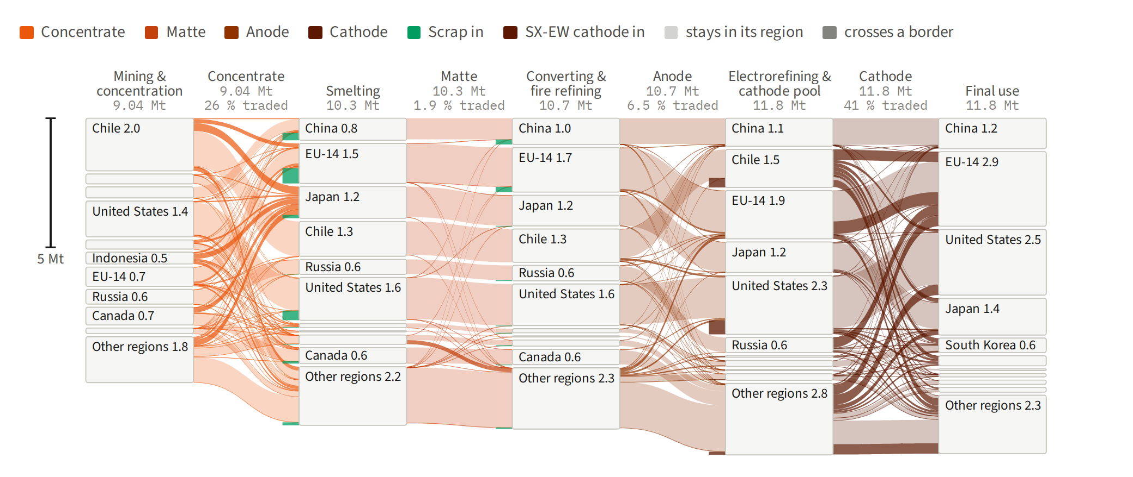
(b) 2024
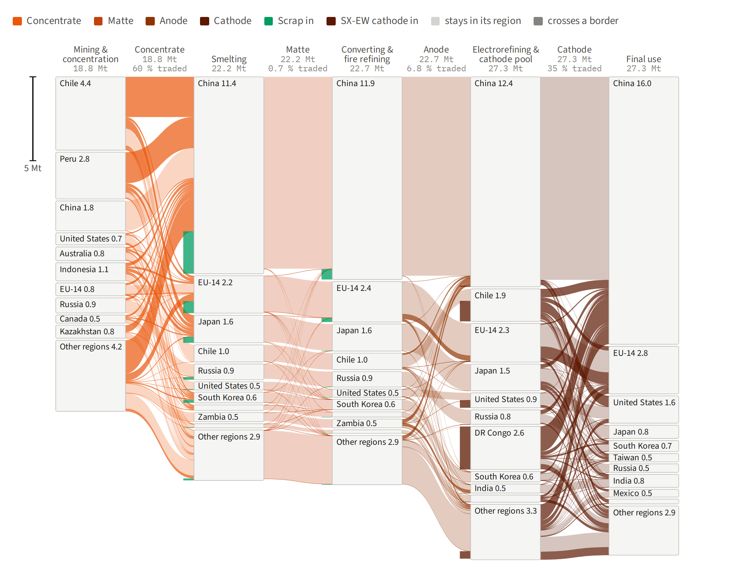
- The concentrate funnel. In 2024 Chile → China (2.4 Mt Cu) and Peru → China (1.9 Mt) are the two largest trade legs of the system; China's smelters take 7.4 of the 11.3 Mt of concentrate traded, including 71 % of Chile's and 75 % of Peru's concentrate exports. In 1995 Japan was the largest buyer.
- Cathode flows back out of the mining regions. The largest cathode legs in 2024 are DR Congo → China (1.5 Mt Cu), Chile → United States (0.6 Mt) and Chile → China (0.5 Mt).
Figure 12. Trade-linked flow of copper along the SX‑EW route, 1995 and 2024
Ore leached and electrowon where it is mined, on the same scale as Figure 11. The first gap carries ore to leaching within each region. SX‑EW cathode is pooled with electrorefined cathode and not traded under its own name, so the second gap gives each region's cathode shipments multiplied by the SX‑EW share of its cathode pool, an assumption of this figure, not of the model.
(a) 1995
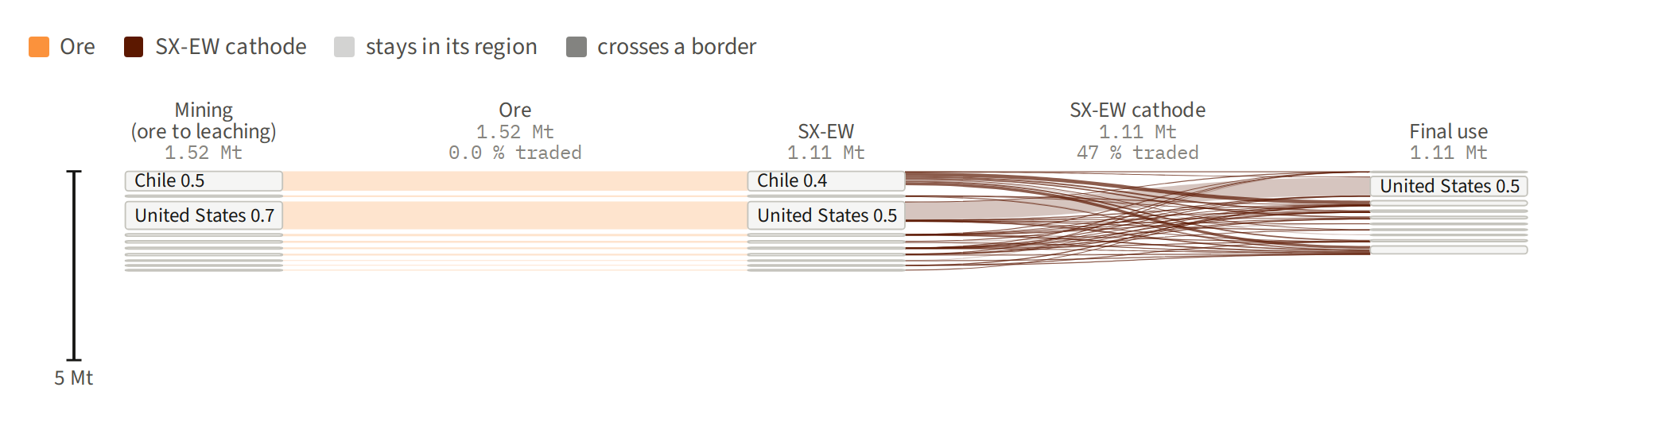
(b) 2024
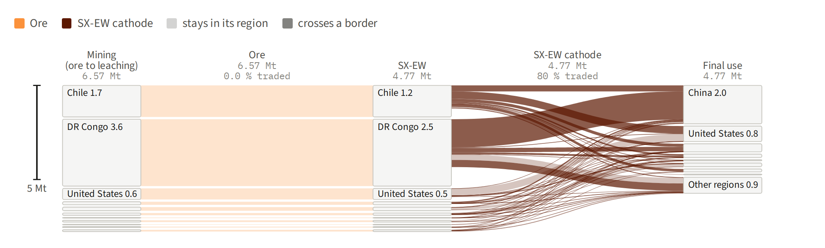
- The leach route moved to the DR Congo. In 1995 the United States (0.74 Mt Cu of ore leached) and Chile (0.51 Mt) dominated; in 2024 the DR Congo leaches 3.6 Mt and Chile 1.7 Mt, of 6.6 Mt worldwide.
- SX‑EW cathode is mostly exported. On this attribution, 80 % of SX‑EW cathode crossed a border in 2024, against 47 % in 1995; the DR Congo shipped 2.3 of its 2.5 Mt Cu abroad.
Figure 13. Exports and imports by region and commodity, 1995 and 2024
Cross-border trade per region in Mt Cu, imports to the left and exports to the right, stacked by commodity; the black tick marks net trade (exports minus imports). The 20 regions with the largest gross trade in 2024 are ordered by their 2024 net exports, on one horizontal scale for both panels.
(a) 1995
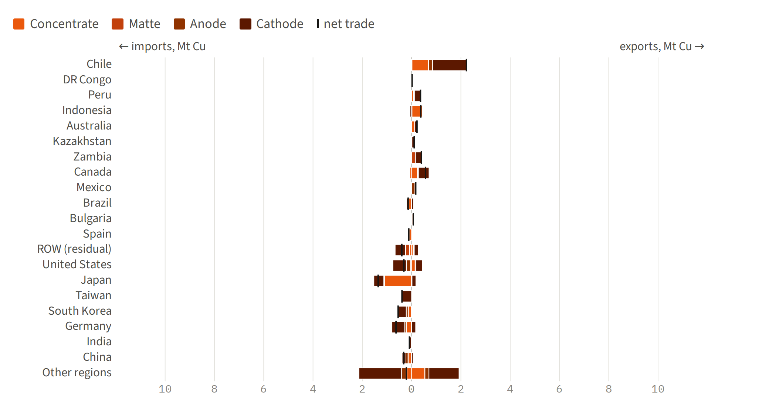
(b) 2024
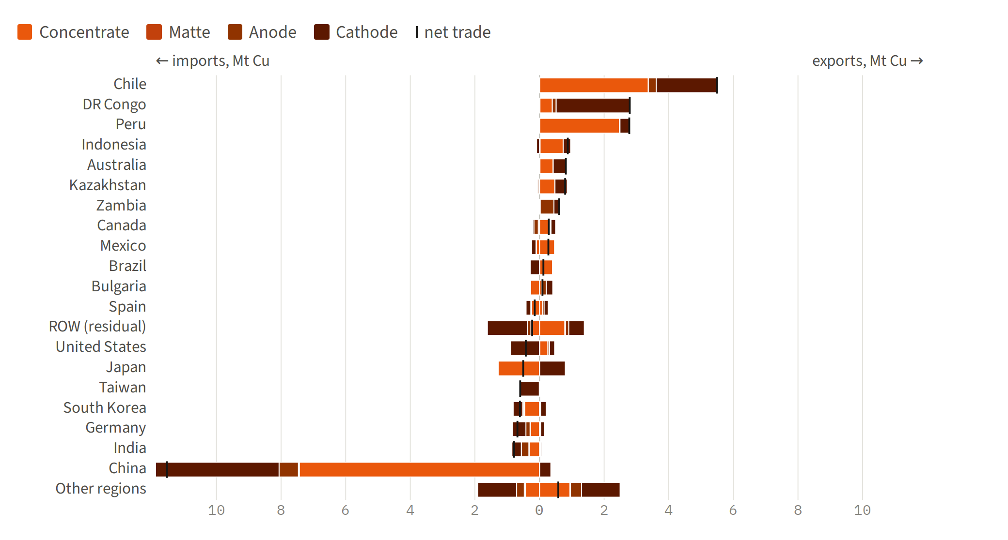
- China became the importer. Japan imported 1.5 Mt Cu in 1995 and 1.3 Mt in 2024, the United States 0.8 and 0.9 Mt, while China went from 0.4 to 11.9 Mt, more than half of all copper traded.
- Chile remained the largest exporter. Its exports rose from 2.2 to 5.5 Mt Cu, joined in 2024 by the DR Congo and Peru (2.8 Mt each); Japan exports 0.8 Mt of cathode while importing 1.3 Mt of concentrate, the profile of a smelting hub.
Figure 14. Traded share of world output, per commodity, 1995–2024
Cross-border trade of concentrate, matte, anode and cathode as a share in % of each commodity's world output; trade between EU‑14 members counts as cross-border.
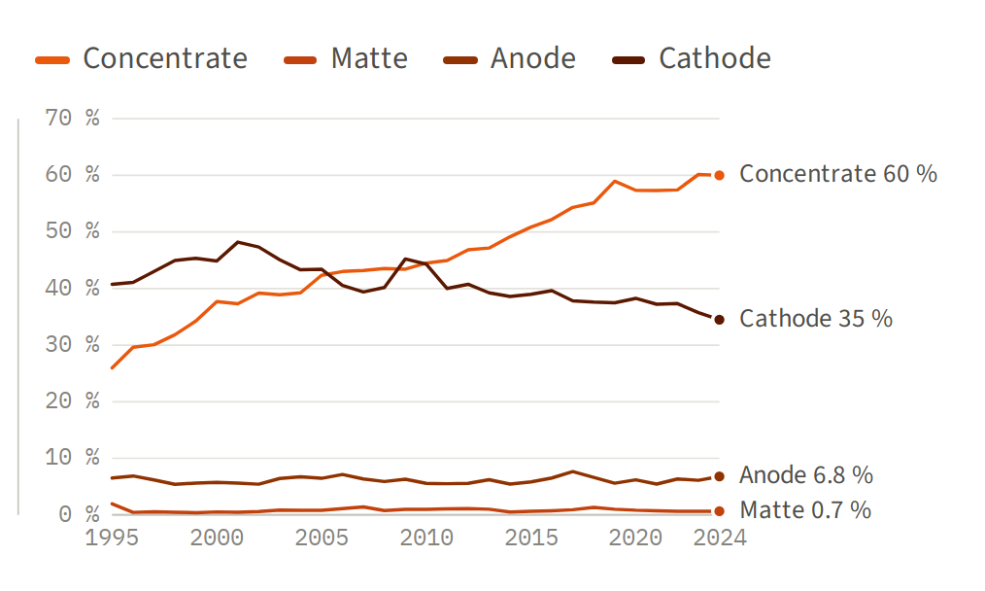
- Concentrate more than doubled its traded share. From 26 % of world output in 1995 to 60 % in 2024.
- Cathode trade peaked early. Its traded share reached 48 % in 2001 and eased to 35 % by 2024, while China's share of world refined cathode rose from 9 % in 1995 to 45 % (Figure 8).
Figure 15. World cross-border trade by commodity, 1995–2024
World cross-border trade in Mt Cu per year, stacked by commodity.
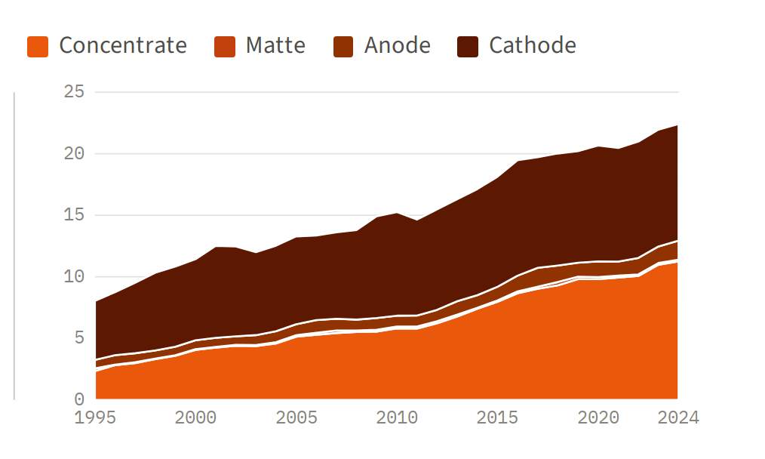
- Concentrate overtook cathode in 2017. It has been the largest traded form of copper every year since, at 11.3 Mt Cu in 2024 against 9.5 Mt of cathode.
- The intermediates are minor. Anode trade ranged between 0.65 and 1.5 Mt Cu a year, and matte never exceeded 0.26 Mt.

Data and sources
All numbers are pySUTO posterior flows of run opt_20261022_112855_928da10c (constraints const_20261022_111531_df61bf5c, imputation imp_20261022_111102_1b49a2b3), valued in contained copper: a tonne is a tonne of copper. The run's data feeds are ICSG statistics, CEPII's BACI trade database (HS 1992) and the materialflows.net crude-ore extraction series. Its uncertainty ranges are computed in run uncprop_20261029_090754_0446e784 and are not drawn here. EU‑14 denotes the 14 EU member states resolved in the model: Germany, Italy, France, Spain, Poland, Belgium, the Netherlands, Austria, Sweden, Bulgaria, Greece, Portugal, Slovakia and Luxembourg. The trade-linked figures of Chapter 5 follow Sun, X., Hao, H., Zhao, F. and Liu, Z. (2017), Tracing global lithium flow: a trade-linked material flow analysis, Resources, Conservation and Recycling 124, 50–61, doi:10.1016/j.resconrec.2017.04.012.

