DOCUMENTATION WORK

- MINI-PROJECT-

Object-oriented programming

Name: Nechita Florina-Elena

Group: 30424_2

Coordinator: Varadi Robert

1. Task Description

Task name: “Hotel Booking”

The idea of this hotel booking application is that the user, after they log in/sign up, can easily reserve a hotel room to their liking.

The user can choose the type of room, the number of the room, the meal plan, the date of the arrival and the number of nights they want to reserve the room for.

An important part of the application is also how the hotel admin interacts with the reservations made by modifying the availability of the hotel rooms.

1. Class Diagram

Front Page

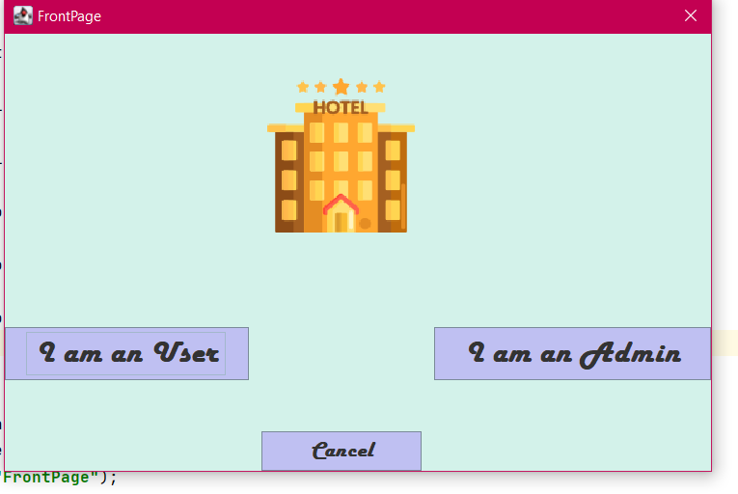

In this Class, using a JFrame, we can choose if we are an admin or a user. If we click on the “I am a User” Button, the Login Page will pop up. If we click on the “I am an Admin” Button, The Staff Login Page will pop up. The “Cancel” Button if clicked, exits the app.

Login Page

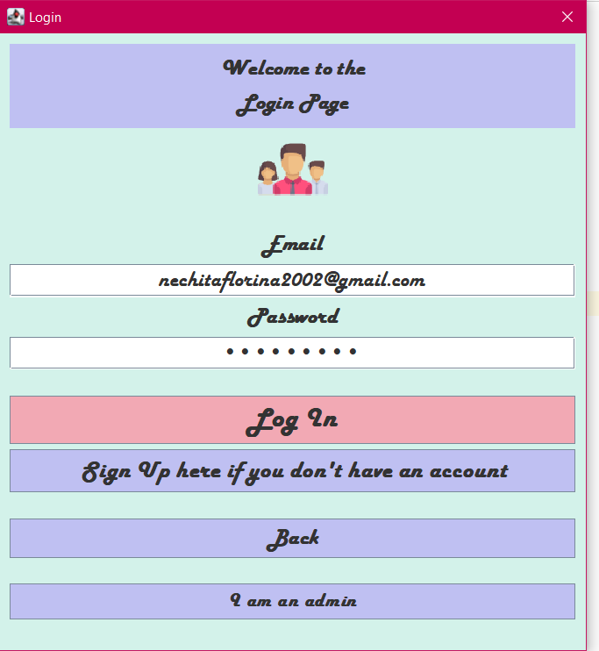

This is the Login Page. We have text fields for email and passwords. The text from the text fields will be checked in the postgres database that is connected. If the credentials are correct, the Room Page appears, if not, an error will pop up.

If the user does not have an account, they can create one clicking on the “Sign Up here” Button, which will take them to the Signup Page.

The “Back” button will bring back the Front Page.

The “I am an admin” Button will open the Staff Login Page.

Signup Page

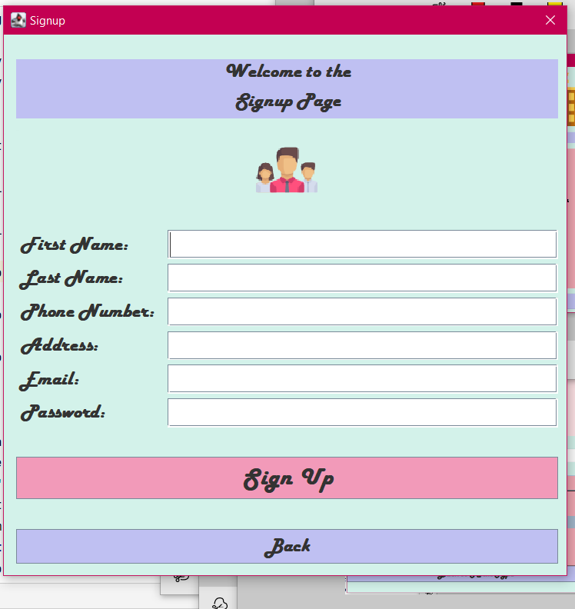

The data introduced in the text fields will be taken and introduced in the “Guest” table from the database.

After the data is introduced, if the “Sign Up” Button is pressed, the Login Page will open again.

If some data is missing, an error will pop up.

The “Back” Button takes us back to the Login Page.

Room Page

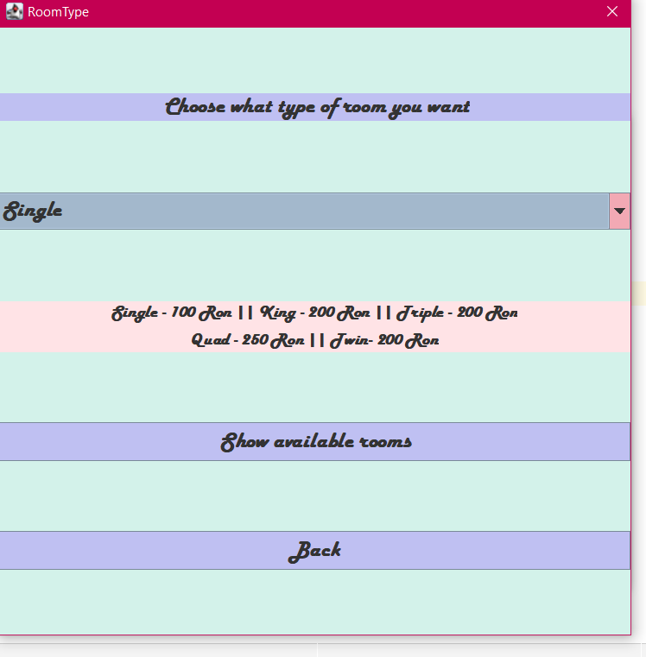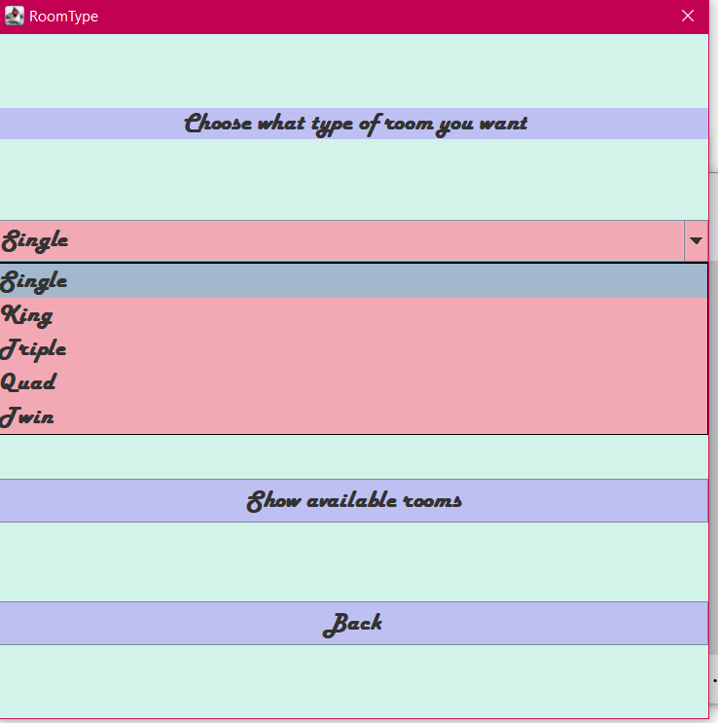

In the Room Page we can choose (from a comboBox) which type of room we want. The option that we chose, will be submitted to the next page (Rooms Available Page).

The “Show available rooms” takes us to the next page.

The “Back” Button sends the user back to the previous page.

Rooms Available Page

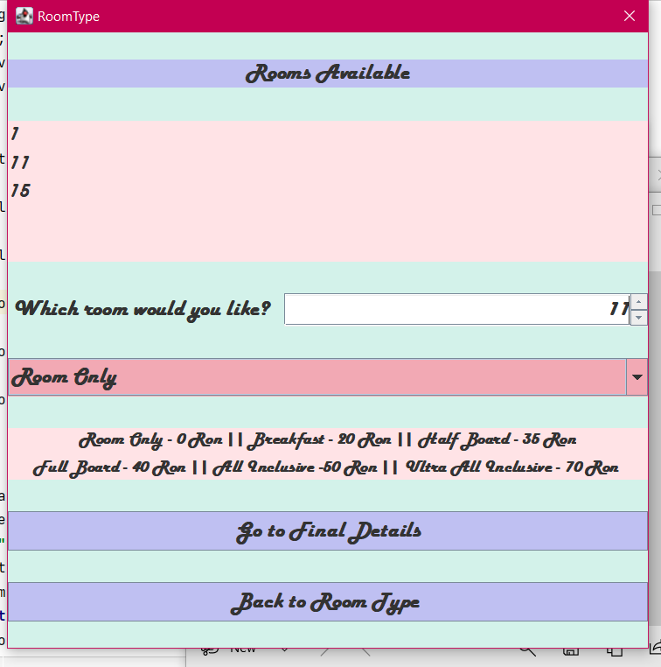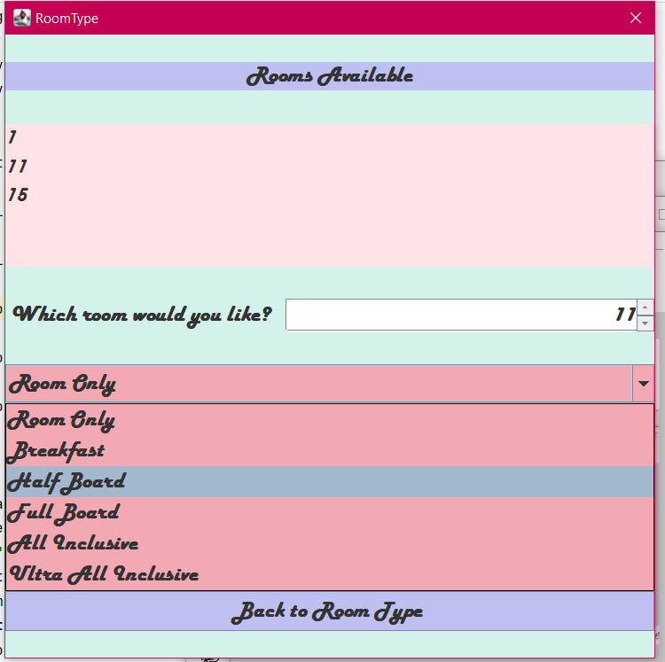

We are now on the Rooms Available Page. In the textArea, the available rooms that correspond with the room type that we previously chose will be displayed.

Here we can also select (with the help of a spinner) the number of the room we would like to reserve.

From the comboBox we can pick which meal plan we prefert.

The “Back to Room Type” sends us to the Room Page.

Clicking the “Go to Final Details” Button, the user will be lead to the Reservation Page and all the details will be submitted.

Reservation Page

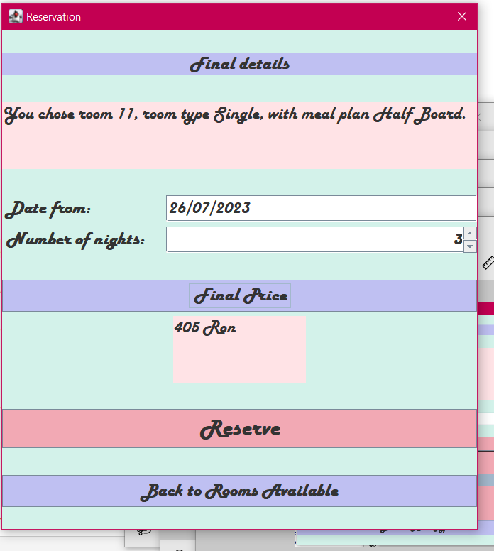

In the textArea will be displayed all the details that we previously chose. We can choose the date of the arrival (introducing data in the text field) and the number of nights we will be staying at the hotel (using the spinner).

The total price will be calculated and displayed as well.

Final Price = Nr. Of Nights * (Room Price + Nr. Of People * Meal Plan Price)

After clicking the “Reserve” Button, the Bill Page will open.

The “Back” Button sends us to the Rooms Available Page.

Bill Page

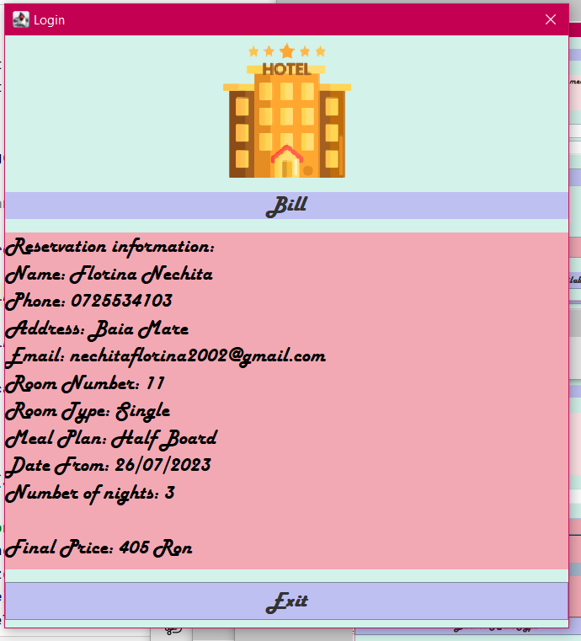

On the Bill Page the details of our reservation will be shown.

It displays the details using a “SELECT” type of SQL command.

The “Exit” Button opens the Front Page.

Staff Login Page

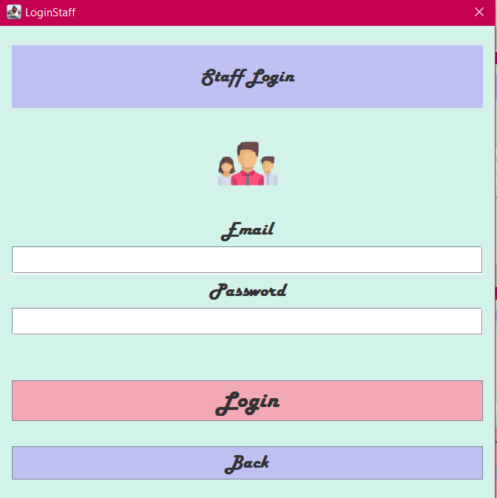

Here is the Login Page where the admins can access their accounts.

The Staff Login credentials will be checked in the “Staff” database table.

The “Back” Button takes us back to the Front Page.

Staff Room Page

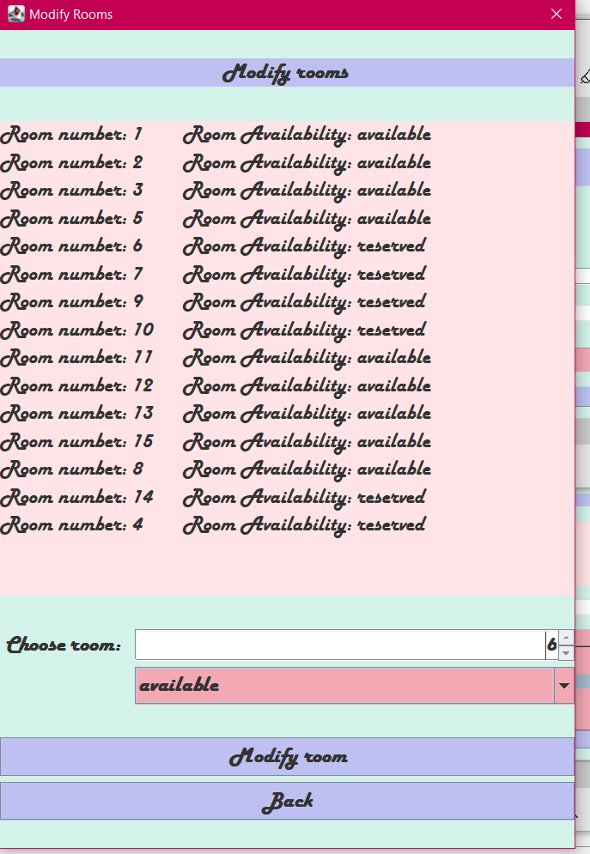

In this page, the admin can modify the status of a room.

The “Modify room” will change the selected room’s status (using the comboBox) from available to reserved and vice-versa (we select the room using the spinner) and the altered data will be displayed.

We use an “UPDATE” SQL command to modify the data from the “Rooms” table.

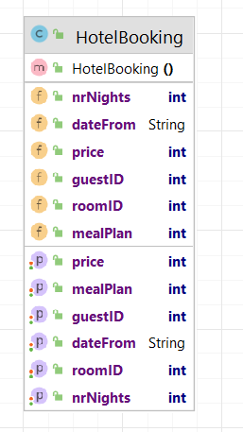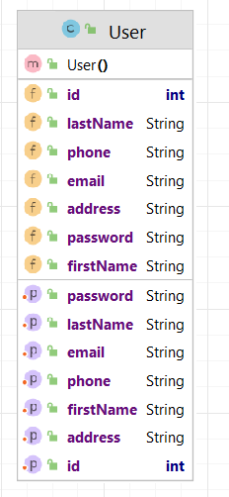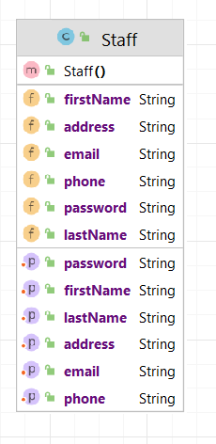

The HotelBooking, User and Staff classes are used to transmit data from an interface to another.

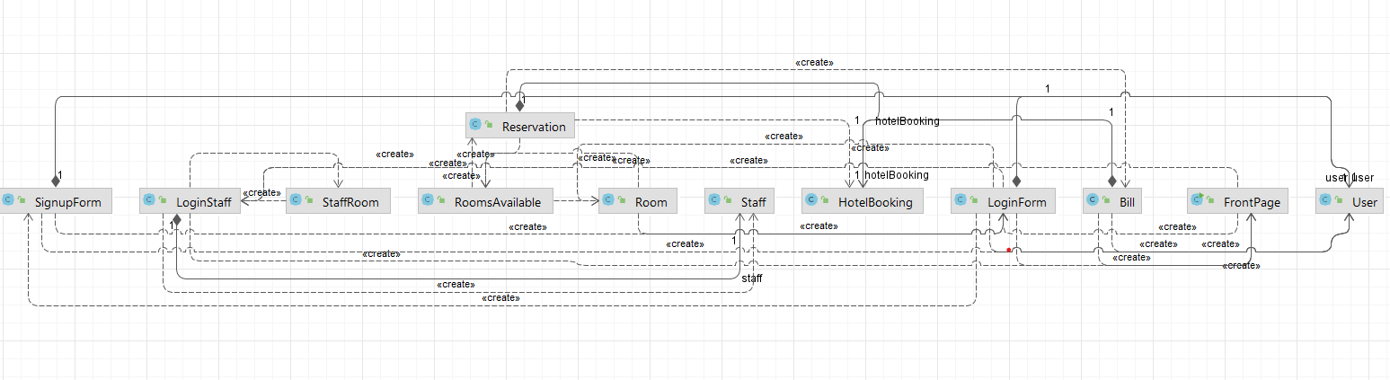Class Diagram

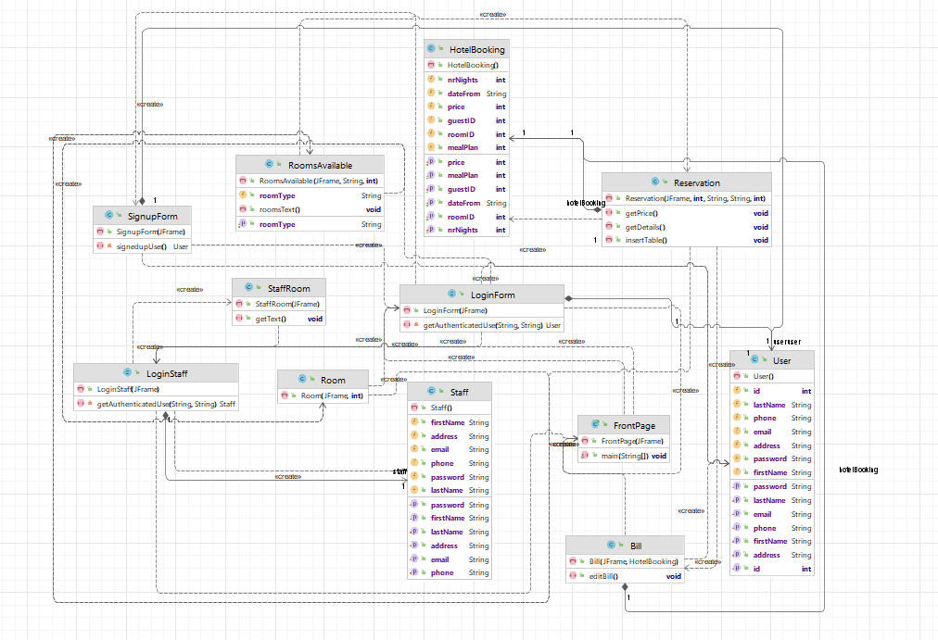

1. Future development

In the future I would like to have the exceptions handled more efficiently and more bugs to be covered.

More functionality for the admin part of the application is also a segment that can be developed further. I have some ideas for this part such as: a calendar synchronization or more control over the reservations/rooms altering.

The design can also be improved.

1. Bibliography and web resources

<https://moodle.cs.utcluj.ro/mod/folder/view.php?id=38381> – Marius Joldoș – lectures and laboratory guides

<https://youtu.be/SbDR8PwTYdU>

<https://youtu.be/bandCz619c0>

<https://www.w3schools.com>

<https://java-programming.mooc.fi/>