Conversation Intelligence Copilot
Conversation Analysis Bot for Contact Centre Insights — submission report · 22 October 2026

1. Problem framing
Contact-centre analysts and leaders need answers they can act on and defend: which issues drive negative sentiment, where communication could improve, how a conversation unfolded, and what to review first. The prototype turns a natural-language question into a coordinated, verifiable analysis: a LangGraph supervisor routes the question to specialist agents that run deterministic analytics, retrieve source evidence, explain the result, choose charts, and pass quality and governance checks before anything is shown.

2. Dataset and preparation
Syncora.ai customer-support sample (Kaggle): 3,000 conversations, 41,965 messages, 2025-08-01 to 2025-12-02. Preparation (scripted, idempotent): schema discovery and explicit column mapping; removal of the random lowercase filler that ends every message (raw text kept); PII masking and customer pseudonymisation; 17 data-quality checks; a versioned taxonomy mapping the opening message to one of 8 issue topics and 51 products (domains inferred); message and conversation sentiment; empathy and resolution-fit signals; DuckDB tables and manifests.
- Timestamps are not in turn order in any of the 3,000 conversations: turn index is authoritative; conversations are dated by their earliest message.
- 2,987 agent IDs for 3,000 conversations (max 2 each): per-agent rankings would be unreliable, so coaching analysis is sample-size gated.
- Messages are templated (426 unique texts); customer follow-ups and agents' closing actions are largely independent of the issue — reported, not hidden.

3. Architecture and agent flow
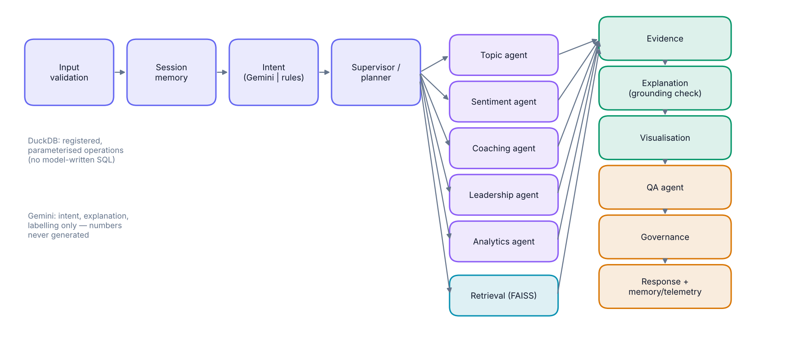
Input validation → session memory → intent (Gemini structured output, or a deterministic parser) → supervisor/planner (resolves follow-up references and the date window; picks registered operations, one specialist and a retrieval mode) → topic / sentiment / coaching / leadership / analytics agent, in parallel with retrieval when the query is known, or after it when the query depends on the result → evidence assembly → explanation (Gemini, rejected if it contains any number not in the verified results) → visualisation planner → QA agent → governance agent → response → memory and telemetry. Each request is checkpointed; each node emits real start/finish events that the UI and the Agent Harness show.

4. Model and tool choices
Component | Role
Gemini Flash (google-genai) | Intent, grounded explanation, batch classification; structured JSON with closed enums; rate-limited, retried, cached, circuit-broken; tokens and cost recorded.
LangGraph | Explicit, testable routing, parallel branches, checkpointing, observable nodes.
DuckDB | All numbers: registered, parameterised operations; Wilson intervals, chi-square and z-tests for uncertainty.
FAISS + embeddings | Exact cosine search with metadata filters; MiniLM preferred, local LSA fallback.
SQLite | Session memory, checkpoints, telemetry, audit, human review.
React · Recharts · React Flow | Chat-first workspace, validated declarative charts, live agent graph.

5. The four analytical demonstrations
Q1 — Negative topics, November 2025 (latest month in the data): 239 of 682 conversations negative. Top five by count: General help request (49), Duplicate charge (42), Paid but service not delivered (30), Feature not working (28), Login / account locked (24). By rate, Duplicate charge leads; the chi-square p-value (0.0566) shows the differences are not significant at 5%, and the answer says so.
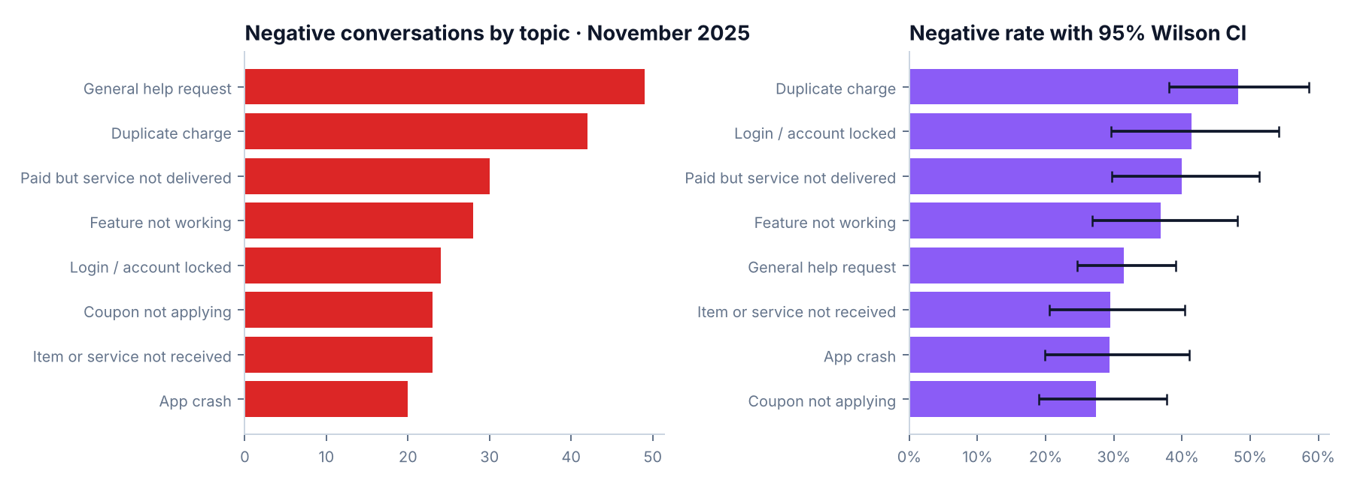
Q2 — Coaching: no agent has ≥ 3 conversations, so the answer ranks conversations for a team-lead review instead of people, with evidence. Workforce-wide, 3,215 of 10,966 negative customer turns (29.3%) were followed by an acknowledgement or apology, and 57.3% of assessable closing actions did not fit the issue. Output is flagged for human review; personnel-decision questions are refused.
Q3 — Trajectory: per-turn customer sentiment in turn order, turning points with the agent turn that preceded them, and the annotated transcript.
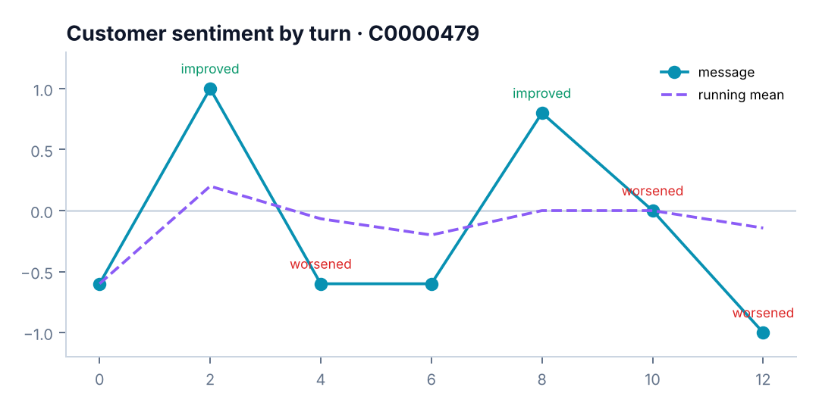
Q4 — Leadership: a documented priority score (volume, negative rate, escalation requests, unresolved endings, resolution misfit, trend). First: Item or service not received (score 67.1); each recommendation names a finding, driver, action, owner, evidence and uncertainty. Sensitivity: Sensitivity: the #1 concern stays #1 in 92% of 13 weight scenarios; mean top-5 overlap 94%.
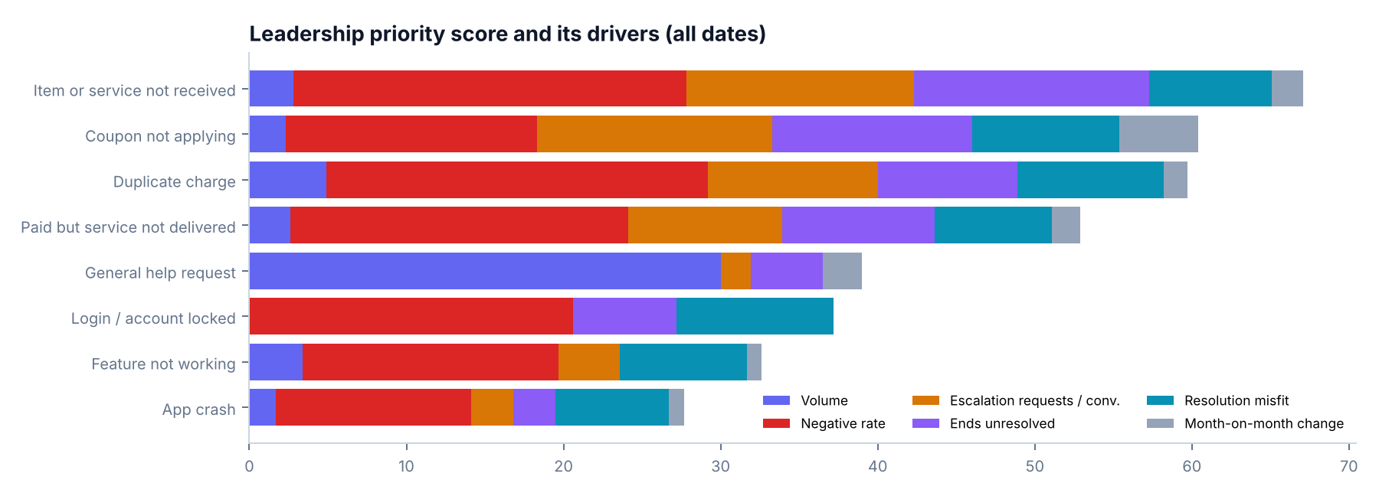

6. Bonus extensions
- Knowledge retrieval: conversation-aware chunks (4 turns, overlap 2), FAISS with metadata filters, one passage per conversation, evidence with message IDs and CSV lines. On 36 paraphrased queries: topic precision@5 61.7% vs 12.5% random with sentence-transformers/all-MiniLM-L6-v2 (36.7% with the LSA fallback used when the model is unavailable).
- Specialised LLM agent: Gemini classification of unique masked texts (sentiment, act, empathy, resolution, topic, product) in bounded, resumable batches with a content-hash cache and honest coverage reporting; scripted-SDK tested; not run live (credential blocked).
- Memory: session store of resolved intent, scope, plan and deterministic references; follow-ups such as 'compare the top two', 'previous month', 'the first one', 'why ranked first', 'which findings are uncertain'. Follow-up routing on the evaluation sessions: 100%.

7. Evaluation
Measure | Result
Q1 vs independent oracle | exact match
End-to-end QA pass rate | 100% of 51 requests
Unsupported questions refused | 6/6
Intent (rules fallback) | 100% tuning set; 50% held-out
Retrieval topic P@5 | 61.7%
Latency p50 / p95 | 167 / 776 ms
Automated tests | 97 backend · 8 Vitest · 10 Playwright — passing

Gemini could not be evaluated live: the development environment's credential returned 401 API_KEY_SERVICE_BLOCKED. All results above are for the deterministic path.

8. Limitations
- Live Gemini behaviour (intent, explanations, labels, latency, tokens) is unmeasured.
- Sentiment/empathy mappings are developer judgements; human-agreement metrics await labels from the in-app blind review.
- The deterministic intent parser is brittle on paraphrases (held-out accuracy above), though most misses fail safe.
- Retrieval still misses some paraphrases (generic help and paid-but-not-delivered queries regressed with MiniLM); the LSA fallback is much weaker.
- Synthetic, templated data: most topic differences are not significant; no cost, churn, CSAT or handle-time data.
- No authentication/RBAC; single-node storage; Docker images not built in the sandbox (registry rate limits).

9. Next improvements
- Enable Gemini; run labelling and the intent/explanation evaluation live; compare with rules and human labels.
- Pretrained or Gemini embeddings with hybrid BM25 + vector search; re-run the retrieval benchmark.
- Collect a few hundred human labels for calibrated sentiment/empathy evaluation.
- SSO/RBAC, managed storage, OpenTelemetry/LangSmith, CI evaluation gates.

