1. Speedup = Timp_secvential(1proc)/Timp_paralel (nrProc)

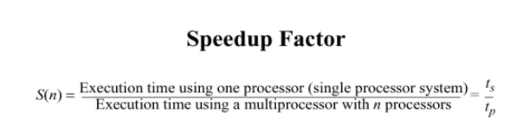

1. Efficiency = = Timp_secvential(1proc)/Timp_paralel * nrProc

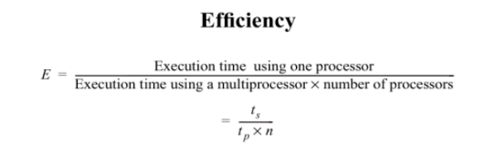

Block partition??

Cyclic partition??