Introduction

The tests were made on a Laptop PC using a dual-core Intel i7-7500U CPU with 4 threads clocked at 2.70Ghz.
The System has 8GB of RAM an SSD Hard-Drive and a dedicated GPU.
Note: other programs were running during the tests.
The executables were compiled using Visual Studio 2017 on Windows 10.
Small adjustments were made to the projects in order to be able to compile the MPI programs.
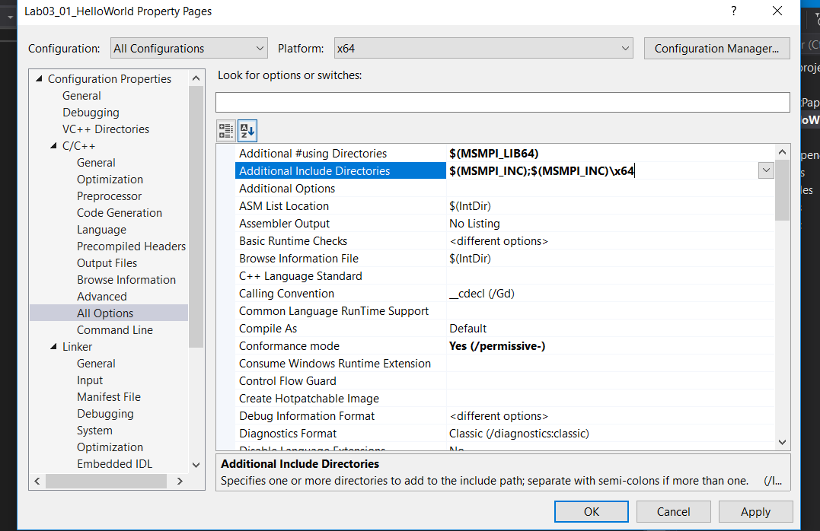
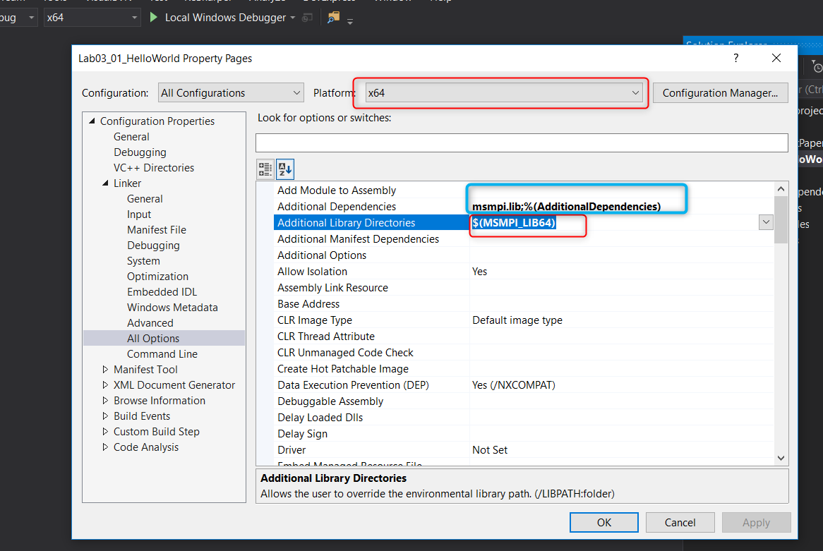
Execution Times
 | No Procs | No Elems | Direct Sort |  | Ranking Sort |  | Bucket Sort |  | Odd Even Sort
 | No Procs | No Elems | Proc Idex | Time(s) | Proc Idex | Time(s) | Proc Idex | Time(s) | Proc Idex | Time(s)
Oversubscribe | 8 | 1,000,000 | Proc0 | 0.252 | Proc0 | 3364.105 | Proc0 | 0.296 | Proc0 | 0.540
Oversubscribe | 8 | 1,000,000 | Proc1 | 0.197 | Proc1 | 3359.762 | Proc1 | 0.374 | Proc1 | 0.607
Oversubscribe | 8 | 1,000,000 | Proc2 | 0.294 | Proc2 | 3361.686 | Proc2 | 0.414 | Proc2 | 0.614
Oversubscribe | 8 | 1,000,000 | Proc3 | 0.283 | Proc3 | 3361.677 | Proc3 | 0.405 | Proc3 | 0.607
Oversubscribe | 8 | 1,000,000 | Proc4 | 0.312 | Proc4 | 3364.177 | Proc4 | 0.400 | Proc4 | 0.624
Oversubscribe | 8 | 1,000,000 | Proc5 | 0.299 | Proc5 | 3362.256 | Proc5 | 0.425 | Proc5 | 0.617
Oversubscribe | 8 | 1,000,000 | Proc6 | 0.313 | Proc6 | 3364.189 | Proc6 | 0.399 | Proc6 | 0.629
Oversubscribe | 8 | 1,000,000 | Proc7 | 0.300 | Proc7 | 3364.193 | Proc7 | 0.412 | Proc7 | 0.610
Oversubscribe | 8 | 1,000,000 | MAX | 0.313 | MAX | 3364.193 | MAX | 0.425 | MAX | 0.629
 | 4 | 1,000,000 | Proc0 | 0.183 | Proc0 | 2961.680 | Proc0 | 0.233 | Proc0 | 0.327
 | 4 | 1,000,000 | Proc1 | 0.219 | Proc1 | 2959.567 | Proc1 | 0.316 | Proc1 | 0.426
 | 4 | 1,000,000 | Proc2 | 0.218 | Proc2 | 2961.787 | Proc2 | 0.315 | Proc2 | 0.417
 | 4 | 1,000,000 | Proc3 | 0.218 | Proc3 | 2961.772 | Proc3 | 0.321 | Proc3 | 0.415
 | 4 | 1,000,000 | MAX | 0.219 | MAX | 2961.787 | MAX | 0.321 | MAX | 0.426
 | 3 | 1,000,000 | Proc0 | 0.249 | Proc0 | 3463.755 | Proc0 | 0.287 | Proc0 | 0.353
 | 3 | 1,000,000 | Proc1 | 0.300 | Proc1 | 3461.900 | Proc1 | 0.359 | Proc1 | 0.449
 | 3 | 1,000,000 | Proc2 | 0.306 | Proc2 | 3463.840 | Proc2 | 0.364 | Proc2 | 0.449
 | 3 | 1,000,000 | MAX | 0.306 | MAX | 3463.840 | MAX | 0.364 | MAX | 0.449
 | 2 | 1,000,000 | Proc0 | 0.301 | Proc0 | 4643.262 | Proc0 | 0.387 | Proc0 | 0.380
 | 2 | 1,000,000 | Proc1 | 0.359 | Proc1 | 4643.329 | Proc1 | 0.462 | Proc1 | 0.456
 | 2 | 1,000,000 | MAX | 0.359 | MAX | 4643.329 | MAX | 0.462 | MAX | 0.456
Serial Time | 1 | 1,000,000 | Proc0 | 0.515 | Proc0 | 8529.562 | Proc0 | 0.587 | Proc0 | 0.658
 |  |  | Direct Sort |  | Ranking Sort |  | Bucket Sort |  | Odd Even Sort
SpeedUp | 2 Procs |  | 1.432 |  | 1.837 |  | 1.268 |  | 1.444
Ideal |  |  | 2 |  | 2 |  | 2 |  | 2
Efficiency |  |  | 71.594% |  | 91.847% |  | 63.409% |  | 72.179%
SpeedUp | 3 Procs |  | 1.679 |  | 2.462 |  | 1.612 |  | 1.466
Ideal |  |  | 3 |  | 3 |  | 3 |  | 3
Efficiency |  |  | 55.966% |  | 82.082% |  | 53.724% |  | 48.873%
SpeedUp | 4 Procs |  | 2.355 |  | 2.880 |  | 1.826 |  | 1.545
Ideal |  |  | 4 |  | 4 |  | 4 |  | 4
Efficiency |  |  | 58.871% |  | 71.997% |  | 45.644% |  | 38.620%
SpeedUp | 8 Procs |  | 1.645 |  | 2.535 |  | 1.379 |  | 1.046
Ideal |  |  | 8 |  | 8 |  | 8 |  | 8
Efficiency |  |  | 20.565% |  | 31.692% |  | 17.237% |  | 13.077%
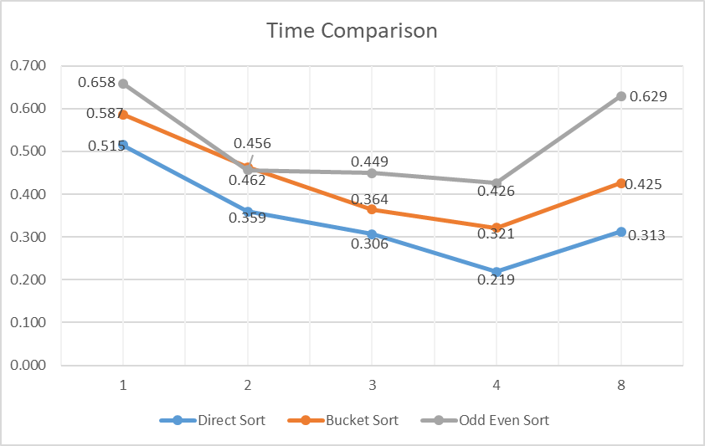

*Ranking sort was not included in the same chart because the execution times are way too big compared to the others
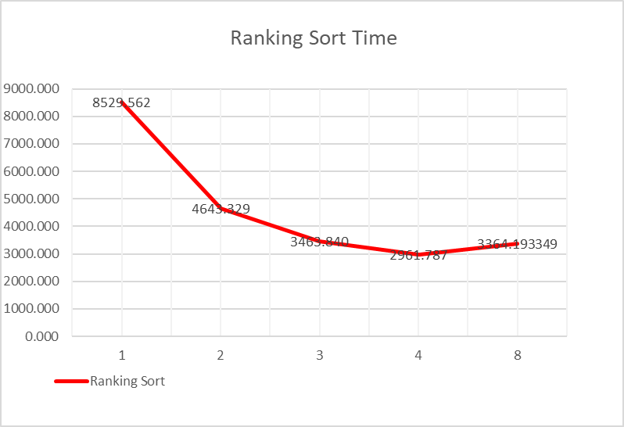

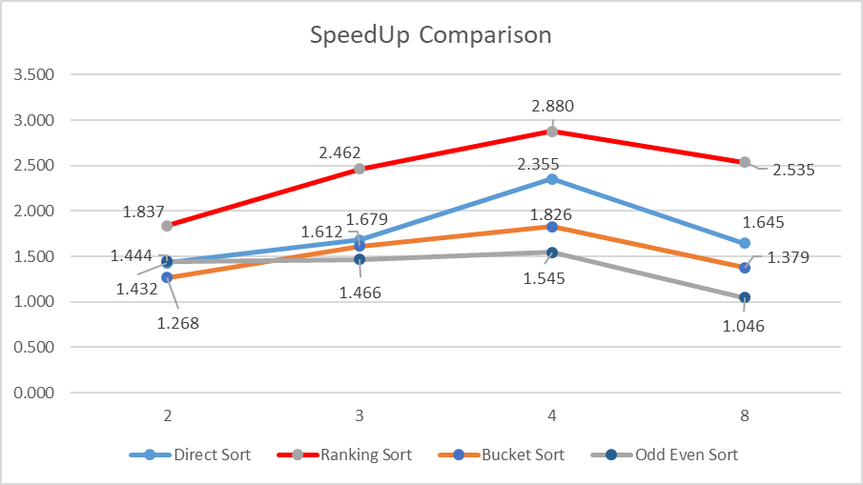


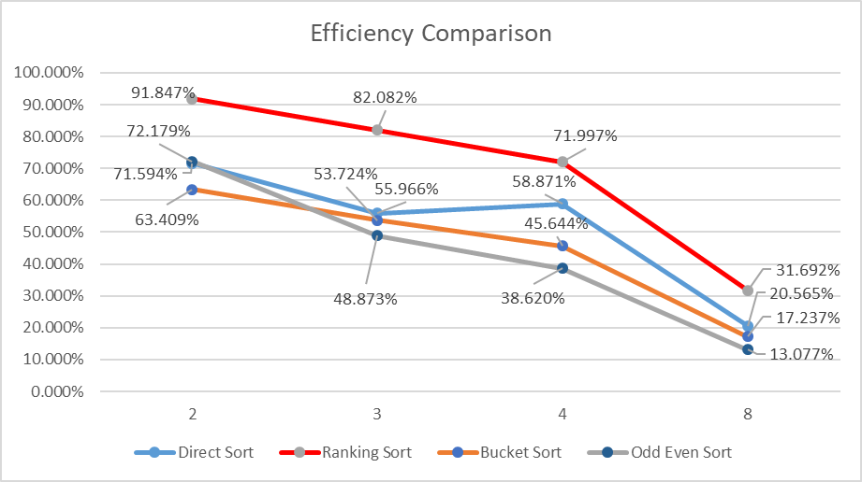

Observations:

1. Direct Sort

  - Checking that algorithm works (number of elements = 12) with 4 processors

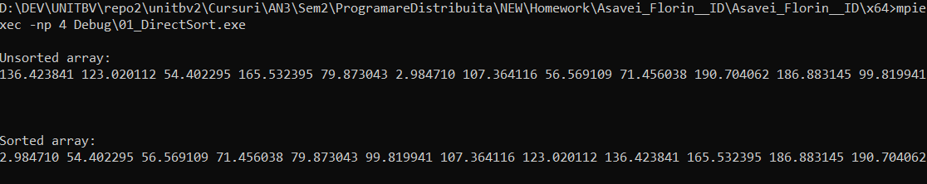

  - Performance Observations:
- The execution time decrease by more than half when using 4 processors.
- Best efficiency is achieved when using 2 processors
- Compared to the other 3 algorithms, it is the fastest in all scenarios

Ranking Sort

  - Checking that algorithm works (number of elements = 12) with 4 processors

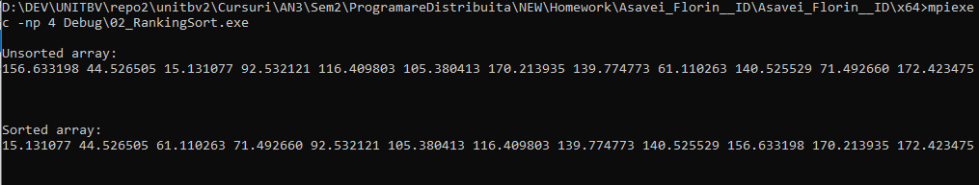
  - Performance Observations:
- This is the slowest algorithm ~ 15.000 times slower than the others
- Execution time is reduced in half just by using 3 processors and it becomes 3 times faster if we use 4 processors
- This algorithm benefits the most out of using Parallel Computing
- It is the only one that achieved more than 90% efficiency when using 2 processors.

Bucket Sort

  - Checking that algorithm works (number of elements = 12) with 4 processors

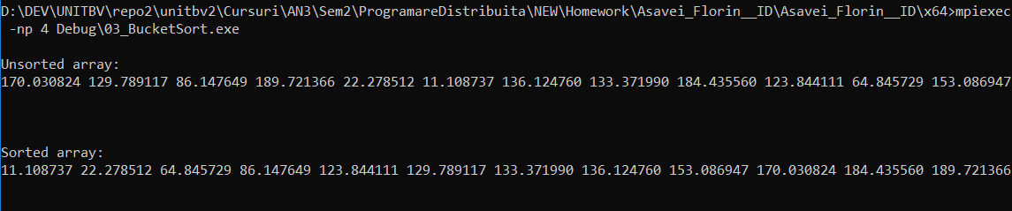

3.2 Performance Observations:
- Second fastest algorithm (after Direct Sort)
- The speedup is most linear out of all algorithms
- The load is not evenly distributed, there are significant differences in processor execution times, and since we have to consider the program finished when the last processor finishes sorting his bucket, the overall timing increases

Odd Event Sort

4.1 Checking that algorithm works (number of elements = 12) with 4 processors
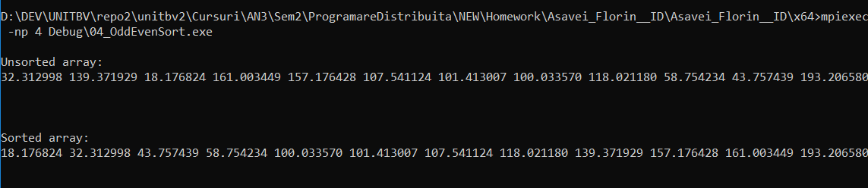

4.2 Performance Observations:
- The second slowest algorithm out of the 4
- It the lowest overall efficiency
- Best efficiency achieved when using 2 processors
- Not much improvement is achieved if we use more than 2 processors
- Processor load is distributed evenly, there is not that much difference between the times

Overall Observations:

All algorithms resulted in better execution times when using multi-processing.
It seems that the best Efficiency is achieved when using 2 processors.
Speedup and Efficiency decreases when we oversubscribe (using 8 processors)

