Lecture Notes

Lecture 1: What is deep uncertainty?
Real world political decision making characteristics:
- Decision making is multi-actor, cross-scale, and polycentric
- Values are diverse and incommensurable
- Knowledge is uncertain and contested
- Various problem perceptions exist
- Problem formulating and problem solving are intertwined
- Price of being wrong is high
Deep uncertainty: A situation where the various parties to a decision do not know or cannot agree on one or several of the following:
- The outcomes of interest and their relative importance
- The inner workings of the system under study
- The values of key exogenous parameters, and how they might develop in the future. 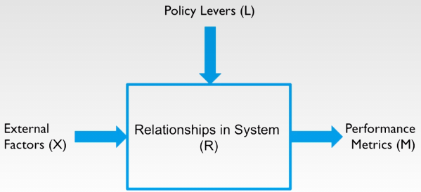
Knight (1921): in case of risk we know both the consequence and probability of different courses of actions, if either is unknown, you speak of “uncertainty” and you cannot quantify anymore.
Keynes (1937): If you don’t have scientific knowledge on probabilities, you speak of uncertainty.
In this course we don’t only consider scientific lack of probabilities, but also disagreements about knowledge.

