**Critical Point Drier – Instructions**

**by Greg Wanger**

WARNING:

The Critical Point Drier (CPD) can reach high pressures that are potentially dangerous. Users are advised to monitor the equipment at all times during the heating process. Do not let the CPD exceed 1450 PSI (100 Bar).

Wear appropriate PPE – Eye Protection and Cryo Gloves

Note:

Please only use Ethanol in the CPD

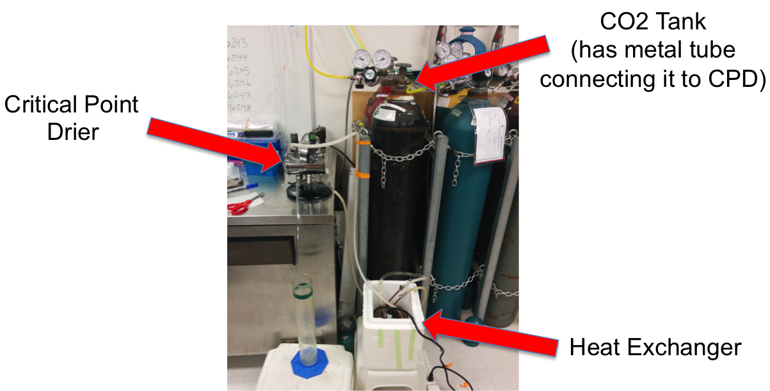

Instructions:

**Pre Cool Stage – Sample Loading**

1. **Remove specimen boat from the CPD**
   1. Replace door and close all valves
2. **Fill the heat exchanger with ice and water so that the copper coil is mostly covered** 
   1. Turn on the fish pump making sure the water outlet flows back into the heat exchanger (recirculating loop)

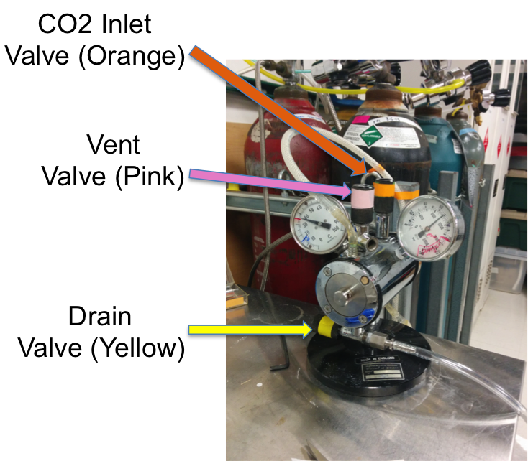

1. **Allow the CPD to cool to below 15oC**
   1. Leave the CPD to equilibrate for 5-10 minutes
2. **Fill the CPD specimen boat with 100% ethanol and transfer samples to the boat**
   1. Use appropriate containers to keep specimens separated while allowing good flow of solvent into and out of containers
   2. Specimens should remain under Ethanol at all times (DO NOT LET SAMPLES DRY)
3. **Load specimen boat into CPD and close the door**
   1. Make sure the pin in the window end of the chamber lines up with the groove of the boat
   2. Tighten the door “finger tight” with the hex key

**CO2 Infiltration Stage**

1. **Open the valve on the CO2 cylinder**
2. **Fill the chamber with liquid CO2 by SLOWLY opening the INLET VALVE (Orange)**
   1. if a leak is detected from VENT or DRAIN valve open the valve slightly and then reseat it
   2. the pressure will rise in the chamber (monitor the pressure gauge) and should reach ~800 PSI (55 Bar) @ 15oC and the CO2 will float on top of the solvent
3. **Flush the chamber with fresh CO2 by slowly opening the DRAIN VALVE (Yellow) allowing the solvent to escape.**
   1. Place the end of the drain tube in a container like a large graduated cylinder
   2. The tube will cough and sputter and solid CO2 powder will come out of the tube
   3. Flush the chamber for ~2 minutes
4. **Close the DRAIN VALVE (Yellow) and allow the CO2 to permeate the sample**
   1. 5-15 minutes (longer for thicker samples i.e. thick biofilms, large porous minerals) – flies: 20min
   2. Maintain temperature at <15oC
5. **Repeat steps 8 and 9**

**Heating Stage**

1. **Close all valves on the CPD and slowly open the VENT VALVE (Pink) while watching the level of the liquid though the window**
   1. allow the CO2 Level to drop until it is just above the top of the specimen boat
   2. reseal all valves
2. **Drain the ice water from the heat exchanger and refill with hot water from then sink.**
   1. As the temperature rises in the chamber the pressure will begin to rise.
   2. Monitor the pressure and if the pressure rises above ~1500 PSI (100Bar) slowly open the VENT VALVE (Pink) to bring the pressure below 1500 PSI (this does not happen very often if you follow the above steps)
   3. Allow the temperature to rise to >35oC (above the critical point)
   4. You may need to add more hot water to the heat exchanger to bring the temperature up to this level

**Venting Stage**

1. **Once the desired temperature is reached (>35oC) slowly open the VENT VALVE (Pink) and bleed out the CO2 VERY, VERY slowly.**
   1. The escaping gas should be barely audible
   2. Re-condensation of CO2 will occur if venting is too fast
   3. Venting rate should be around 100 psi/minute
2. **When pressure has reached zero, open the chamber and remove your samples**
3. **Reseal the door and leave all valves open**
4. **Drain the heat exchanger and unplug the pump**
5. **Log your work**