**CON MONGO**

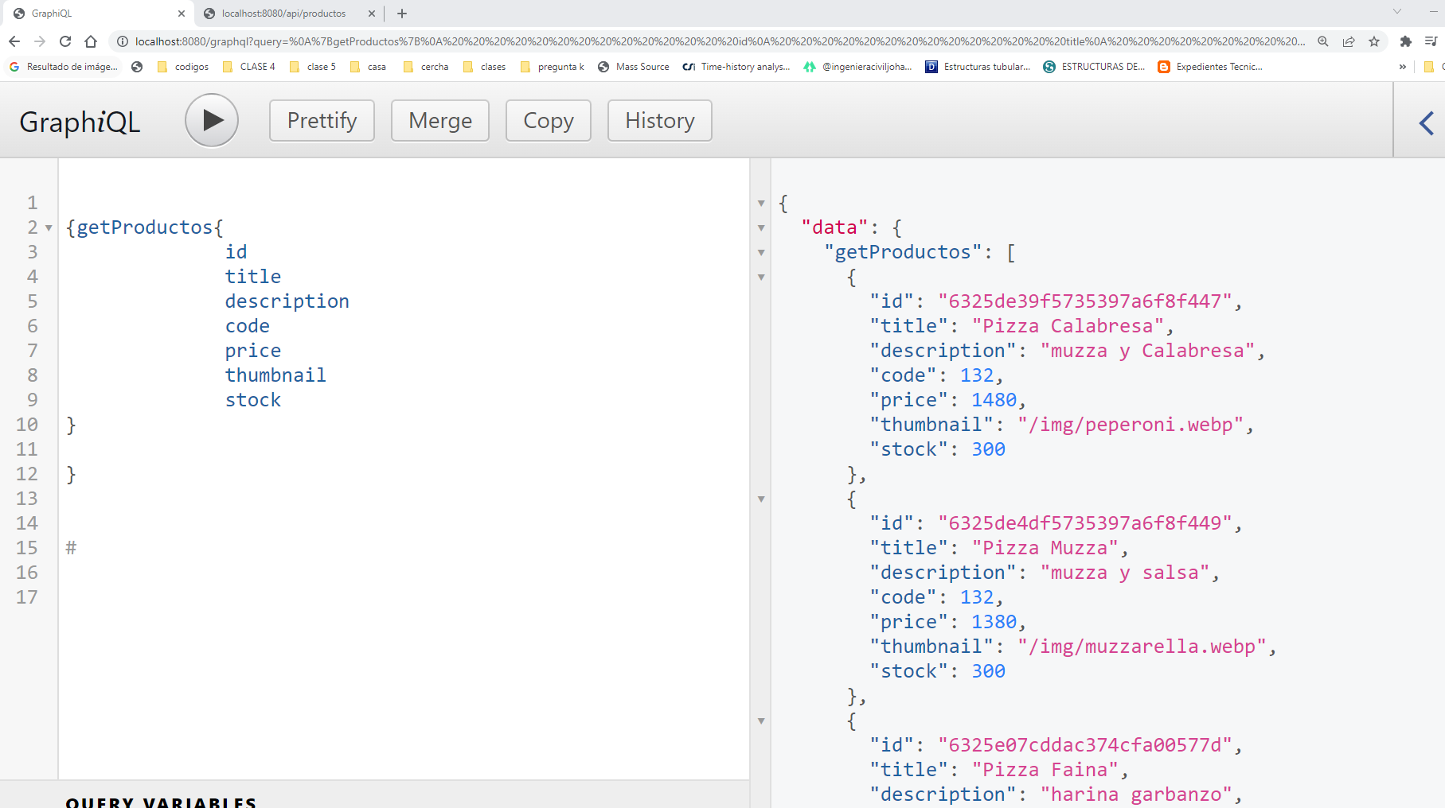

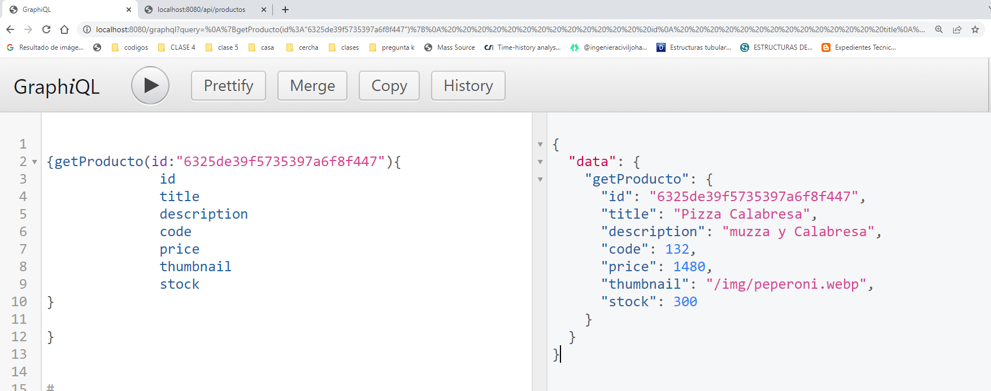

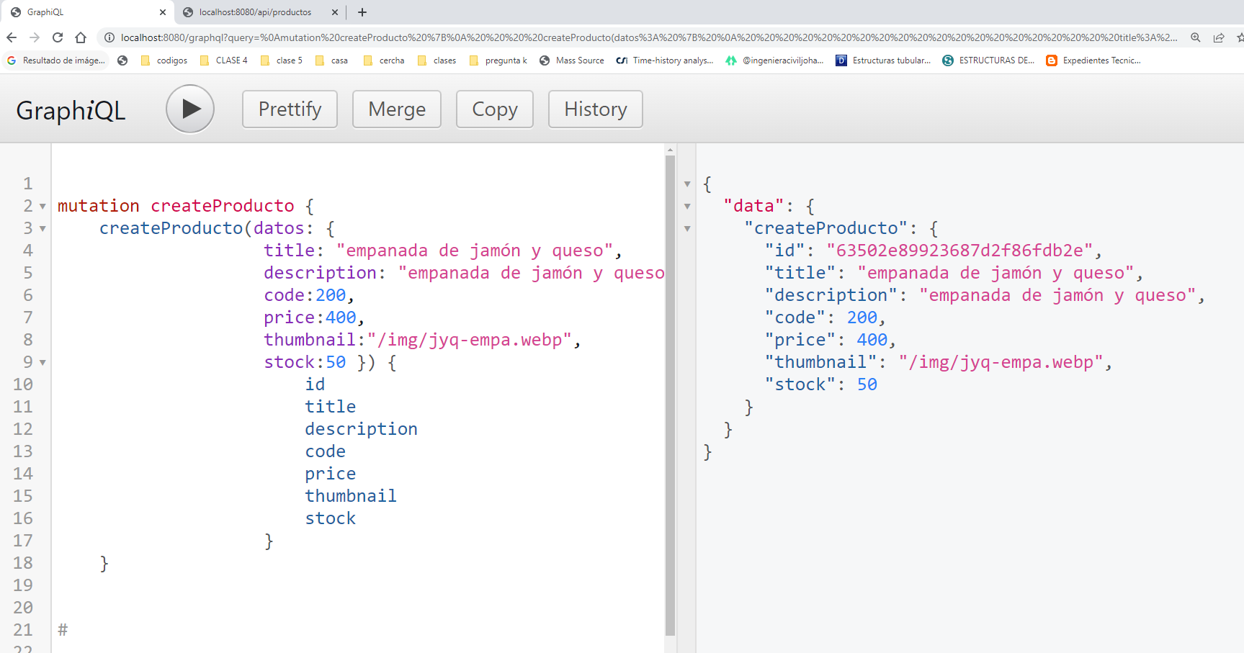

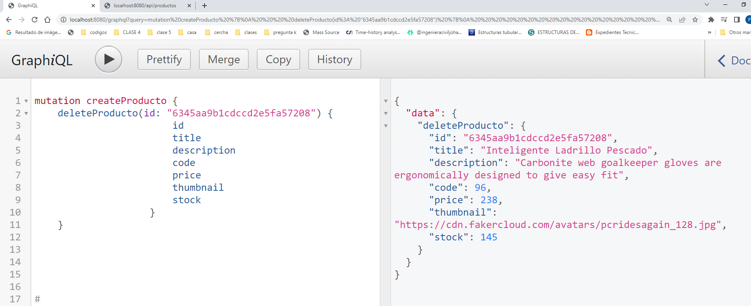

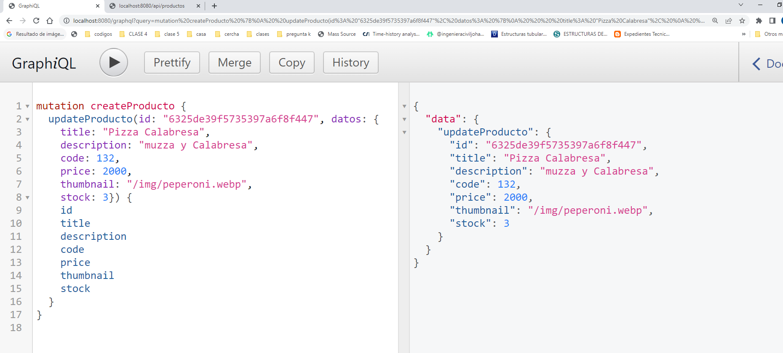

**CON ARRAY**

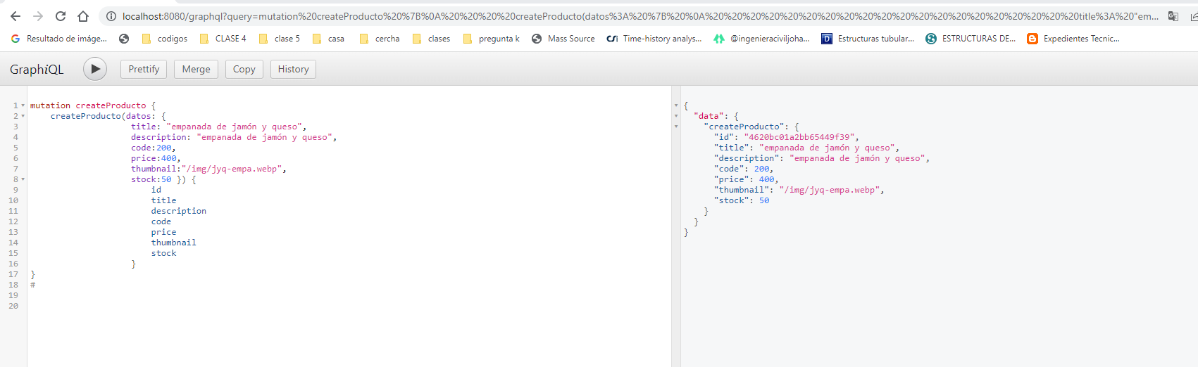

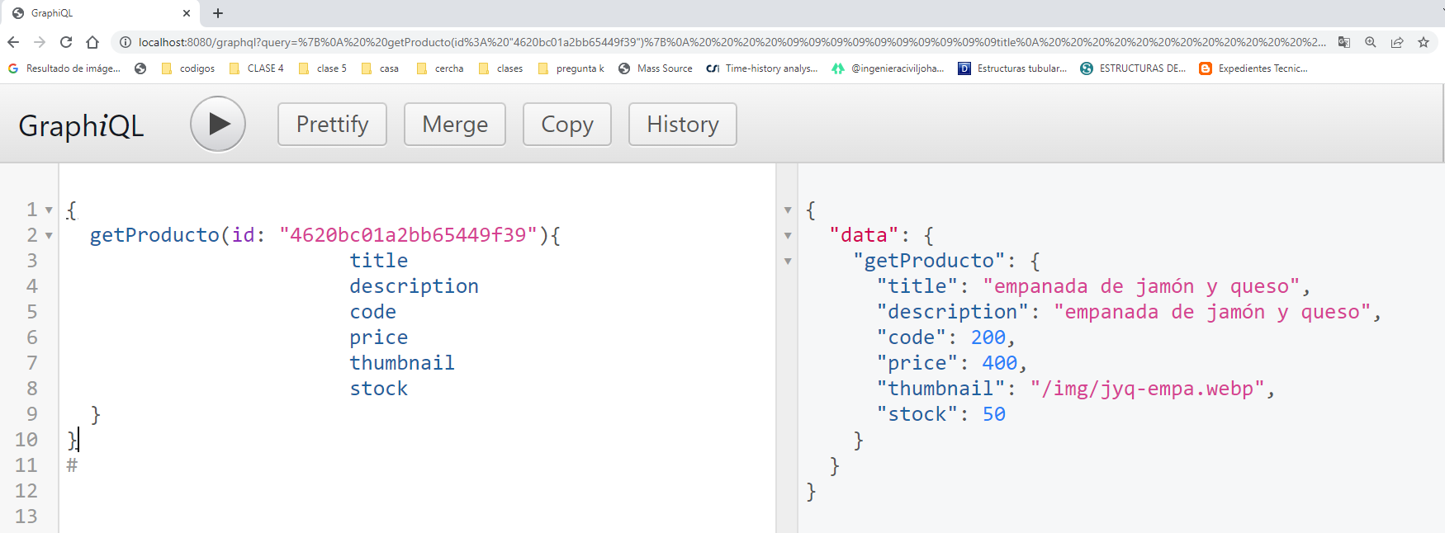

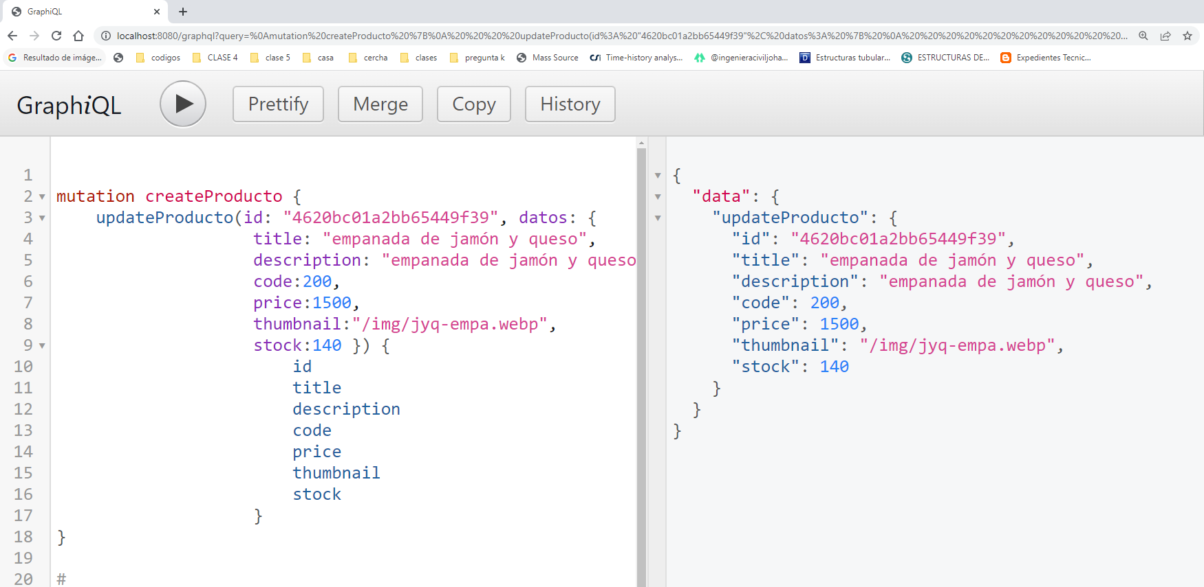

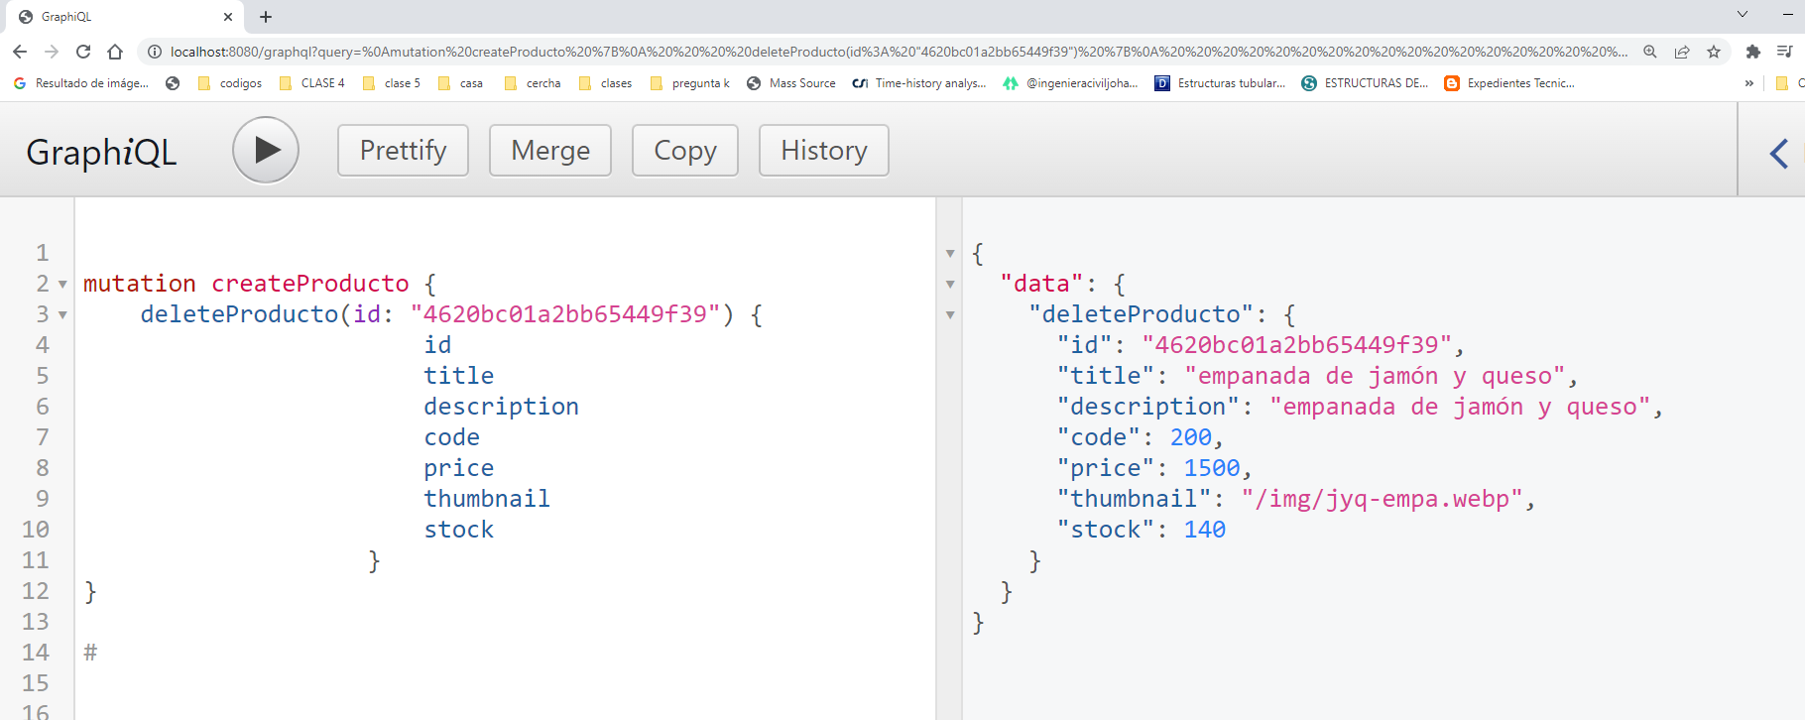

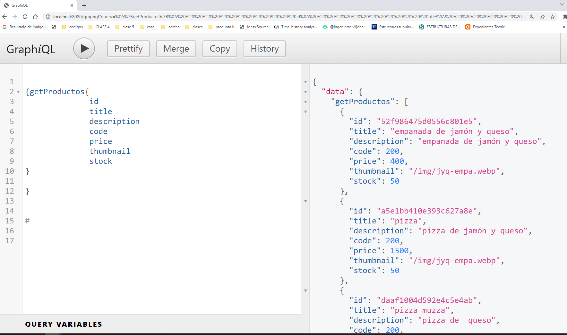

{

getProducto(id: "4620bc01a2bb65449f39"){

title

description

code

price

thumbnail

stock

}

}

6325de39f5735397a6f8f447

mutation createProducto {

deleteProducto(id: "6345aa9b1cdccd2e5fa57208") {

id

title

description

code

price

thumbnail

stock

}

}