Keys of Everything



The complex whole made easy

Get joy with the calm of order

and the thrill of imagination.

Perform some keywords here...

flove.org/games

GUIDE

Play it alone

Play it with more people, it’s more fun

HOW TO START

LEVEL I: 9 Cards

LEVEL II: 15 Cards (2 more triads)

A. Order all the Cards in groups of 3 (optional)

B. Play the Games

GAMES


VOWS
(Optional, Advanced)

Get 1 Card (randomly, etc) and get

Abstract Practical
Vow it for a time Flove.org/(write it here)

LINKS

1. Get 1 card & express something related to it

Not too obvious, not too original



2. Others Guess the Card andor Rate the relation

More...

1.1. Write in the Cards’ back, keep it covered

1.2. Mix them, and try to guess its source word

2.1 Ask for custom Links (negatives, acts...)

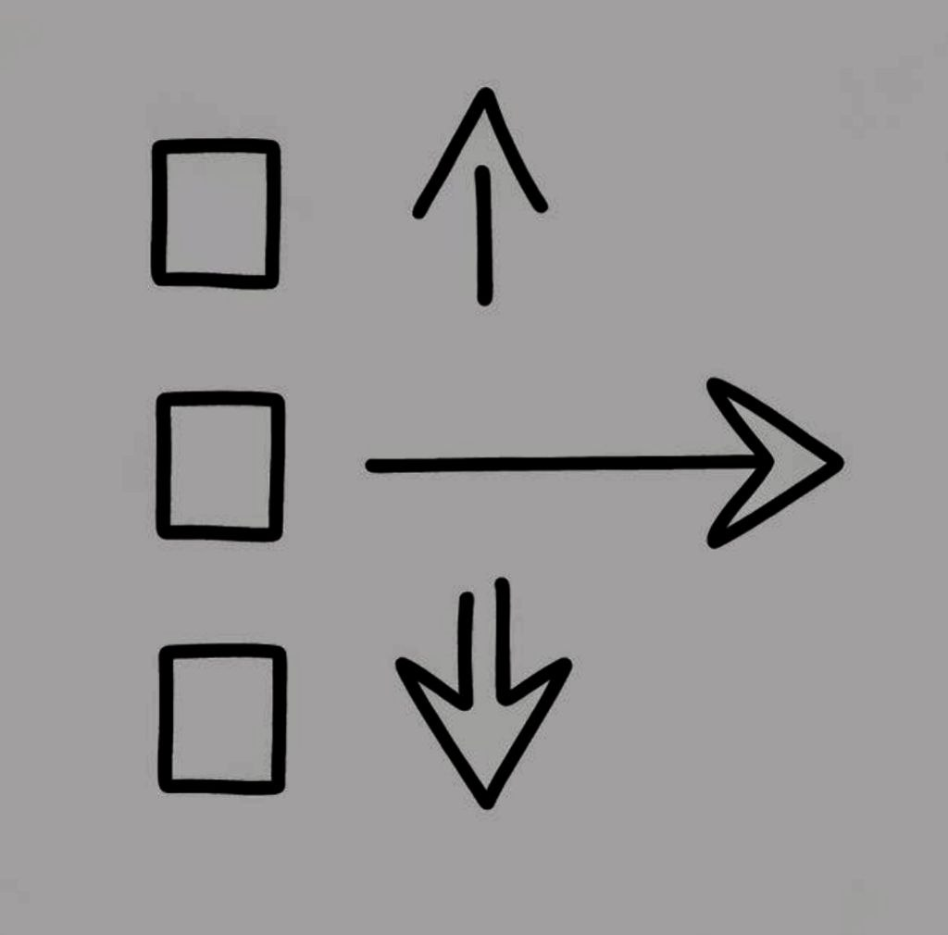
RANKS

0. Set up

-Order the cards in objective groups of 3, or:

-Give 3 Triads (not questions & economy) covered

-Order them: Abstract to concrete (optional)

1. Ask to Make vertical lists of 3 & Explain why

2. Add Perspectives (better with extra Decks)

Place these Magic Cards along your plays:

SUBJECTIVE-OBJECTIVE & MOMENTUAL-GENERAL

3. Contrast Perspectives & Relate 1s, 2s and 3s

4. LEVEL II:Add the Economy & Questions triads

ADVANCED RANKS

LEVEL III: BIOLOGY: 4x5s & 2x5 plus 1

-Order the 5 Senses as square vertexes & center

-Do the same with the 5 Elements & explain Why

-Order 5 linear pairs of Systems with centroid

Choose easier pairs first, then centroid, then the rest…

-Order the Systems pairs from micro to macro

-Order 5 senses in line with the 5 systems pairs

The inner part o that sense represents that system’s pair

LEVEL IV: METAPHYSICS, SCIENCES & PSYCOSOCIAL

-Make related groups of 2,3 and 4 & Explain why

MAGICAL CARDS

SUBJECTIVE-OBJECTIVE & MOMENTUAL-GENERAL:

Default perspective is subjective & momentual, but suggest to refocus that and try to get into the General Objective one, for having richer debates. It’s very useful to use extra decks for contrasting these perspectives.

TIMES & SPACES: Know Linearity and Confluence

Play objectivity by ordering Times linearly & see a Confluence in the middle – second with Spaces. Also objectivize the Times Triad with the Questions one.

TAO-YIN-YANG: Know Confluence and Gender where

Wherever you place TAO is where you tend to position Confluence subjectively and when you place i.e. Yin in the second, it would mean all other seconds are your femenine side within there.

SYMBOLS: Know Confluence and Cycle more close

SOULS
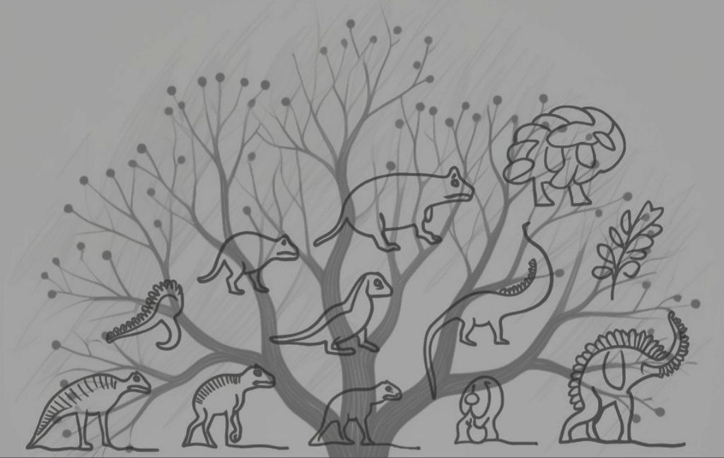
1. ADD an

Animal & Colour

2. ADD
3 Adjectives of each

- -

- -

- -
[OFFERS WANTS]

[1 AM, 2 GET, 3 PROJECT]

3. Add an older Ancestor & Sense & 3 Adjectives
Use the popular matters and species taxonomy for Ancestors and the Biology cards for ancestor Senses-Channels

More hints

VOWS: What if i don’t do it after?
It’s up to you and your Karma

LINKS: Words related because of what logic?
Provide a reasonable traceability and a novel insight

RANKS: Order them vertically because of what?
Subjective momentum, try after general & objective

SOULS: What if i troll the replies?
All outerly expressed comes from and reveals an inner side of oneself. By trolling SOULS one might think is hiding its inner, but that gives a more potential richer link and in betweens, altough it might be a bit harder to clarify.

MORE tricks

Record the games, PROSODY is more key than words

Define by (accumulatuve) images, gestures...
Couple cards & define them with wise.flove.org
Gamify it: Give points & Get Analysis (& decks)
Share: Gift the deck & Sell a pack for friends

Play again, contrast the plays, share results
Create triads and Invent new rules

