Glory is fleeting but obscurity is forever.
Napoleon Bonaparte

ERD → it’s a way for building intuitions about your database.

Conceptual data model
1) What is a data model?
What information should we include in our data base:
Who? User and/or customer or car company.
When? During analysis phase.
How? Research (talking with the people from the “who?”)

A data model does not have a technical part.

We came to an agreement that we were going to use Entity Relationship Diagrams (ERD) to represent the conceptual data models.

2) What are the building blocks of a conceptual data model (ERD)?
- Entity types: concepts/subjects/individuals for our mini-world of database.
They are different from Entities.
Entity Type: Lecturer.
Entities: Mario, Collin, Fernando.

- Attributes: properties that we want to include in the database, these properties describe our entities.

- Relationships: middle blocks that connect entity types. What links might exists between the entities.

Universe / miniworld:

Our webpage should provide an overview of different tv series, with the possibility to look them up by title, genre, country of origin, language, year of first broadcast and then an overview of different episodes of the TV series. The episodes should be grouped by season. Of each episode, we want to know the title and when it first aired, how long he episode lasted.
For each episode we want to have a list of cast crew members.
Then, visitors should be able to give ratings for each TV series.

Entities:
- TV Serie
- Episode
- Rating
- Visitor / Reviewer
- Cast
Entities are represented in our ERD as rectangles.

Debatable:
- Crew members
- Season
- Location
- Genre

Attributes: common properties. For example: the name of a person, number email, etc…
An attribute has a domain, this is the values that they can have.
You recognize them as descriptions of your entities.

- Title → TV Serie
- Country → TV Serie
- Language → TV Serie
- Year of first broadcast → TV Serie
- Genre → TV Serie
- Size of casting → Casting
- Overview → TV Serie
- Range / Score → Rating
- Duration / Length → Episode
- Season → Episode
- Air date → Episode
- Name → Episode
- Name → Visitor
- Age → Visitor
- Email → Visitor
- Gender → Visitor
- Name → Cast
- Age → Cast
- Role → Cast

Relationship: What links might exists between different concepts. Whe you read two entities an relationships, you’ll have a full sentence. The name is normally a “verb” or “of”.

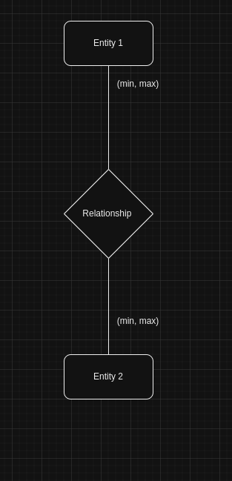

Is for entity 1 ok to exists or not? (if you can not exists, therefore is mandatory) → you put 1 in the minimum. If you can exists without the relationship, you put 0.

Each dog belongs to an owner. And an owner can have multiple dogs. A dog can have at most 1 owner.

The min of the owner is 0 → Why? An owner can exists without a dog.
The min of dog is 1 → Why? Each dog belongs to an owner.

The max of owner is n → technically it’s infinity.
The max of the dog is 1 → One dog has one owne or a dog belongs to one owner.
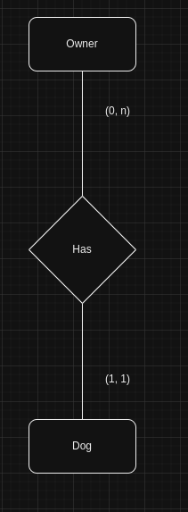

When you include more relationships, you risk to include Redundacy. The Attends could be redundant and it’s only not redundant, when an owner attends a class without a dog.

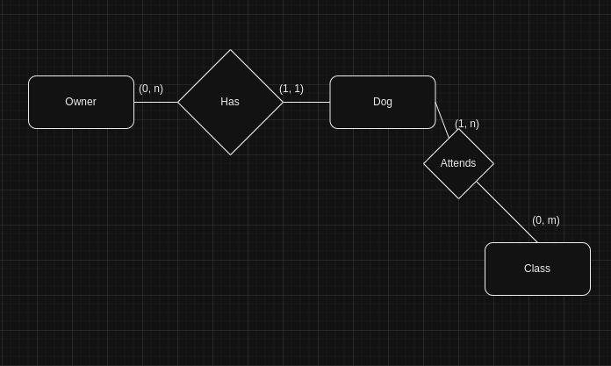

Attends could be redundant in the following diagram:
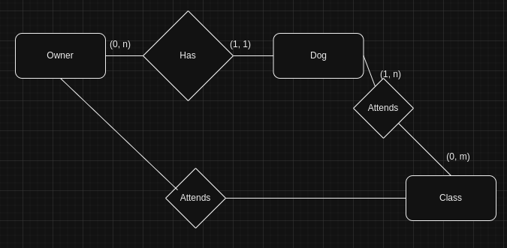

The ERD for our miniworld would be:

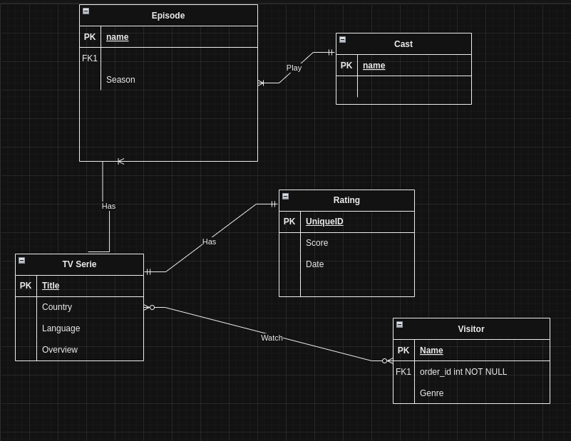

FROM Canvas we take the school example:
1) A student can be assigned to a classroom.
2) A teacher can create test for courses.
3) A student can be grated for the test.

What are our entities?
- Classroom.
- Student.
- Course/Subject.
- Teacher.
- Test.
- Grade.

What are the attributes?
- Room number → Classroom
- Name → Student
- Name → Teacher
- Name → Course/Subject
- Date → Test
- Score → Grade

For our implementation we have:
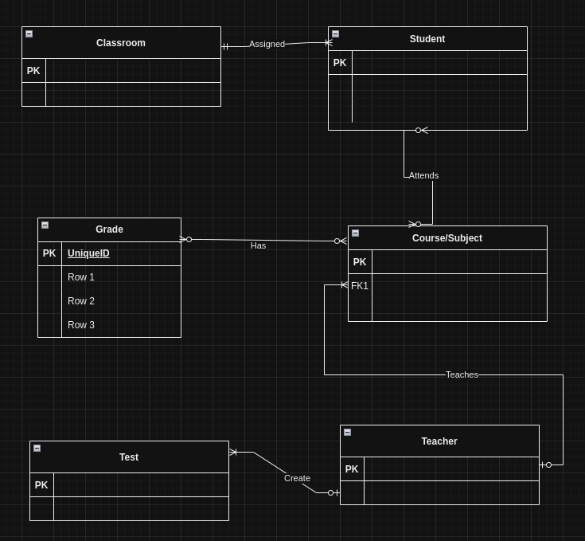

Don’t mind about primary and foreign keys at the moment, we only care about the diagram and how all its relationships.

