Before logistic regression, review linear regression

We created a line that fitted the data and could predict what were the values of the new data points that were coming.
With this line we could:
1) calculate R-squared and determine if weight and size are correlated. Large values imply a large effect.
2) Calculate a p-value to determine if the R-squared value is statiscally significant.
3) Use the line to predict size given weight.
weight
size
We also talked about multiple regression. We could model the mouse size depending on the weight and tail length. We just needed to add a new dimension to our model.

We could compare models, for example, we could compare if calculating the size based on the weight was a better model than calculating the size based on the weight AND tail size. Comparing the simple model to the complicated one tells us if we need to measure weight and tail size, or we can get rid of the tail size.

Now that we remember linear regression, let’s start with logistic regression.

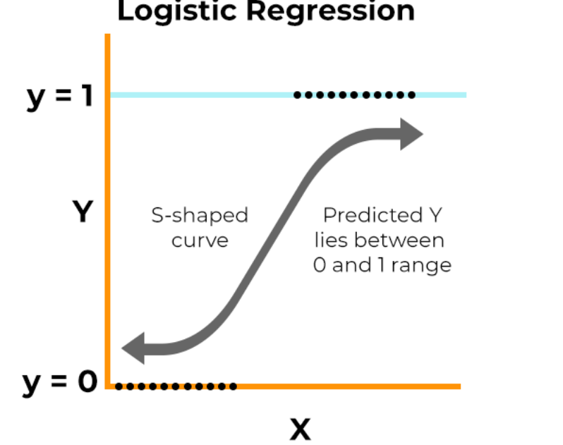
Instead of fitting a line to the data, logistic regressions fits an “S” shaped “logistic function”.
Obese
Not obese
weights
Logistic regression predicts whether there is something True or False, instead of predicting something continuous
This means that the curve tells you the probability (likelihood) that a mouse is obese based on weight. If we weight a heavy mouse it’s a high probability that the mouse is obese, whereas if we weight a light mouse there’s a low probability that the mouse is obese.

Although logistic regression tells the probability that a mouse is obese or not, it’s usually for classification. For example, if the probability of a mouse is obese is > 50%, then we’ll classify it as obese, otherwise we’ll classify it as “not obese”.

We can have simple models or complex models (adding new variables like multiple regression).

One big difference between linear regression and logistic regression is how the line is fit the data. With linear regression, we fit the line using “least squares”. In other words, we find the line that minimizes the sum of squares of the residuals. We also used the residuals to calculate R-squared and to compare simple models to complicated models. Logistic regression doesn’t have the same concept of a residual, so it can’t use least squares and it can’t calculate R-squared. Instead it uses something called Maximum likelihood. You pick a probability scaled by weight, of observing an obese mouse- just like the S curve, and you use that to calculate the likelihood of observing a non-obese mouse that weighs a certain amount X and then you calculate the likelihood of observing a different mouse and you do that for all of the mice, and lastly you multiply all of those likelihoods together, That’s the likelihood of the data given this particular S curve. Then, you shift the line and calculate the likelihood again. And again, and again. Finally, the curve with the maximum likelihood is selected.

