My.Flove.org

MyFlove
MyFamily
MyFreedom
3 apps in one, nice!

MYFLOVE
“If I had to tell 3 things about my self would be..”
“3 tunned chatbots being myself in different lifes”
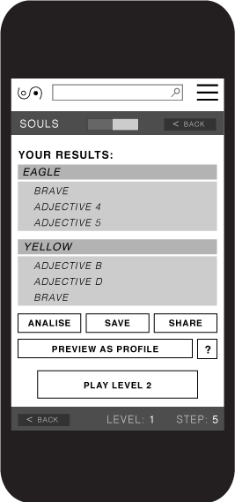

MYFAMILY
WHY?
People we are connected, and when there is a potential benefit we can achieve together, we are very likely to more easily want to connect with others.
As any life, we can’t survive by ourselves only, we always need others, whether is for self reflecting ourselves in them and-or for sharing personal care and material things. Such organizations naturally show up in our life time as friends, mates or more formally speaking, as Families.
So with MyFamily project we just want to reinforce some key virtual groupings and agreements that render those virtual agreements in an increase of quality of life.

WHAT
MyFamily is a self-building community aplication for managing shared assets and small services.
A family starts when one or more founders decide to crowdfund, share or liberate an asset, within an informal group, a more formal community or within an intelligent agent.
MyFamily offers you additional contracts for funding social projects in the real world (MyFreedom recommendations).

HOW
Within the MyFamily environtment we offer a simple set of features to start with, that every user within his-her profile could go on activating-deactivating as long we develop them.
All data interacted by anyone will belong to the person, who will always have the option to share any of it. We will use the shared data for MyFreedom project to develop its inteligent recommendations.
We start asking a simple inventory of Havings & Wants, providing contracting tools for automating some of uses of those.

Automation of Assets Transferability
“Program how your things would behave towards others at some given momentums”
From a more informal and simple allowing one of MyFamilies to use my car in certain soft conditions, to a more complex and formal heritage declaration to be released with scheduled timings along conditional thresholds for commiting certain tasks on certain places (i.e. see below: forking parties).

Educational Volunteering Network
Since donations can be given in time, and everyone studies something which is potentially interesting to other people in the same situation, offers of “generic hours” should be maximized being employed by the donnor teaching to the most posible audience his-her more especialized knowledges.
As with the interactive data which is shared with the MyFlove system, when “generic hours” are donated to a-the common pool, MyFreedom project has to offer the best posible initiative for anyone investing his-her “practical teaching” hour.

Confidenceness regulating actions
«It says you are 44% mum, 32% partner, 22% granny, 4 % cousin of me»
Novia | Abuela | Madre | Hermana | Prima
Cuidados y afectos regulares | Se alegra por ti y te ayuda | Acompañamiento emocional | Íntima amistad y complicidad | Fraternidad y colaboratividad
Darte preferencia de atención | Poder verte o oirte | Llamarte a cualquier hora | Pasar tiempo libre juntas | Invitarte a eventos
Limitarte cosas que hacer | Decirte que propósitos tener | Prescribirte actitudes | Dar consejo sobre cualquier asunto | Responderte y enviarte mensajes
Criticarte con dureza | Mostrar desaprobación | Comentar negativamente | Mostrarse contrariada | Criticarte constructivamente
Regalos sorpresa regulares | Te regala todo lo que pueda | Te regala cosas si te portas bien | Regalos anuales | Te invita a eventos
Compartir todo contigo | Compartir y guardarte las cosas | Recibir herencias y avalarte totalmente | Prestarte dinero y avalarte | Prestarte cosas con facilidad
Tienes su dinero | Te da dinero si lo necesitas | Te da dinero a veces | Te puede prestar algo de dinero | Te presta dinero si es muy urgente
 |  |  |  | Saber tu dirección y teléfono
 |  |  |  | Te avala
.
MYFREEDOM
Along the functionalities for free being yourself and free familying others, we also are a common or global Family, that we call it MyFreedom.
You have to be free to give your data. With your given data, MyFreedom would develop an Artificial General Intelligence, to be used, for example, to route any kind of data or more material contributions given to the common pool (MyFreedom trying to be an automated Best Pool to Gift - Loveliest investing machine).
“MyFreedom should always try to be the best recommendor for anyone gifting and sharing things”

HOW
MyFreedom should stand open to receive any kind of asset, whether is a thing, money or some hours, promising the donor the maximum profit for his-her donated thing.
MyFreedom should be an algorithm that chooses who is the best Family who to donate a received present. The receiver should be the Family who more needs it, more will share it further, etc.
Besides tactics local effectivism, we can approach the overall most need or more viral actions wanted. A set of universal actions that can be easily enforced in daily life, so we need to crowdsource that.
Alongside this more crowpolicying project, in this initial stage, we should be also standing clear with some criteria for the prioritazing of which personal, local and social tasks that increase pleasant living and collective intelligence in a more healthier environment. As initial concrete candidates for that would be the most unwanted and necessary possible tasks and all volunteering associations present in society that are working for social change without aim for material profit.
For incentivating contributions, we could and should acknowledge and reward donations and these tasks commiting in the most beautiful and lovely posible way.

Acknowlegments
The acknowledgement of a commit or a donation given to MyFreedom is aimed to develop reputation for the donor. We hope this to very useful for users easier getting simpathy from other users. It also can serve as a World Cleaner tool for companies that want to publicly compensate their dubious or harsh environmental impact.

Rewards
When we first think of rewarding a donation, it can sound a bit selfish since a donation is intended, (or gets its profound reciprocal energy) because it shouldn’t expect a reward for it. But this is not a problem within us, since the donor is free to donate it to his Family, other Families or to MyFreedom.
As we said earlier, we want to crowdsource the best replies to the question of: “Who would be the best posible receiver of a donation given instead of random?” for every different situation.
Since a basic reply to this question would involve “You (the donnor) (also) have to receive the best energy from your gifting” (gifting yourself better usually makes you a better overall gifter) and while we are not having enough collective intelligence developed yet, we also want to offer our own estrategic reply to such questions, then we are to lead to think about, apart of the gifts routing protocols, about which are the best possible rewards we could give.

Forking parties
What could be best than donate something and get some currency to get some products that are only sold in a party where you commit some task, find shared knowledges and suggest new tasks?
«Know what to say you when you doubt about not shraing someting»

Case: Ecocrowdcrafted hi-tech offer for direct funding

1-One person at a forking party creates a profile (my.flove.org) and a group of artist with its own bylaws (trustful.flove.org) that automate processes of a common pool where resources are shared and redistributed accordingly between members and related groups, and invites 7 people.

2-All accept but rename their family status: From Standard Brothers to Custom Cousins+.

3-They see very cheap, recicled and ecological materials that are getting increasingly sponsored, and decide to do a sculpture 90% ecological (eco.flove.org) with those.

4-They open an artist project to replicate Keops sculpture at an open crowdcrafting platform (craft.flove.org) where most of them agree to choose to share it as freed (license.flove.org).

5-During the craft there was only one outsider contribution, but a key one that was given at the prototyping phase. So the artists would have to forward a % of benefits (if any) to the contributor.

6-Once they have finished the sculpture, the artists add an identifier to it, a built-in chatbot with a data dump from their community of artists (General data from 8 people), slightly tunning that with some surrealist, mischevous personality types premium addons. They also decided to implement a minimal scanner that will help the sculpture to gather feedback from viewers through face recognition mechanism.

7-The communitty of artists are asking for donations to their work in whichever different currencies with its own peculiar routing for investing it.

8-The sculpture accepts any donation without needing of membership of any kind, but it also suggest you to register in the network (my.flove.org, free.flove.org) for getting the advantatge of your donation getting acknowledged reputation.

9-In the network, you will be able to create a profile, play with trascendence apps and enable contents for making groups, crafts, share things, do shopping or engage in other social actions.

10-When you create information there, you can give make it completely private, colectivelly: give it to be analized by the network bots for giving you better recomendations, and-or public.

11-Artists can add a maximum fee of 50% to donations given to the sculpture to be direcdted to their own private benefits. The other 50% can be directed by the donor to the artists project’s maintenance or development, or to friendly projects of them, Universal restoration (gives Reputational Points to artists) (i.e. Blue economy+), or other more original restorations related to the context of the work itself (x2 points) (i.e. Action that restores the British «theft» to Egipt).

12-The (ro)bot will recommend the donation to go (be automatically routed by it) to the part that most matches donor wants&wishes and artists wants&wishes, considering first to invest it in artists projects public tasks that could be performed by the donor himself, or otherwise will refer to some artists’projects, to its own development or to some universal or original restoration projects.

13-The artists have also decided to donate a 10% fee to the Klown Army.

Klown Army
Klown Army is fictionary family clan bringing lovely actions to its edges.
Flove.org/klown_army
Flove.org/flove_army

DEVELOPMENT
...Under construction...

Enjoy the test, Activate more, go next
From «Instagram» through «Boomerang» to «Facebook»
Develop any part, any time, for any pack

P2P
Zeronet, bitmessage, retroshare, twister

Blockchain 3.0
Aion, polkadot, dfinity, ...
Holochain, mark s. miller, ...

Messenger-as-a-network:
Status.im
Akasha.world

Others:
Aragon, MetaMask, SingularityNET

Design projects:
As we introduced the use of the term Family or Freedom with the aim of bringing closer to reality what it is proposed to happen through virtual machines, we have to consider the both the interacting to be similar of to what we humans really like the most to interact with, and so we want to analogy with MyFreedom personality the symbolisms of actual cultural or social artifacts.
Since we see “a party” as the best environtment for evolving altogether, we also want MyFamily interfaces to be close to the “party” effect.
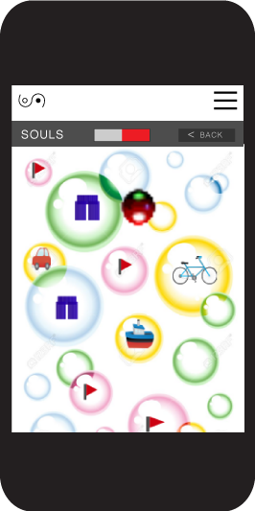

Monumental design

Art works are a very special kind of products because they can live forever in the digital world.
We aim to build a monument that reflects a set of contemporary economic relations and society transformations, where we have a passage from competitive systems/architectures to collaborative and community systems.
With a strong experimental nature, and different artistic languages [expressions] will be used to mark the social transitions we are living in the present, transitions from a hyper-hierarchical set of relations of domination to a self managed peer-to-peer frame.

Case: Virtual Sistine chapel project
The only reproduction of the Sistine Chapel ceiling was painted by Gary Bevans at a church in Goring-by-Sea, West Sussex, England. A full-size architectural and photographic replica of the entire building was commissioned by the Mexican Government and funded by private donors. It was on view at Mexico City from June 1 to July 15, 2016; it may then be exhibited at other Mexican cities and possibly elsewhere in the world.
No picture taking is allowed inside of the Sistine Chapel, but online the Sketchfab offers a 3D model https://sketchfab.com/models/0782ce447bd2467183586660cc230e84. During the summer it has approximately 20,000 visitors per day.
We propose artists to make their proposals for decentraland space, videogame, theme, etc., based in this idea.

DEVELOPMENT PLAN RESUME
Develop any part, any time, for any pack

Version: | Cosateca compartiva | Red compartiva (V2) | Vida compartiva (V3)
SISTEMA
Intencionalidad | Conversar | Localizar | Tecnificar
Desarrollo | Nuclear | Modular | Nodal
Localización | Crear nodo local | Red de nodos | Confederalismo
Arquitectura | Centralizada | Descentralizada | Distribuida
Aplicación | HTML5 Appeado | Mini Apps | Apps entrelazadas
Datos
Propiedad | Propia | Colectiva | Remunerada
Representación | Multilingüe | Gamificada | Sinestésica
Mineria | Formularios | Subliminalidad | Multimedia
Multipublicación | Externa | Integrada | Infinita
Documentación | Visibilización de flujos | ChatBots | Robótica
Funcionalidades
Personal
Referencia | Actividad | Perfil | Perfiles
Descripción | Texto plano | Exportable | Biometrias
Reputación | Me gustas | Valoraciones | % compartiva
Local
Entidades | Usuarias | Agentes | Arbitraje
Confianzas | Comentario | Aval | Confis
Grupos | Descripción | Familias | Familias libres
Social
Federación: | Mediación | Integrativa | Asistencia
Comunidad: | Autócrata | Secciones | Rentas
Formalización: | Safe creative - DOI | Marca GPL | Institucional
Material
Extracción | Ecológico boleano | Medidores | Compensadores
Manufactura | Artesanía boleano | Proyectos | Crowdcrafting
Oferta | Oferta de cosas | Oferta/demanda de cosas/servicios | Co-oferta, Híbridos y Packs
Regalo | Clausulado | Dar al común | Común redirige rápido
Préstamo | Ofertante elije claúsulas | Claúsulas ideales para cosas y solicitantes | Accesos automatizados
Intercambio | Por otra cosa | Venta en horas, MS, faircoin y bitcoin | Intercambio dirigido incluyendo euros
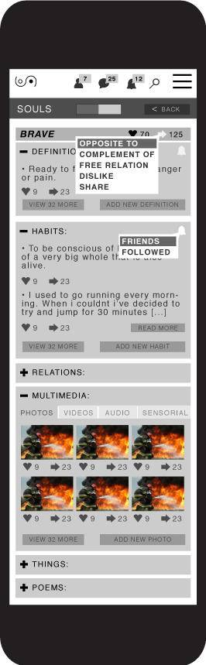

CROWDFUNDING

Seed funding
Proposal on division of the revenues
In order to balance an expectable return to our funders with the social proposes of the project we decided to create a model that associates a logical curve to our redistribution model where we start on a Stage 1 with:
15% Promoters.
75% for investors.
10% for Families
And end on Stage 2 applying a mathematical curve to be defined.
10% Promoters.
15% for investors.
75% for Families

Token offer
All fundings will be acknowleged with a token spendable at forking parties

