**Lumbering**

<https://www.wisconsinhistory.org/turningpoints/tp-027/>

Wages of a bowsman running the river from Stevens Point got about $90 for the trip

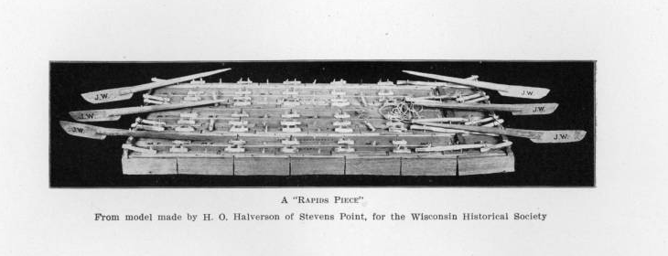

*”crib” raft model*

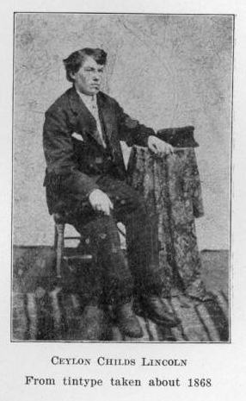

“*My first experience in rafting was in 1868, when I went down with Homer Chase of Stevens Point as pilot - a first class man. Being a sucker, I was unfortunately hired to make the trip on a flood-trash fleet, belonging to Walter D. McIndoo.*

*The ice went out of the river April 17, and the next day we started with five men at each oar, to run the Stevens Point dam, near which the lumber had lain throughout the winter. The first trip for a sucker made his hair stand on end, and brought to his mind all the misdeeds of his past life.*

*We ran down the centre of the river, until within twenty rods of the dam. There the current drew off to the right and came in between two piers, about thirty feet apart; between these piers was the slide, constructed of long logs (called “fingers”) fastened with chains to the dam; on either side of the slide, the water dropped about fifteen feet. Below the dam, the river boiled and rolled into whitecaps. If one was fortunate enough to make the slide properly, he could make his landing in the right place; otherwise, there was great danger of saddlebagging one of the piers and breaking to pieces. Sometimes the raft turned a complete somersault, and the men who did not leap for the pier were drowned. Even when going over the slide, our rafts generally sank until we were standing waist-deep in the water, bumping along on the rocks.*

*Our fleet was made up of twenty-seven rapids pieces, which when coupled together, three abreast, made nine Wisconsin River rafts. It took twenty-seven trips to get out fleet over over each dam and rapids, fourteen for each crew of twelve men, and made a great deal of gigging. After running over some of the rapids we had to walk, or rather go on a dog-trot, five miles with our clothes wet and our shoes full of sand, and be there on time when the piece was set loose.*

*The next obstacle below Stevens Point was Conant Rapids. There the river makes a big double turn to the right. At the second bend is a large red rock, projecting out of the water about a foot. To make the run here, the bow oar must be pulled several strokes to the right, while the steersman pulled the reverse, and as the raft turned, the tail would just slide over the rock. As soon as you passed this rock, the raft dove through the “hog hole” -- a place where the water draws between rocks and dives down ten feet or more and then rolls back. These were fearful-looking places to run. The men usually stepped back behind the oars and grabbed the sucker line, and the pilot and steersman held down their oars to keep them from striking on rocks, and being knocked from their hands. Often a wave caught them, and swung them sideways, sweeping some of the men into the river. This was a place where many lives were lost.”*

*-Ceylon Childs Lincoln. ‘Personal Experiences of a Wisconsin River Raftsman.’ 1911.*

-----

1858- Stevens Point Founded<https://www.stevenspointarea.com/about/stevens-point-area-facts/>

Central Wisconsin Railroads -- Ray Specht 3.00

<http://www.pchswi.org/pubs/booklets.htm>

<http://www.pchswi.org/archives/rrhist/RR_StevensPoint/RR_SP_pt1/rr_stpt_part1_1.html>

Nov. 15, 1871- 1st Train

"The whole city was out in great numbers to welcome the first locomotive ever seen here,"- Caleb Swayze

|  |  |
| --- | --- |
|  |  |

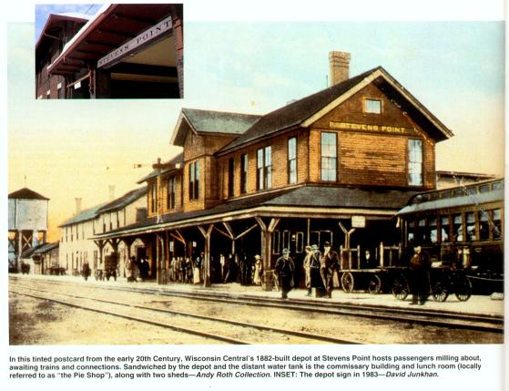

1860’s- Stevens Point Considers R-R

Population- 1800

1871- Construction Chart

<http://www.wisconsinhistoricalmarkers.com/2013/01/marker-418-historic-southside-railroad.html>

<https://www.american-rails.com/wisconsin-central-railway.html>

<https://www.wisconsinhistory.org/Records/Image/IM24601>

<http://trn.trains.com/photos-videos/videos/2016/11/trains-presents-cn-in-stevens-point-wis>

All of the following Taken from A Standard History of Portage County by McGlachlin

* The first settlers viewed Point as a “rough lumber camp” iii

Chapter 4

* 1st log driving by Lieutenant Jefferson Davis in 1829 to build Fort Winnebago
* Had tension with the Menoninees and Winnebagoes--1837 and 1848 treaties took their land and gave it to European settlers
* 1831 Daniel Whitney got permit from the War Department to build a sawmill at Whitney’s Rapids
  + Grignon’s Rapids next in 1836 due to high prices of lumber that drew many to area
* By 1839 above and below Point being used for the lumber industry, 1840 had 30 people in Portage ready to start on something
* 1847 decided that Conant’s Rapids the Point head perfect for a port so started setting up houses and building a small village
* Became the “northern gateway to the pineries” (51)
* Survey done by William L. De Witt in 1851 made Point famous and drew many to the rich lumber industry
* Hunt’s Gazetteer says in 1853 “‘it is the principal depot of the lumbering trade of WI’” (52)
* 5 saws exporting 3,000,000 feet of lumber in 1853
* Transported in cribs (grub planks) 12 by 16 feet until a Rail Road was installed
  + Took 8 men to work each crib but delay in getting to market pushed towards other sort of transportation like trains
* 1857 3,000 men working lumber and made $4,128,000 that year

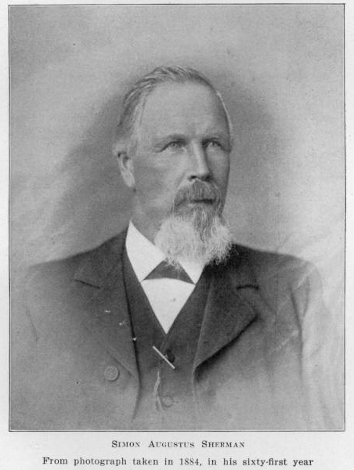

-----

**Founding of SP**

<https://www.wisconsinhistory.org/Records/Article/CS2382>

(Puts lumber industry in context with stevens point and railroads)

<http://www.pchswi.org/archives/communities/stevenspoint/viewstpt1854.html#top>

http://www.pchswi.org/archives/communities/stevenspoint/stpt_handbookintro.html

**Railroads**

Wisconsin Central Railroad (Important)

Was supposed to have permanent headquarters in Point but secretly took clause out of the parameters for the contract

Matthew Wadleigh (Important WC R-R Conductor from Stevens Point)

1870- City Raised 30,000 $ for R-R and Donated Land

Nov. 15, 1871- 1st Train in Point

"The whole city was out in great numbers to welcome the first locomotive ever seen here,"- Caleb Swayze

May 1872- Ten Stall Roundhouse

*(Still in use today- Get Pictures)

<http://www.pchswi.org/archives/rrhist/RR_StevensPoint/RR_SP_pt1/rr_stpt_part1_1.html>

Wisconsin Central RR (From American-Rails.com)

1870s - Fed. Gov. offered free land grants to attract railroad development in WI. and surrounding states

State established the “Wisconsin Central Railroad Company on Feb. 4, 1871

Original goal following its establishment was to run a 260 mile route from West Menasha (present day Neenah) to Ashland, Stevens Point was 63 miles into the journey and made for a natural stop along the way

* Built in record time in 120 days in 1871.
* The article continues on about the Wisconsin Central throughout the late 19th cent. but then spends heavy amounts of time in the 20th century away from central Wisconsin.
* [https://www.american-rails.com/wisconsin-central-railway.html#gallery[pageGallery]/2/](https://www.american-rails.com/wisconsin-central-railway.html#gallery%5BpageGallery%5D/2/)

Decent site for present day images of Soo Line 2713 display in SP, doesn’t have much information beyond mentioning some of the businesses that cropped up in direct response of the railroad running through the city. Including businesses that catered specifically to railroad passengers.

<http://www.wisconsinhistoricalmarkers.com/2013/01/marker-418-historic-southside-railroad.html>

City of SP contributed $30,000 ($546,733.28 in today’s money) to finance railroad’s construction.

From 1872 until 1887, Stevens Point had the only shops and one of the few yards on the entire railroad

1872, WC moved its operating headquarters to SP .

**Train Whistle:** “As the story goes, the three-foot-high, 15-inch diameter whistle on the shop roof was the pride of the railroad and could be heard on a clear day in Waupaca 25 miles away. Signaling shift changes, the thunderous blasts from the whistle became the despair of neighbors, interrupting the peace and composure of the residents. It rattled windows and even shook plates off of cupboard shelves. Thus, Stevens Point became one of the first Wisconsin communities to field complaints about railroad whistles.”

**Death of a Railsmen: “**The country’s economic downturn that began in late 1893 continued for a number of years, and WC business diminished accordingly along with that of many other railroads. The WC tried to reduce the impact to its employees as much as possible. At Stevens Point Shops, the employees’ work days were reduced from ten-hour days to eight hours in an effort to keep as many employees as possible working.

The WC was reorganized in July 1899, and once out of bankruptcy, money was allocated for major improvements. A massive mainline grade and curve reduction project between Stevens Point and Neenah was implemented, and in 1900 WC President Whitcomb instituted longer divisions as a part of the major changes being made on the railroad. Waukesha and Stevens Point would no longer be division points; in their place were Fond du Lac, Abbotsford, and St. Paul. Abbotsford replaced the Stevens Point division-office duties in mid-September 1900. After employees transferred to their new terminals, the WC further reduced Stevens Point employment in December 1900.

Stevens Point had a healthy economy at the time. Many businesses were doing well, including a furniture company and a paper mill which were doubling their capacities. Yet, the City of Stevens Point was quite upset with the closing of the car shops and took legal action to attempt to reclaim the land it had given the railroad for the shop facilities; however the City dropped its legal action when it realized that it could not win. Nonetheless, it took some time for ill feelings to subside.”

Leased out by Soo Line in 1909 due to troubles.

**Video**

<http://www.milwaukeepbs.org/local-programs/programs/around-corner-john-mcgivern/watch-episodes-detail/9OyavN2PibQ>

<https://www.youtube.com/watch?v=9OyavN2PibQ&ab_channel=MilwaukeePBS>

**----**