Comparison Authentic2 and generic own developed LoginHandler.

This document tries to analyze the tool Authentic2 as possible solution to implement the bridging within Umbrella. The analysis explores the functionality of this tool and compares it against an alternative which consists of a self developed LoginHandler based on Shibboleth.
The main motivation is to consider that pieces of work can be reused, therefore saved from Umbrella project workload.
The organization of this document is first to give a description on how to configure and use the Authentic2 for our use case. This is use is to bridge federations. A central part would save the minimal information to be able to authenticate users into the system. Users would be able to link to other SAML2 federations, SSL systems, etc. The way is thought of being Umbrella the central part, where users are uniquely identified, and enable the possibility of linking such account with all other accounts that users might have in other federations in a persistent way.

In order to write a precise analysis, Authentic2 has been deployed on a server. The testbed is composed by two different virtual machines, connected in the same private network for the sake of simplicity. The virtualization layer runs on kvm using qemu images. The first machine is called lxb007.devops.gsi.de and it runs Debian Wheezy with 3GB of RAM and 3.2 GHz. This machine deploys the elements of the IdP, this is: the Shibboleth IdP software, an LDAP directory with the Umbrella users, and the Tapestry web interface developed at PSI. The second macchine is lxb003.devops.gsi.de and it runs Debian Jessy with 512MB of RAM and 1.6 GHz. This one hosts the Authentic2 tool, which consist of Django Framework and is deployed into a Gunicorn server. Additionaly the django_auth_ldap is deployed in order to implement the authentication against the existing LDAP directory.
Additionally, Authentic2 Service Provider has been configured in 2 external federations: Umbrella test (Umbrella.psi.ch) and SWITCH.

The scenario is that Authentic2 will be the IdP with the LDAP backend running on lxb007.devops.gsi.de.

Authentic2:
Authentic2 is an open-source software, developed under the GNU AGPL version 3. It is essentially a versatile identity provider that uses the Lasso implementation of the SAML2 protocol. Besides SAML2 it supports many protocols and standards, including SAML2, CAS, OpenID, LDAP, X509, OATH, and it can bridge between them.
The whole documentation on how to install and configure the tool is under http://pythonhosted.org/authentic2/index.html .
This tool uses the Django Framework and can be configured to run on different type of servers. The one that comes configured by default with Debian package is gunicorn. Authentic2 has a SQLite database as back-end for the application, and also for storing persistent data related to linking of accounts of users, as well as mapping of attributes among federations.

Installation
It is simple for Debian systems to add the specific repositories and install authentic2 package. This procedure deploys and configures authentic2 in the system. The main locations are:
/usr/lib/authentic2/manage.py - which is the main files that runs the application
/etc/authentic2/authentic2.conf – configuration file.
/usr/share/pyshared/authentic2 – python files of the application. Includes the settings.py file and urls.py file, that can be tuned for configuration.

Configuration
In the context of the Umbrella bridging, the goal is to make Authentic2 a SAML service provider proxy. Further information on this topic can be found here: http://pythonhosted.org/authentic2/config_saml2_idp.html
The basic steps:
- Configure Authentication with the existing LDAP. More info: http://pythonhosted.org/authentic2/auth_ldap.html. Specifically in the testbed, these lines have been added to the settings.py file:
##for the LDAP

AUTHENTICATION_BACKENDS += ( 'django_auth_ldap.backend.LDAPBackend', )

import ldap
from django_auth_ldap.config import LDAPSearch

# Here put the LDAP URL of your server
AUTH_LDAP_SERVER_URI = 'ldap://lxb007.devops.gsi.de:389'
# Let the bind DN and bind password blank for anonymous binding
AUTH_LDAP_BIND_DN = "XXXX"
AUTH_LDAP_BIND_PASSWORD = "XXX"
# Lookup user under the branch o=base and by mathcing their uid against the
received login name
AUTH_LDAP_USER_SEARCH = LDAPSearch("ou=people,dc=eurofel,dc=eu",
ldap.SCOPE_SUBTREE, "(uid=%(user)s)")

- Declare Authentic 2 as a SAML2 service provider on tge Shibboleth IdP using the SAML2 service provider metadata of Authentic 2. The metadata is on: http://lxb003.devops.gsi.de/authsaml2/metadata.
- Add and configure a SAML2 identity provider entry in Authentic 2 using the metadata of the identity provider. The metadata of the IdP is under: http://lxb007.devops.gsi.de/idp/profile/Metadata/SAML
http://umbrella.psi.ch/idp/profile/Metadata/SAML
- Define the policies for the IdP, taking into account that for the Shibboleth implementation the “Requested NameID” has to have Transient. But also for linking of accounts this information needs to be kept in a persistent way in the system. Therefore, it is important to select the option: “This IdP sends a transient NameID but you want a persistant behaviour ...” Settings of the policy are found in Illustration 1.
There is the main field that describes which behaviour it is going to follow with a persistent NameID. This option applies when an assertion with a persistent nameID is received and the nameID is not recognized as an existing federation. Two values are possible: “Create new account” and “Account linking by authentication”. The value “Create new account” makes Authentic 2 create a user account associated to the nameID received. The value “Account linking by authentication” makes Authentic 2 ask the user to authenticate with an existing account to associate the nameID to this account. In the case of Umbrella it would be interesting to use the second case, where the user has already an account in Umbrella federation.
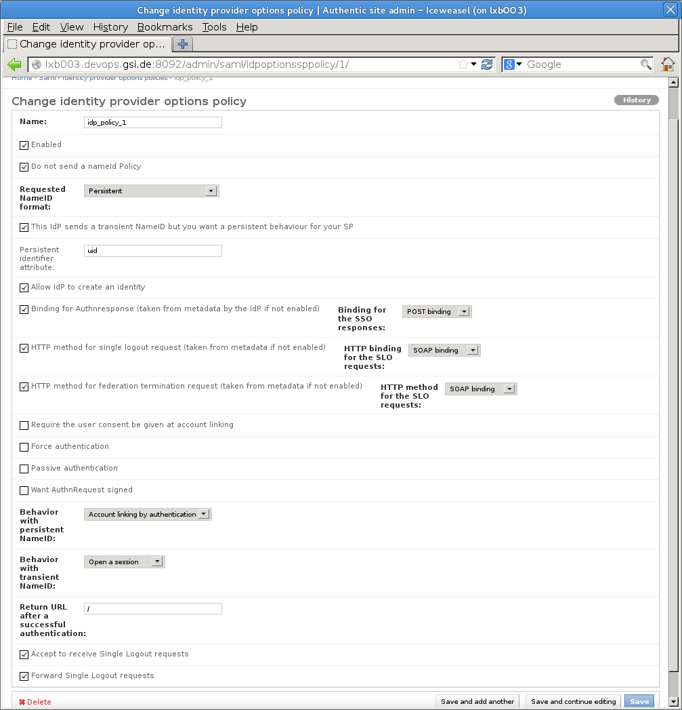IlluIllustration 1: Policies for IdP
Up to this point, Authentic2 is authenticating users locally against the LDAP directory running on lxb007.devops.gsi.de.
Enclosed in Authentic2 is the bulk script that facilitates the bulk load of IdPs and SPs from a metadata file (http://pythonhosted.org/authentic2/sync-metadata_script.html), and after having deal with the slug column (the slug column name was being taken from the name of the DisplayName in the metadata, which is not unique. Uniqueness is a requirement of slug column) we have the SAML2 federations from SWITCH. Also, I have enabled my local federation and the umbrella test federation on “umbrella.psi.ch”.

We can see in the next screen a sample of the administrative tasks that a user can accomplish, Illustration 2. The user has a local account in the system for accessing Authentic2, at the moment configured with LDAP back-end. This user is able to link her account to any of the federations registered in Authentic2, or in this case, to an X509 certificate too. This linking will only proceed if after successful authentication against the target federation. This linking information is saved on the authentic2 database in a persistent way, therefore when the user connects to any of those linked accounts will get the local account.
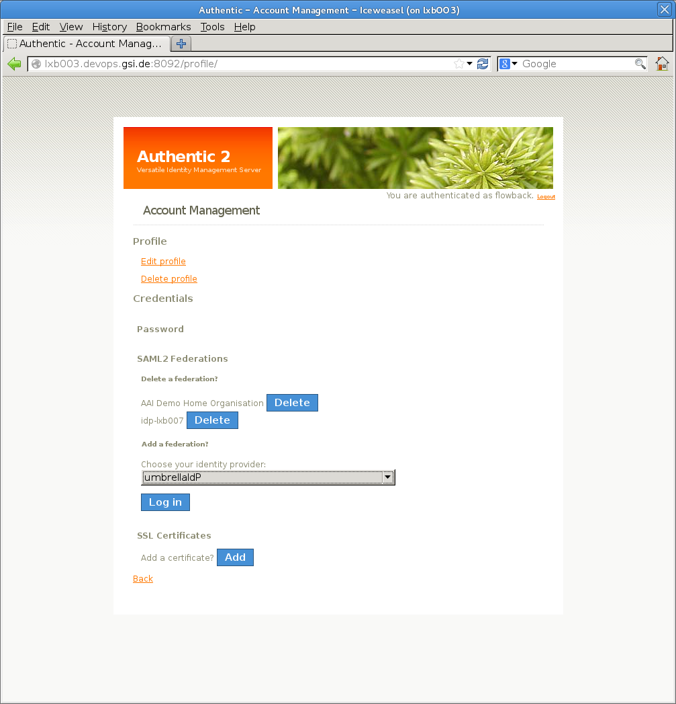Illustration 1: User administrations, from user's point of view

Manage attributes:
User attributes can be taken from LDAP directories, the user Django profile or taken from the user Django session if Authentic 2 is also configured as a SAML2 service provider. Indeed, when Authentic 2 acts also as a SAML2 service provider, attributes contained in the SAML2 assertion received from third IdP are put in the user session. Attributes can thus be proxyfied during SSO with Authentic 2 configured as a SAML2 proxy.
By default, the namespace and format of attributes in assertion is SAMLV2.0 X500/LDAP Attribute profile.
The mapping of attributes is the most interesting part. It is useful to use the attributes from the session pushed by third SAML2 identity providers. This is implemented and can be configured in a fine-grained way. http://pythonhosted.org/authentic2/attributes_in_session.html
The mapping is saved in the table saml_libertysessionsp, some fields are:
- id- identifier
- django_session_key- this is the key of the django session that identified the user locally.
- federation_id – identifier of the federation where it has been linked.
Another tables keep the correspondance between attributes. These are: saml_authorizationattributemap and saml_authorizationattributemapping.

Comparison of Authentic2 versus own LoginHandler
Following some criteria are discussed:
Criterion | Authentic2 | BridgingLoginHandler
License | GNU AGPL version 3 | Apache 2 license
Protocols it supports | SAML2, CAS, OpenID, LDAP, X509, OATH | Shibboleth supports SAML1, SAML2, CAS, Multifactor, Social networks, LDAP, x509
Documentation | Limited to the use cases that it solves. Only one website: http://pythonhosted.org/authentic2 | Wide documentation distributed in wiki pages, website of Shibboleth divided into “General documentation” and “Developers documentation”
User community | Not known. | Standard de-facto for the majority of Organizations and Universities world-wide.
Support and Activities | Recent submissions of code.  Mailing-list inactive (tried to send several mails even individually to the main developers with no answer). | Active mailing-list with many active users answering in less than one day in average.
Framework/  Development | Django. Developed in Python. | Development center exists. Developed on Java or C++.
Deployment | Possibility of deployment of Django is by WSGI, that can be integrated into Apache, gunicorn or uWSGI servers. This is yet another application to be maintained. | Deployment on servlet containers: Jetty 7, Apache Tomcat, Jboss Tomcat or Glassfish. The development of a new LoginHandler would consist on just adding the new .jar to the existing application.

Approach for Bridging | Use Authentic2 | Use Shibboleth and a Custom Login Handler
Description | Install and configure standard Authentic2. Maybe some development work required. | Install a standard Shibboleth IdP and SP. Connect them via a custom IdP login handler, which is protected by the SP. Development work required to create custom login handler.
License | GNU AGPL version 3 | Shibboleth uses Apache 2 license, any license could be used for the custom login handler.
Protocols supports | Authentic2 supports SAML2, CAS, OpenID, LDAP, X509, OATH | Shibboleth supports SAML1, SAML2. There are login handlers for Jaas (LDAP, MySQL, …), CAS, Kerberos, X.509, HTTP Basic Auth, Facebook, and some more
Documentation | Limited to the use cases that it solves. Only one website: http://pythonhosted.org/authentic2 | Extensive documentation on official Shibboleth wiki and the Shibboleth website. Divided into “General documentation” and “Developers documentation”. In addition many issues and questions were discussed already on the Shibboleth mailing lists in the past 10 years.
User community | Unknown, but probably small and focused on France. | Large community because it is the de-facto standard FIM software for academic organisations world-wide.
Support, Activities and Sustainability | Recent submissions of code.  Mailing-list inactive (tried to send several mails even individually to the main developers with no answer). Code seems to be mostly maintained by the French company Entrouvert. | Active mailing-list with many active users answering in less than one day on average. Support can also be received via the local federation (e.g. SWITCHaai). The sustainability of project is ensured by Shibboleth consortium that is funded by many federation and organisations that use Shibboleth.
Framework/  Development | Django. Developed in Python. | Development center exists. Shibboleth is developed in Java (Identity Provider) and C++ (Service Provider).
Deployment | Possibility of deployment of Django is by WSGI, that can be integrated into Apache, gunicorn or uWSGI servers. This is yet another application to be maintained. | Identity Provider has to be deployed in a servlet container like Jetty, Apache Tomcat, Jboss Tomcat or Glassfish. The deployment of a custom LoginHandler would mean adding the new .jar to an existing standard Shibboleth IdP installation.

