CRISP – WP16

Revised architecture document and development status

CRISP Deliverable D16.2

Document identifier: | CRISP_D16.2.doc
Date: | 10 May 2013
Authors | RI

Abstract: This document summarizes the current developments for the Umbrella AAI system.

FIM Architecture Document
CRISP – Cluster of Research Infrastructures for
Synergies in Physics
Work Package 16

Table of Contents
1. Introduction 3
1.1 Status quo 3
2. The need of Bridging 7
2.1 Benefits 7
3. Bridging proposal within CRISP 9
3.1 Design 10
4. Bridging prototypes 13
4.1 Umbrella-x509 13
4.1.1 The use case: Grid 13
4.1.2 Design proposal for bridging 15
4.2 Umbrella-eduGAIN 17
5. Web-based vs Non-web based 17
6. Roadmap and Future work 18
Bibliography 18

Introduction
The main goal of the work done in the Phase 2 of the WP16 is to continue developing the federated identity system to broad the community of users.
In the last years, many solutions arose to solve the federation of identities, as this has been pointed out as a common concern for any kind of community, going from research, social networks, and banking applications. These solutions consist in enabling access to services in other institutes, using their credentials from the home institution, this is the so called Federated Identity and the way it is designed, set up and administered is Federated Identity Management (FIM). Furthermore, many national networks started to collaborate to benefit from each other. Every of them have implemented their particular solution, based mostly in de-facto standards, although there is still a lack of a common ground. The national borders and the different laws existing, indeed constraint international collaborations, as they stand for different administrations.
The concept proposed here is to enable to join different user communities, this is, different federations, crossing national and organizational borders, that we call bridging, explained further in this document.
In “D16.1: FIM Architecture Document” the architecture of a FIM system solution is described. This solution has been coined with the name of Umbrella [1], which points the fact that all the credentials of a user are unified under a unique identification. This system was developed, and is currently being implemented in the Photon/Neutron (P/N) community. Umbrella has been therefore postulated as the starting point for bridging federated identity systems, where use cases are heterogeneous and different to the P/N community. Further developments of Umbrella are the greater part of this piece of WP16 in CRISP project, and are focused on the design of a bridging solution covering other kind of federations.
The need of Bridging is discussed first in this document (Section 2 The need of Bridging). Then, the proposal to solve bridging in the context of CRISP is discussed in Section 3 Background. In Section 4 Bridging prototypes, a description of the prototypes is given. The difference between web-based and non-web based resources is discussed in Section 5 Web-based vs Non-web based, and finally the outlook and future steps are described in Section 6 Roadmap and Future work.

Status quo
Several user communities have already federated access to their services. These users own accounts extensively in different communities, from commercial solutions to scientific organizations, including social networks. Those federations are islands on their own and do not share anything between each other. A user from one federation can only use services at that federation at a time.
Nevertheless, many of the existing federations have information in common and they often overlap. For example, a student at a University may be doing also some research for an organization and at the same time is subscribed to a social network, thus, he has credentials to three different federations: the university, the organization and the social network. None of these systems can benefit of the information from each other, and the user needs to remind the credentials to each federation. Hence, bridging federations is important.
Next, some relevant scenarios are described together with their FIM and the Authentication Authorization Infrastructure (AAI) solutions and federations.
Umbrella
The basis of the proposed common solution is an EU-wide federated user database. This system has been postulated as an AAI solution for the participating research infrastructures EuroFEL (PSI), ESRF, ESS, FAIR (GSI), ILL, and XFEL, and is explained in depth in the first document "CRISP WP16 FIM Architecture Document".
The Umbrella approach to FIM consists in a single central Identity Provider, which contains minimum information about the users to uniquely identify them, and a local part with further user information located at each service provider. This design provides a unique and persistent user identification, assuring confidentiality and delegating all the authorization tasks to the local Web User Offices (WUOs). The Umbrella uses an account linking to match central identities with the local ones. This central account still needs to be created at the Umbrella system. This procedure is actually similar to that used in many social networks to access to different internet services with an account from a specific social network.
A global system will only be sustainable on a long-term basis if it is a common one accepted by all facilities. At the moment of writing this document, Umbrella is already in a very advanced status and it is being implemented in several facilities. Therefore, it is considered already a good starting point for bridging and the most realistic scenario.
High Energy Physics
The High Energy Physics (HEP) community is very much present in this phase of development, specifically GSI-FAIR organization. This community is specialized in using particle accelerators and detectors. Depending on the experiment, beams of a certain kind of particles are accelerated and reach a high energy, up to when they are made to collide with each other or with stationary targets. In this moment detectors record the results of these collisions. In this extensive community access to computing resources is done through Grid technology [4], following the experience reached at the World Large Hadron Collider Computing Grid (WLCG) project [5]. This infrastructure allows already the users to access resources in a federated manner, through x509 certificates issued by the national accredited Certificate Authorities of the International Grid Trust Federation (IGTF) [6]. This distributed Public Key Infrastructure (PKI) accomplishes a high level of trust and fine-grained authorization.
This community is making an effort to avoid the user to deal with x509 certificates because this process leads to unwanted long administrative tasks. Several solutions already exist for this issue: CILogon and Terena Certificate Service, which generate certificates from web interfaces.
On the other hand, web accounts for accessing browser-based applications also exist in this community. Therefore, support for web based and non-web based, is required. Access to web based resources could benefit from standard solutions based on Shibboleth or SAML2. But for the access to the Grid, Shibboleth is not a solution. In this case, enabling the option of having a service that could generate x509 certificates from web credentials would simplify the user experience and also the administrative steps of delivering such a certificate.
In section 4.1 Umbrella-x509 is described how to bridge Umbrella to the PKI infrastructure.
National Research and Education Network (NREN)
Many NREN [2] have been established world wide, enabling many of the academic users to use their institute credentials to access services at other institutes, inside the same federation. In the context of the P/N community, where Umbrella has started, there are several NRENs such as, Deutsches Forschungsnet in Germany, Janet in the UK, Switch-AAI in Switzerland or Surf Net in The Netherlands, to which it would be useful for the users to bridge.
Social Networks
Social networks are changing the way of using computing resources for the younger generations. These users expect to find no barriers anymore between personal and professional data, and to control what to share, when and with whom. This fact influences the way they use data, also at work.
In addition, social networks are federating identity of many of the commercial applications, commonly used. In general, web applications are increasingly relying on the intuitive and easy way of enabling access to their resources, taking information from the accounts existing in the Social networks, like Google, OpenID, Facebook, etc. This is a one-step process for accessing resources where users do not need to create an additional account, by hand, with another password to be remembered.
This leads to the necessity of an intuitive solution and friendly interface, which facilitates the access to resources.
EduGain
EduGAIN [7] is a service developed and operated by the European GÉANT project and aims to interconnect different federations worldwide. It provides a common set of technical standards, rules and policies to secure exchange of information related to Identity, Authentication and Authorization. This set allows organizations to support AAI-enabled services.
A wide amount of organizations and universities have adopted the eduGAIN interfederation services, and it is a running project open to new necessities. Even though it is a European research project, eduGAIN embraces also non-European federations.
A drawback of this framework is that the user cannot link his federations unless these organizations agreed before hand.
What to bridge
Ideally, the development of a service capable of connecting any kind of federation would be the definite solution, but federations hold different levels of assurance (LoA) and the complexity is too high for such a task. Determining what federations to bridge is therefore the first step. As mentioned before, in the context of P/N community already some NRENs have their own solutions. Those are examples of federations that overlap often in functionality, and users would benefit from the bridging.
A federation worth to bridge is eduGAIN. This is a very great-extended community and, at the moment of writing this document, is playing a key role in the federation of identities as part of GÉANT network. GÉANT is well placed in the Europe2020 project to make relevant contributions.
In addition, there is an interest from the HEP community to avoid dealing with x509 certificates administration. This community would benefit from the creation of such certificates from web-based credentials.
Furthermore, the majority of the users have accounts in commercial and social networks. Allowing a single interface for single-sign-on would have a positive impact for both, the user and the resources. Therefore, to bridge to Identity Federations as Linked-in, Google, Facebook, OpenID, etc. is also under consideration. However, those federations should also trust and recognize Umbrella as an identity provider in order to get a bi-directional bridge. This case is at the moment out of the scope in this project, because it would require rather lengthy negotiations.
In the Figure 1: Examples of federations where to bridge is shown the idea of having a unique Umbrella identifier that is linked to the other federations where the user has accounts. This way, the user only needs to remember the Umbrella credentials.
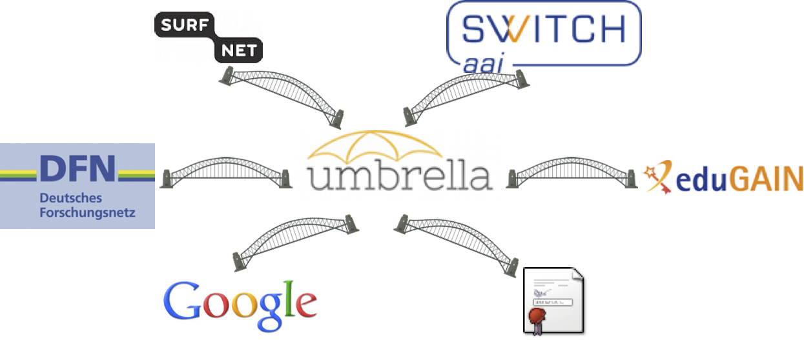
Figure 1: Examples of federations where to bridge

The need of Bridging
Setting inter-federation services would improve users experience towards access to federations: it would enable a user from one federation to access a service in a different federation. The need of inter-federation connection has been already addressed from different kind of communities [3].
There are numerous advantages to bridge:
- Reducing the number of accounts to be remembered by the user.
- Harmonizing security interfaces consolidates a better integration of the resources.
- Having a central system for the users to access to federations eases the burden of administrators, by reducing the helpdesk activities.
- Improving privacy compliance by allowing the user to control what accounts to link.
- Reduce the overlap in between federations.
- Improving body of standards that is facilitating both connectivity and security.
- Participating parts could benefit of the detection of security risks, as those could be rapidly communicated to the rest. For example, an email detected in a black list, could be notified to the rest, saving time and risks.

Benefits
The scope of the present work focuses on the scientific community. This community has a special interest in a common approach to FIM, as it would benefit to join efforts. In particular, the research community relies on mobility and it is important to ease the users experience whenever resources in different institutions are required.
The interest to go in the same direction has been shown in the Federated Identity Management for Scientific Collaborations (FIM4R) series of workshops [4]. State-of-the-art FIM implementations are discussed in these meetings, which are indeed closely related to CRISP, because it focuses on the scientific community. Umbrella has been present already from the first workshop, strengthening the concept of this alternative.
The research community would specially benefit from the bridging. These benefits are summarized in Table 1: Benefits of Bridging for some use cases, and how they would benefit from bridging to others.
 | eduGAIN | grid | NRENs | Soc. networks
eduGAIN | - | No need to manage x509 certificates from the users point of view. | Connect to services in other NRENs. | Remove boundaries between personal and professional at own will.
grid | Possibilities of new Security Level of Assurance (SLA) | - | Possibilities of new SLAs.
NRENs | Merging accounts. | No need to manage x509 certificates from the users point of view. | -
Soc. networks | Merge accounts and soften boundaries. | No need to manage x509 certificates from the users point of view. Foreseeable low SLA. | Possibilities of outsourcing the Identity management for certain use cases. | -
Table 1: Benefits of Bridging

Background

Bridging was a necessity pointed since long, but never widely tackled. There are several solutions existing today in small scale that point to valuable designs.

Authentic2
Authentic2 is an open-source, under GNU AGPL version 3, versatile identity provider. It uses the Lasso implementation of SAML2 protocol. It supports many protocols and standards, including SAML2, CAS, OpenID, LDAP, X509, OATH, and can bridge between them.
The whole documentation on how to install and configure the tool is under http://pythonhosted.org/authentic2/index.html
This tool uses the Django Framework and can be configured to run on different type of servers. The one that comes configured by default with Debian package is gunicorn. Authentic2 has a SQLite database as backend for the application, and also for storing persitant data related to linking of accounts of users, as well as mapping of attributes among federations.

Bridging proposal within CRISP
The consolidation of a wide amount of FIM solutions leads to the idea of bridging them. In order to solve bridging of federations, all the components involved need to be understood: Inside a federation, Identity Providers give information about users to Service Providers via user attributes. Attributes are given certain name and semantics. This semantics and the set of attributes supported is defined in the Federation, and, therefore, understood by all the members inside. As each federation may use custom sets of attributes inside, new elements need to be in place to translate attributes between federations.
This has been subject of study for some time for eduGAIN. This approach was proposed by TERENA [6]. It requires a strong trust model among the federations, which must agree on the way the Identity providers (IdP) and SPs behave, to become interoperable. This is implemented through a set of policies [19] that every federation must adhere to, a profile [20] to ensure interoperability on a protocol level and a central metadata repository where metadata for Identity and Service providers that have opt-in to eduGAIN are aggregated. The elements in charge of "translation" of attributes among federations are called mangling, and consist on XML and regular expression library.
This approach is based on SAML2. Most of the NRENs have implemented their AAI solution in SAML2, which makes them technically interoperable with each other and with eduGAIN. Nevertheless, this approach is rather costly to implement, since several components need to be in place, and most importantly, legal agreements have to be set before hand. It implies a release of information of the users; hence, it has to fit to the data protection laws, which are normally making this process too long.
The Umbrella approach overcomes this complexity by enabling a user-initiated process. In this way, it drops legal issues involved with delivery of personal data. This makes the process a bottom-up approach and results in a better user experience, as the bridge is built on demand. It also eases administrative tasks, since the user would manage the bridging process. Only very light new components are added.
This linking of accounts has been coined as bridging in this document.
By bridging, a user that has got accounts in several federations, could access from a unique Umbrella account to services in the other federations. And vice versa, a user that has got an account in a federation, could access services of the Umbrella federation. Similar to an actual bridge, it would smooth differences among communities and improve mobility.
Federations hold different information for the users. It could even happen that the same piece of information for users has a different naming in different federations, for example the email address could be defined as “mail” or as “email”. Therefore, it is necessary to map such information into Umbrella, similar to the "translation" of attributes mentioned before with the eduGAIN approach. Also, it is needed a mapping between the unique identifier of the user, and the identities in the federations.

Design
There are two main use cases that are going to be explained further:
- The user wishes to create the bridge. The direction for building the bridge will be from the Umbrella federation to the rest of federations. The concept of Umbrella means to have this unique Umbrella-ID and from this, connect to all the others.
- The user wishes to login by using the bridge. Eventually, both directions will be built. Accessing services of Umbrella by using external credentials has been developed now for a couple of prototypes, and it will be explained in the section 4 Bridging prototypes.
Creating a bridge
To create the actual connection between accounts, a user of one federation must visit the federation interface where he wishes to join. The linking point will show a login for the wished federation and after successful login, the accounts are linked in a linking table, containing a unique identifier of the user from each federation. This process is shown in figure Figure 2: Building bridge.
There are a few new elements included in the Umbrella functionality in order to "translate" the attributes:
- Lookup table: this table contains the map of the Umbrella unique account to all the bridged accounts.
- Attributes mapping table: contains the map between the Umbrella attributes and the attributes in the bridged federation.
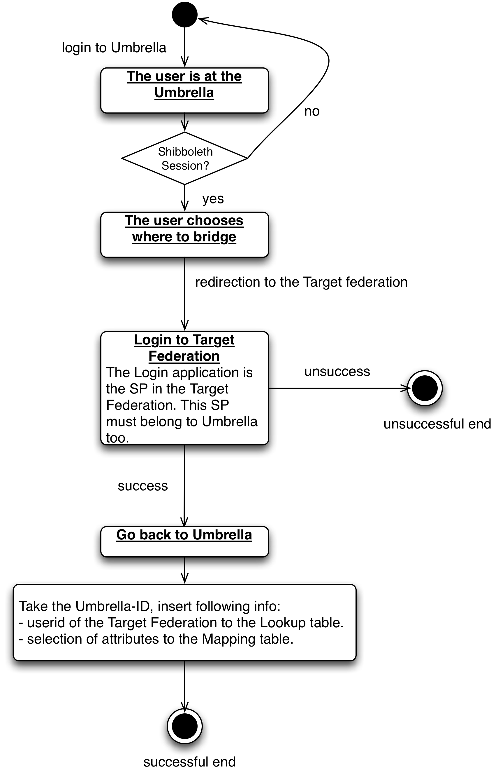
Figure 2: Building bridge
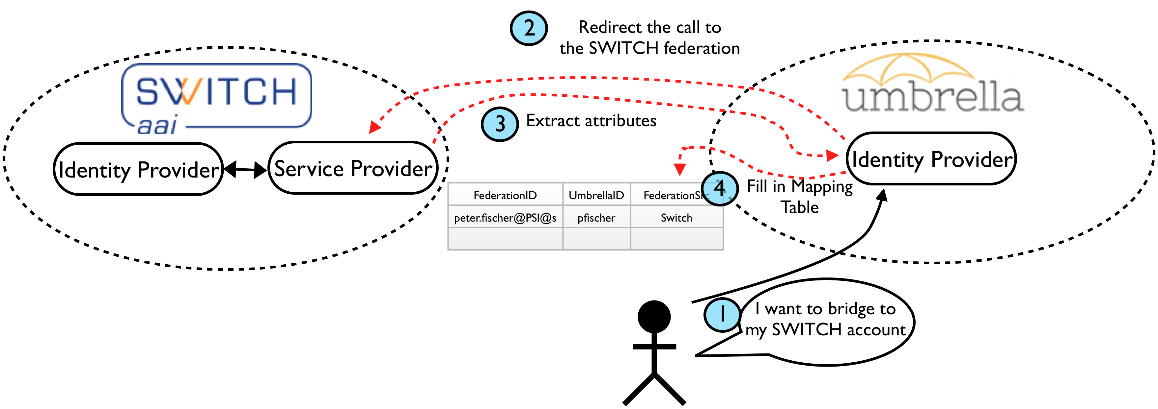
Figure 3:Building Bridge
The lookup table in the middle would look like Table 2: Linking of accounts, where three columns are shown:
- FederationID: a cross federation id.
- UmbrellaID: unique identifier of the user in the Umbrella Federation.
- FederationSource: the federation where the identity is coming from.

FederationID | UmbrellaID | FederationSource
peterfischer@ETHZ@switch | pfischer | Switch
peter.fischer@PSI@switch | pfischer | Switch
p.fischer@DIAMOND@Janet | pfischer | Janet
Table 2: Linking of accounts

This lookup table is filled in when the bridge is built, together with the attributes mapping table. These attributes are needed when accessing the bridge further. In order to access a service from the other federation by using the bridge, the set of attributes of the other federation need to be released, those are taken from the table.
Log-in through the bridge
A user wishes to use a Resource protected by a SP in an external federation. He is going to use the Umbrella credentials and has created a bridge to his account in the external federation.
The user will access the resource, and it will be asked to login. He gets redirected to the login page of Umbrella. He can create a session with the Umbrella credentials and, because the information is saved in the tables mentioned before, the information returned is the one mapped in those. Therefore the SP understands the information that gets back.
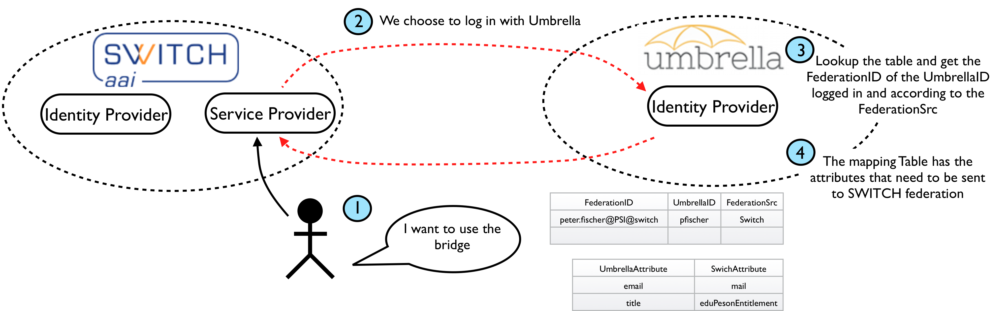
Figure 4: Connecting through the bridge built

Bridging prototypes
Next are presented two prototypes that follow the previous proposal exposed. The complete use cases, requirements, and solution are explained.

Umbrella-x509

The use case: Grid
As mentioned earlier in this document, the HEP community is successfully running a Federated way of accessing the resources. The grid computing model implements the PKI infrastructure, using x509 certificates. This is one of the target use cases to bridge to Umbrella. In this community, GSI-FAIR (http://fair-center.org/) organization is a member in the CRISP project; therefore it represents the link to this kind of federation.
4.1.1.1 GSI-FAIR
GSI-FAIR is a new international accelerator facility for the research of antiprotons and ions. It is located nearby GSI-Darmstadt. The GSI facility – once upgraded and together with a new proton linear accelerator – will serve as pre-accelerator and injector for the new complex.
It will gather different experiments and collaborations. There are four main pillars: APPA Physics (Atomic, Plasma Physics and Applications), nuclear matter physics, NUSTAR (Nuclear Structure, Astrophysics and Reactions) physics and physics with High Energy antiprotons. Collaborative work is done among different institutions and Universities.
Different experiments have no conflict of interests, as they try to reach diverse goals. Nevertheless confidentiality of data owned by the user is crucial.
There are two major experiments at GSI-FAIR with very similar computation to HEP experiments: Antiproton Annihilations at Darmstadt (PANDA) [12] and Compressed Baryonic Matter (CBM) [13]. The Grid middleware adopted for those experiments has been AliEn [14]. This is a lightweight Open Source Grid Framework developed by the ALICE (A Large Ion Collider Experiment) Collaboration at CERN that offers to the end user a transparent access to distributed computing and storage resources all over the world. It constitutes the production environment for simulation, reconstruction, and analysis of physics data of the ALICE, and in 2004 was adopted for PANDA, establishing one of the computing solutions. This middleware provides federated access to computational resources as well as a central data catalog. The concept of Virtual Organizations allows to dynamically sharing resources among different physical organizations, joining together people working for the same project.
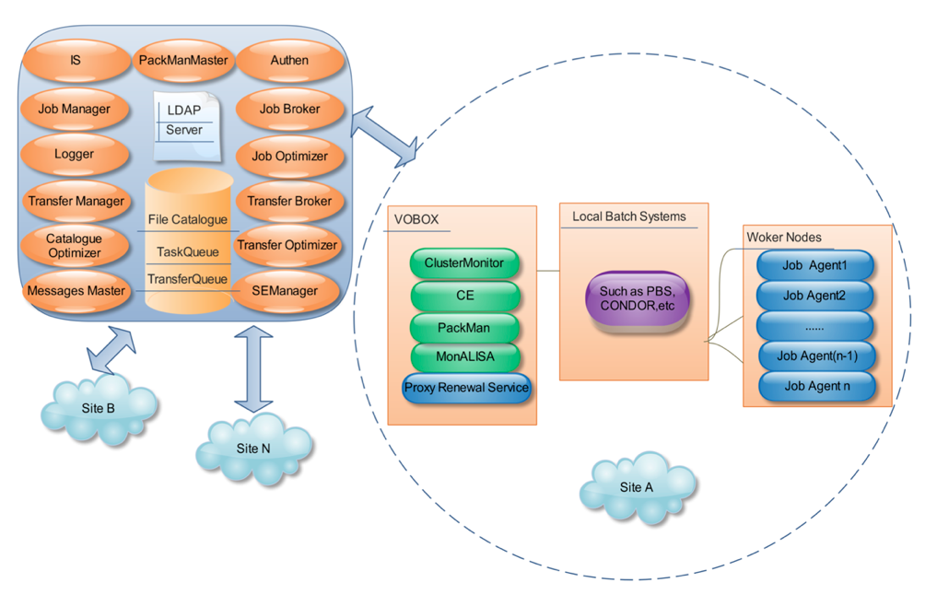
Figure 5: AliEn
The key processes involving authentication and authorization are described in Figure 5: AliEn. Authentication is implemented with x509 PKI. The SOAP messages are transported securely through SSL/TLS encryption. The x509 certificates provide each entity with a unique identifier and a method to assert that identifier to another party through the use of an asymmetric key pair bound to the identifier by the certificate. Proxy certificates are used in order to delegate credentials to remote servers and therefore to allow single-sign-on.
Authorization mechanisms are based on the File Catalog and the quota of each user, relating to job execution and amount of data. This mechanism is implemented inside AliEn and it is a step completely decoupled from Authentication.
Therefore, it is valid to consider that the majority of the users in the FAIR-GSI community hold their own personal x509 certificate.

Design proposal for bridging
The PKI model in the Grid is very scalable and efficient, but some users find it difficult to manage [18], because they have to manually deal with the request, installation, and possible updates of the certificates, and also because of the level of assurance required for a certificate to be trusted. Therefore, some communities have developed some solutions where the administrative tasks are removed by automatically providing certificates through, for example, portals or other tools inside a federation. Hence, a reduction on the administrative costs when having to manage new users.
In particular, Grid does not rely on web technologies. To accomplish the federated access to grids there are two main approaches:
- By leaving the federated identity management to the issuing authority, and generating certificates from accessible interfaces, like web or portals. This approach has been explored already explored from Terena Certificate Service and CILogon.
- Credential Conversion. This approach simply converts one type of credential to another; in this case the technical challenges are on the policy mappings and constraints and levels of assurance. One example in this direction is the EMI Translation Service that is used in the pilot project "CLI" from CERN. Nevertheless, this pilot project has demonstrated that translation of credentials, among other things, implies complex deployment and support.
Therefore, here the first approach is taken. Leaving the federation responsibility to Umbrella enables the possibility to generate certificates for a user from the portal, on demand.
There would be two directions of building the bridge, as seen in the Figure 6: Bridge AliEn and Umbrella.
The part of the left in this figure shows that through Umbrella, the user would get an x509 certificate generated from that Federation. Umbrella should be in the Certificate Authorities accepted by the AliEn Grid Federation, in order to be accepted. In this way, the provision of the certificate is immediate and automatic. Still, the authorization is duty of the Virtual Organization, as desired.
The right side of the figure shows the case when having already an x509 certificate. The user would have the possibility of building a bridge to the Umbrella Federation. As a result, the user could eventually have access to those Service Providers (SPs) in the Umbrella Federation, as the mapping would allow the user to release attributes to those SPs.
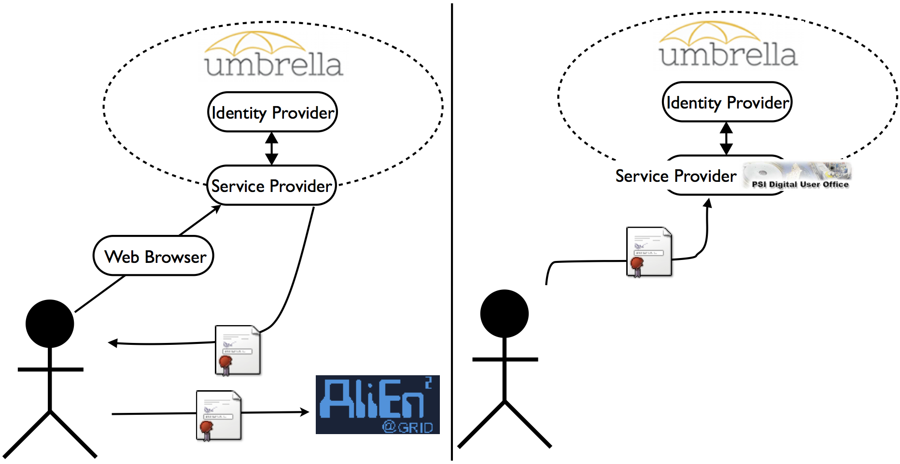
Figure 6: Bridge AliEn and Umbrella
Using x509 to authenticate to Umbrella
Umbrella needs to enable x509 login. Thus, the IdP must accept x509 certificates as a new way of authentication. For this, a x509 login handler [21] from the Shibboleth community is used.
This handler considers the certificates installed in the client browser. It extracts the subject information back to the IdP and sets the authentication context urn:oasis:names:tc:SAML:2.0:ac:classes:X509.
A new login page is also provided, that brings a new possibility for log-in, now with certificates. It is compatible with username password login, presenting in such front page this option too.
These two new components: handler and login page, should then be correctly placed in the handler configuration inside the IdP.
The authentication criteria for the certificates are defined in the web server in the IdP.
There are two phases when logging in: the authentication and, if successful, extraction of attributes. Attributes are extracted from the IdP Data Connector, such as LDAP, JDBC and so on. If the user authenticating is present in the IdP, attributes will be extracted.
A user that builds a bridge to this x509 certificate should authenticate with it. Upon authentication, the subject of such certificate is subtracted and transparently added a new record to the Lookup table that links this subject to the username.
Next, as the user wishes to use any other resource in Umbrella federation, he could choose either the certificate or the username/password of the Umbrella. When using the certificate, then, again transparently to the user, the subject is subtracted and the Umbrella identifier is looked up in the table. Since the bridge is built, then this Umbrella identifier is an existing user in the Umbrella federation.
Using Umbrella authenticate to x509
The project CILogon, already mentioned, aims to ease the administrative tasks of administering x509 certificates. It bridges the world of Institutional SAML Identity Providers and the world of Grid and Research Cyber-Infrastructure. Using CIlogon, a user with campus-provided credentials can download a relatively short-lived proxy certificate for user authentication by logging in to the CILogon service site. This can be used in both browser-based scenarios such as portals and in back-end service scenarios.
This functionality has been tested with a sample federation, and installed into AliEn Grid middleware at PANDA. This solution is promising for the expedition of x509 from the Umbrella federation.

Umbrella-eduGAIN
To be written.

Web-based vs Non-web based
As demonstrated along this document, a number of solutions are already available for federating access to web-based resources. That is, these solutions allow an organization providing services over the web to consume the identities of its research partners, business partners, customers or other affiliates. However, there is no good solution for to take these FIM solutions beyond the web such as e-mail, instant messaging, file sharing, or remote computing.
It is also of interest of this project to enable SSO federated solutions to access to computing resources and data storage. In this direction, Moonshot [15] is making an effort in implementing a SSO system for providing federated access to non-web-based resources using the eduroam [16] credentials.
Moonshot is an emerging tool that came to the picture of the FIM with the aim to cover the non-web based use cases, that, by the time the project started, there were no so good solutions, like the case of SAML for web based resources.
Moonshot proposes to combine three key security technologies: the Extensible Authentication Protocol (EAP), the Generic Security Services Application Programming Interface (GSS-API) and Security Assertion Markup Language (SAML) to create a solution for federated authentication. EAP is an authentication framework used in the eduroam federation for accessing to wireless network, while GSS-API simplifies integration with application protocols and applications, and SAML provides federation for the web.
The project is now in the phase of running a Pilot where different communities and use-cases will adopt this solution and bring it to a pre-production status.
This tool is particularly interesting; because the provision of the identities is done through SAML, hence open to connect to FIM solutions already existing.
Moonshot is also a good fit for Grid to ease the existing administrative tasks. The approach to be applied here would be the conversion of credentials, this means, authenticate users with Moonshot, and afterwards to convert this credential to a certificate. Here the technical challenges are in the correct conversion, ensuring that the attributes are fetched and converted appropriately.
Some steps have been done in this direction. To demonstrate the concept, there is a sample prototype of the Moonshot solution running on virtual machines at GSI. However, further progress will be left as a Future work because Moonshot is not yet recommended to be deployed or used in any infrastructure by the time of writing this document.

Roadmap and Future work
To be written.

Bibliography
[1] Abt, B. et al., Umbrella, https://umbrella.psi.ch
[2] NREN, http://en.wikipedia.org/wiki/National_research_and_education_network
[3] IDaaS: https://cloudsecurityalliance.org/guidance/csaguide-dom12-v2.10.pdf
[3] Broeder, D. et al., Federated Identity Management for Research Collaborations, https://cdsweb.cern.ch/record/1442597
[4] http://indico.psi.ch/conferenceDisplay.py?confId=2230
[4] Foster, I. et al., The Anatomy of the Grid: Enabling Scalable Virtual Organizations, International Journal of High Performance Computing Applications
[5] Worldwide LHC Computing Grid, http://wlcg.web.cern.ch/
[6] International Grid Trust Federation, http://www.igtf.net/
[7] TERENA, http://www.terena.org/
[8] edugain, http://www.geant.net/service/eduGAIN/Pages/home.aspx
[9] Security Assertion Markup Language, http://www.oasis-open.org/committees/download.php/27819/sstc-saml-tech-overview-2.0-cd-02.pdf
[10] Heimdal kerberos, http://www.h5l.org/
[11] Openldap, http://www.openldap.org/
[12] AliEn, http://alien2.cern.ch/
[13] PANDA, http://www-panda.gsi.de/
[14] CBM, http://www.fair-center.eu/for-users/experiments/cbm.html
[15] Moonshot, https://community.ja.net/groups/moonshot
[16] eduroam, http://www.eduroam.edu.au/
[17] http://indico.psi.ch/confRegistrationFormDisplay.py/display?confId=2230
[18] AAI needs for Distributed Computing Infrastructures (DCIs). EU EMI project, https://twiki.cern.ch/twiki/pub/EMI/EmiJra1T4Security/AAI_DCI_v0.2.pdf
[19] http://www.geant.net/service/edugain/resources/Documents/Introduction%20to%20the%20eduGAIN%20policy%20framework.pdf
[20] http://saml2int.org/
[21] https://wiki.shibboleth.net/confluence/display/SHIB2/X.509+Login+Handler

