**Title**: Creating and Customizing Authoring Reports.

**1. Introduction**

In today's data-driven world, reports are essential for communicating insights, tracking performance, and supporting informed decision-making across various industries. Creating and customizing reports involves structuring information in a clear, engaging, and audience-specific manner to ensure maximum impact. This process includes selecting the right tools, integrating data sources, designing visual elements, and tailoring content to meet specific business or technical needs. By leveraging modern reporting tools and best practices, organizations can enhance clarity, improve collaboration, and deliver reports that provide actionable insights efficiently.

**2. Importance of Authoring Reports**

* **Decision-Making:** Reports often serve as the foundation for business decisions, project evaluations, and strategic planning. Well-authored reports distill complex data into actionable insights.
* **Audience-Specific Communication:** The customization of reports ensures that the content is relevant to different audiences, such as managers, executives, technical teams, or clients.
* **Performance Tracking:** Reports can track key performance indicators (KPIs), project progress, financial performance, and operational efficiencies, providing stakeholders with essential data to gauge success.
* **Documentation and Compliance:** Authoring reports is vital for record-keeping, audit purposes, and compliance with industry regulations. Clear reports ensure transparency and accountability.

**3. Key Components of an Authoring Report**

1. **Title Page**
   * Includes the report’s title, date, author name, and any other relevant metadata.
   * Helps in identifying the purpose and the context of the report quickly.
2. **Table of Contents**
   * Provides a roadmap for navigating the report.
   * Allows readers to quickly jump to sections of interest.
3. **Executive Summary**
   * Summarizes key findings, conclusions, and recommendations.
   * Targeted towards senior stakeholders, offering them a high-level view without delving into details.
4. **Introduction**
   * Explains the background of the report, including its objectives, scope, and methodology.
   * Outlines the purpose of the report and the problem being addressed.
5. **Methodology**
   * Describes how data was collected, analyzed, and processed.
   * For technical reports, this could include statistical methods, survey designs, or tools used.
6. **Body of the Report**
   * The main section, containing detailed findings, analysis, and discussions.
   * Often divided into sub-sections that focus on various aspects of the topic.
   * Includes data visualizations like graphs, tables, and charts to support conclusions.
7. **Conclusion and Recommendations**
   * Summarizes the key insights drawn from the report.
   * Provides actionable recommendations based on the findings.
   * Suggests possible next steps or future research.
8. **Appendices**
   * Includes supplementary materials like raw data, detailed calculations, or technical specifications.
   * Helps keep the main body of the report concise and focused.

**4. Steps in Creating and Customizing Authoring Reports**

1. **Define the Report’s Objective**
   * Establish a clear understanding of the report’s purpose. What questions does the report aim to answer? For example, is it meant to provide insights on sales performance, customer satisfaction, or project timelines?
   * Understand the report's role in decision-making: Does it provide an analysis, give recommendations, or serve as a status update?
2. **Understand the Target Audience**
   * Different stakeholders have different needs:
     + **Executives and Managers:** Require high-level insights and strategic overviews, often with an emphasis on metrics and KPIs.
     + **Technical Teams:** Need detailed data, methodologies, and in-depth analysis.
     + **Clients or Customers:** Want clear results, often with a focus on outcomes and value delivered.
   * Knowing the audience helps shape the tone, content, and level of detail in the report.
3. **Data Collection and Preparation**
   * Identify data sources (e.g., databases, spreadsheets, surveys, sensors).
   * Gather, clean, and organize data to ensure accuracy and completeness. This might involve removing duplicates, correcting errors, and handling missing values.
   * Transform data into a format suitable for analysis. In cases where data is spread across multiple sources, integration or aggregation may be required.
4. **Select Reporting Tools and Platforms**
   * **Excel:** Common for simple, one-off reports and data manipulation.
   * **Business Intelligence (BI) Tools (e.g., Power BI, Tableau):** Used for more dynamic, interactive, and visual reports that allow users to explore data in real-time.
   * **Reporting Software (e.g., Crystal Reports, SAP BusinessObjects):** Provides templates and advanced features for creating highly formatted and structured reports.
   * **Custom Development:** For complex reporting needs, developers might create tailored reports using tools like Python, R, or web-based frameworks.
5. **Design the Report Layout**
   * **Organize Sections:** Define logical and consistent sections within the report. Use headings, subheadings, bullet points, and numbering to break down the content.
   * **Balance Text and Visuals:** Reports should balance narrative sections with data visualizations (graphs, tables, charts). Overloading the report with text or visuals can overwhelm the reader.
   * **Usability:** Ensure the report is easy to read and understand. Use appropriate font sizes, colors, and spacing for better readability.
6. **Customization of Report Features**
   * **Visual Elements:**
     + Select the right types of visualizations (e.g., bar charts, pie charts, line graphs, heatmaps) based on the data.
     + Customize visual elements to highlight trends, comparisons, or outliers.
     + Tailor color schemes to enhance clarity and ensure accessibility (e.g., colorblind-friendly palettes).
   * **Conditional Formatting:** Highlight specific data points or trends using conditional formatting, such as color-coding negative and positive values, highlighting outliers, or applying data bars.
   * **Dynamic Content (for Interactive Reports):** BI tools allow for interactivity, such as the ability to drill down into data, apply filters, and explore different data views based on user preferences.
7. **Incorporate Calculations and Metrics**
   * Derive key metrics or KPIs that provide insights from raw data. For example, averages, growth rates, profit margins, or customer retention rates.
   * Customize formulas and functions based on the specific needs of the report. Some reports may require custom metrics or complex statistical analysis.
8. **Review and Revise**
   * Review the report for consistency, accuracy, and clarity. Validate that the data and analysis align with the objectives of the report.
   * Seek feedback from colleagues or stakeholders before finalizing the report to ensure it meets the target audience's needs.
9. **Distribute and Share the Report**
   * **Static Reports:** PDFs, Word documents, or printed copies can be used for one-time reports or for distribution in meetings.
   * **Dynamic Reports:** Web-based reports, dashboards, and BI tools offer the advantage of interactivity and real-time updates.
   * **Automation:** Consider automating the generation and distribution of regular reports using scheduled tasks or tools that generate reports at predefined intervals.

**5. Customization Techniques**

* **Report Filters:** Allow report recipients to focus on specific subsets of data, such as filtering by time period, region, department, or product category. Filters enhance the usability of reports, particularly for large datasets.
* **Theming and Branding:** Tailor the report's appearance to align with the organization's visual identity. This may include adding company logos, color schemes, fonts, and other design elements.
* **Interactive Features:** In digital reports, interactive elements like drop-down menus, buttons, and sliders allow users to adjust data visualizations and focus on what matters most to them.
* **Tailored Summaries:** For audiences that only need high-level insights, tailor summaries or executive overviews to focus only on the most relevant metrics and findings.

**6. Tools for Authoring Reports**

A wide range of tools are available to facilitate the creation, customization, and sharing of reports. These tools cater to different needs, from basic text-based reports to advanced data visualization and collaboration:

1. **Word Processing Tools:**
   * Microsoft Word and Google Docs are widely used for creating structured, text-based reports with formatting and styling options.
2. **Business Intelligence Tools:**
   * Power BI, Tableau, and Looker provide dynamic, data-driven reports with interactive dashboards and advanced visualizations.
3. **Spreadsheet Software:**
   * Excel and Google Sheets enable data analysis, simple chart creation, and tabular reporting.
4. **Report Writing Software:**
   * Crystal Reports and JasperReports generate structured, pre-formatted reports, making them ideal for automated reporting.
5. **Online Collaboration Tools:**
   * Notion, Confluence, and other collaborative platforms help teams co-author, edit, and share reports efficiently.

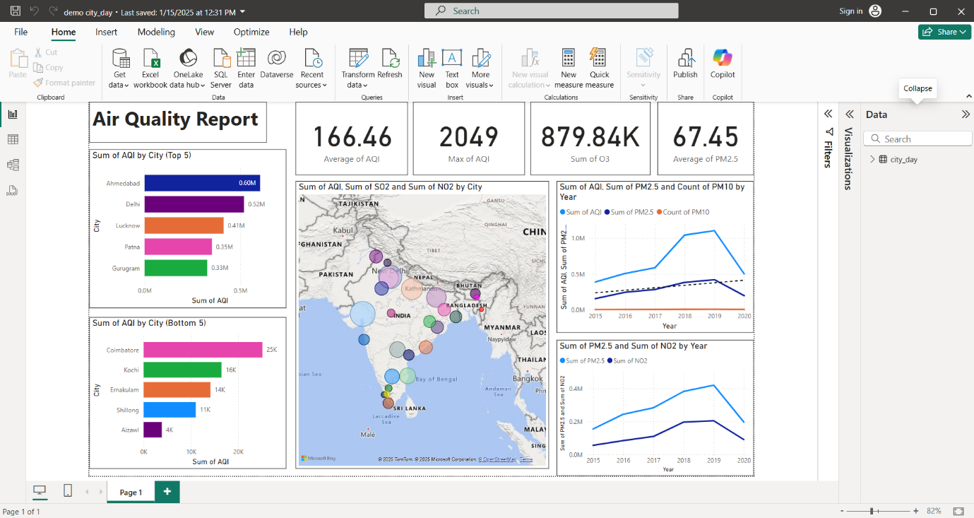

**7. Challenges in Authoring Reports**

Creating effective reports involves several challenges that can impact their accuracy, readability, and usefulness:

1. **Ensuring Data Accuracy:**
   * Incorrect or outdated data can compromise the report’s credibility.
   * Always verify sources and use data validation techniques.
2. **Engaging the Audience:**
   * Overly complex or monotonous reports may fail to capture attention.
   * Use visuals, clear formatting, and concise language to enhance readability.
3. **Managing Time Constraints:**
   * Tight deadlines can lead to rushed, lower-quality reports.
   * Plan ahead and automate repetitive tasks to improve efficiency.
4. **Balancing Detail and Simplicity:**
   * Providing excessive detail can overwhelm readers, while oversimplifying may omit key insights.
   * Aim for clarity by structuring content effectively and focusing on essential information.
5. **Customization vs. Standardization:**
   * Striking a balance between standardized formats and customized content requires additional effort.
   * Use templates and automation tools to streamline report generation while allowing necessary customizations.

**8. Best Practices for Authoring Reports**

* **Clarity and Simplicity:** Avoid overcomplicating the report. Use clear language, avoid jargon (unless necessary), and ensure the report is structured logically.
* **Consistency:** Ensure consistent formatting, color schemes, and data presentation. Inconsistent styles can confuse readers and detract from the message.
* **Actionable Insights:** Focus on providing recommendations or conclusions that can help the audience take action based on the report's findings.
* **Test and Review:** Test the report's functionality (if interactive) and accuracy before sharing it widely. A review process can ensure that all critical aspects are covered.
* **Timeliness:** Ensure the report is distributed at the right time to allow stakeholders to act on the information promptly.

**9. Conclusion**

Creating and customizing authoring reports is a vital process in transforming raw data into structured, actionable insights for decision-making. By following a clear methodology, utilizing the right tools, and customizing reports to meet specific audience needs, reports can become powerful tools for communication, performance tracking, and business strategy. Tailoring the layout, visuals, and content to suit the objectives and audience of the report will enhance its impact and utility, ensuring it provides value and drives decisions.