Architecture

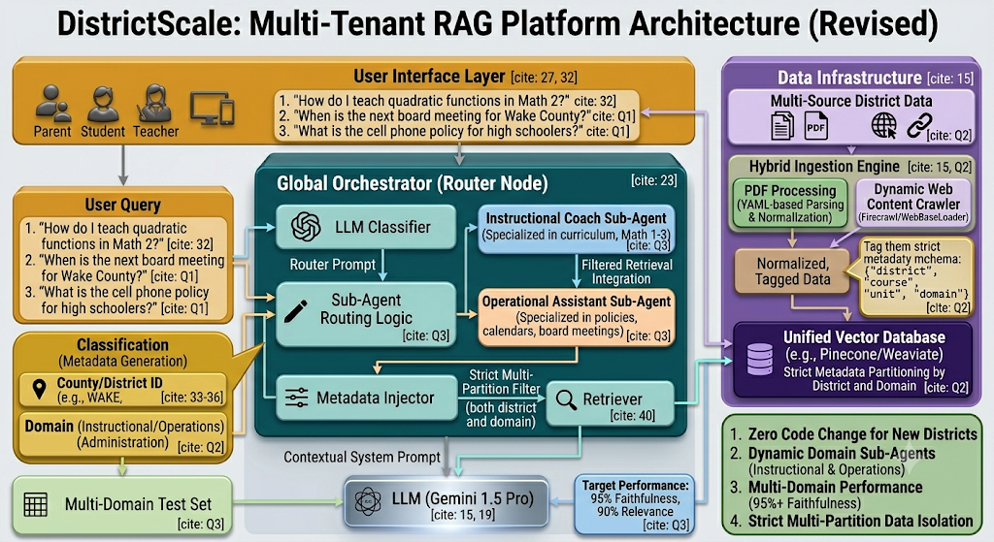
Scope
One agent – Route to parent/student or teacher based on the context or prompt
Orchestrator – langraph
UI -> Login -> nice to have ->
Add a disclaimer - this was created for learning purpose
Please refer to county’s website for actual info. This is only for our project
Data Persistence -> sql lite -> Nice to have

Is Agent to Agent AtoA protocol needed?

https://developers.googleblog.com/en/a2a-a-new-era-of-agent-interoperability/

Git hub link: https://github.com/satsraja12-eng/wc-math-rag/blob/main/README.md

Deployment : Azure , Copilot
Vercel/Railway

- UI design -> login screen with authentication and authorization (TBD)
- UI should have a single chatbot
- Based on the question orchestration layer (Langraph) routes to the correct agent: Parent,Student,Teacher agents
- Agent -> Parent/Student/Teacher
- Langraph is the orchestration layer
- Vectordatabase -> PINECONE or chromadb
- Guardrails (TBD)
- Put some input data/corpus data -> start with one specific county or district
- Scope -> Highschool/Middleschool Math curriculum and within 2 or 3 counties within NC
- Collin County Texas – Frisco ISD high school curriculum
- Plano ISD high school curriculam
- Wake County NV -

- For security -> come up with some guard rails -> Login – Authentication/authorization
- Evals for data accuracy (Langsmith or fireworks) -> LLM as a judge/prompt sensitity/
- Add finetuning (optional)
- One agent – Route to parent/student or teacher based on the context or prompt
- Orchestrator - langraph

