Team Breakout Handout
Deadline to submit: 23rd June 7pm PT
Meet your team, pick one use case, and sketch an end to end AI agent design. You have 15 minutes. You are not expected to finish, this is just the start.
1 Who is on this team
Add everyone’s full name and email. Leave the last rows for members who join your team later.
# | Full name | Email
1 | Vidya Gopal | Vidyagopal01@gmail.com
2 | Sudhir Yadunath | sudhircy@gmail.com
3 | Vamsidhar Dokiparthi | dokiparthi@gmail.com
4 | Anushree Vijay Naik | anushree317@gmail.com
5 | Omar Raja | omar.raja11@gmail.com
6 | Sathish Rajaraman | sats.raja12@gmail.com
7 | Rajeswari J | Rajesrijupiter3@gmail.com
Point person (owns this doc and coordinates the team): Sathish Rajaraman

2 Warm up: go around the room
Icebreaker.
Sathish from Cary NC. I would like to have an agent that crawls through my work laptop , emails, Jira , sharepoints and checks for any specific reminders or follow up that I need to do for the day rather than rely on a calendar or manually add a reminder myself. We have decided to adopt this project as a team since we all like learning.

Hello Everyone, I am Sudhair from New York. I am interested in adopting the project that covers the learning platform suggested by Satish. Hence, we have decided to go adopt this for our project submission as a team.

Hello everyone, I’m Vidya, joining from Frisco, Texas.
I'd happily hand off an AI agent that turns meetings into action by automatically capturing decisions, creating tasks, assigning owners, tracking progress, and ensuring nothing falls through the cracks.

For this journey, I like the project that was suggested by Satish since it involved education and I like anything with education. Hence we have decided to go adopt this for our project submission as a team.

Hello Everyone, I am Vamsidhar Dokiparthi from Atlanta, Georgia
An AI agent that plans meals, manages grocery shopping, tracks pantry inventory, and helps families save time, money, and food waste.

For this journey, I like the project that was suggested by Satish since it involved education and I like anything with education. Hence, we have decided to go adopt this for our project submission as a team.

Hi, I am Anushree from San Francisco, Bay Area.
I like the project that was suggested by Satish since it involved education and I like anything with education. Hence we have decided to go adopt this for our project submission as a team.

Hi, I am Rajeswari J, from San Jose, California, Bay Area.
I like the project that was suggested by Satish since it involved education and I like anything with education. Hence, we have decided to adopt this for our project submission as a team.

Hi, I am Omar Raja, from Dallas, Texas.
I like the project that was suggested by Satish since it involved education, and I like anything with education. Hence, we have decided to adopt this for our project submission as a team.

3 Pick a topic and sketch the design
Talk through these three questions together, then jot your thinking below.
Q1. Pick the use case. A localized, student-centric AI assistant that serves as a single point of truth for families and educators, acting as an instructional coach and administrative helper across multiple NC counties. It will support curriculum guidance (Math 1, 2, 3) and operational queries (policies, calendars, board meetings).

Q2. Knowledge and tools. The agent utilizes a Router-and-Specialist architecture powered by a Hybrid Ingestion Engine and a metadata-aware vector retrieval system.

- Knowledge Sources:
  - Curriculum Knowledge: Ingests structured instructional materials (PDFs, Docx) via a YAML-driven normalization pipeline, ensuring consistent parsing across different district formats.
  - Operational Knowledge: Real-time data ingested via an automated crawler (Firecrawl/WebBaseLoader) that scrapes district calendars, board meeting minutes, and policy pages.
  - Contextual Knowledge: Metadata-tagged data (District ID, Course, Unit) enabling precise, secure, and isolated context retrieval for every student.
- Reasoning Engine: Gemini 1.5 Pro provides high-context reasoning for intent classification, synthesis, and specialist agent task execution.
- Orchestration Framework: LangGraph (Python) manages stateful multi-agent workflows. It utilizes conditional edges for dynamic intent-based routing and maintains a persistent 'State' object for cross-domain context tracking across parent/student sessions.
- Vector Storage: Pinecone or Weaviate serves as the primary Vector Database, implementing high-performance metadata filtering to partition data by District, Course, and Domain.
- Data Ingestion Stack:
  - Static Pipeline: A YAML-driven normalization pipeline that enforces structural consistency on disparate curriculum documents.
  - Dynamic Pipeline: Firecrawl/WebBaseLoader automates the ingestion of district-specific web content, calendars, and policy pages.
  - Note: Raje and Vidya discussed – Can we use snowflake/sqllite/any other database for data persistence? Collection of data (educational PDF) needs to be dedicated to two resources. (search by API call or google search from the web. From Satish: Do we need a persistence database like sqllite,snowflake or is vectordb sufficient for this usecase?)
- Functional Architecture Blocks:
  - Ingestion Block: Dual-stream pipeline (PDF Normalizer & Web Crawler) that extracts content, chunks data, and enriches it with mandatory uniform metadata.
  - Retrieval Block: A filtered similarity engine that locks query scope based on the Router-determined metadata (e.g., District == 'Wake').
  - RAG -chunking?
- End-to-End Data Flow:
  - Ingestion: Raw Source (PDF/URL) → Normalizer/Scraper → Embedding Model → Vector Database.
  - Query: User Input → Global Orchestrator (Intent Detection) → State Construction → Metadata Filter Application → Vector DB Retrieval → Specialist Agent (Context-aware generation) → Final Response.

Q3. Autonomy and evals. The agent operates as a multi-domain School District Assistant. Autonomy is managed by a Global Orchestrator that routes queries to specialized sub-agents based on intent and district context. We will evaluate performance using a multi-domain test set (Instructional + Administrative) and measure against a target of 95% faithfulness and 90% relevance.

4 Our project
Use the space below to capture your use case and how you would design the agent. Bullet points are fine.

Our Project: Ed-Copilot (POC Phase)
This project creates an AI-powered "Co-pilot for Families," serving as a unified "front door" for student and parent needs. We are evolving our Math RAG proof-of-concept into a multi-tenant, domain-agnostic platform.
Deployment : Azure , Copilot
Vercel/Railway

Elevator Pitch
Ed-Copilot is the intelligent "front door" to the K-12 experience, unifying fragmented curriculum and district operations into a single, secure, and conversational interface. Our vision is to empower students and parents with a trusted AI partner—starting with immediate instructional coaching and administrative support, and evolving into a dedicated guidance engine that proactively maps individual pathways from early curriculum milestones all the way through to college and career success. We are building the foundational digital infrastructure to transform how families, students, and districts interact through this family-centered platform.
- UI design -> login screen with authentication and authorization (TBD)
- UI should have a single chatbot
- Based on the question orchestration layer (Langraph) routes to the correct agent: Parent,Student,Teacher agents
Core Components:
- The Global Orchestrator: Uses a "Router-and-Specialist" pattern to route intents—whether instructional (Math/Curriculum) or administrative (Policies/Calendars)—to the appropriate agent.
- Agent -> Parent/Student/Teacher
- Langraph is the orchestration layer
- Hybrid Ingestion Engine: Automates the processing of diverse data sources (PDFs, web-based calendars, and policies), normalizing them into a unified, queryable knowledge base.
- Vectordatabase -> PINECONE or chromadb
- Multi-Tenant Architecture: Employs metadata-centric partitioning to ensure district-specific and student-relevant data is accurate, secure, and isolated.
- Guardrails (TBD)
- Put some input data/corpus data -> start with one specific county or district
- Scope -> Highschool Math curriculam
- For security -> come up with some guard rails
- Evals for data accuracy (Langsmith or fireworks) -> LLM as a judge/prompt sensitity/
- Add finetuning (optional)

Scope:
- POC Scope (3 Weeks):
  - Domain 1: Instructional (Math Coaching).
  - Domain 2: Administrative (Policies, Calendars, Board Meetings).
- Future Extensions: Expansion into additional instructional domains (e.g., Science, Humanities, ELA) and integration of College Guidance & Pathway planning.
Phased Implementation Plan (3-Week POC):
- Week 1: Foundation. Build the Global Orchestrator (LangGraph), implement the Math Specialist, and load sample Math curriculum.
- Week 2: Expansion. Implement the Web Crawler (e.g., Firecrawl/WebBaseLoader) for the Administrative domain (Policies/Calendars) and integrate the Admin Specialist.
Week 3: Integration. Perform end-to-end testing, finalize multi-domain routing, and prepare the demo for stakeholders.
Next step. Agree how and when you will meet over the next 3 weeks. Building a prototype is optional but highly recommended. Just give us the architecture pitch.

Architecture

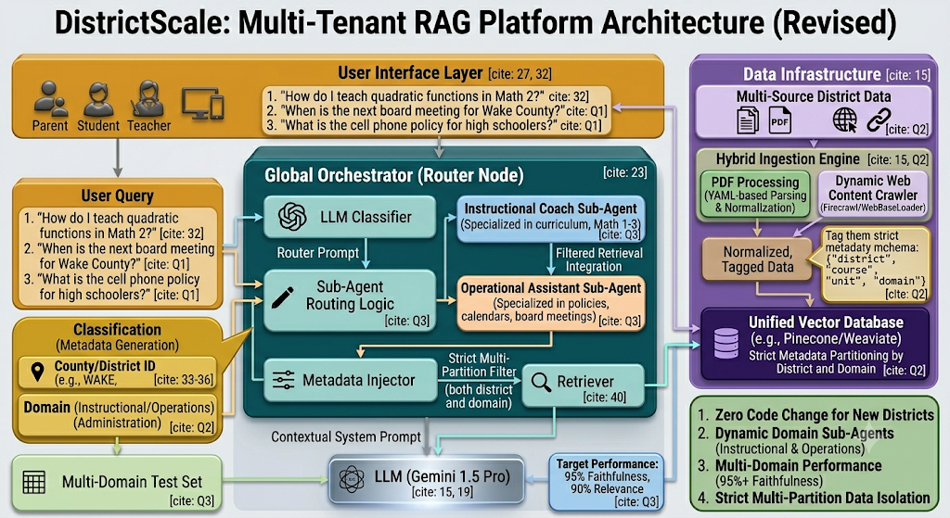

Foundational Architectural Principles:
- Modular Router-First Design: Our "Global Orchestrator" separates user requests from domain-specific intelligence. This enables the seamless integration of future experts—like Attendance or Policy sub-agents—without disrupting the primary architecture.
- Multi-Tenant Metadata Framework: Leveraging unified tags for Domain, Course, and District ensures robust data privacy and isolation, allowing a single vector store to safely manage concurrent school districts.
- Durable Hybrid Knowledge Ingestion: This pipeline transforms all incoming information—from static curriculum documents to live web updates—into standardized segments, guaranteeing a reliable and uniform retrieval process.
- High-Scalability Infrastructure: Engineered for rapid expansion with minimal code; incorporating a new subject or district is achieved through configuration updates rather than modifying core logic.

Architectural Foundation for Future Extensions

Our "Router-and-Specialist" architecture is intentionally designed to support complex, multi-modal agents like the College Guidance Counselor without requiring system re-engineering.
- Plug-and-Play Specialist Integration: Because the Global Orchestrator decouples intent from execution, adding a "College Guidance Specialist" is a modular task. We simply add a new domain-specific specialist node to the graph and update the Router to recognize guidance-related queries (e.g., "prerequisites," "pathways," "college application").
- Leveraging the Hybrid Ingestion Engine: College guidance requires diverse data—from university admissions websites (scraped via web crawler) to high school graduation prerequisite PDFs. Our engine is already primed to ingest and normalize these distinct data formats into the same unified vector store, ensuring the Guidance agent operates on consistent, up-to-date information.
- Contextual Data Continuity: Since our architecture maintains a shared metadata fabric (District, Grade, Course History), the Guidance Specialist is "aware" of the student's background from previous interactions with the Math and Administrative agents. This allows for personalized pathway recommendations (e.g., linking a student’s current Algebra 2 enrollment to specific Engineering or STEM pathways) without the student needing to repeat their academic history.
- State-Aware Orchestration: The Global Orchestrator serves as the conversation hub. When a user transitions from an instructional question ("How do I solve this?") to a guidance question ("What does this course mean for my college options?"), the architecture preserves the conversation context, enabling a seamless transition between agents.

