## PHASE - 03

## WEBSITE TRAFFIC ANALYSIS



**INTRODUCTION:**

This project involves analyzing website traffic data to gain insights into user behavior, popular pages, and traffic sources. The primary goal is to assist website owners in enhancing the user experience by gaining a comprehensive understanding of how visitors interact with the site.

**OBJECTIVE:**

The primary objectives of this project are:

* To understand user behavior on the website.
* To identify popular pages and features.
* To determine the sources of website traffic.
* To provide actionable insights for website owners to enhance the user experience.

**LOADING DATA:**

We can load the data from the given dataset using the following commands as shown:

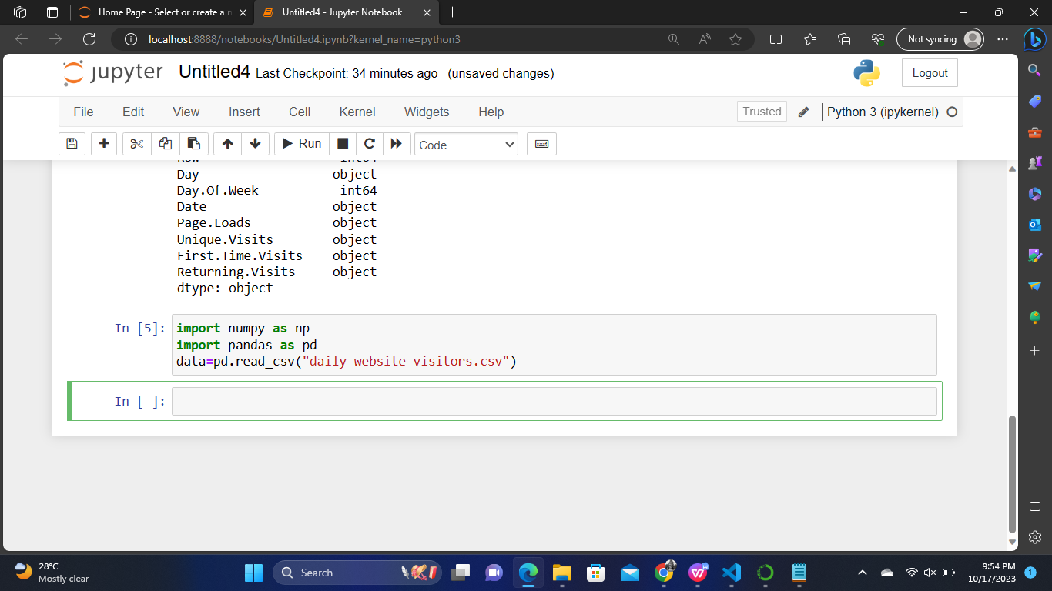

**DATA EXPLORATION:**

We can get initial understanding of the data's structure and contents using the following commands as shown:

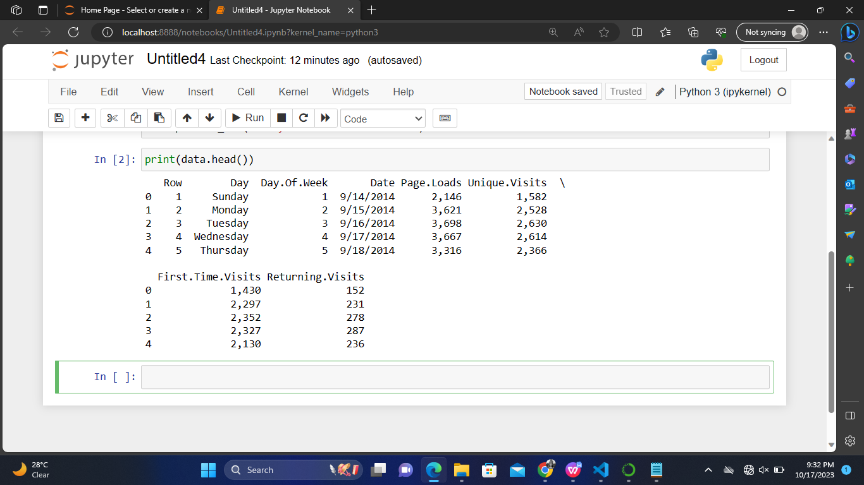

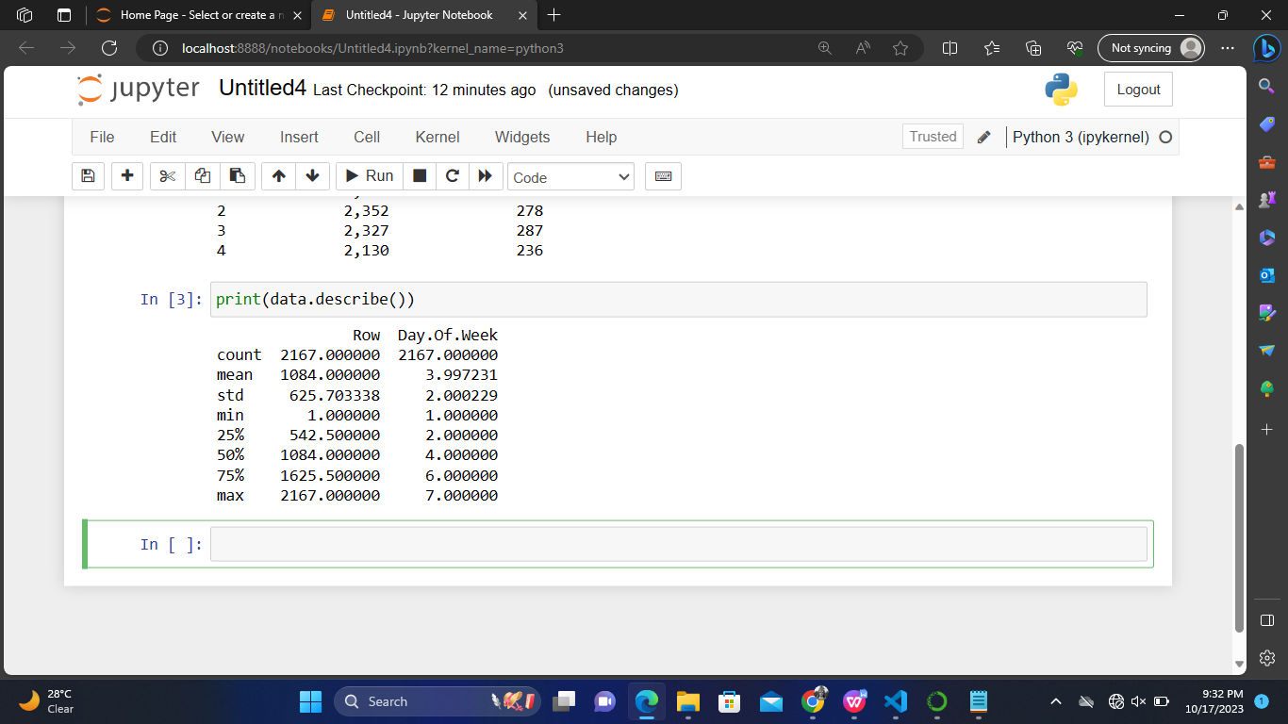

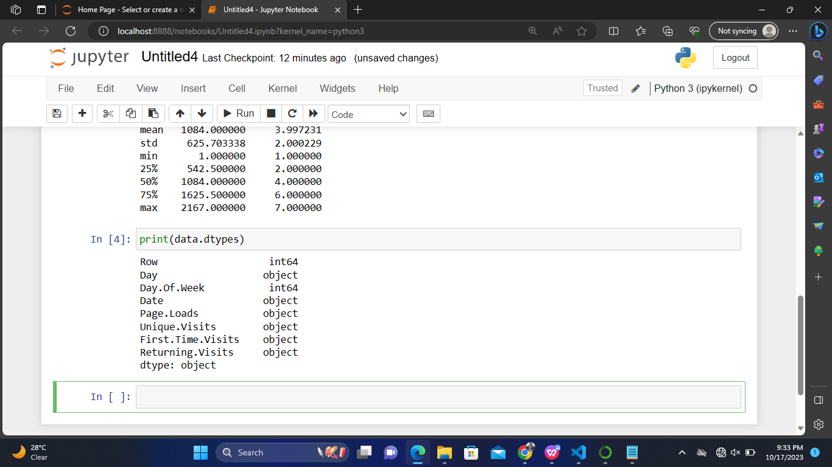

**DATA PROCESSING AND CLEANING:**

Processing data in data analysis is a critical step that involves various tasks to clean, transform, and prepare data for meaningful insights and decision-making. The data processing phase ensures that the data is in a suitable format, quality, and structure for analysis.

We can process and clean the loaded data by using the following methods:

**HANDLING MISSING DATA:**

We can the handle the missing data in our data using the commands as shown:

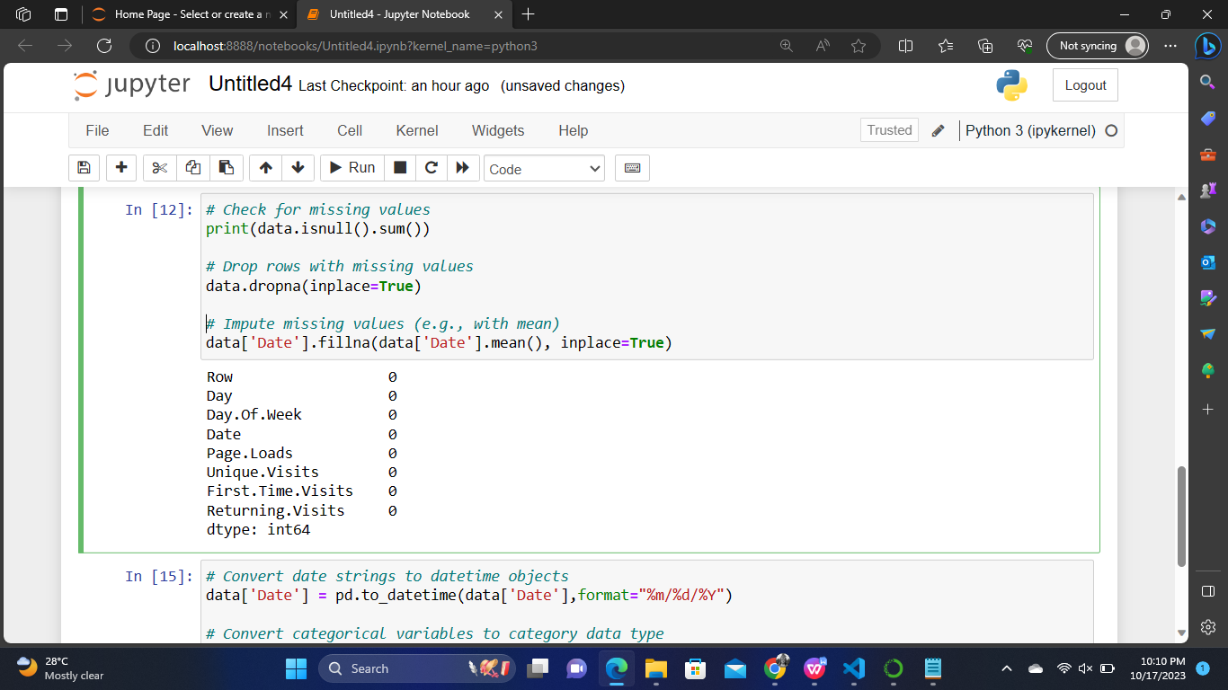

Here we have no null values with the given dataset so handling the missing values can be optional

**DATA TYPE AND CONVERSION:**

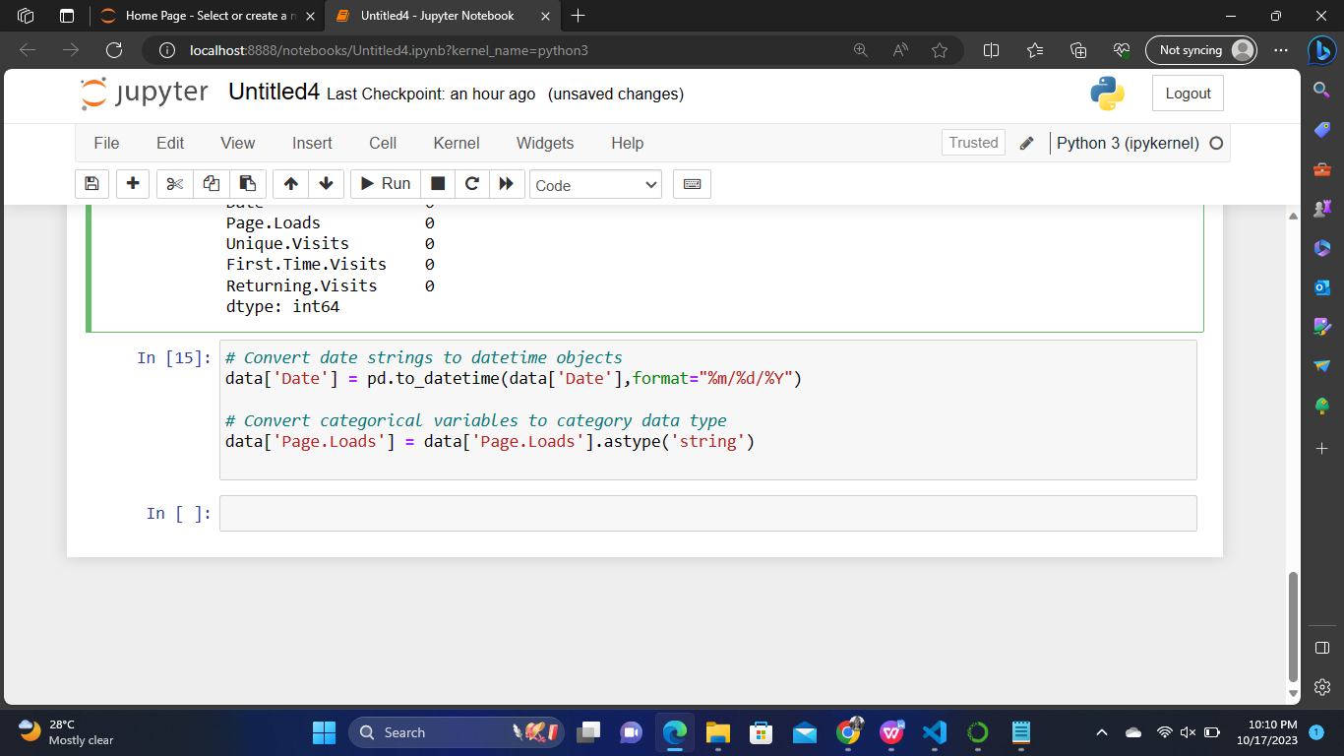

We can convert our data in the convenient manner for analysis the data.

**DATA CONSISTENCY:**

We can address inconsistencies like duplicate records and drop those records to make our dataset clean and neat for analysis the data.

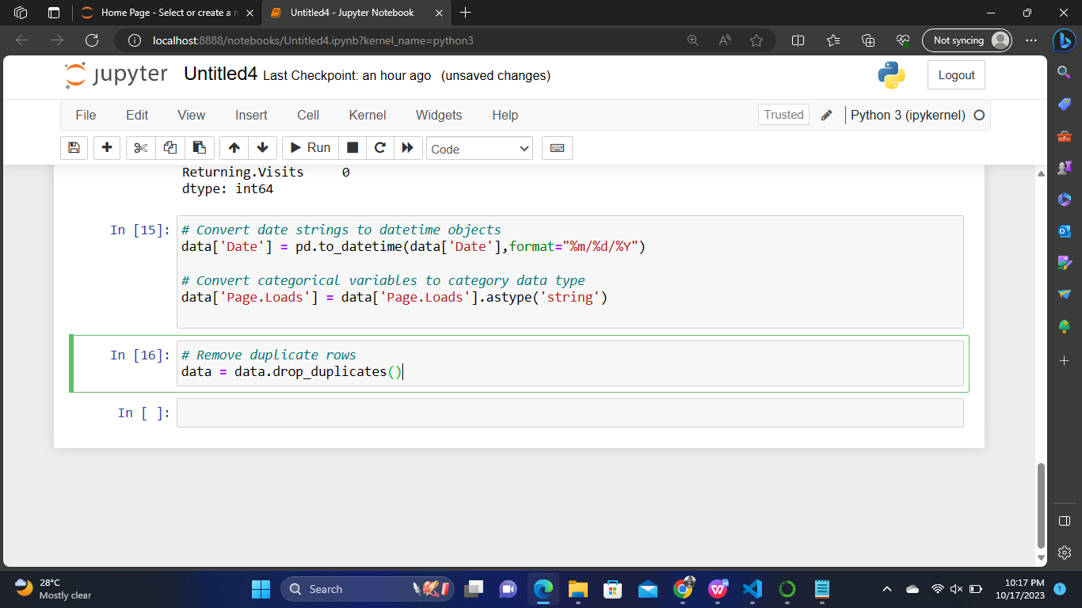

**CONCLUSION:**

From the above methods, we have performed the data processing and cleaning of dataset given to analysis the website traffic.

This way of processing and cleaning make our data more accurate and ensures that the data is in a suitable format, quality, and structure for analysis.

This phase also gives more details about the given data which makes it more easier to analyze the data for making predictions on the website traffic.

**PROJECT DONE BY :**

GIRIVASAN.K [511321205008]

SAKTHIVEL.R [511321205026]

POOVARASAN.M [511321205023]

SARAVANAN.C [511321205032]