Will Flowers

Comp 116

7/25/13

Dr. Zhang

Final Project-Average Temperature over Time

For my final project I attempted to look at two questions about weather in the last 30 years. How has the average temperature changed? Does the average amount of precipitation each year affect the average temperature? To study these questions I used data collected in the Raleigh/Durham area from the National Climatic Data Center (NCDC) (Global Summary of the Day). I used python to write a program to import specific data from the downloaded files, and write that data to a new file. Then I extracted that data, and performed some statistical analysis of it, and wrote that to a new file. I then graphed some of data and results.

From NCDC I used data collected at the Raleigh/Durham station. I specifically used the daily average temperature, daily maximum temperature, daily minimum temperature (Degrees Fahrenheit), and the daily amount of precipitation (Inches). I computed the mean of all the daily average, max, min, and precipitation for each year between 1982 and 2012 (inclusive). Of each of these this data sets, I calculated the mean, median, standard deviation, and variance. I also calculated the correlation coefficient between the average temperature of each year, and the average precipitation.

Has the temperature risen? My data seems to say maybe a little. The average temperature in 1982 was 59.7, and the average temperature in 2012 was 62.18. As shown in the graph below, there are ups and downs, but with a standard deviation of only 1.2, the temperatures are pretty closely packed together. There is definitely controversy surrounding this issue, and the bigger issue of global warming. Says Hons Van Storch, a German Scientist in an interview for CNS news, just days ago, “…the past 15 years shows an increase of [.11(Fahrenheit)] or ‘very close to zero.’” The mean of the average temperatures was 60.17, not far from the mean of the year 1982, 59.7. The data does suggest some increase, but it is also hard generalize one location’s data, for the world.

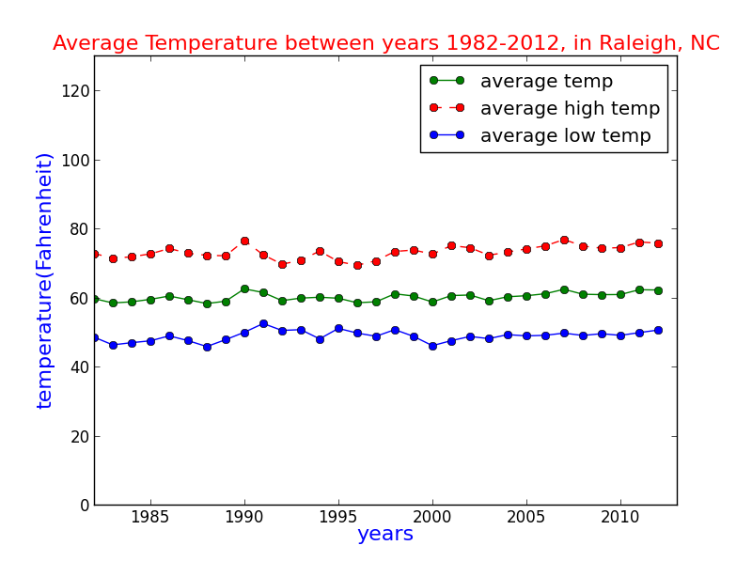

Does the amount of precipitation per year have an influence on the average temperature? My data loosely supports this. The correlation coefficient between average precipitation per year, and average temperature was (-).27. Thus, the two variables are loosely inversely related. A coefficient of .27 is on the cusp of breaking into the .3-.7 range, which, according to Dr. Bruce Ratner, would indicate a moderate linear relationship, as opposed to a weak one in the 0-.3 range. As the subplots below, show, the amount of rain fall varies heavily year to year, and does not seem to be predictable.

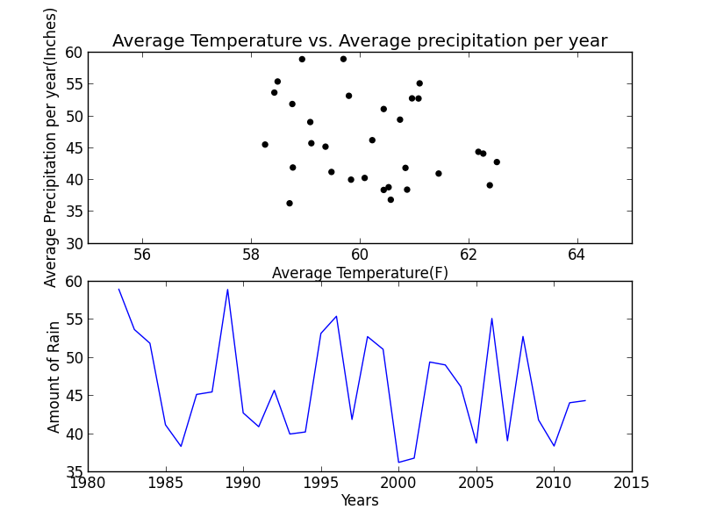

In conclusion, there seems to be an indication of a small rise in temperature over the last 30 years. Also, it seems that precipitation and temperature may be loosely related. It will be interesting to see what the future holds as far as weather, and weather patterns are concerned.

Works Cited

*Global Warming? Temperature Up 'Very Close to Zero' Over 15 Years*. (2013). Retrieved July 25, 2013, from cnsnews.com: http://cnsnews.com/news/article/global-warming-temperature-very-close-zero-over-15-years

*Global Summary of the Day*. (n.d.). Retrieved July 24, 2013, from NNDC Climate Data Online: http://www7.ncdc.noaa.gov/CDO/cdoselect.cmd?datasetabbv=GSOD&countryabbv=&georegionabbv=

Ratnor, B. (2013). *The Correlation Coefficient: Definition*. Retrieved July 25, 2013, from DM Stat-1 Articles: http://www.dmstat1.com/res/TheCorrelationCoefficientDefined.html