**­I. Introduction**

This tutorial is intended to show the usage of the APEX extension *Flows for APEX* 22.1 as well as explaining the integration of a flow into an APEX application. It also incorporates some good practices. After this tutorial and with some training/coaching, you are ready to build your own process-based applications!

We assume that you have basic understanding about Oracle APEX. If not, we suggest you follow the steps outlined in this blog post: <http://nielsdebr.blogspot.com/2019/08/getting-up-to-speed-with-oracle.html>

Also, this tutorial is not meant to explain the BPMN 2.0 standard. There are good books and online materials already available explaining this.

For further information about Flows for APEX and documentation you may visit the GitHub repository: [*https://github.com/flowsforapex/apex-flowsforapex*](https://github.com/flowsforapex/apex-flowsforapex)

**II. Contents**

|  |  |
| --- | --- |
| Exercise No. | Abstract |
| Exercise #01: Installation of Flows for APEX | Install the newest version of Flows for APEX inside your APEX workspace |
| Exercise #02: Model your first flow | Model an example flow with the Flows for APEX bpmn modeler to define a simple business process |
| Exercise #03: Create data model | Create the underlying SQL tables for storing the explicit process data |
| Exercise #04: Create application | Create the application with all pages, reports, and forms, that are needed within your business process |
| Exercise #05: Link application to flow | Link the application elements to your flow to have the process steps controlled by your bpmn model |
| Exercise #06: Define user roles | Define the APEX user roles and authorization schemes |
| Exercise #07: Testing | Test your application by creating test cases and observe the process using the Flows for APEX monitoring plugin |
| Exercise #08: Versioning | Deal with changes and multiple versions of your flow |
| Exercise #09: Process Variables | Use process variables on different places in your business process to enhance working with your flow |
| Exercise #10: Error handling | Detect and handle errors in your flow by using the Flow Monitor tools |

# Exercise #01: Installation of Flows for APEX

If not already available, apply for a free APEX workspace on apex.oracle.com.

Download the newest version of Flows for APEX from

Install Flows for APEX by importing the file

**FLOWSFORAPEX_EN_<apex-Version>_<application_id>_UTF8_<version>.sql**

from the *Applications* folder into your APEX workspace. During the installation process select the default options including:

* choose *UTF.8* as file character set
* select *Auto Assign New Application ID (default)*
* install the *supporting objects*

Additionally, to enable the timer functionality for your flow, you need to add a certain DBMS Scheduler job to your workspace. Install it by importing and executing the file **enable_timers.sql** from inside the folder *Enable_Timers* using the **SQL Scripts** function of the **SQL Workshop**.

*Notice that you might not have the right to create new jobs inside your own private workspace. In this case, the previous execution of the SQL statement “grant create job to <workspace_schema>”, invoked by the workspace sys, is necessary. Inside your free APEX workspace at apex.oracle.com, this right is already granted.*

Install the Sample Process Flow Application on the same way by importing the file

**FLOWSFORAPEX<version>_SAMPLE_APP_EN_<apex-Version>_<application_id>_UTF8.sql**

from the download folder. This app provides a demonstration for integrating a modelled flow into an APEX application. As part of this tutorial, we will reuse the plug-ins for processing the single tasks and displaying the process diagram inside this application.

Open the **plug-ins** page under the *Shared Components* section of the installed *Sample Process Flow Application* and export the four listed plug-ins

* Flows for APEX - Manage Flow Instance
* Flows for APEX - Manage Flow Instance Step
* Flows for APEX - Manage Flow Instance Variables
* Flows for APEX - Viewer

These plug-ins will be imported to our new application later in chapters #04 and #05.

# Exercise #02: Model your first flow

Start the previously installed *Flows for APEX* application. Switch to the **Flow Management** page (second entry in the navigation menu) and click the **Create Flow** button at the top right.

Enter *ExpenseFlow* as Name and *0* as Version. If you want, you can name a *Category*, to help organizing your different flows inside your workspace. Create your new flow by clicking the button **Create**. At the top of the page, you can see the attributes of the current process as well as stats about the process instances. Click the **Edit Flow** button below to open the flow modeller tool.

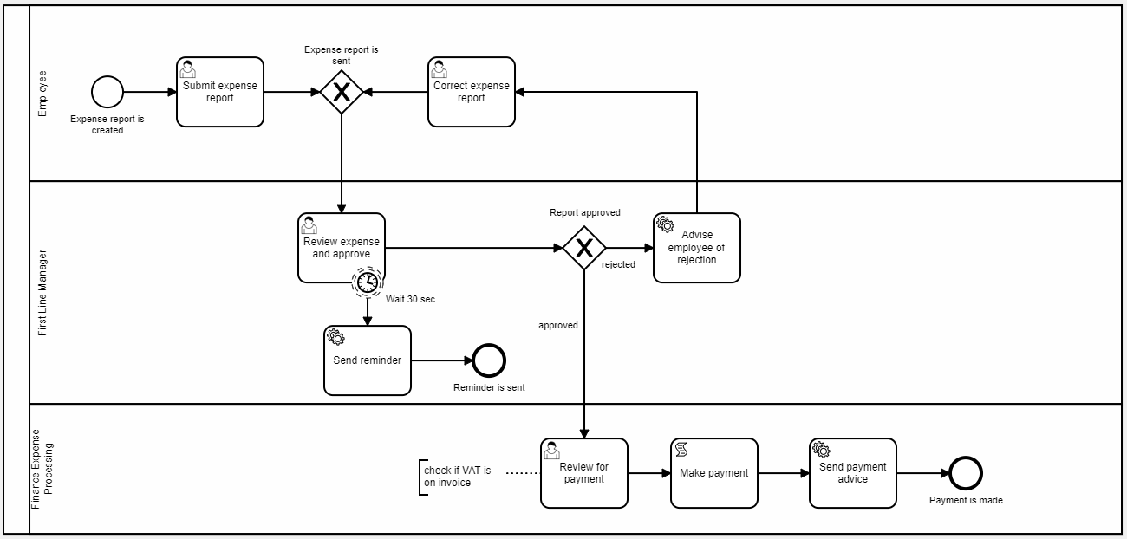Model the depicted BPMN process by combining the specific elements as shown below.  
Also observe the following hints:

* All BPMN elements can be accessed via the toolbar on the left. Click the needed element and position it on the modelling area. After placing an element, you can access the different types by clicking the **wrench** icon displayed next to it after selection. In this example you need *User*, *Service* and *Script* tasks. Apart from that, this flow contains *Start, Boundary* and *End Events*, *Exclusive* G*ateways* and *Swim Lanes* (modelled by using the **Create Pool/Participant** function on the toolbar).
* After selecting a placed element, additional settings are shown in a separate tab at the right. For this tutorial, set each element’s **ID** to its name in underscore notation (e.g., Submit expense report -> Submit_expense_report). These IDs are used to identify the process steps from inside your application. Proceed for all tasks and events as well as the gateway routes. For *non-labelled* sequence or message flows or collaborations, you do not have to assign a specific ID.
* To enable role authorization for multiple lanes in your flow, the lane IDs must match the corresponding user roles static IDs. Since they consist of capital letters, use capital letters for the IDs as well or convert them to uppercase in your views (as done later in Exercise 03). *Note: for large flows, you might want to avoid the usage of lanes to preserve readability.*
* The shown *Timer Boundary* Event can be modelled by dragging a boundary event to the border of a task and changing its type afterwards. Set the **Timer Definition Type** to *Duration* and enter *PT30S* for the **Timer Definition** to define a 30 second duration using the ISO 8601 syntax. The source of the depicted arrow pointing to the *Send Reminder*task must be set to that Timer Boundary Event.
* The **Text Annotation** as show at the *Review for payment* task can be used, to give extensive information about elements in the process. Alternatively, you can use the **Element Documentation** field inside the element’s settings tab to provide a reference, for example a documentation page. All those documentation elements have no further usage inside an end user application depending on that flow.

When done with modelling, click the **Save Flow** button to save your process.

# Exercise #03: Create data model

First, we need to create a **table** to store the relevant user data during the execution of a single process instance. Open the **SQL Commands** page inside the **SQL Workshop** of your workspace and execute the following statement:

create table expenses(

expe_id number generated by default on null as identity minvalue 1 maxvalue 9999999999999999999999999999 increment by 1 start with 1 cache 20 noorder nocycle nokeep noscale not null enable

, expe_name varchar2(150) not null enable

, expe_value number not null enable

, expe_status varchar2(15)

, expe_created_by varchar2(255) not null enable

, constraint expe_pk primary key (expe_id) using index enable

);

In addition, we create two page-specific **views**, that we will use for our business application later. Create those views by executing the following statements:

create or replace force view expe_p0001_vw

as

select expe.expe_id

, expe.expe_name

, expe.expe_value

, expe.expe_status

, expe.expe_created_by

, tibx.link_text

, tibx.sbfl_prcs_id

, aclr.user_name

from expenses expe

join flow_task_inbox_vw tibx

on expe.expe_id = tibx.sbfl_business_ref

-- enable authorization roles if you have lanes defined in your flow

join apex_appl_acl_user_roles aclr

on upper(tibx.sbfl_current_lane) = aclr.role_static_id

and aclr.application_id = v(‘APP_ID’)

create or replace force view expe_p0002_vw

as

select expe.expe_id

, expe.expe_name

, expe.expe_value

, expe.expe_status

, expe.expe_created_by

from expenses expe

# Exercise #04: Create application

In this chapter we build the application for executing the defined business process.

Start by creating a new APEX application named *ExpenseApp*, keeping all the default settings.

We will deal with the automatically created page 1 later and start with the first additional page. For that we need a form page, that serves as entry point to the process by creating a new expense report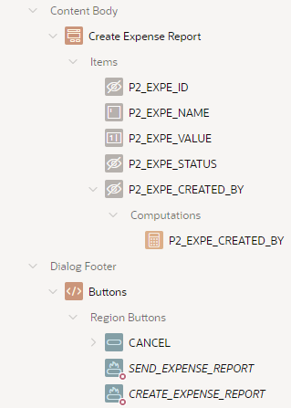. Create a new modal dialog page of the type **Form** called Create *Expense Report*. Select the default *Navigation Preference*, so no menu entry will be created. Choose the view **EXPE_P0002_VW** as *Data Source* and select **EXPE_ID** as *Primary Key Column*.

After creation, change the type of the items

* **P2_EXPE_STATUS**
* **P2_EXPE_CREATED_BY**

to *hidden* since they are not to be manually set by the end user.

Rename the labels of the displayed items **P2_EXPE_NAME** and **P2_EXPE_VALUE** to *Report name* and *Value*.

Next create a *Computation* on the item **P2_EXPE_CREATED_BY** item to retrieve the current user’s name. Use the settings shown on the right.

In the buttons section of the dialog

* 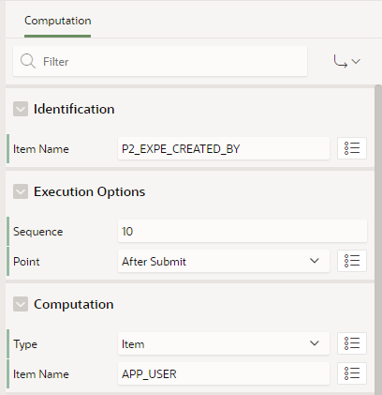delete the button **DELETE**
* rename the button **SAVE** to *SEND_EXPENSE_REPORT*
* rename the button **CREATE** to *CREATE_EXPENSE_REPORT*.

The code for processing the submitted forms is added later in chapter #05.

Save this page and **go back to Page 1**.

This page will contain a report showing all current process instances for a specific user and provide the links to the next page respective to the following user tasks.

On page 1, move the automatically created region *ExpenseApp* to the **Content Body** of the page and change its type to **Interactive Report.** Rename the region to *Expense Reports* andchange the source to the previously created view **EXPE_P0001_VW**. Additionally, add the following W*here Clause*:

user_name = :APP_USER

This ensures, that the report shows only process instances inside the accessible lanes for a specific user.

Change the type of the columns **EXPE_ID, SBFL_PRCS_ID**and **USER_NAME** to *Hidden Column* and the type of the column **LINK_TEXT** to *Link*. Enter the following values under the *Link* section (**target type** set to *URL*):

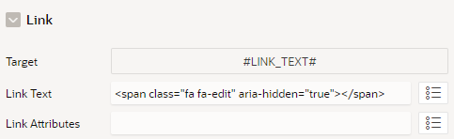

**Link Text**: <span class="fa fa-edit" aria-hidden="true"></span>

Rename all the displayed column’s headings accordingly to their content (*Report name, Value, Status*, *Created by* and *Link*).

Create a button named and labelled **Create** in this regionand set its position to *Right of Interactive Report Search Bar*. Change its **behaviour** to *Redirect to Page in this Application* and set the recently created Page 2 as **target**.

Add a **Dynamic Action** which is executed when the *Dialog Closed*event occurs and use it to refresh the region *Expense Reports*.

Finally save your changes to this page.

In addition to the previous form to create and modify expanse reports, we need another form for the approving and reviewing steps of the process.

Create another modal dialog page of the type **Form** called *Review Expense Report*. Again, do not create a navigation menu entry and choose the view **EXPE_P0002_VW** as *Data Source* as well as the column **EXPE_ID** as *Primary Key Column*.

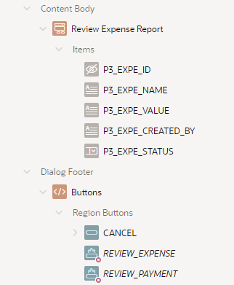After creation, change the type of the items

* **P3_EXPE_NAME**
* **P3_EXPE_VALUE**
* **P3_EXPE_CREATED_BY**

to *Display Only* and arrange them in a row.

The type of **P3_EXPE_STATUS** should be set to *Select List* to ensure process conform input values. Under the *List of Values* section insert the following input static values:

* Display: approve, Return: approved
* Display: reject, Return: rejected

The return values should match with the corresponding gateway routes in the modelled process.

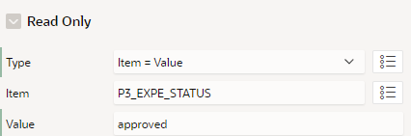Add a condition for the **Read Only** attribute of the item *P3_EXPE_STATUS* using the following settings:

Like on the previous pages, rename the form field labels to *Report name, Value*,   
*Created by* and *Status*.

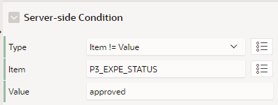In the buttons section of the dialog, delete the **DELETE** Button and rename the **SAVE** button to *REVIEW_EXPENSE*. Enter the **Server-side Condition** shown on the right.

Ein Bild, das Text enthält.
Rename the **CREATE** button to *REVIEW_PAYMENT* and set the **Database Action** field under the **behaviour** section to *SQL UPDATE action*. Enter the displayed **Server-side Condition**.

Save the changes to this page and start with adding the processing elements for the created forms in the next section.

# Exercise #05: Link application to flow

**Prerequisites**

To control the modelled flow and its single tasks from within your application, you need to be able to reference the current process ID, subflow ID and step key. Create three Application Items **PROCESS_ID**, **SUBFLOW_ID** and **STEP_KEY** under *Shared Components > Application Items* so you can use the items on all your pages. Be sure to choose *Unrestricted* or *Checksum Required* for the **Security** setting of the items to allow them being set by the flow engine.

The functions, that shall be executed on the script and service tasks, are bundled inside a custom PL/SQL package. To install that package to your workspace, upload and execute the downloaded file **expense_pkg.sql** inside the **SQL Scripts** section.

Next, import and install the four exported plugins from chapter #01 in the **Plug-ins** section of your application’s *Shared Components*. While installing the **Flows for APEX – Manage Flow Instance** plug-in, you can enter a value for the component setting *Global Flow*. Enter the name of the modelled flow **ExpenseFlow** to set the needed reference.

**Monitor process instance**

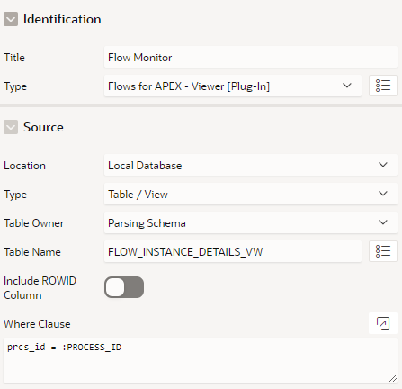To be able to monitor the current state of a specific flow instance, the viewer plug-in can be used to embed a diagram view inside the application.

Create a new empty Modal Dialog page named *Flow Monitor*. Add a new region to this page named equally and choose the installed **Flows for APEX - Viewer** plug-in as the region’s *type*. Select the Flows for APEX specific view**FLOW_INSTANCE_DETAILS_VW** as the region’s *source* and enter the following *Where Clause*, so the process ID application item is used to identify the current process instance:

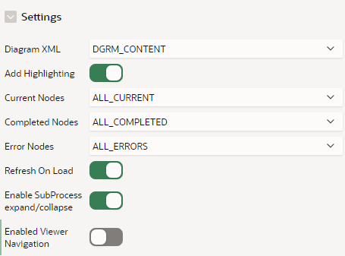prcs_id = :PROCESS_ID

Under the attributes tab of the plugin enter the values displayed on the right.

Finally enable the *Stretch to fit window* setting under the page’s **Template Options**, so the diagram is shown in an appropriate size.

Save your changes to this page and **return to page 1**.

Now we want to add a link to the previously created dialog page inside the report. For that we use the column **SBFL_PRCS_ID** which we set to *Hidden Column* before. Change its type to *Link,* enter *Flow Monitor* as the column’s heading and set the following options inside the **Target** dialog:

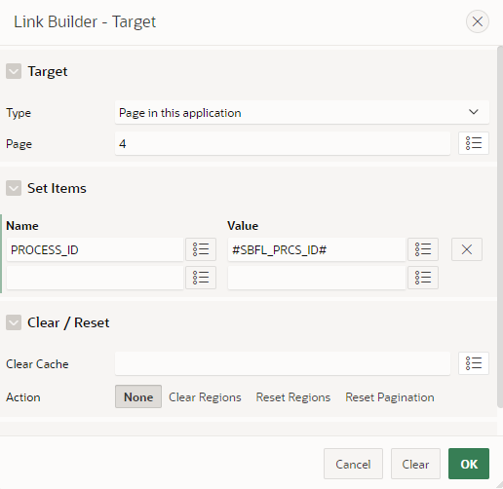

Additionally, instead of displaying the process ID, add the following **Link Text**:  
<span class="fa fa-eye" aria-hidden="true"></span>

# Ein Bild, das Text enthält. Automatisch generierte Beschreibung

Finally save your changes to Page 1.

**Processing forms**

Switch back to the first created form **page 2** and open the processing tab. Under the *Processing* section you can find the automatically generated process for storing the expense report input data to the region source. Here we must add the flow-specific processes to control the single tasks inside our modelled flow.

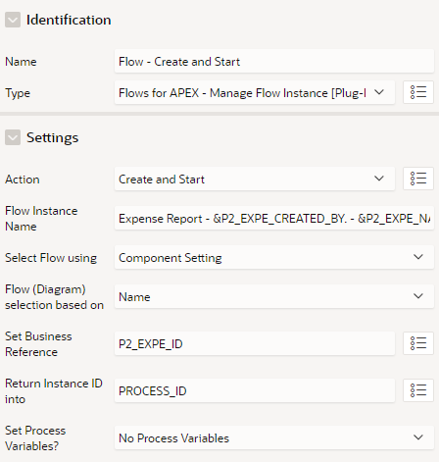Create a new process named **Flow – Create and Start** of the type *Flows for APEX – Manage Flow Instance*, the previously installed plug-in, and enter the settings show on the right. This provides a correct creation and initialization of the referenced flow.

For clearly identifiable process instances, you can use a combination of static text and Item Values as the *Instance Name:*

*Expense Report - &P2_EXPE_CREATED_BY. - &P2_EXPE_NAME.*

Change the **Server-side Condition** to *When Button* Pressed and choose the button *CREATE_EXPENSE_REPORT.* Ensure the correct execution order by putting the process element below the *Process Form* element.

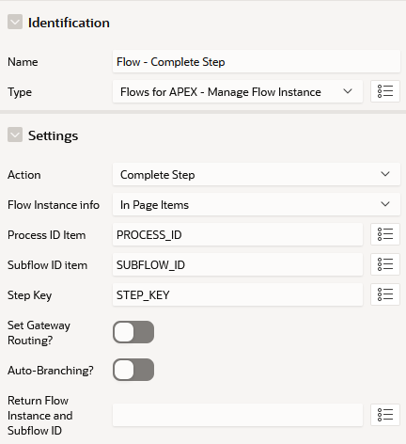

Create a second process named **Flow - Complete Step** and put it below the previous one. This process is used for moving one step forward inside the flow. Change its type to the previously installed *Flows for APEX – Manage Flow Instance Step* plugin and set the displayed values under the settings tab.

Like the first process, set the **Server-side Condition** to *When Button Pressed* and enter the second button’s name *SEND_EXPENSE_REPORT*.

Remove the **Server-side Condition** from the *Close Dialog* process so it is always executed at the end.

Save this page and **switch to page 3**.

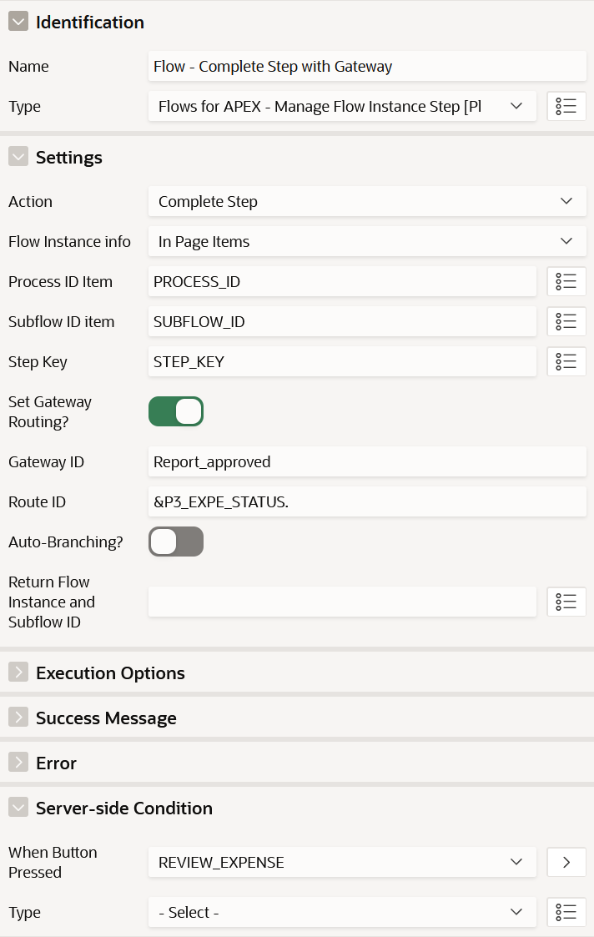For this form page, two separate *Complete Step* processes are needed. Add the process elements using the *Flows for APEX – Manage Flow Instance* Step plugin like before and use the following settings:

Again, remove the **Server-side Condition** from the *Dialog Closed* process and save your changes to the page.

**bpmn modeller settings**

Inside the bpmn modeller you can use additional information and settings to call APEX pages or run scripts inside your application. Open your modelled *ExpenseFlow*inside the **Flow Management Section** of the Flows for APEX application and Click the **Edit Flow** button.

**User Tasks**

User Tasks are designed to open a specific APEX page when reached inside the process flow by providing a generated link to that page. Click the first user task **Submit expense report** and open the *APEX* tab in the settings panel on the right.

Here you can specify the Application where your Flow Diagram is used as well as the page to execute the User Task. Be sure to use the correct application ID of the *ExpenseApp* here. Alternatively, you can leave the field blank to use the currently opened application. *Note: Sometimes the usage of the alias causes conversion errors when querying the generated link. We recommend using the application ID or leaving it empty in this case.*

By setting the **Page Item** and **Item Values**, references to the current process ID, subflow ID and Step Key are granted. The ID to the explicit expense entry has been set as the business reference variable during the creation of the process instance inside the plugin and can be accessed via the substitution string *&F4A$BUSINESS_REF*.

Enter the following values to create a connection to page 2:

* Input: Use APEX meta data
* Application: ExpenseApp
* Page: Create Expense Report
* Page Items:

|  |  |
| --- | --- |
| Item Name | Item Value |
| PROCESS_ID | &F4A$PROCESS_ID. |
| SUBFLOW_ID | &F4A$SUBFLOW_ID. |
| STEP_KEY | &F4A$STEP_KEY. |
| P2_EXPE_ID | &F4A$BUSINESS_REF. |

Quick Tips:

* Under Pages Items block click on “generate user task items” to quickly add PROCESS_ID, SUBFLOW_ID and STEP_KEY references.
* Une image contenant texte

  Description générée automatiquementAfter adding a new item, you can use the quick link to populate the item with the right substitution syntax for built-in variable (PROCESS_ID, SUBFLOW_ID, STEP_KEY and BUSINESS_REF).

Similarly change the settings for all existing User Tasks:

**Correct expense report**

* Input: Use APEX meta data
* Application: ExpenseApp
* Page: Create Expense Report
* Page Items:

|  |  |
| --- | --- |
| Item Name | Item Value |
| PROCESS_ID | &F4A$PROCESS_ID. |
| SUBFLOW_ID | &F4A$SUBFLOW_ID. |
| STEP_KEY | &F4A$STEP_KEY. |
| P2_EXPE_ID | &F4A$BUSINESS_REF. |

**Review expense and approve**

* Input: Use APEX meta data
* Application: ExpenseApp
* Page: Review Expense Report
* Page Items:

|  |  |
| --- | --- |
| Item Name | Item Value |
| PROCESS_ID | &F4A$PROCESS_ID. |
| SUBFLOW_ID | &F4A$SUBFLOW_ID. |
| STEP_KEY | &F4A$STEP_KEY. |
| P3_EXPE_ID | &F4A$BUSINESS_REF. |

**Review for payment**

* Input: Use APEX meta data
* Application: ExpenseApp
* Page: Review Expense Report
* Page Items:

|  |  |
| --- | --- |
| Item Name | Item Value |
| PROCESS_ID | &F4A$PROCESS_ID. |
| SUBFLOW_ID | &F4A$SUBFLOW_ID. |
| STEP_KEY | &F4A$STEP_KEY. |
| P3_EXPE_ID | &F4A$BUSINESS_REF. |

**Script Tasks / Service Tasks**

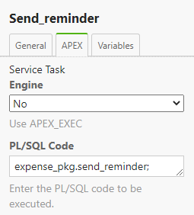On Script and Service Tasks you can trigger the execution of PL/SQL code by invoking functions and procedures of custom packages. Again, the settings can be entered under the *APEX* tab after clicking a task in the modeller.

Leave the setting for Engine on *No* and use the following procedure calls as **PL/SQL** **code** for the Script and Services Tasks in the model:

* Send reminder: *expense_pkg.send_reminder;*
* Advise employee of rejection: *expense_pkg.advise_employee;*
* Make payment: *expense_pkg.make_payment;*
* Send payment advice: *expense_pkg.finish_expense;*

Finally save your changes to the flow diagram by clicking the *Save Flow* button.

# Exercise #06: Define user roles

The mapping of the three lanes inside the modelled flow can be realised by using the APEX user role mechanism. By that you can ensure that each user gets access only to the current steps inside its permitted area.

Open the **administration** page inside your workspace and click **Manage Users and Groups**. Create three new users as end users using an accessible mail address of yours and free to choose names and passwords. To maintain consistency when assigning the roles, you can name then accordingly to the lanes inside the modelled flow or by using shortcuts (e.g., EMP, FLM, FEP).

Return to the *ExpenseApp* AppBuilder and go to *Shared Components > Application Access Control*. Create three new **Roles**, named identically to the lanes in the model:

* Employee (Static ID: EMPLOYEE)
* First Line Manager (Static ID: FIRST_LINE_MANAGER)
* Finance Expense Processing (FINANCE_EXPENSE_PROCESSING)

Then add the user role assignments by adding each role to one of the previously created users.

*Note: By using this way of role management, all users sharing a lane can see the related process instances. So, in this case, each employee can edit all existing expense report entries. This is due to the logic behind lanes in BPMN processes. Additionally, it allows us to combine the employee’s and manager’s tasks to one single form page since there are no accessibility issues between them. To enable further authentication, you can use the CREATED_BY attribute in combination with a strictly implemented hierarchy between employees and managers with proper page and region visibilities as well as the APEX authorization schemes. For bigger and more complex business applications, Flows for APEX allows the reservation of single process tasks to show other users, that an instance is already being processed internally. Thus, concurrent operations on a single process instance can be prevented. Notice that this functionality as well as further authorization techniques are not included as part of this tutorial for the sake of convenience.*

# Exercise #07: Testing

In this chapter we want to test our application in combination with the modelled flow.

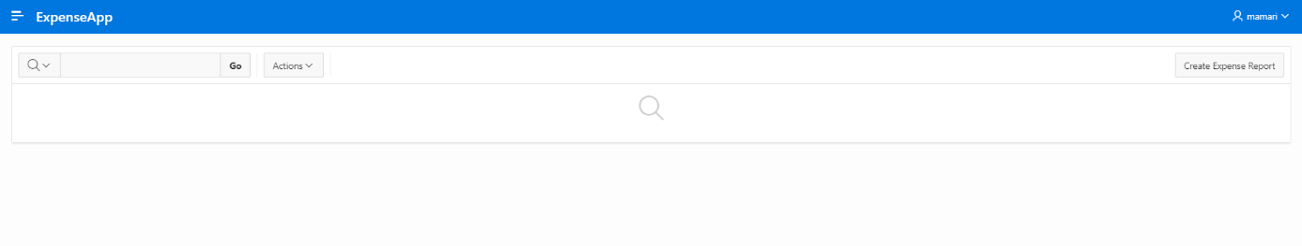Start by logging in into the **ExpenseApp** with a user from the *Employee* group.

**Expense report creation**

By clicking on the **Create** button, the following Modal Dialog appears.

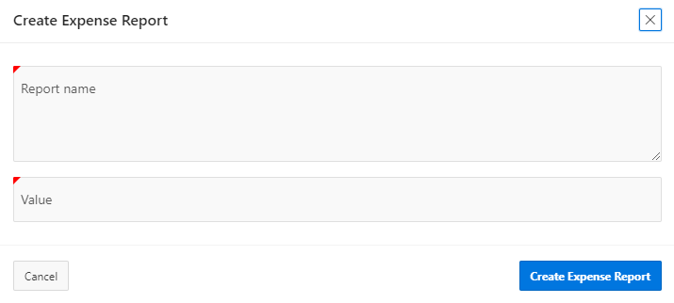

Fill the required input fields and click the button **Create Expense Report** to submit the data and create a new entry.

The diagram of the process instance can be displayed by clicking the *eye icon* in the corresponding row.

The diagram for a newly created process instance will look as follows:

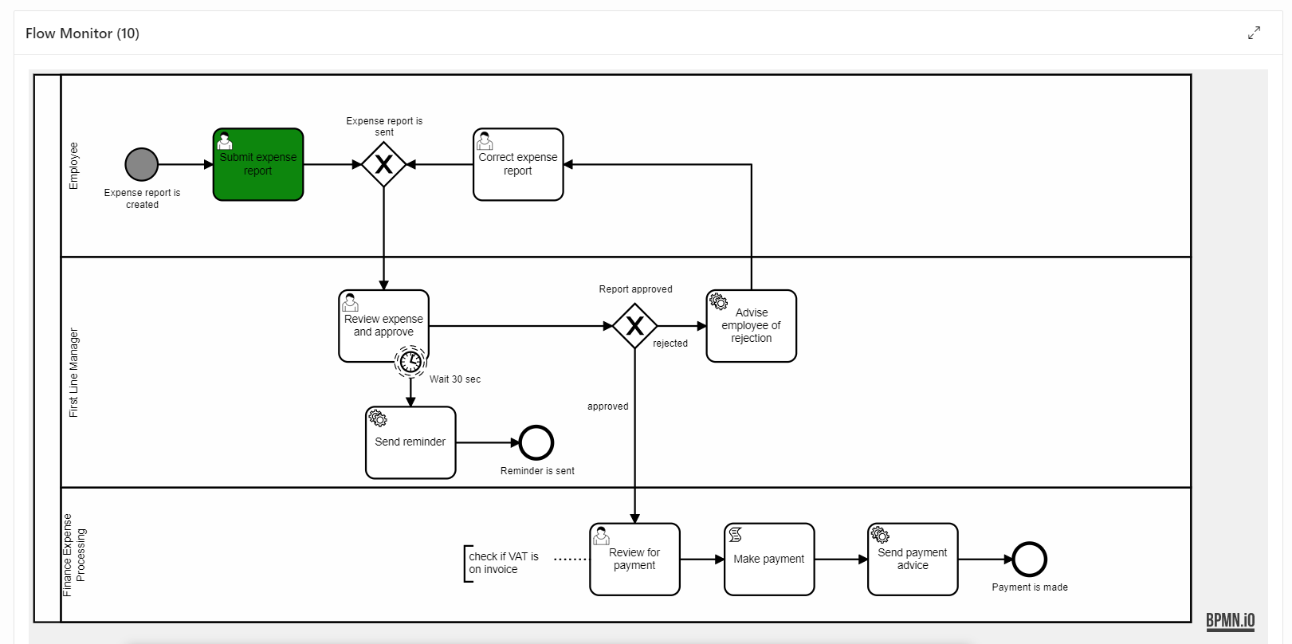

To complete this user task, you need to edit the expense report entry inside the *Expense App* by clicking the *Pencil* icon inside the row. You can keep the entered values and click on **Send Expense Report** to finish this step.

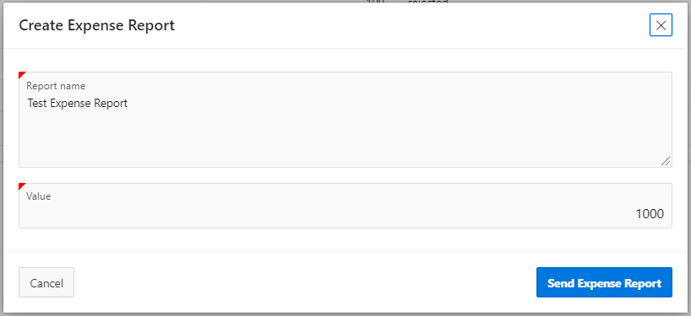

You are required to log in as a *First Line Manager* group user now to proceed. Looking on the flow monitor again you will see that the activity for the current instance has been updated. As shown below, a timer has been started.

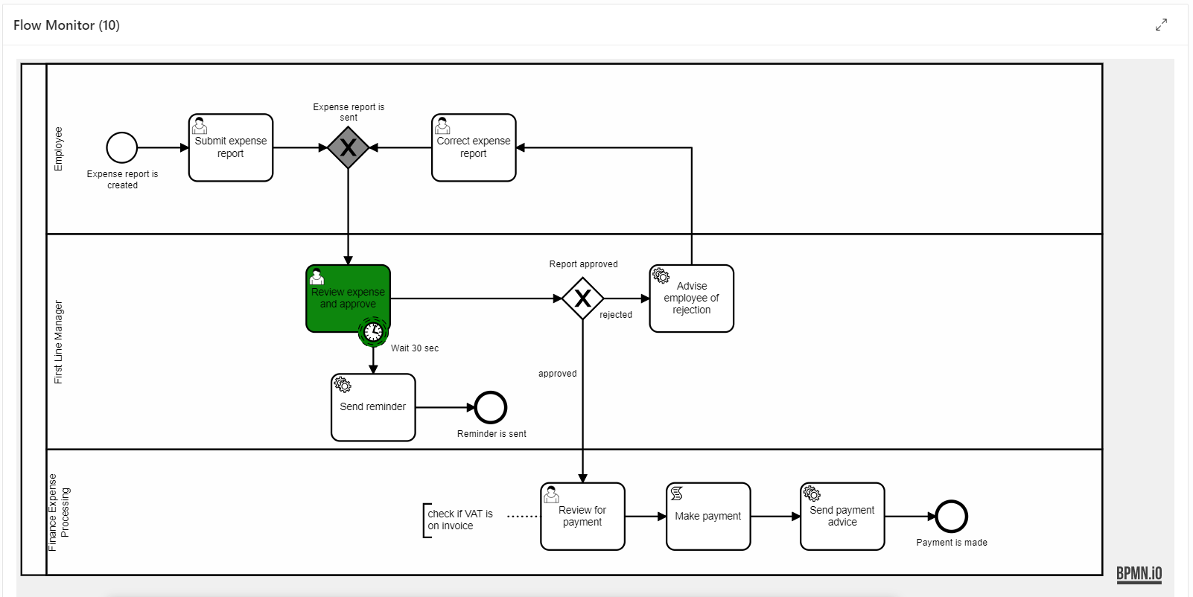

After the timer’s end, you will notice that all *First Line Manager* group users received a reminder email.

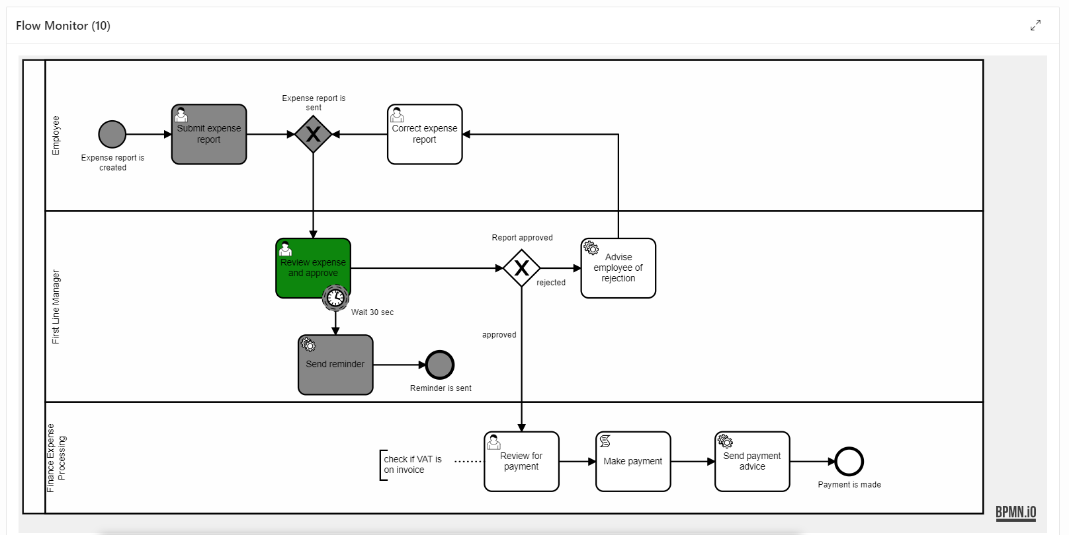

**Expense report approval**

Proceed the flow by clicking the link column again to review the expense report.

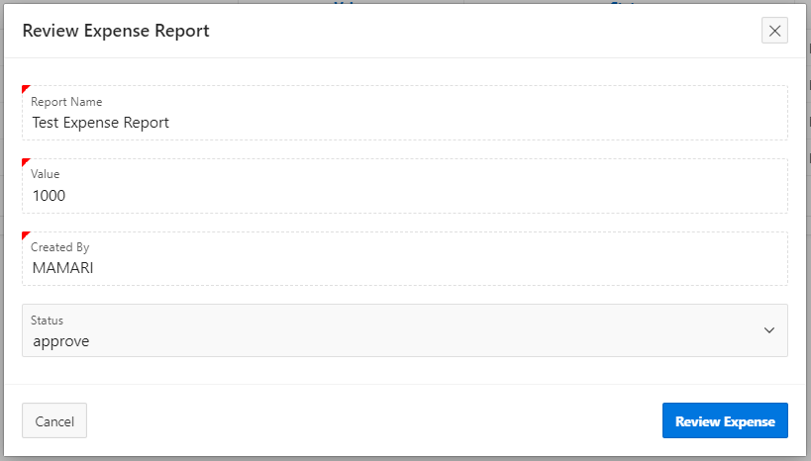

After approving the expense report, the current activity on the Flow Monitor moved into the *Finance Expense Processing* Line.

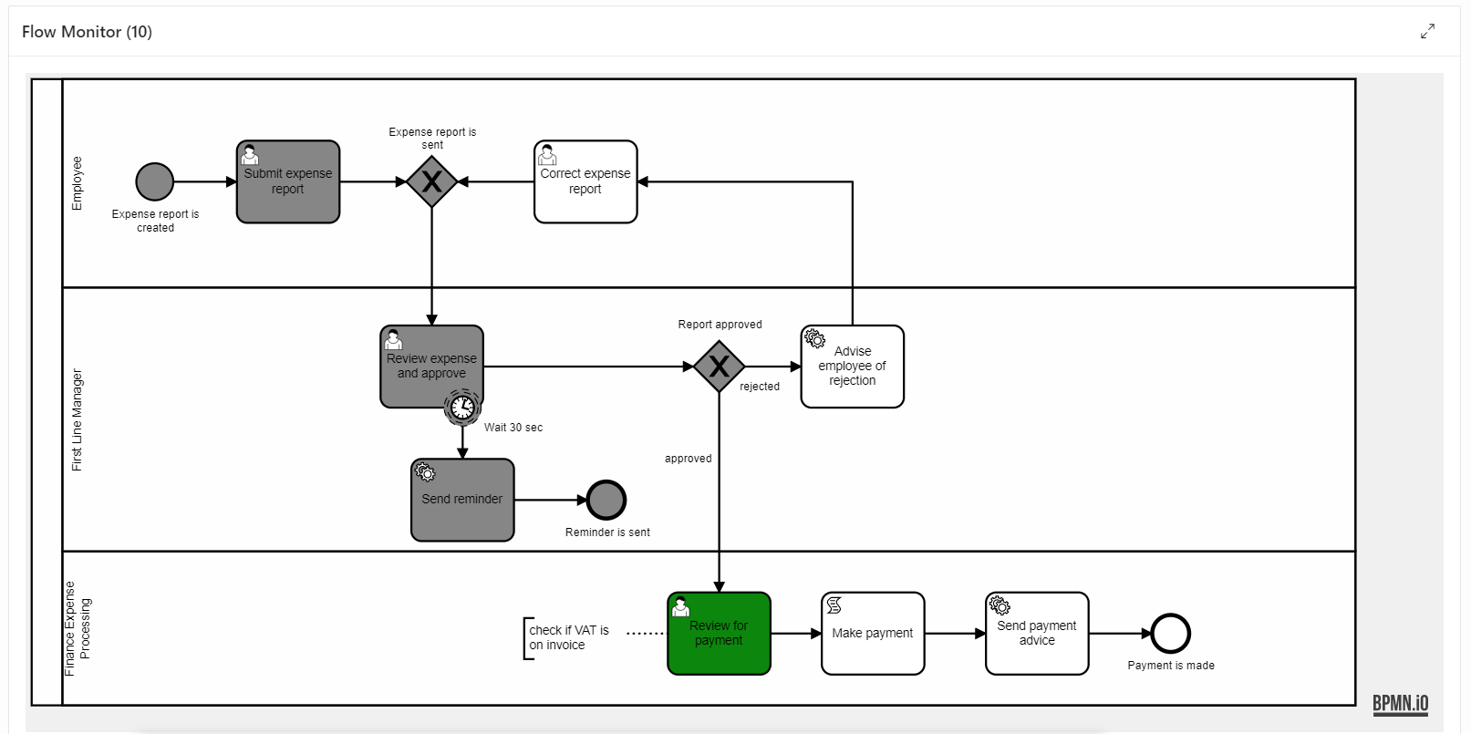

**Expense report payment review**

You need to log in with a user from *Finance Expense Processing* group and review the payment as shown below.

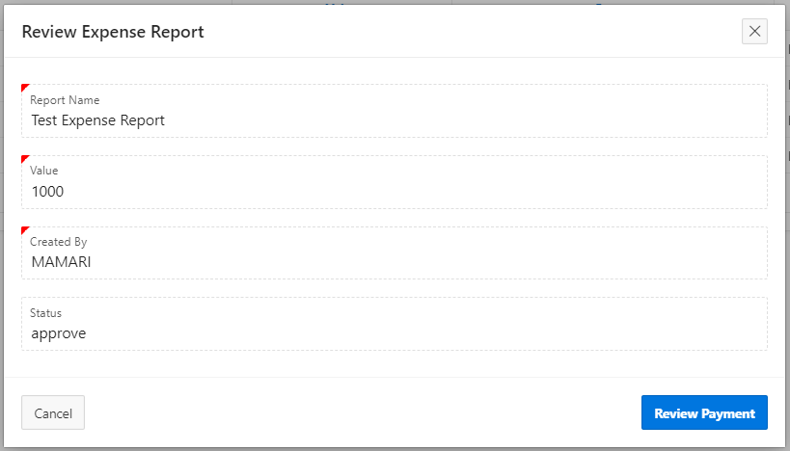

That will end the flow and you will notice that an email was sent to confirm the payment.

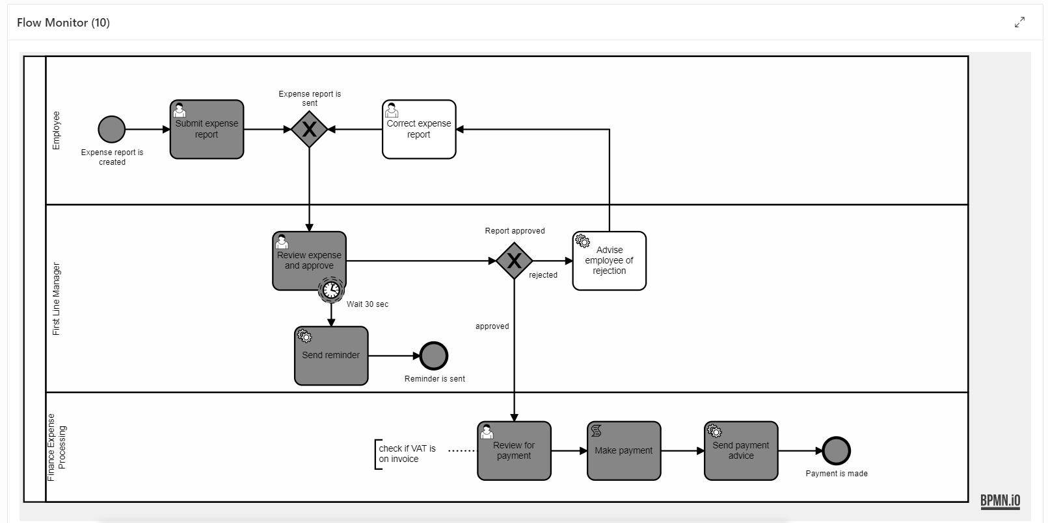

*Note: By using the view FLOW_TASK_INBOX_VW in the page specific view on page 1, only running instances that need to be worked on are displayed. Because of that, you can’t see the completed (paid) expense report there. For documentation purposes this could be achieved by using the view FLOW_INSTANCES_VW, which includes all the instances and join it to the expense table using the business reference.*

**Expense report rejection**

You can repeat the steps until the review of the expense report and choose to reject the report this time.

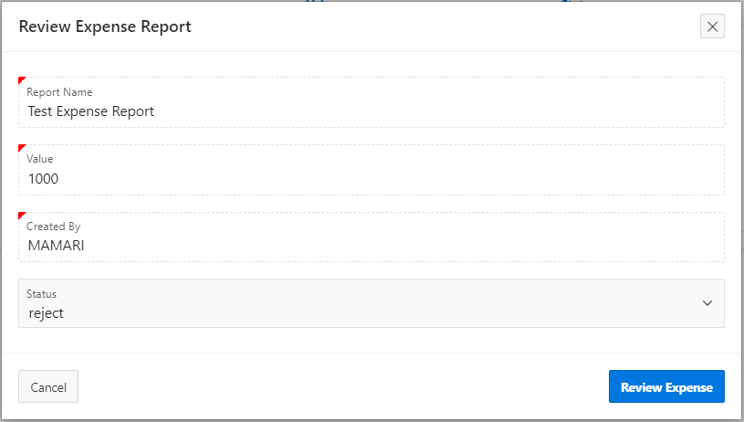

This will bring you the into the **Correct expense report** activity after receiving rejection email.

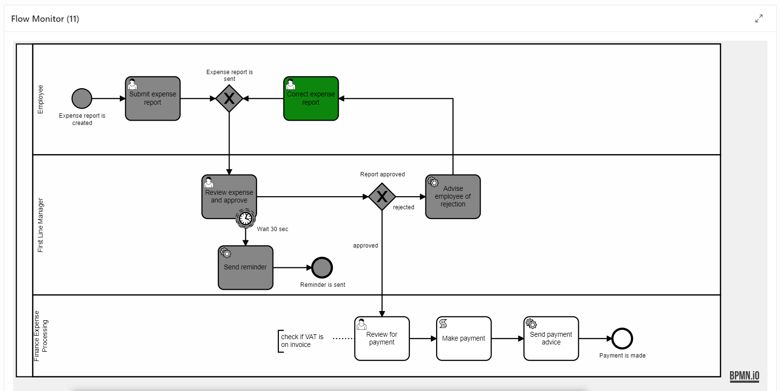

You can correct your report and send it again in to be reviewed by user from the *First Line Manager* group.

# Exercise #08: Versioning

In Flows for APEX each process instance is based on a diagram name and a version. This allows you to have multiple versions of your flow while ensuring the runnability of the single instances. Additionally, the status attribute is used to mark the current version of your diagram and if changes to the diagram can be expected.

Each newly created diagram will start with the status **draft**. This status is typically used during the modelling phase, where you can edit and test your diagram at any time without changing the version. Once your flow is ready for production, you can set its status to **released**, which makes it immutable. For further changes you would have to create a new version of the diagram, starting with **draft** status again.

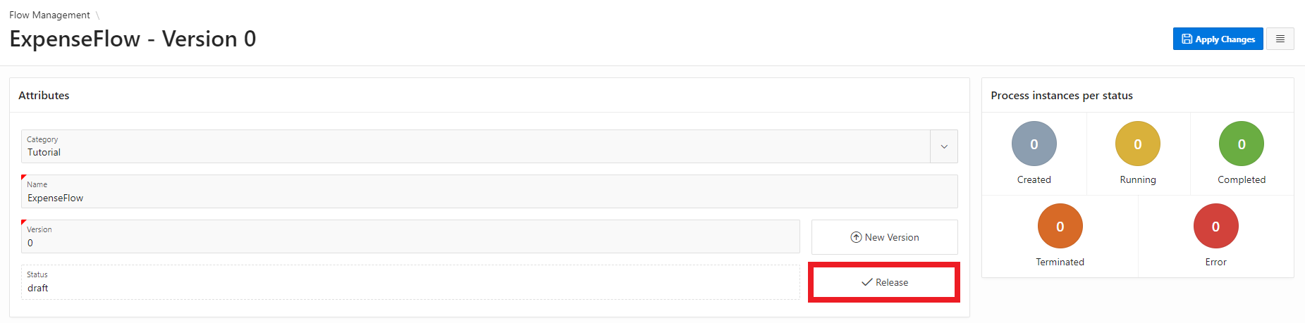Open the *Flows for APEX* application and go to the **attributes** panel of your modelled flow.

Click the button **Release** to change the status of this diagram to *released*. The **Edit Flow** button is now hidden to prevent changed to your diagram.

Open the *Expense App* and start a new process instance by creating an expense report. If you do not specify a diagram version in the Component Settings, always the released version of the diagram will be used. Otherwise, if no *draft version 0* exists, errors might occur.

Now we want to create a new version of the diagram. Go back the *Flow Modeller* and click the button **New Version**. Enter *1* as the version identifier and click **Add Version** to close the dialog. A new version of the diagram has been created. Click the **Edit Flow** button and make some minor but visible change to the diagram, for example change the timer text and definition from 30 to 60 seconds.

To release this new version of the flow, the old version must be set to **deprecated** first. This can be done by clicking the button next to the status field on the attributes panel of the version 0 diagram. Now you can change the status of the new diagram to **released**.

Inside the *Expense App* create another process instance. By comparing the corresponding diagram windows using the viewer plugin you can see that the first entry still uses the deprecated diagram, while the second entry is based on the new version instead.

After all existing instances of a deprecated diagram have finished, you can set the diagram status to **archived** to indicate that it is not used for processing anymore.

# Exercise #09: Process Variables

Process variables provide a way to store process relevant information throughout the whole execution of a single instance. They are stored persistently in the database and hence (in contrast to APEX items) can be used without an APEX session.

In this demo, process variables for a flow instance already have been used to store the business reference and the path to choose for the gateway, depending on the user’s input. This works automatically by using the pre-configured attributes in the process plugins.

Starting with *Flows for APEX* 21.1, setting process variables is also possible in the flow modeler.

In this chapter we want to modify the approval process in a way, that the First Line Manager only has to approve expenses, when the value exceeds a certain limit.

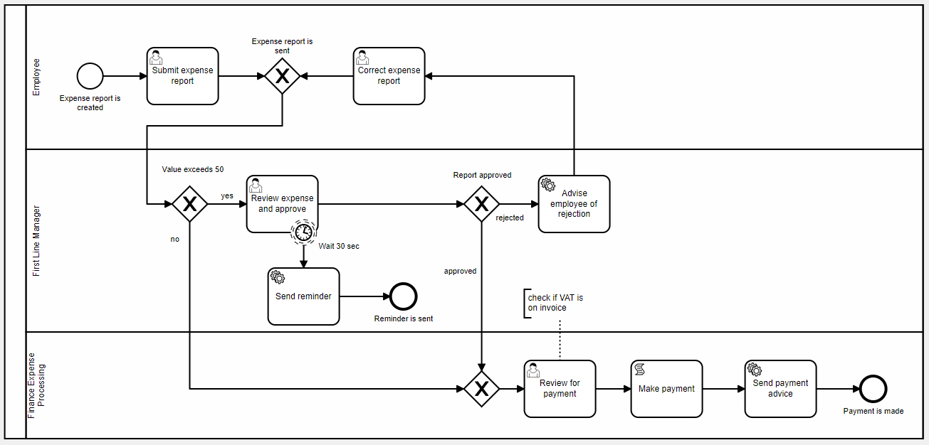First, open the modelled flow in the Flow Modeler. Extend the process flow as shown below by adding an additional gateway. Be sure to set the IDs of the gateway and the routes as before by using the underscore notation (e.g., Value exceeds 50 -> Value_exceeds_50).

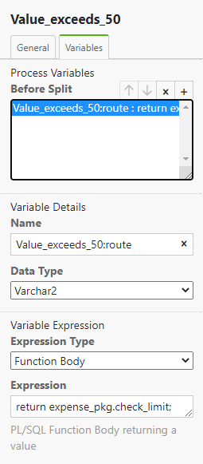Select the new gateway and open the *variables* tab on the properties panel on the right.

For opening gateways, you can define variables and their value expressions here, that are set *before* the gateway splits up. For merging gateways, you can set variables *after merging* and for tasks you can set variables both *before* and *after* the task.

Create a new variable expression by clicking the **plus** icon on the upper right and enter the settings shown on the right. In this case we use a package function to determine the correct gateway route. Inside the function we use the package *flow_process_vars* to retrieve a prior set process variable, compare it to a static limit and return the name of the gateway route depending on that.

Save the changes to the model, go back to the App Builder and **open** **page 2**.

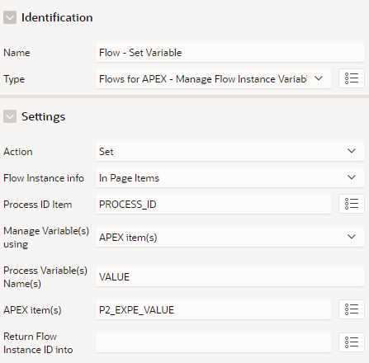

In the processing section of the page, we now want to add a process to set a variable, that will be used inside the *check_limit* function of the package.

Create a new process and select the plugin *Flows for APEX – Manage Flow Instance Variables* as type. Enter the following settings and position it right after the *Flow – Complete Step* process.

The input value of an expense report will now be saved after creation with a reference to that process instance, so it can be used at the gateway we defined earlier.

Save your changes to the page and go back to application.

If you now create an expense report with a value below 50, the review step of the First Line Manager will be skipped, and the process continues at *Review for payment*.

# Exercise #10: Error handling

Starting from Flows for APEX v21.1, the engine is able to detect errors while processing a modelled flow and display the error information to the user. Using the Flow Monitor of the Flows for APEX Engine App an admin can then analyse, where the error occurred and initiate the needed error handling routines or fix the error directly by using the Flow Modeler. After that, a single step can be restarted so that the Flow can continue properly.

In this exercise we will manually enter an incorrect PL/SQL code on a Script Task and fix it afterwards, to test out the logging and restart functionality.

Open the Flow Modeler and edit your modelled flow. Select the *Make payment* Script task and change the PL/SQL code to something, that will not execute, e.g. *expense_pkg.make_payments;*

Save your changes and open the *Expense App*. Create a new expense report and move forward in the process until the task *Review for Payment* should have been completed. Now open the Flows for APEX Engine App and go to the **Flow Monitor** page (third entry in the navigation menu).

The *Flow Instances* report contains an overview of all the current instances. You will see that the *Status* column of your current instance is marked as **error** and has a red background. Click on the *Flow Name* of this instance to open the diagram in the viewer. You can see that the *Make payment* task is marked red as well.

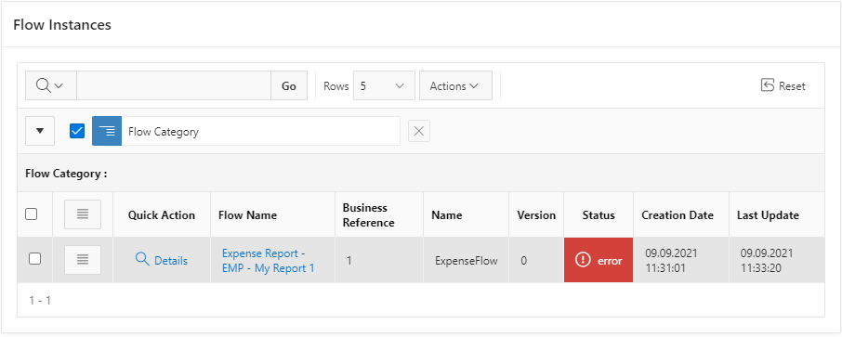

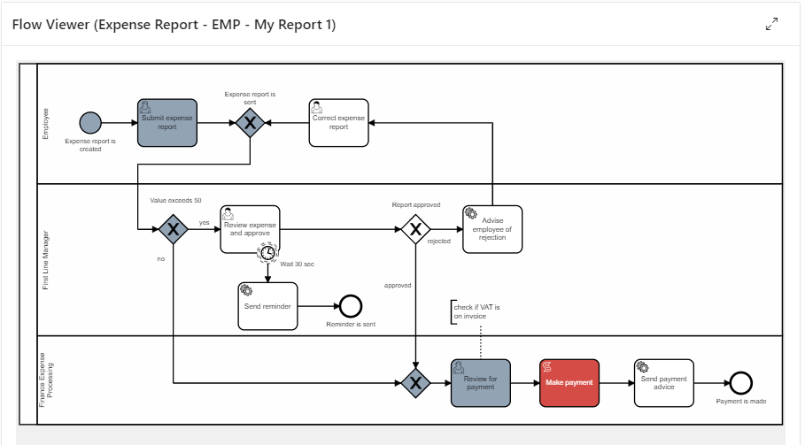

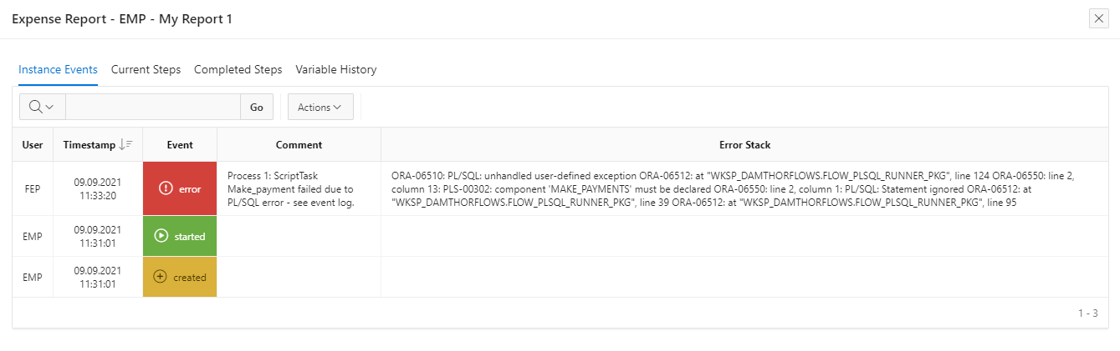If you click on the task, you can see detailed information like the PL/SQL code that gets executed on this Script Task. Close this dialog and click on the **Details** link in the *Quick Action* column for this instance. On this page you can see more information about the instance as well as the current existing subflows and process variables. Click on the **Audit** button in the top right corner. This will open the event log for the current instance, including all the logged information on instance, subflow and step level. In the *error stack* column, you can now see, what error has happened in the process.

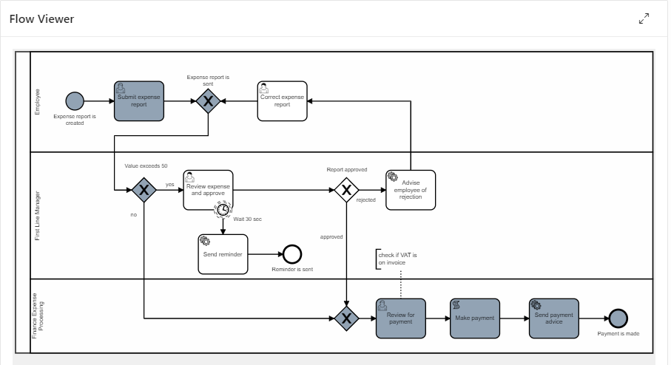Close this dialog and fix the error in the **Flow Modeler** by changing the PL/SQL statement back to the correct spelling. Save the diagram, go back to the **Flow Monitor**, and open the *Details* page of the instance again. Now we want to **restart** the *Review Payment* task so the process can continue. This can be done by clicking the *Quick Action* in the corresponding row of the *Subflow* report on the left. Enter an optional comment on the restart action and **confirm** the dialog. You can now see that the task has been successfully executed and the process could be finished.