**How Strong Is Your Password? A Guide to Secure Password Practices**

* **Why Passwords Are Important:**

Passwords are important because we use them to access different web applications in our daily lives. If we use simple or weak passwords, hackers can easily guess them and take control of our accounts, putting our personal data and the entire application at risk

* **How Hackers Exploit Weak Passwords:**

Hackers can easily exploit weak passwords using techniques like brute force or dictionary attacks, allowing them to gain unauthorized access to user accounts and sensitive data.

**Common Techniques Used by Attackers**

>> Brute Force Attacks

>> Dictionary Attacks

>> Credential Stuffing

>> Social Engineering

**Examples of Weak Passwords**

>> 123456, password, admin, qwerty, iloveyou

* **Tools to Check Password Strength:**

>> https://www.passwordmonster.com

>> <https://bitwarden.com/password-strength/>

>> <https://password.kaspersky.com/>

>> <https://nordpass.com/secure-password/>

**Practical :**

**>>** [**https://nordpass.com/secure-password/**](https://nordpass.com/secure-password/)

**I think this site is great for checking password strength, and it also shows how many times a password has been involved in data breaches**

* **Interface:**

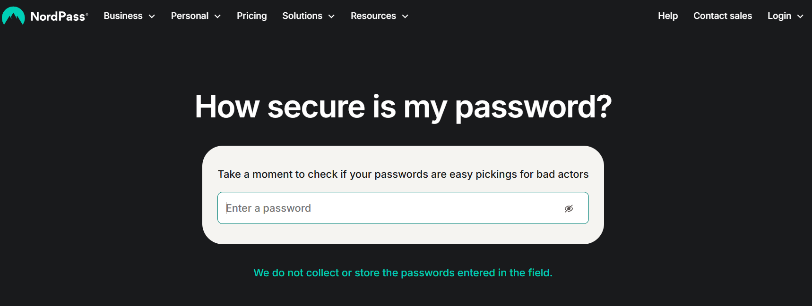

* **After entering the password: easy password**

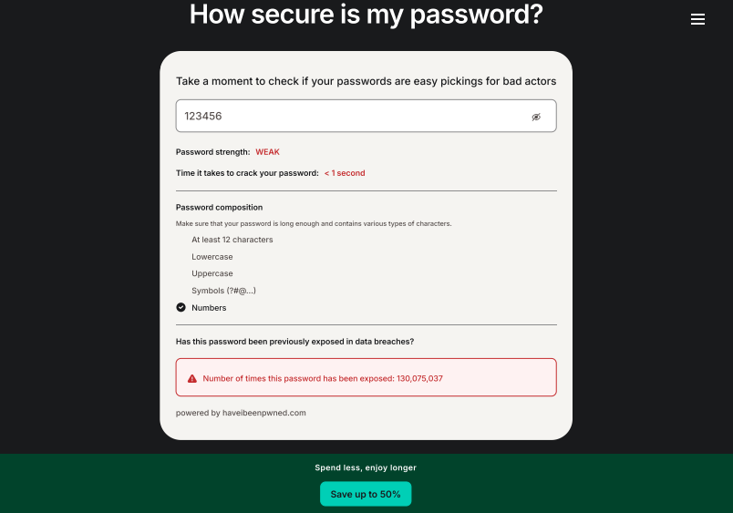

**After using strong password:**

it says time to crack the password 31yr for Brute Force attack

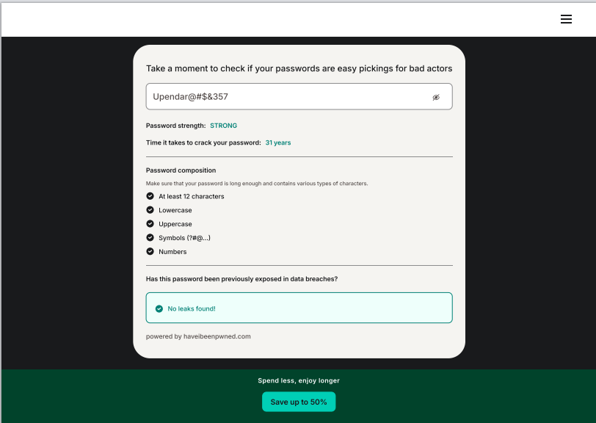

**Test your password if its says week use the strong password and use complex and mixed char to check the strength of password**

* **Best Practices and Recommendations for Password Security**

In the digital age, passwords act as the first line of defense against unauthorized access to personal, corporate, and financial data. As cyber threats become more sophisticated, following strong password practices is essential to protect sensitive information. Below are some key best practices and recommendations that every user should adopt

**1.Use System-Generated Passwords:**

Avoid predictable or reused passwords. Let your system or password manager generate long, random, and unique passwords for each account.

**2.Mix Characters:**

Strong passwords use uppercase, lowercase, numbers, and special characters. Example: Instead of summer2025, use G7$kLp!wZx9@.

**3.Avoid Common Words & Personal Info:**

Stay away from dictionary words, names, birthdays, or anything easy to guess. Hackers use tools that can crack such passwords quickly.

**4.Enable MFA (Multi-Factor Authentication):**

MFA adds an extra layer of security with a one-time code or authentication app, even if your password gets exposed.

**5.Change Passwords Often & Don’t Reuse:**

Update important passwords every 3–6 months and avoid using the same password across multiple sites to prevent chain breaches.

**6.Use a Trusted Password Manager:**

Apps like Bitwarden, KeePassXC, or 1Password securely store your credentials, auto-fill logins, and alert you about weak or reused passwords

**My personal trick:** sometimes using the same strong password twice in a creative way can even confuse hackers. 😊