**Understanding VPN – What, Why, and How to Use It**

**Intro:**

In today’s digital world, privacy and security are becoming increasingly important. A VPN (Virtual Private Network) is one of the essential tools to protect your identity, secure your connection, and access blocked content. This guide will help you understand what a VPN is, why we use it, and how to use a free VPN service step by step

**What is a VPN?**

A VPN (Virtual Private Network) is a service that creates a secure, encrypted connection between your device and the internet. It masks your IP address, making your online activities private and secure — like a private tunnel through the internet.

**Why Do We Use a VPN?**

**1. To Protect Privacy**

A VPN hides your IP address and online activities from websites, hackers, and internet providers.

**2. To Stay Secure on Public Wi-Fi**

It encrypts your internet connection so no one can steal your data on public networks like in cafes or airports.

**3. To Access Blocked or Restricted Content**

VPN lets you bypass region-based blocks and view content that may not be available in your country.

**4. To Bypass Government or ISP Censorship**

It helps you access websites or services blocked by your government or internet provider.

**5. To Download or Torrent Safely**

VPN keeps your identity hidden while using P2P or torrent services online.

**6. To Prevent Online Tracking**

It stops advertisers and trackers from following you across websites and collecting your data.

**How Does a VPN Work?**

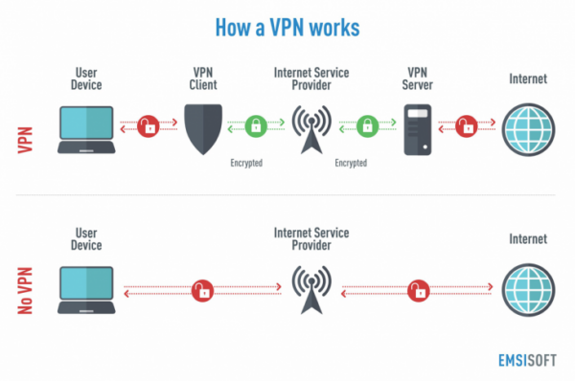

When you use the internet normally:

Your device → ISP → Website (your IP is visible)

When using a VPN:

Your device → VPN server (encrypted) → Website (VPN IP is visible)

So, websites only see the VPN server’s IP, not yours. This protects your identity and data.

**Practical**

**>> Currently, I am using a trusted and reputable browser extension.**

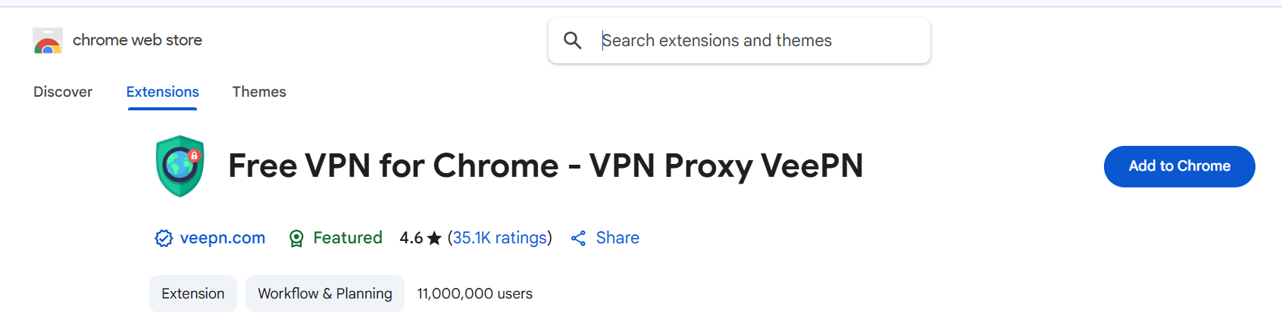

**>> Add to chrome**

**After adding to chrome it gives a pop-up alert click Add extension**

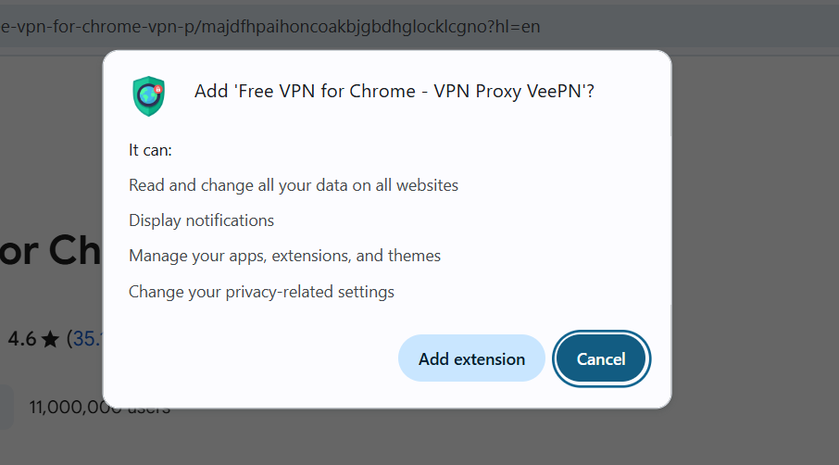

Click the add extension

**>> Check on top right if extension is available or not**

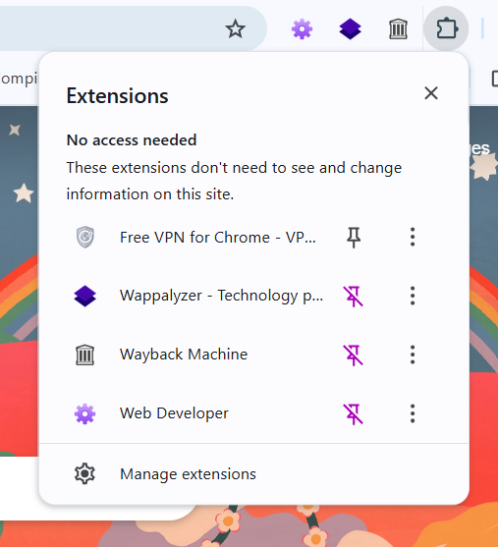

**Interface of VPN Extension looks like this a show in fig**

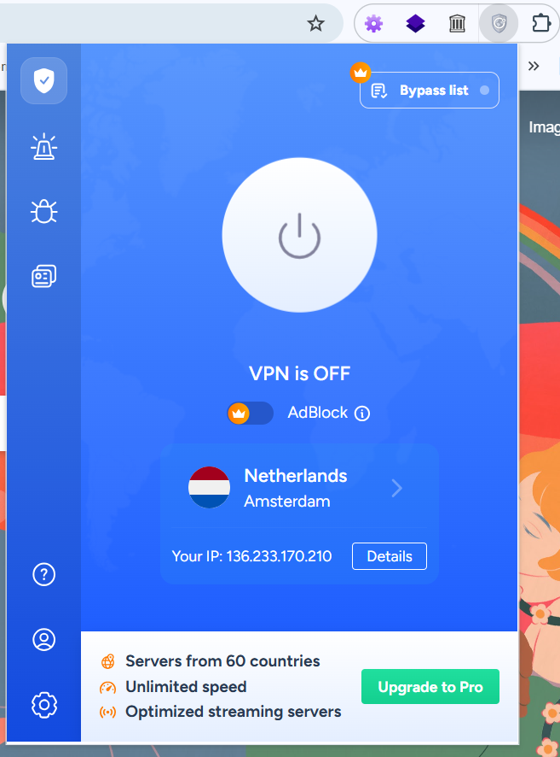

Before connecting to VPN it shows your connected IP

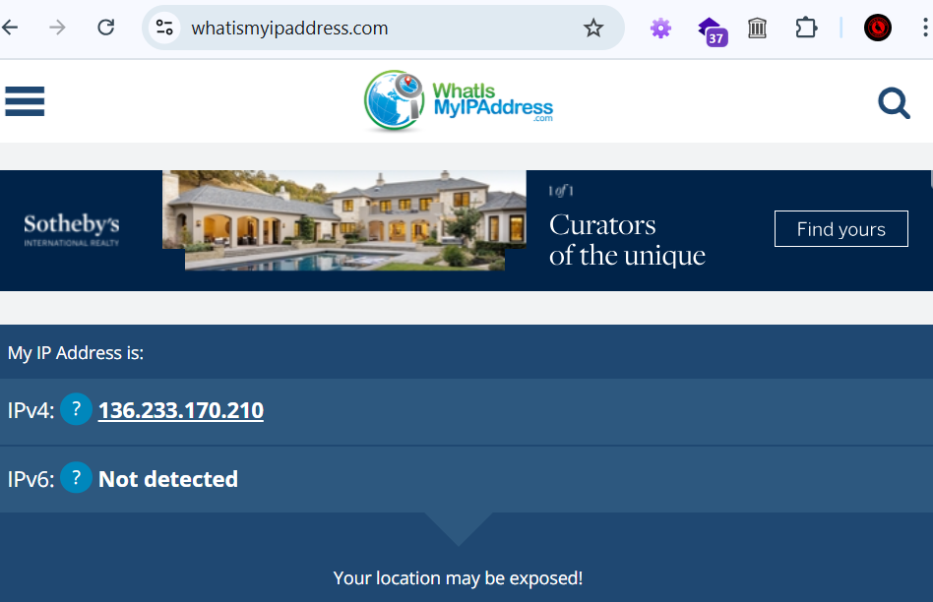

Now start the VPN the interface looks like this

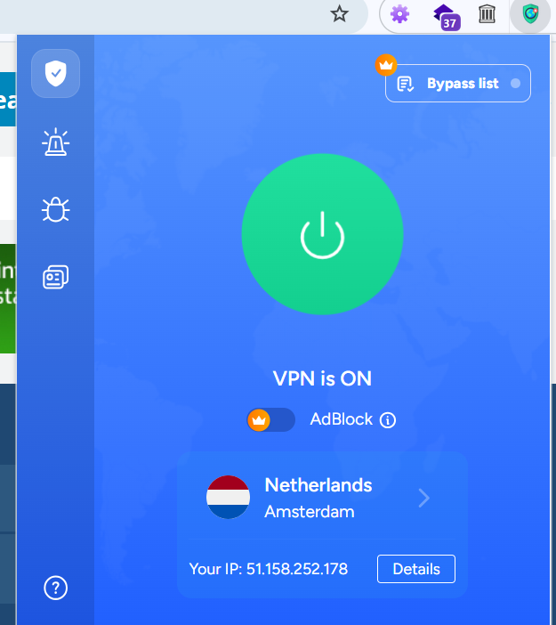

**After connecting to VPN the IP address is changed**

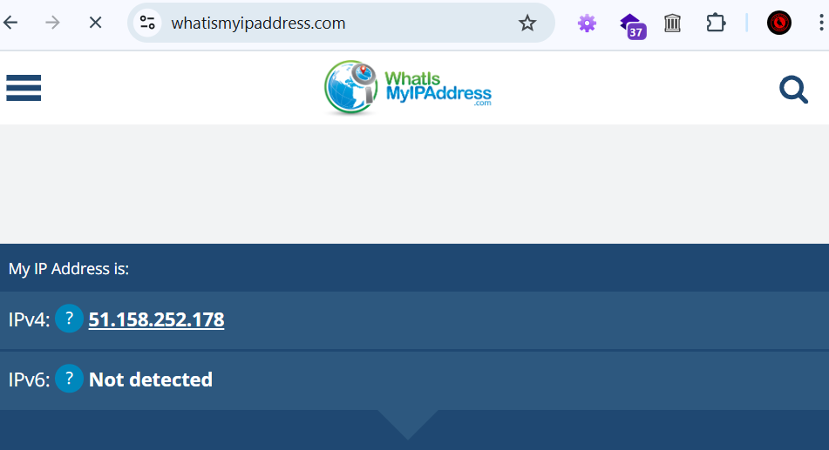

**Conclusion**

Using a VPN is one of the simplest and most effective ways to protect your privacy, secure your internet connection, and access content without restrictions. Whether you're browsing on public Wi-Fi, accessing geo-blocked services, or simply concerned about online tracking, a VPN is a valuable tool.

Remember to choose a reputable VPN service that respects your privacy and does not log your activity. Start small — try a trusted browser extension or a free VPN — and gradually explore advanced features as needed.

Stay safe, stay private, and take control of your digital experience.