Understanding Browser Extensions: What Every User Should Know

* **What Is a Browser Extension?**

A browser extension is a lightweight, add-on application that runs inside a browser to add or modify features. It interacts with web pages or browser behaviour without needing to reload or visit the application separately

* **Why Do We Use Extensions?**

Browser extensions enhance the overall user experience by providing quick access to specific functionalities directly within the browser. They make everyday tasks more flexible and efficient—such as storing and auto filling passwords, customizing the layout or behaviour of web applications, and integrating productivity tools without needing to open separate apps. Extensions also streamline workflows by offering real-time features like grammar suggestions, dark mode toggles, or developer utilities, making web browsing smarter and more tailored to the user’s needs.

* **How Extensions Communicate with Browsers:**

Browser extensions communicate with the browser using special APIs that let them send messages and interact with web pages. They can inject scripts into pages to read or change content and use background scripts to handle tasks quietly. All communication happens in a controlled way so the browser stays safe and fast.

* **What is a Sandbox Extension:**

A sandboxed extension runs in a limited, secure environment that keeps it separated from the browser and your data. This sandbox protects users by preventing the extension from doing anything harmful or accessing sensitive parts of the browser without permission. It acts like a safety bubble around the extension to keep everything secure.

* **Advantages of using Browser Extension**

1.Productivity

2.Convenience

3.Security

4.Customization

5.Accessibility

6.Automation

7.Integration

8.Speed

**Installation of Extension:**

**Practical**

For now, I am going to install wayback machine

>> Search wayback machine extension on browser

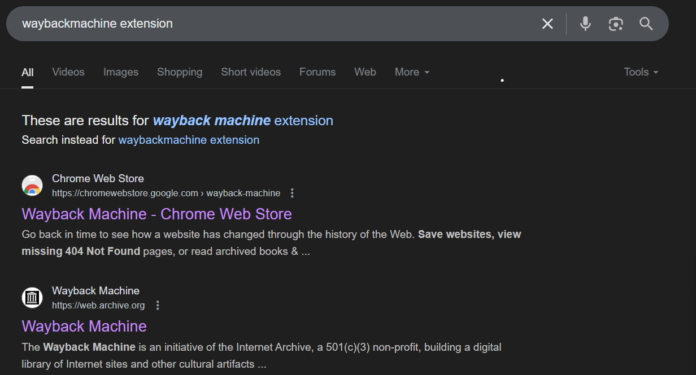

>> Click the first link it redirects to extension page

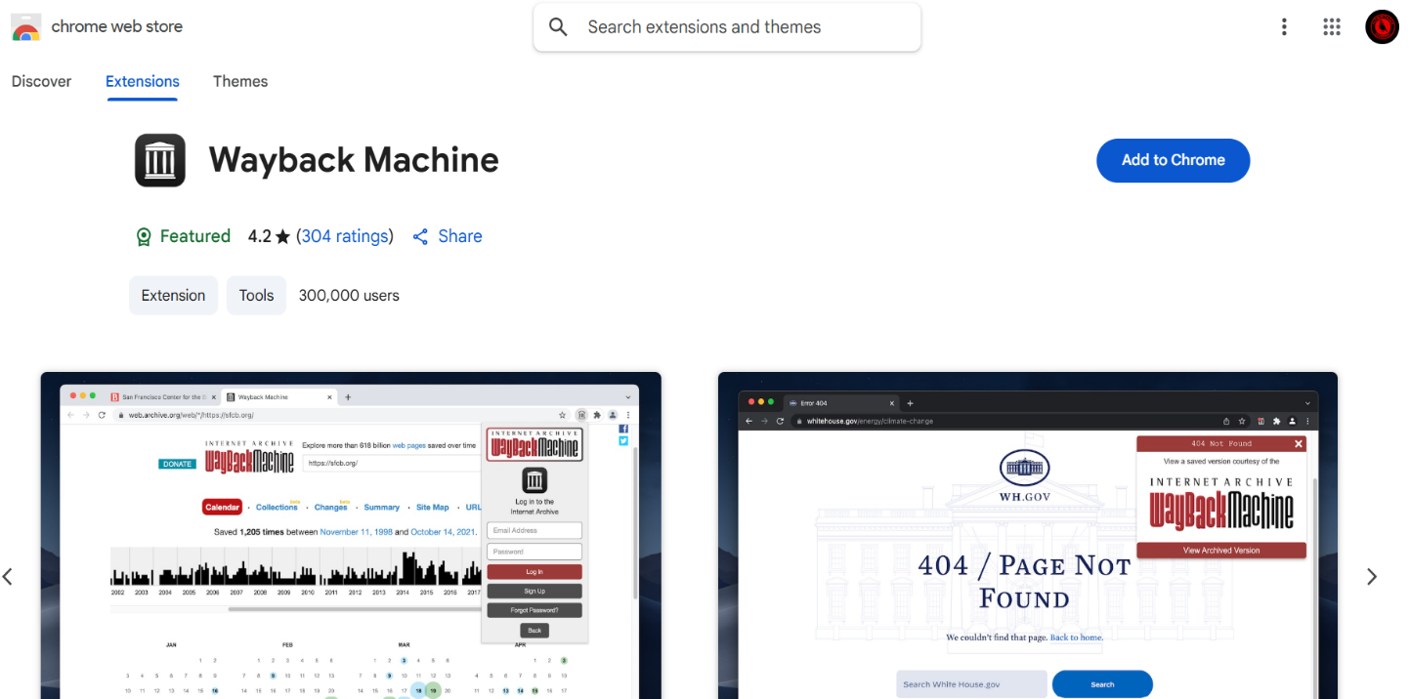

>> click the Add to chrome.

After clicking the Add to Chrome it gives the pop-up button it says to Add extension .click the Add extension

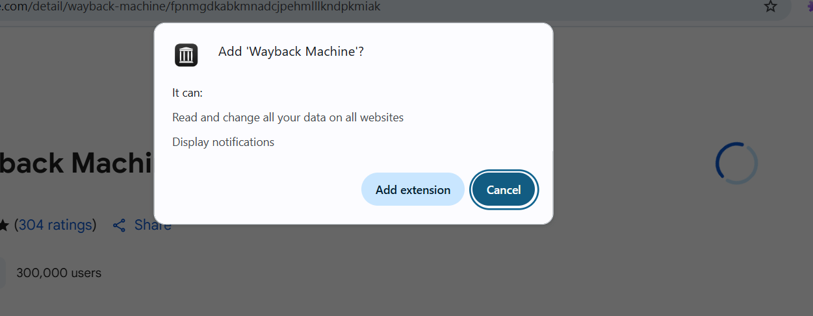

>> “That’s it! We’ve successfully added…

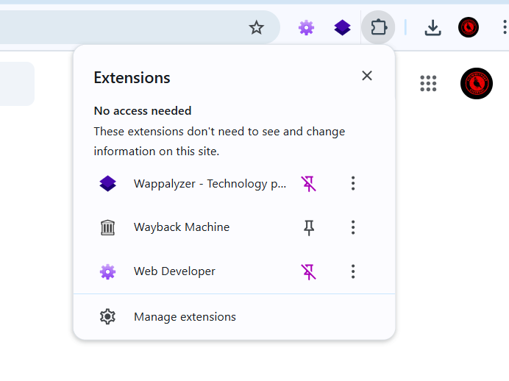

Note:

You can view your installed extensions at the top-right corner of the browser. To keep a specific extension visible at all times, simply click the puzzle icon and select “Pin” next to the extension you want to display.

>> Check the extension is it working or not

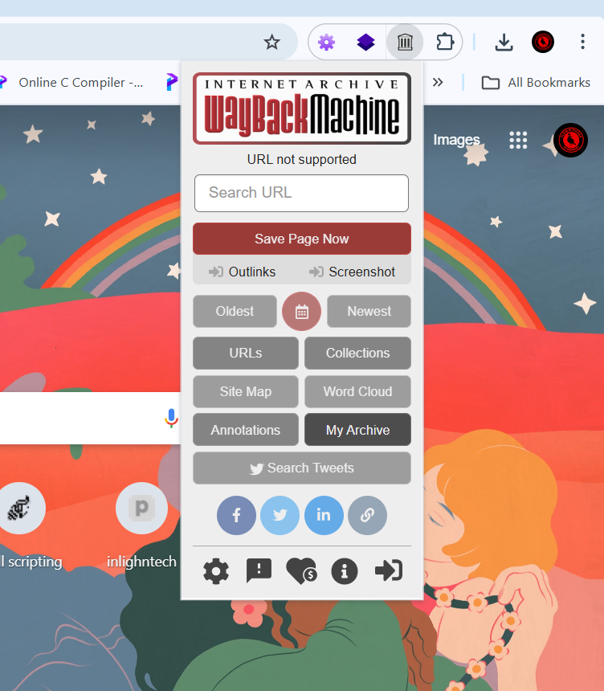

The extension we added to browser is working

>> For removing the extension from browser

Click the three-dot menu (⋮) at the top-right corner of your browser, then navigate to “Extensions” to manage, enable, disable, or remove your installed extensions.

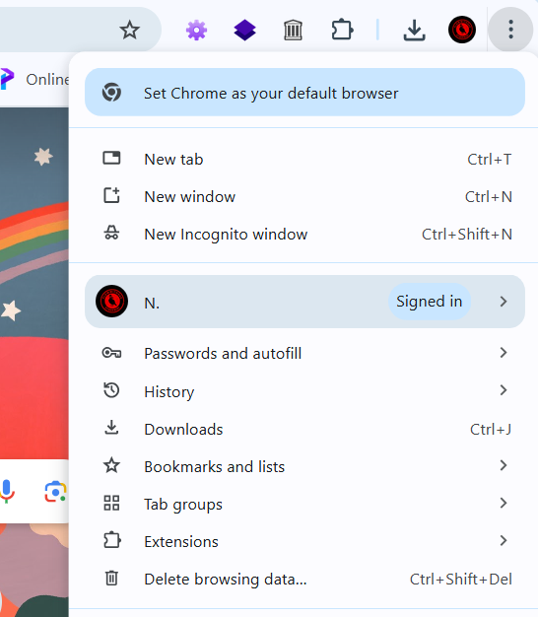

>> It says to remove form chrome

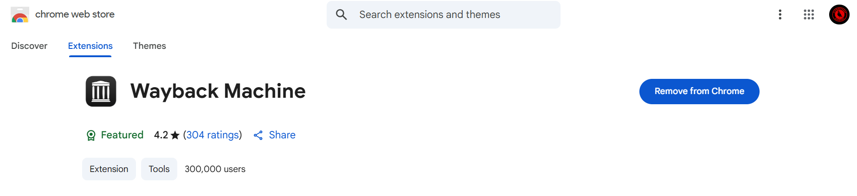

Click remove it will remove the extension from browser

>> Work flow of extensions

You open a website → The extension sees the URL → Injects a content script → Reads or modifies the page → Shows result via popup or background alert.

**>> Disadvantages of using browser extensions**

While browser extensions can enhance functionality and convenience, they also pose certain drawbacks such as potential privacy risks, increased memory usage, reduced browser performance, and the possibility of malicious or poorly maintained extensions compromising security. Users should be cautious and only install trusted extensions with necessary permissions.

**1.Privacy Risks** – Extensions can access sensitive browsing data.

**2.Security Threats** – Malicious or hijacked extensions can steal information.

**3.Auto-Updates Risks** – A trusted extension can become malicious after an update.

**4.Over-Permission** – Many ask for more access than they need

**5.Tracking** – Some extensions send usage data to third parties.

Precautions for Safe Browser Extension Usage

1.Install from trusted sources only (e.g., Chrome Web Store, Firefox Add-ons).

2.Review permissions before installing—avoid “access to all websites” unless necessary.

3.Limit extensions—only keep the ones you actively use.

4.Regularly review and remove unused or suspicious extensions.

5.Check user reviews and ratings before installing.

6.Do not install cracked or pirated extensions from third-party sites.

7.Turn off extensions in incognito mode unless absolutely required.

8.Monitor updates—beware of extensions that suddenly ask for new permissions.

9.Use browser settings to restrict access (site-specific permissions).

10.Enable extension sandboxing and update your browser regularly for security patches.