Cluedo — Team 53
A Python + Pygame implementation of Watson Games' classic Clue! murder mystery board game. Built as a five-person Software Engineering coursework project at Sussex (G6046).
3–6 players take turns to deduce the murderer, the weapon, and the room. Each slot can be a local human or a built-in AI; mixed games are supported. The game is hot-seat: one machine, one screen, humans pass the device, AI slots auto-resolve in the GUI.
Repository: https://github.com/floydsimmy/SWECOURSEWORK2026

Install
Requires Python 3.10 or later. Developed and tested on Python 3.13.
pip install -r requirements.txt
requirements.txt pins:
pygame==2.6.1
pytest==9.0.3

Run
python -m src.main
(or equivalently python src/main.py)
Both invocations open the same Pygame window at 1200 × 800.

Player setup
- From the title screen, click Start New Game.
- Enter between 3 and 6 player names. For each slot, the button on the right toggles between Human and AI; any mix is allowed (subject to the 3–6 player count). Empty and duplicate names are rejected with a visible error.
- Click Start Game to deal the cards and begin.
The engine selects one suspect, one weapon, and one room as the hidden solution; the remaining 18 cards are dealt round-robin. Each AI slot is given a private DetectiveNotes seeded only from its own hand — the AI never reads the hidden solution.

Controls
The game is mouse-driven from start to finish.
Action | How
Move (dice + grid) | Click Roll Dice. The board highlights every reachable corridor tile and every reachable room (via doors). Click a highlighted tile or room to move there.
Make a suggestion | Click Make Suggestion (requires being in a room) → pick suspect + weapon → Confirm
Make an accusation | Click Make Accusation → pick suspect + weapon + room → Confirm
End your turn | Click End Turn
Quit | Close the window, or click Quit to Menu on the game screen
When the current player is an AI slot, the GUI auto-resolves its turn (roll, move, suggest, optional accuse) and prints the public actions to the in-game log. The AI never reveals the cards in its hand.
Suggestions and accusations validate inputs and surface clear errors (out of turn, eliminated, missing room) without crashing the game. When a suggestion is made, the suggested suspect and weapon tokens move into the suggester's current room and remain there afterwards (per F12 in the user requirements). The in-game suggestion log surfaces this token movement on the line below the suggestion, so the side effect is visible to the player.

Screenshots
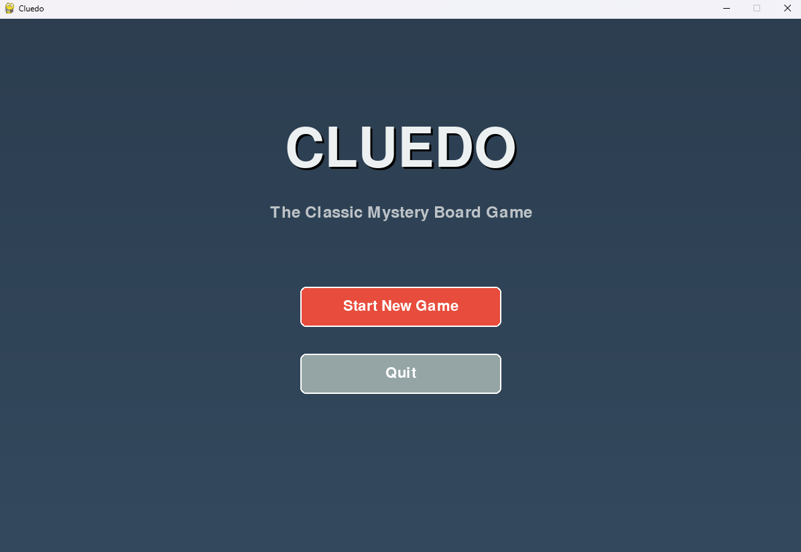
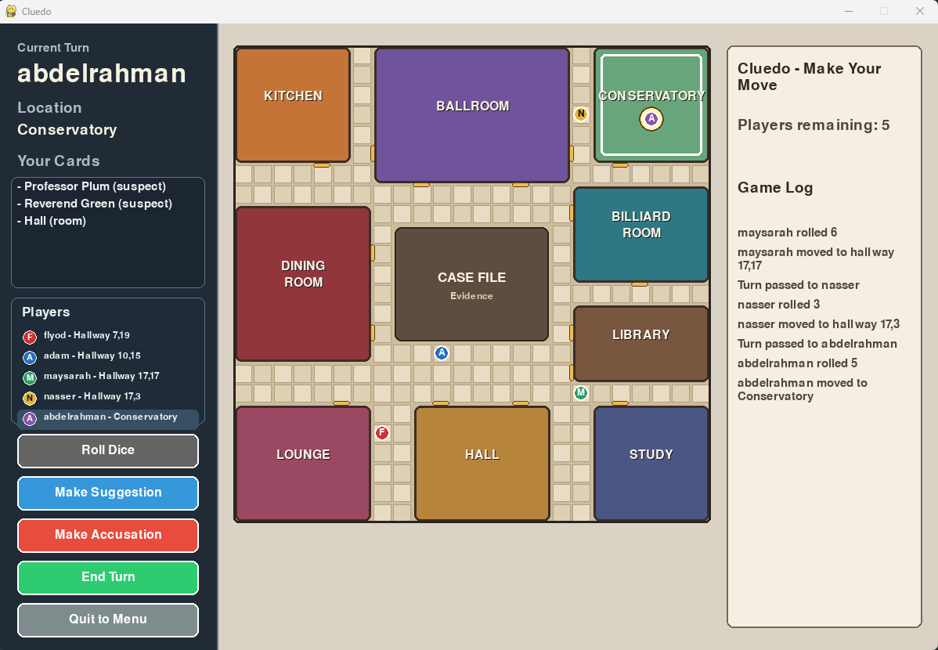
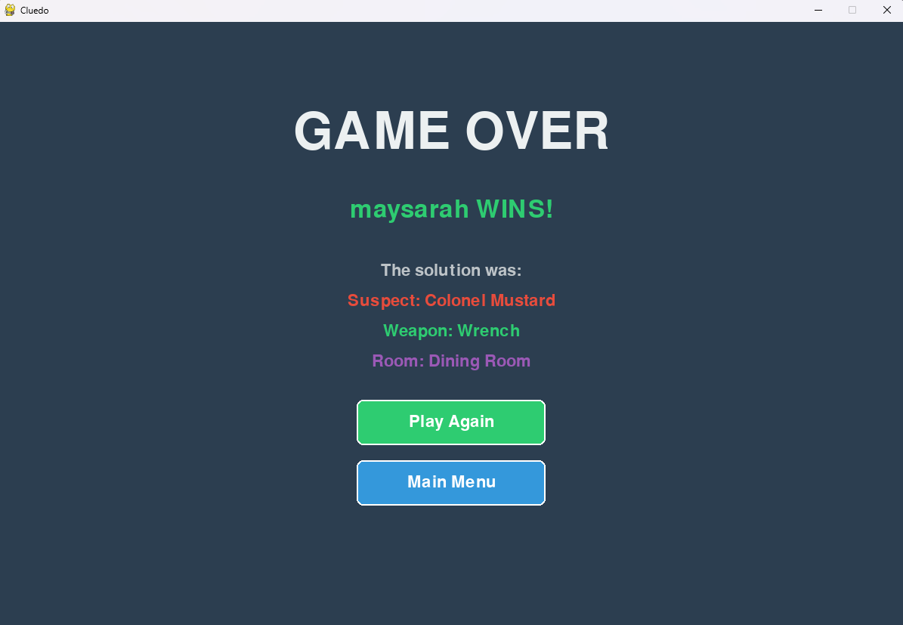

Run the tests
python -m pytest -q
The unit test suite covers engine setup, dealing, turn cycling, dice + grid movement, suggestion + refutation, accusation, validation, edge cases, the AI player module's behaviour and privacy invariants, dice-roll fairness, and the engine-level guard against rolling twice in a single turn. Expected output: 116 passed.

Documentation
Process, design, testing, and reporting documentation lives under docs/. Start at docs/README.md for a marker-facing index of every deliverable.
Engineering decisions and deviations from the original user requirements are recorded as ADRs in docs/decisions.md.

Team 53
Person | Role
Floyd | Technical Lead & Integrator
Maysarah | Game Logic Engineer
Adam | Scrum Master, Documentation Lead & Product Owner
Nasser | UI/GUI Engineer
Abdurrahman | QA Lead

