Chart Creation in ggplot2

Install R/RStudio
Request via the Software Request Tool and direct them to this website to install both R and RStudio: https://posit.co/download/rstudio-desktop/.

RStudio is an integrated development environment (IDE) for R, which makes it more user-friendly to write and debug your code.

Download Packages
When you install R, it comes with several base packages available. Each package includes a series of functions you can use to accomplish certain tasks more efficiently, like transforming and visualizing data.

Before we dive into what packages you need to install and how, you want to make sure your packages are being installed in a location where you have write privileges. Here are instructions:

https://www.ascendientlearning.com/training-resources/tutorials/how-to-change-the-default-library-in-rstudio

Mine are saved in my C:/ folder, but you may have a better place to save them:

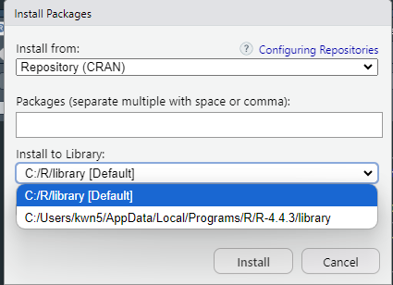

To install the packages needed for this tutorial, please run the following command in R:

install.packages("openxlsx", "tidyverse", "ggtext")

This downloads the following packages:
- openxlsx
- tidyverse
- ggtext

Class Materials
All class materials are available for reference and download here: https://github.com/flrnclee-cdc/ggplot2-tutorials/tree/main

This repository will be continually updated with tutorials, so be sure to bookmark it!

Resources
https://ggplot2.tidyverse.org/
https://ggplot2-book.org/

