Felix Singerman - 7970742

CSI2132: Database I Assignment 1

**Entity Relational Model**

1. A database is being constructed to keep track of the teams and games of a baseball league. A team has a number of players, not all of whom participate in each game. It is desired to keep track of the players participating in each game for each team, the positions they played in that game, and the result of the game. Design an ER schema diagram for this application, stating any assumptions you make.

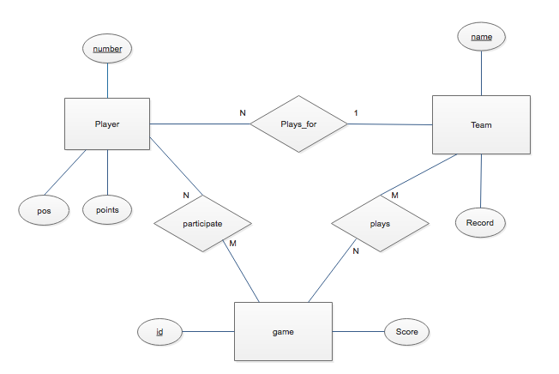

**Enhanced Entity Relational Model**

1. Consider the BANK ER schema in Figure 1, and suppose that it is necessary to keep track of different types of ACCOUNTS(SAVINGS_ACCTS, CHECKING_ACCTS, ... ) and LOANS (CAR_LOANS, HOME_LOANS, ... ). Suppose that it is also desirable to keep track of each ACCOUNT’s TRANSACTIONS (deposits, withdrawals, checks, ...) and each LOAN’s PAYMENTS; both of these include the amount, date, and time. Modify the BANK schema, using ER and EER concepts of specialization and generalization. State any assumptions you make about the additional requirements.

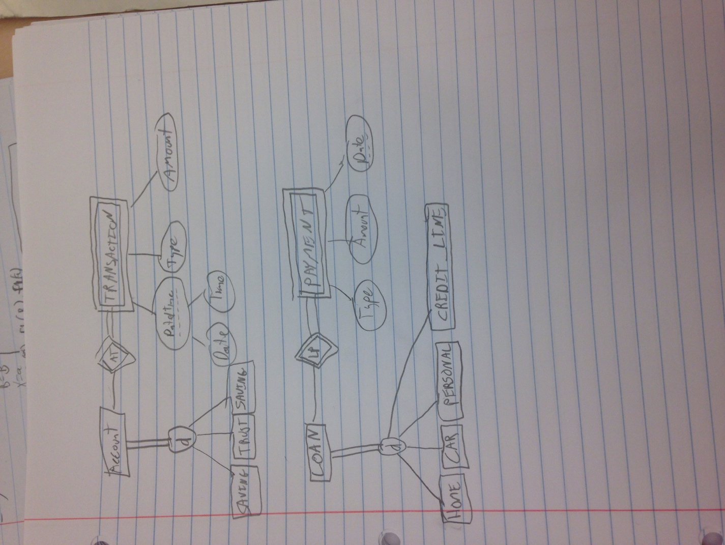

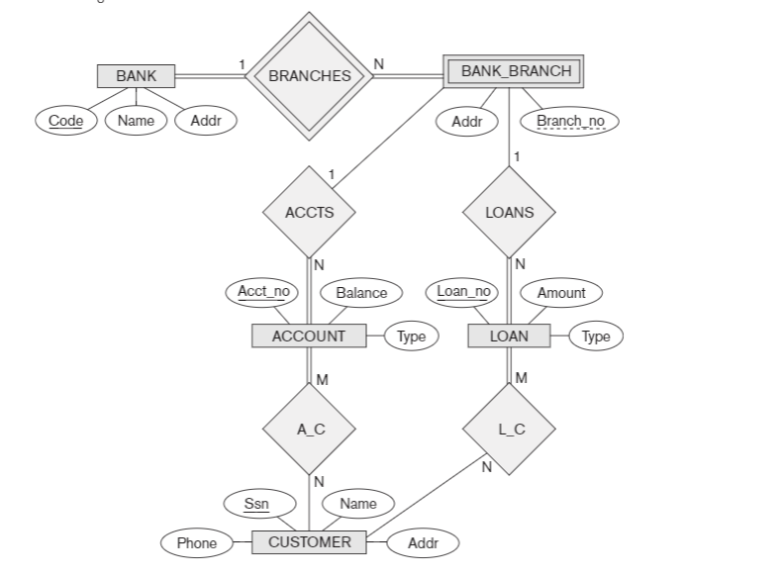

**Figure 1: An ER diagram for a BANK database schema.**

**Relational Model**

1. Consider the AIRLINE relational database schema shown in Figure 2, which describes a database for airline flight information. Each FLIGHT is identified by a Flight_number, and consists of one or more FLIGHT_LEGs with Leg_numbers 1, 2, 3, and so on. Each FLIGHT_LEG has scheduled arrival and departure times, airports, and one or more LEG_INSTANCEs—one for each Date on which the flight travels. FAREs are kept for each FLIGH. For each FLIGHT_LEG instance, SEAT_RESERVATIONs are kept, as are the AIRPLANE used on the leg and the actual arrival and departure times and airports. An AIRPLANE is identified by an Airplane_id and is of a particular AIRPLANE_TYPE. CAN_LAND relates AIRPLANE_TYPEs to the AIRPORTs at which they can land. An AIRPORT is identified by an Airport_code. Consider an update for the AIRLINE database to enter a reservation on a particular flight or flight leg on given date.
2. Give the operations for this update.

INSERT INTO seat_reservation

<FlightNo, LegNo, Date, SeatNo, CustName, CustPhone>;

repeat that per leg1

1. What types of constraints would you expect to check?

We would have to check the constraints that the seat number being reserved is also still available.

We would also have to check if the number of seats of available on each leg is greater than 1 before making a reservation.

1. Which of these constraints are key, entity integrity, and referential integrity constraints, and which are not?

The insert operation into SEAT_RESERVATION will have to check all the key, entity integrity and referential integrity constraints for the relation.

We would have to check the number of available seats on each leg of the flight is greater than 1 does not fall into any of the above types of constraints.

1. Specify all the referential integrity constraints that hold on the schema shown in Figure 2.

FLIGHT_LEG.FLIGHT_NUMBER --> FLIGHT

FLIGHT_LEG.DEPARTURE_AIRPORT _CODE --> AIRPORT FLIGHT_LEG.ARRIVAL_AIRPORT_CO DE --> AIRPORT LEG_INSTANCE.(FLIGHT_NUMBER,L EG_NUMBER) --> FLIGHT_LEG

R.A --> S OR ¬R.(X) --> S

LEG_INSTANCE.DEPARTURE_AIRPO RT_CODE --> AIRPORT LEG_INSTANCE.ARRIVAL_AIRPORT_ CODE --> AIRPORT LEG_INSTANCE.AIRPLANE_ID --> AIRPLANE

FARES.FLIGHT_NUMBER --> FLIGHT

CAN_LAND.AIRPLANE_TYPE_NAME - -> AIRPLANE_TYPE

CAN_LAND.AIRPORT_CODE --> AIRPORT

AIRPLANE.AIRPLANE_TYPE --> AIRPLANE_TYPE

SEAT_RESERVATION.(FLIGHT_NUMB ER,LEG_NUMBER,DATE) --> LEG_INSTANCE

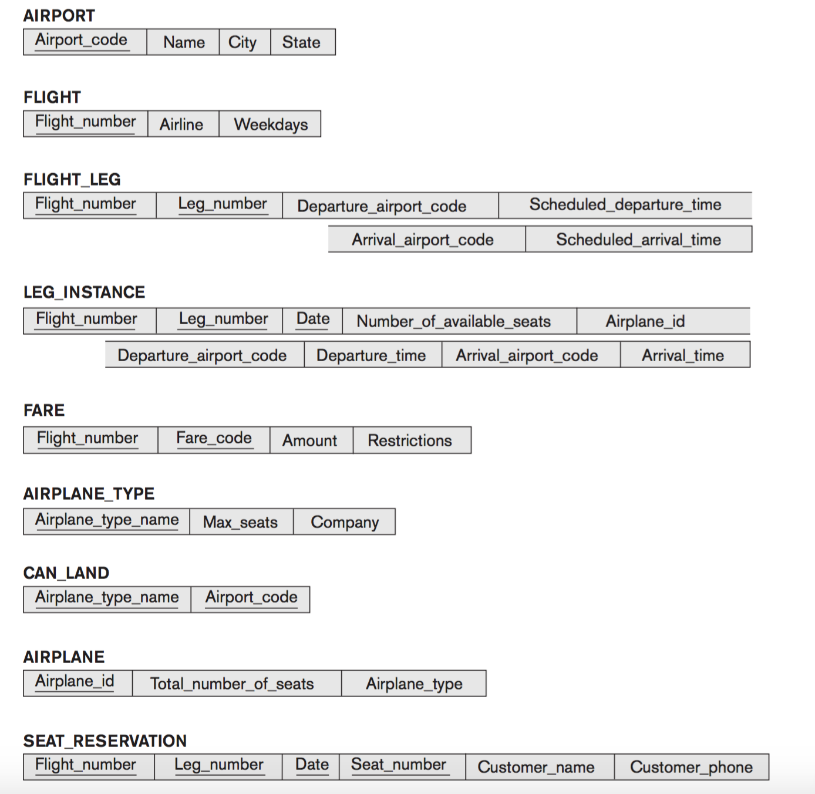

**Figure 2: Referential integrity constraints displayed on the AIRLINE relational database schema.**

**Mapping Relational Model to Entity Relational Model**

1. Figure 3 shows an ER schema for a database that can be used to keep track of transport ships and their locations for maritime authorities. Map this schema into a relational schema and specify all primary keys and foreign keys.

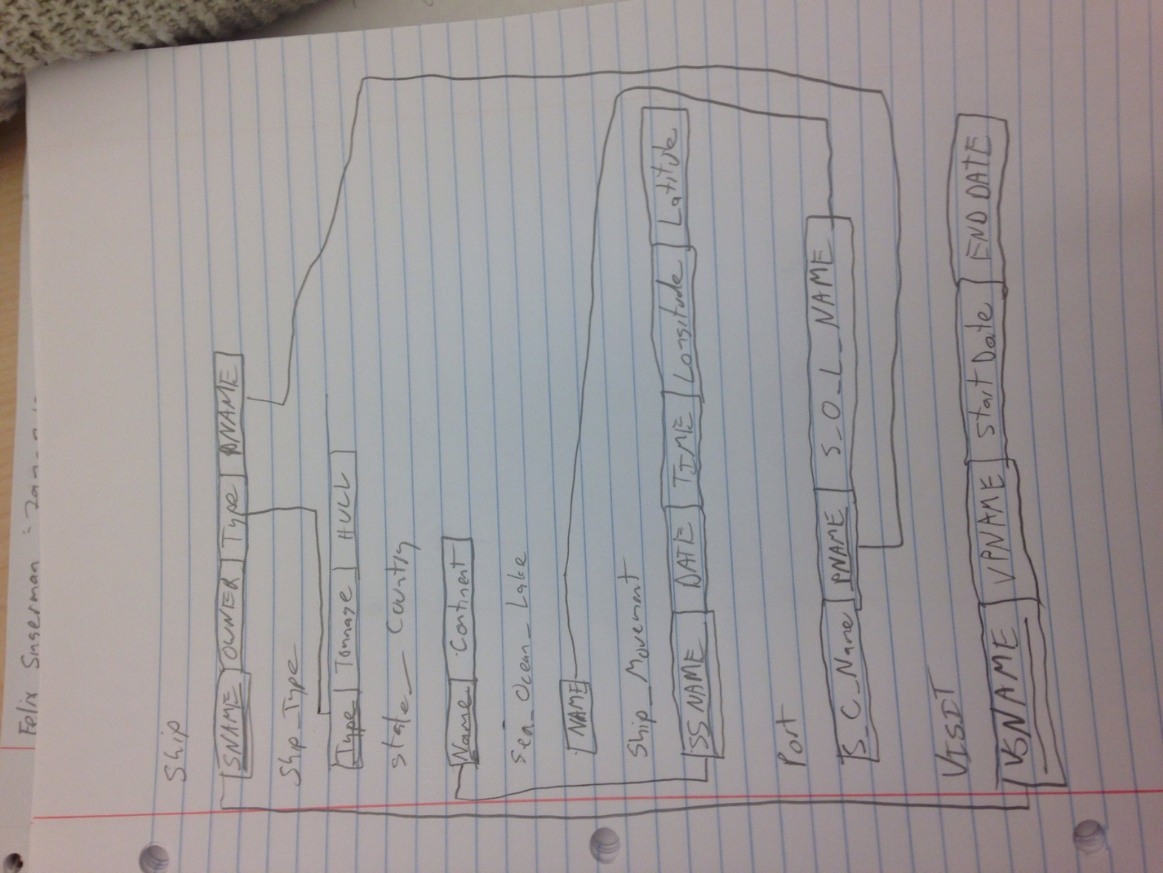

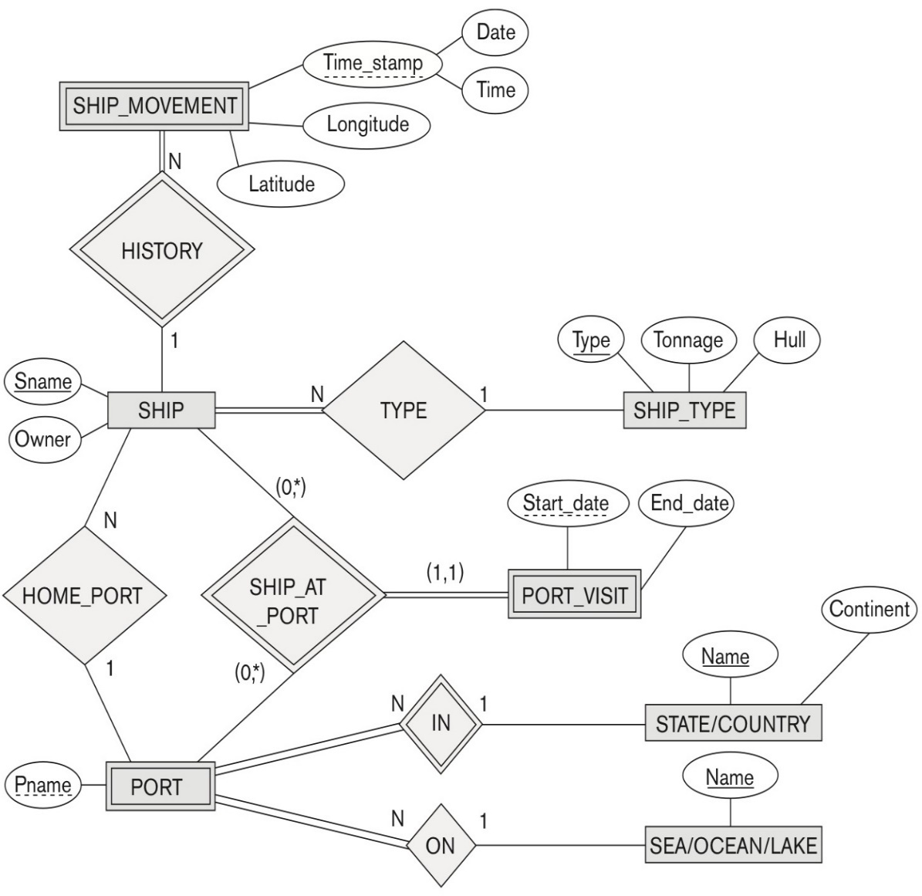

**Figure 3: An ER schema for a SHIP_TRACKING database**