An introduction to Statistical Modelling using GLMs

Lindesay Scott-Hayward

2020-05-25

Table of Contents

# Course Information

This is a *sample* book written in **Markdown**. You can use anything that Pandoc’s Markdown supports, e.g., a math equation $a^{2}+b^{2}=c^{2}$.

The **bookdown** package can be installed from CRAN or Github:

install.packages("bookdown")  
# or the development version  
# devtools::install_github("rstudio/bookdown")

Remember each Rmd file contains one and only one chapter, and a chapter is defined by the first-level heading #.

To compile this example to PDF, you need XeLaTeX. You are recommended to install TinyTeX (which includes XeLaTeX): <https://yihui.name/tinytex/>.

# Introduction

You can label chapter and section titles using {#label} after them, e.g., we can reference Chapter 2. If you do not manually label them, there will be automatic labels anyway, e.g., Chapter 4.

## Figures and Tables

Figures and tables with captions will be placed in figure and table environments, respectively.

par(mar = c(4, 4, .1, .1))  
plot(pressure, type = 'b', pch = 19)

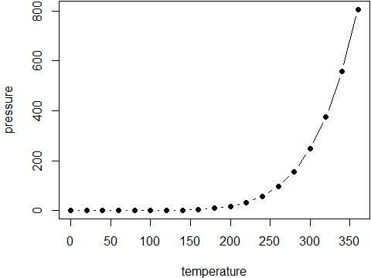

Figure 1: Here is a nice figure!

Reference a figure by its code chunk label with the fig: prefix, e.g., see Figure 1. Similarly, you can reference tables generated from knitr::kable(), e.g., see Table 1.

You can also do a text reference for a figure which is useful if you want special characters;

(ref:myfig) Define a text reference **here** with some math symbols like $θ$.

par(mar = c(4, 4, .1, .1))  
plot(pressure, type = 'b', pch = 19, col=2)

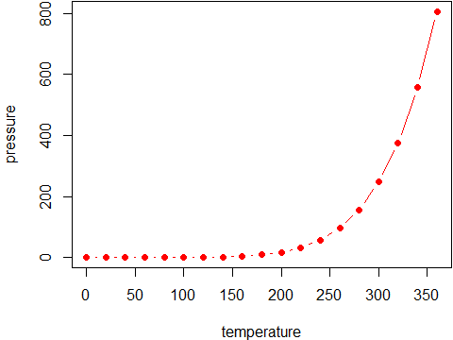

Figure 2: (ref:myfig)

Here i am referencing 2.

par(mar = c(4, 4, .1, .1))  
plot(pressure, pch = 19, type = 'b')  
plot(cars, pch = 19)

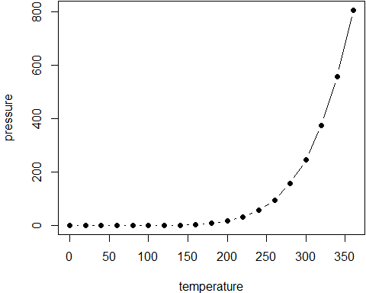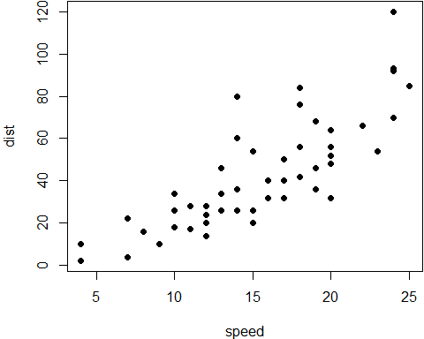

knitr::kable(  
 head(iris, 20), caption = 'Here is a nice table!',  
 booktabs = TRUE  
)

Table 1: Here is a nice table!

|  |  |  |  |  |
| --- | --- | --- | --- | --- |
| Sepal.Length | Sepal.Width | Petal.Length | Petal.Width | Species |
| 5.1 | 3.5 | 1.4 | 0.2 | setosa |
| 4.9 | 3.0 | 1.4 | 0.2 | setosa |
| 4.7 | 3.2 | 1.3 | 0.2 | setosa |
| 4.6 | 3.1 | 1.5 | 0.2 | setosa |
| 5.0 | 3.6 | 1.4 | 0.2 | setosa |
| 5.4 | 3.9 | 1.7 | 0.4 | setosa |
| 4.6 | 3.4 | 1.4 | 0.3 | setosa |
| 5.0 | 3.4 | 1.5 | 0.2 | setosa |
| 4.4 | 2.9 | 1.4 | 0.2 | setosa |
| 4.9 | 3.1 | 1.5 | 0.1 | setosa |
| 5.4 | 3.7 | 1.5 | 0.2 | setosa |
| 4.8 | 3.4 | 1.6 | 0.2 | setosa |
| 4.8 | 3.0 | 1.4 | 0.1 | setosa |
| 4.3 | 3.0 | 1.1 | 0.1 | setosa |
| 5.8 | 4.0 | 1.2 | 0.2 | setosa |
| 5.7 | 4.4 | 1.5 | 0.4 | setosa |
| 5.4 | 3.9 | 1.3 | 0.4 | setosa |
| 5.1 | 3.5 | 1.4 | 0.3 | setosa |
| 5.7 | 3.8 | 1.7 | 0.3 | setosa |
| 5.1 | 3.8 | 1.5 | 0.3 | setosa |

Reference this table using Table 1

You can write citations, too. For example, we are using the **bookdown** package (Xie 2020) in this sample book, which was built on top of R Markdown and **knitr** (Xie 2015).

## Equations:

You may refer to it using (1), e.g., see Equation (2.1).

Please make sure equations without labels are not numbered by either using the equation* environment or adding or to your equations. The same rules apply to other math environments, such as eqnarray, gather, align, and so on (e.g., you can use the align* environment).

use split to have multiple lines with one equation reference

there are also ‘example’ and ‘exercise’ environments (labelled with exm and exr respectively)

Example 1: (how to do an example) for this example, we show nothing

Example 2: (how to do a second example) for this example, we show something

these environments can be changed using the css file CSS class being the environment name, e.g., <div class="lemma"></div>

# Literature

Here is a review of existing methods.

# Methods

We describe our methods in this chapter.

We showed some examples in the introduction (Chapter 2)

You can also reference specific sections by giving them a label {#sectionname}

And you can add words to the index such as GLM

## Shiny app

[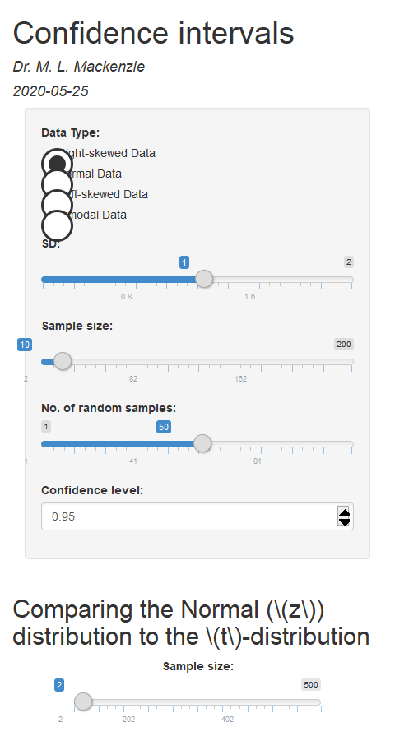](https://lindesaysh.shinyapps.io/mt1007_week22/)

you can use a shiny app embedded in the notes Figure 3.

# Applications

Some *significant* applications are demonstrated in this chapter.

## Example one

## Example two

# Final Words

We have finished a nice book.

If you want to split the book by sections, so each html page is a section you can use split_by=‘section’ in the YAML header.

output:   
 bookdown::gitbook:  
 lib_dir: "book_assets"  
 config:  
 sharing: null  
 split_by: section

# Appendix

# first appendix

Xie, Yihui. 2015. *Dynamic Documents with R and Knitr*. 2nd ed. Boca Raton, Florida: Chapman; Hall/CRC. <http://yihui.name/knitr/>.

———. 2020. *Bookdown: Authoring Books and Technical Documents with R Markdown*. <https://CRAN.R-project.org/package=bookdown>.