**Computer Organization**

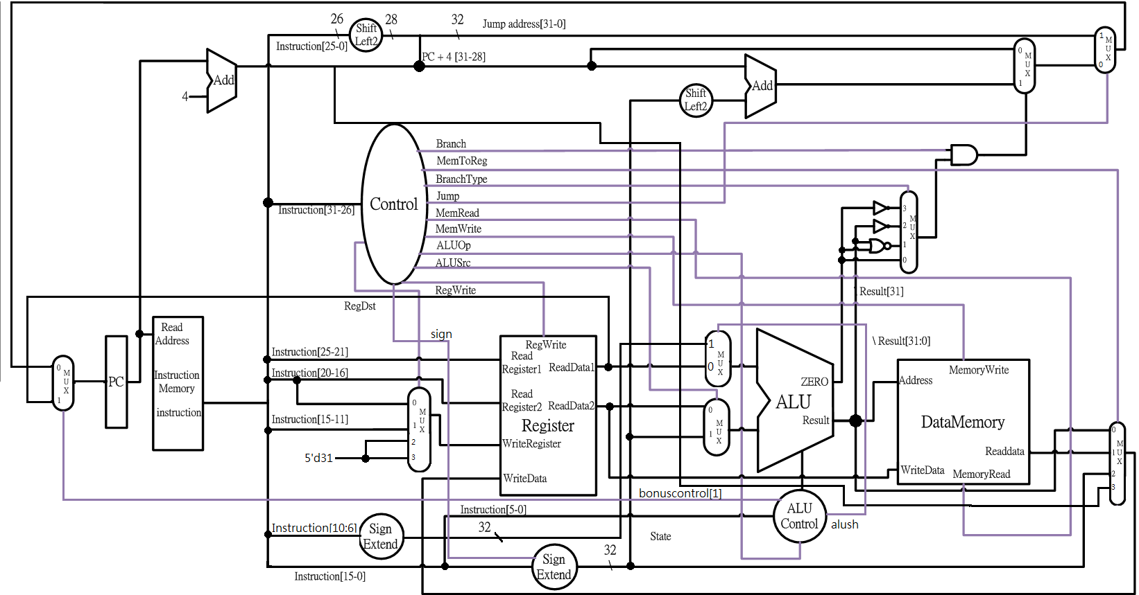**架構圖:**

**設計模組分析:**

**alu_top.v: The very basic a-bit ALU, including and, or, add, less four operations.**

**ALU.v: The 32 bit ALU, connected by 32 alu_top modules. It decodes the ALU_control signal and does the corresponding operations.**

**ALU_Ctrl.v: According to the ALUOp signal from the instruction decoder to generate control signals for ALU.v Input: which type the instruction is. Output: what operation should the ALU do.**

**Adder.v: Just a very simple 32-bit adder, used for program counter (+4 and jump).**

**Data_Memory.v: Used for memory storage (from TA).**

**Decoder.v: Decodes the type of instructions and output some control signals for other muxes, like RegWrite and Branch.**

**Instr_Memory.v: The instruction Memory of the CPU, where we store our program (from TA).**

**Reg_File.v: Our register file, r0 to r14 live here. RegWrite_i used to decide if we want to overwrite the registers or not. (from TA)**

**MUX_2to1.v & MUX_4to1: Implement 2x1 and 4x1 muxes.**

**ProgramCounter.v: The PC of our CPU, it just passes the 32-bits bus from pc_in_i to pc_out_i during clock edges.**

**ShiftAdmount_Extend.v: Does zero extension actually.**

**Shift_Left_Two_32.v: Append two zeros to the input signal.**

**Sign_Extend.v: Just repeat the MSB for 16 times and insert that in front of data_i. In 'ori' case, we insert 16 zeros.**

**Simple_Single_CPU.v: The top module, interconnects all the sub-modules.**

**完成部分: All basic requirements and bonus.**

**遇到問題及解決方法:**

**The most part of troubles is from testbench written by TA. One of my friends and I did this lab very early, but the testbench seemed not so cooperate with us. And even my friend even wrote a mail to TA about such these troubles. The spec and the architecture diagram took a little more time to get through, but made no hard time to us. After this lab, I think specs are quite clear to finish the lab, while there are some things that TAs should concern of and make some improvements.**

**心得收穫:**

**Understand the function call mechanism under MIPS architecture.**

**Understand the jump/branch instructions of MIPS architecture.**

**Using git/github to do source code version control.**

**分工表:**

**0016014徐若揚 Basic and advance.**

**0016045李晏銘 Refactoring, testing, bonus, report.**