Computer Organization

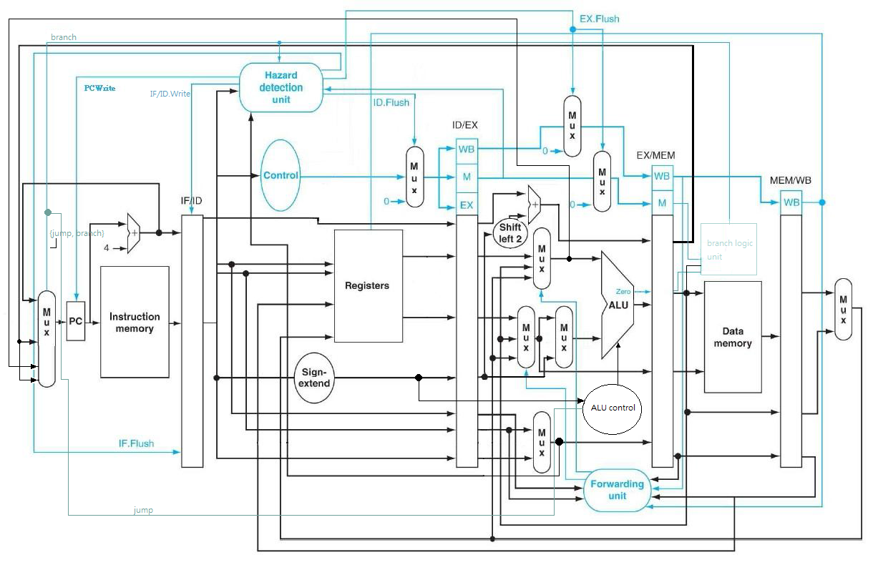架構圖:

設計模組分析:

(almost all modules are from lab 4)

Pipe_CPU.v: The top module,we add the hazard detection unit and forward unit to this CPU. If we find the's a hazard, we need to fetch the temporary results in pipe register and send them to previous stages and maybe raise some stall/flush signals.

Decoder.v: Decodes the type of instructions and output some control signals for other muxes, like RegWrite and Branch.

alu_top.v: The very basic a-bit ALU, including and, or, add, less four operations.

ALU.v: The 32 bit ALU, connected by 32 alu_top modules. It decodes the ALU_control signal and does the corresponding operations.

ALU_Ctrl.v: According to the ALUOp signal from the instruction decoder to generate control signals for ALU.v Input: which type the instruction is. Output: what operation should the ALU do.

Adder.v: Just a very simple 32-bit adder, used for program counter (+4 and jump).

Data_Memory.v: Used for memory storage.

Instr_Memory.v: The instruction Memory of the CPU, where we store our program.

Reg_File.v: Our register file, r0 to r14 live here. RegWrite_i used to decide if we want to overwrite the registers or not.

MUX_2to1.v & MUX_4to1: Implement 2x1 and 4x1 muxes.

ProgramCounter.v: The PC of our CPU, it just passes the 32-bits bus from pc_in_i to pc_out_i during clock edges. Add another signal called pcwrite to decide if we can modify PC or not (load-use cases).

ShiftAdmount_Extend.v: Does zero extension actually.

Shift_Left_Two_32.v: Append two zeros to the input signal.

Sign_Extend.v: Just repeat the MSB for 16 times and insert that in front of data_i. In 'ori' case, we insert 16 zeros.

Hazard.v : Implement the hazard detection on the textbook, consider branch and jump cases.

Pipe_Reg.v: The pipeline unit, keep the registers and control signals and pass them to next stages. We fix/rename the misunderstanding of stall signal to flush.

Forwading.v: The forwarding unit on the textbook. It the previous stage of pipelining need the result of the following stages (src == dst), than send them back. We have to notice that R0 is immutable. We add two muxes to read the forwarda/forwardb signal and choose the correct input of ALU.

完成部分: All basic requirements and advances.

遇到問題及解決方法:

In lw stall cased we need insert another nop and keep the old value of regwrite. When lw is in ex stage, and hazard unit detects data hazard between instruction in id stage and lw, the unit will send out 0 to inform pipe reg not to write to stall, and send out flush signal to idex pipe reg to produce the nop.

Our stage that sending signal of jump is former than branch, and thus branch must be prior to jump due to order of stage. Also, all jumps and branches need to flush previous pipe regs if jumps or branches happen.  
 There's no testcase from TAs so we need to write our own to make.

心得收穫:

Understand the issues and solutions/implementation of hazard detection mechanism in MIPS architecture.

分工表:

0016014徐若揚 Basic and Advance.

0016045李晏銘 Code review and Report.