**Machine learning prediction and experimental validation of antigenic drift in H3 influenza A viruses in swine**

Michael Zeller1,2, Philip C. Gauger1, Zebulun W. Arendsee3, Carine K. Souza3, Amy L. Vincent3, and Tavis K. Anderson3,*

1 Department of Veterinary Diagnostic and Production Animal Medicine, Iowa State University, Ames, Iowa, 50010, USA;

2 Bioinformatics and Computational Biology Program, Iowa State University, Ames, Iowa, 50010, USA;

3 Virus and Prion Research Unit, National Animal Disease Center, USDA-ARS, Ames, Iowa, 50010, USA.

* To whom correspondence should be. addressed: Tel: +1-515-337-6821; Fax: +1-515-337-7428; Email: tavis.anderson@usda.gov

## ABSTRACT (250/200)

The genetic and antigenic diversity of influenza A virus (IAV) circulating in swine challenges the development of effective vaccines and represents a zoonotic pandemic threat. High throughput sequencing technology and rapid analysis methods are able to quantify genetic diversity of IAV, but there are no rapid and accurate approaches to adequately describe novel antigenic phenotypes from these data. This study evaluated an ensemble of non-linear regression models to estimate virus phenotype from genotype using metrics of antigenic distance between IAV strains. Regression models were trained with an IAV in swine phenotypic dataset using genetic sequence identity and pairwise amino acid mutations as predictor features. This approach identified pairwise amino acid identity, ranked the relative importance of mutations in the hemagglutinin (HA) protein of IAV, and demonstrated good prediction accuracy when measured by root mean squared error following ten-fold cross validation. Four previously uncharacterized IAV were selected to test the model using the hemagglutination inhibition (HI) assay. The error between the predicted and measured distances of the uncharacterized strains were 0.34, 0.70, 2.19, and 0.17 antigenic units, giving an average error of 0.85 antigenic units. These results demonstrate that predictive measures trained on HI data can be used to estimate antigenic distances between different strains of IAV in swine using sequence data. We suggest that this method, through the objective quantification of the importance of mutations in the HA, provides criteria for identifying antigenically evolved IAV strains that may not be controlled by existing vaccines, and may represent a pandemic threat.

## INTRODUCTION

Influenza A virus (IAV) is a primary respiratory pathogen in commercial swine in the United States (1). Preventing infection and transmission of the virus has proven difficult due to rapid mutation that allows the virus to evade host immune defenses and impacts the efficacy of vaccination programs by antigenic drift (2). The best approach for effective IAV control has been the development of vaccines that reflect the antigenic diversity of circulating swine IAV strains (3). This is dependent on robust sampling and sequencing of contemporary strains, which is currently achieved primarily through passive surveillance, where clinically sick pigs are sampled, and the hemagglutinin (HA) gene is sequenced and compared to vaccine antigens based on either genetic clade or sequence identity. Vaccines that include a well-matched HA can induce the production of antibodies that may provide sterilizing immunity, help reduce clinical signs, or reduce transmission (4,5). Conversely, mismatched vaccine antigens can result in vaccine failure or potentially cause enhanced disease, emphasizing the importance of careful vaccine strain selection (6).

In the United States, swine IAV is monitored by the United States Department of Agriculture (USDA) in collaboration with regional veterinary diagnostic laboratories in the National Animal Health Laboratory Network (7). These data are primarily synthesized using phylogenetic analysis (7,8), but there is no coordinated effort to characterize the phenotypic differences between circulating viruses (9). This contrasts the approach for human IAV, where vaccine antigens are selected through comprehensive genetic and antigenic characterization of seasonally circulating IAV (10). Thus, the majority of vaccine antigens in use for IAV in swine are selected based solely on the genetic clade or percent amino acid identity. This effort is fraught with risk as there are at least 16 distinct HA genetic clades of IAV in swine derived from multiple human-to-swine interspecies transmission events and subsequent evolution in the swine host (8,11). Further, there is evidence for regional patterns in HA clade persistence (8,12), and the demonstration that as few as six amino acid mutations within the HA may affect the antigenic phenotype of a virus (13,14). Consequently, there is a critical need to not only sequence and genetically characterize swine IAV, but determine from the genetic diversity what is meaningful for antigenic drift.

The antigenic properties of IAV are a manifestation of the structural interaction between IAV and host antibodies (15-18). Structural changes in the HA may alter the interaction with antibodies targeting the virus, and these changes are generally correlated with the number of accumulated amino acid mutations in the HA protein (19). Empirical data has also shown that certain amino acid mutations have a disproportionate effect on antigenic change based on the location of the amino acid in the protein structure (13,15). Though there are relatively few antigenically characterized swine IAV HA genes (9,13), this empirical data may be used to establish antigenic distances between multiple IAV in swine, and be used to gain insight on the contribution of site-specific amino acid mutations. These data can subsequently be used to assign a level of importance to specific amino acid mutations and be used to predict antigenic drift and the biological relevance of genetic diversity collected during surveillance programs.

In this study, machine learning methods were used to model the antigenic properties of IAV in swine and predict the antigenic distance between different strains using HA sequences. Modelling methods, such as the ones we present, are able to complement the prohibitive costs and logistical challenges associated with phenotypic characterization on a large scale. These data can be used in combination with in-field surveillance platforms (20) as an approach for the early detection of antigenic variants and novel viruses. Additionally, these algorithms can be disseminated to swine practitioners in analytical pipelines (11,20,21) to facilitate the rational design of vaccines that include antigens that will likely protect against the circulating IAV strains. Understanding how genetic diversity, and which amino acids within the HA gene are the most important, can allow for the simulation of the antigenic evolution of swine IAV and make predictions about the persistence and circulation of future IAV strains.

## MATERIAL AND METHODS

### The swine IAV H3 antigenic reference dataset

The antigenic properties of two influenza viruses can be quantitatively compared using a hemagglutination inhibition (HI) assay. The assay is based on the ability of the hemagglutinin to agglutinate red blood cells, which express sialic acid on their cell surface (22,23). The HI antibodies raised against a homologous IAV can block the agglutination of red blood cells, even at low concentrations. Genetically different viruses often need a higher concentration of HI antibodies to prevent agglutination compared to the homologous titer. Comparing the antigenic distance between two viruses is calculated by distance , representing a two-fold loss in HI antibody cross-reactivity between the homologous and heterologous HI antibody titers (24). These data have traditionally been used to generate pairwise antigenic distances between IAV in swine that is then visualized using multidimensional scaling to form an antigenic map (9,25,26).

The HI titers were collected from prior swine H3 HA virus characterization studies that used HI assays (23,27,28). The HI titers from new IAV selected as reference strains were collected to expand the dataset using methods described in prior literature, totaling 128 reference antigens tested against 47 reference antisera in various combinations from combined experiments (22). Distances between available HI titers were calculated by subtracting the log2 of the heterologous titer from the log2 of the homologous titer (24). Distances corresponding to the same antigen-antiserum pair were averaged.

### Training and validation of machine learning regression models

Full length HA amino acid sequences for each antigen represented in the dataset were aligned using MAFFT v7.311 (29) and then trimmed to the HA1 domain (amino acids 1-329 using the H3 HA numbering with the signal peptide removed) for subsequent analyses. Percent amino acid difference (100% - amino acid identity) was calculated between each HA pair for all combinations of sequences. Specific amino acid substitutions were not weighted to minimize model assumptions, and prior research in human IAV has suggested that these approaches may add noise to analysis (30,31). All observed site-specific amino acid substitutions in the reference data were identified and treated as bi-directional.

The regression model data was constructed with antigenic distance calculated from HI titer as the training value, with percent amino acid difference as a continuous predictor feature, and site-specific mutations as binary predictor features. Three different machine learning regression models were trained using scikit-learn (32): random forest; adaBoost decision tree; and multilayer perceptron. Model predictions were lower bounded to zero. For each regression model, hyperparameters were tuned using a random search optimization (supplemental Table 1). A fourth regression model was created by averaging the three prior machine learning model predictors, and referred to as the ensemble model below.

Data was split into 80% training data and 20% testing data groups to calculate the Pearson correlation and root mean squared error. Additionally, 10-fold cross validation was used to assess the root mean squared error (Table 1). Given the sparsity of antigenic data available, a leave-one-out cross validation approach was employed to generate a distribution of prediction error for each model (Figure 1). Each antigen included in the training set (n = 128) was iteratively excluded from the training set and distances were predicted using each of the four regression models. The error was calculated as the absolute value of difference between the predicted distance and the empirical distance.

### Mapping antigenic predictions onto evolutionary trees

Maximum-likelihood phylogenetic trees were created to assess antigenic distance predictions of genetically similar sequences of the test antigen sequence compared to the rooted reference sequence. Sequences were aligned using MAFFT v7.311 (29) and phylogenetic trees were inferred using FastTree v2.1.10 (33). Trees were annotated using FigTree v1.4.3 (34) with each tree rooted to a reference strain and sorted in ascending order relative to evolutionary relationship. Each tip within the tree was color-coded based on the antigenic motif designated by H3 numbering positions 145, 155, 156, 158, 159, and 189 as prior work identified these sites as significant for antigenic phenotype (15). Branches were annotated with the ensemble-predicted antigenic distance relative to the rooted reference. Subtrees were pruned to 30 leaves to facilitate viewing.

### Determining the relative importance of genetic mutations

Random forest regression models provide a natural ranking system of feature importance (35). The importance of each predictor feature was calculated by the decrease in the node variance after fitting the random forest model. The feature rankings for the random forest regression model were analyzed to assess the biological importance of observed mutations in the swine H3 antigenic reference dataset. The significance of each amino acid position in the HA was determined by summing the mutation-based features grouped by the position they represented. The resultant significance of each amino acid was projected onto a protein model of a human H3 virus A/Victoria/361/2011 obtained from the Research Collaboratory for Structural Bioinformatics (4O5N) (36).

### Empirical validation of machine learning regression models

The H3 HA amino acid sequences of uncharacterized IAV in swine submitted to NCBI GenBank from the Iowa State University Veterinary Diagnostic Lab from January 2016 to August 2018 were collected and grouped by phylogenetic clade (7,11). The HA gene sequences were trimmed to the HA1 domain (positions 1-329 using H3 numbering with the signal peptide removed). The HA1 sequences were compared against all antigenically characterized sequences to calculate percent amino acid difference and compare the presence or absence of site-specific amino acid mutations. Site-specific amino acid mutations absent from the training set were not considered in additional analyses. The antigenic distance from each uncharacterized HA gene to each reference antigen was predicted using the previously described four trained regression models.

A selection of four contemporary IAV-S were selected as test antigens to be antigenically characterized with in vitro HI assays to validate the regression models using their HA genes. We selected these HA genes from within the H3-Cluster IVA genetic clade, as: a) this is a significant genetic clade that is frequently detected in diagnostic submissions to the Iowa State University Veterinary Diagnostic Lab (11); b) this genetic clade was responsible for more than 300 zoonotic infections from 2012 to present; c) there was a substantial amount of uncharacterized data. Since the ensemble predictions demonstrated the least error in the analyses above, antigenic distances of 106 H3-cluster IVA viruses were predicted against a panel of 44 available antisera using this model. We selected four test antigens/antisera prediction pairs within this genetic clade based on the following criteria: near amino acid sequence identity (≥ 98%) and near predicted ensemble antigenic distance measured in antigenic units (AU) (≤ 2AU); a near identity and far antigenic distance (≥ 3AU), far identity (≤ 95%, ≥ 90%) and near antigenic distance (≤ 2AU), or far identity (≤ 95%, ≥ 90%) and far antigenic distance (≥ 3AU) (Figure 2, Table 2).

The four selected antigen/antisera pairs were tested via HI assay. HI assays were conducted as previously described (23) with empirical distances calculated by taking the log2 of the heterologous titer subtracting from the log2 of the homologous titer. Empirical distances were compared against predicted values by subtraction.

## RESULTS

### Machine learning model performance

Comparison of the empirical antigenic distances against the predicted values indicated that the Pearson correlation for all regression models was within a range between 78%-80% (Table 1). The root mean squared error (RMSE) was between 1.22 – 1.67 antigenic units of error depending on the model. Ten-fold cross validation of the random forest, adaBoost decision tree, and multilayer perceptron regression models had an RMSE of 1.58 ± 0.24, 1.65 ± 0.29, and 1.78 ± 0.33 respectively. The leave-one-out cross validation demonstrated that for all models, 25% had ≤ 0.5 AU, 50% had ≤ 1.0 AU, and 75% had ≤ 1.5 AU distance error. The maximum observed error was 6.5 AU, with each model producing errors > 6.0 AU (Figure 1).

### Mapping antigenic predictions onto evolutionary trees

Four trees were built with sequences genetically similar to each test antigen (Figure 2). Trees were annotated with an amino acid motif based on positions 145, 155, 156, 158, 159, and 189 as these sites have been found to have a disproportionate effect on the observed antigenic phenotype in both human and swine H3 (14). The antigenic motif between test antigen A/swine/Nebraska/A01672826/2017 and reference antiserum A/swine/Indiana/A00968373/2012 match, both being NYNNYK. The antigenic motif of test antigen A/swine/Indiana/A02214844/2017 is NYNNYK, while reference antiserum A/swine/Iowa/A01480656/2014’s motif is KYNNYK, differing at position 145. The antigenic motif between test antigen A/swine/North_Carolina/A01732197/2016 and reference antiserum A/swine/Pennsylvania/A01076777/2010 match, both being NYNNYK. The antigenic motif of test antigen A/swine/Iowa/A01733626/2016 is SYKNYK, while reference antiserum A/swine/Indiana/A01202866/2011’s motif is NYNNYK, differing at positions 145 and 156.

### Empirical validation of the predicted antigenic distance predictions

The predicted ensemble distances of the selected test antigens were validated via HI assay (Supplemental Table 2). Test antigen A/swine/Nebraska/A01672826/2017 was predicted to be 0.16 AU from reference strain A/swine/Indiana/A00968373/2012, sharing 99.4% amino acid identity between the HA1 segments of the HA (Table 2). Both the reference and test antigens are from the H3-cluster IVA clade (Figure 2A), and this pairing represented the near identity and near antigenic distance prediction. The amino acid differences between the reference strain and the test antigen were at M10T and R208I (Table 2). The HI assay demonstrated the antigenic distance between the reference strain antiserum and test antigen was 0.5 AU (Table 2) with an error between the predicted distance and the empirical distance of 0.34 AU.

Test antigen A/swine/Indiana/A02214844/2017 was predicted at 3.30 AU from reference strain A/swine/Iowa/A01480656/2014, sharing 98.5% amino acid identity between the HA1 segments. Both the reference strain and test antigens are from the H3-cluster IVA clade (Figure 2B), and this pairing represents near identity but far antigenic distance prediction. There were 5 amino acid differences between the reference strain and test antigen. The HI assay found a distance of 4.0 antigenic units between the test antigen and reference antiserum and an error of 0.70 AU between empirical and predicted distances.

Test antigen A/swine/North Carolina/A01732197/2016 was predicted at 0.31 AU from reference strain A/swine/Pennsylvania/A01076777/2010, sharing 94.2% amino acid identity between the HA1 segments. The test antigen was selected from the H3-cluster IVA clade and the reference strain from the H3-cluster IV clade (Figure 2C), and this pairing represented a distant identity that was predicted to be antigenically similar. There were 19 amino acid differences between the reference strain and test antigen, with the A107T mutation being the only position not accounted for in the trained model. The HI assay demonstrated an average antigenic distance between reference antiserum and test antigen of 2.5 AU, with a prediction error of 2.19 AU.

A/swine/Iowa/A01733626/2016 was predicted at 6.33 AU from reference strain A/swine/Indiana/A01202866/2011, sharing 91.2% amino acid identity between the HA1 segments. The test antigen is from the H3-cluster IVA clade of virus and reference strain from the H3-cluster IVC clade (Figure 2D). This pairing represents a far identity and far predicted antigenic distance prediction. There are 29 amino acid differences between the reference strain and test strain. The HI assay demonstrated 6.5 antigenic units between test antigen and reference antiserum, giving an error of 0.17 AU between empirical and predicted distances.

### Ranking of features

Random forest regression ranks user-selected features by a metric of importance, calculated by the decrease in the node variance and normalized across the forest for a single model run. The highest-ranking features were stable across runs as they had a consistent decrease in their average variance, though these metrics were susceptible to starting conditions (data provided at https://github.com/flu-crew/antigenic-prediction). The most important feature in predicting the antigenic distance between two strains was amino acid identity within the HA1, accounting for 31.2% of the importance. Transitions between K and N at position 145 accounted for 7.9% of the model importance and was ranked as the most important amino acid mutation. However, transitions between K and S and N and S at the same position 145 received lower ranking in model importance (totaling 0.4% importance cumulatively), demonstrating that the context of the positional mutation is important. Features R222W and I202V (representing bi-directional mutations) ranked at 3% importance. The remainder of the features in the models accounted for less than 3% of the model on an individual basis (Figure 3), with the next ten bi-directional mutations in order of importance as H75Q, I25L, R137Y, D101Y, E62K, P289S, D133N, G50R, H159Y, and E189K (Figure 3). Projecting the cumulative importance of each amino acid position on an H3 crystal structure indicated that position 145, the most important position in the model, is located in the groove of the active site (Figure 4). Other sites of higher importance were more likely observed on the solvent facing side of the trimer. Amino acid position 202 was an exception as it was ranked high but is located on the inside of the trimer.

Of the 728 features included in the model, amino acid identity and the sum of the top ten amino acid mutation features of the model accounted for 66% of the importance. Identity and the top 255 amino acid mutation features accounted for 95% of the calculated importance, whereas the top 401 features accounted for 99% of the calculated importance.

## DISCUSSION

In this study, a model was developed to computationally estimate antigenic distances between different swine-origin IAV based on their amino acid sequence using non-linear machine learning methods. The methodology leverages data that was generated from previous antigenically characterized IAV strains in swine to train regression models. After validation of the quality, the models were used to predict the antigenic distance between paired strains based on their amino acid identity and the mutations present between each strain. Finally, the antigenic distance predictions were confirmed by comparing the distance between homologous and heterologous HI titers. Predicting antigenic distances between two genetically related but antigenically different IAV reduces the number of HI assays that are required to perform the analysis and select candidate strains for a vaccine when sufficient antigenic distance between two IAV suggests a loss in antibody cross-reactivity.

This methodology could aid in controlling swine IAV, which lacks the magnitude and breadth of the World Health Organization’s (WHO) global influenza surveillance effort (37). This effort is supplemented by an international effort to increase sequencing and antigenic characterization of influenza strains circulating in humans, which results in yearly influenza vaccine strain updates for each hemisphere. H1 and H3 IAV vaccine antigen selection is based on prevalence of circulation as well as *in vitro* antigenic characterization based on cross-reactive serological data (10,38). A similar process of strain selection has not been implemented for IAV in swine. Due to multiple introductions of novel IAV into swine from human and avian clades, the genetic diversity of IAV in swine exceeds what is observed for human-origin strains (11,39,40). The genetic diversity of IAV in swine is also confounded by transportation patterns that move regional IAV strains with swine to new geographic locations where additional antigenic drift and reassortment with endemic strains may occur (41). Despite the high prevalence of the virus in swine worldwide, standards and practices of reporting IAV sequences and genetic diversity vary between countries due to the lack of a coordinated global effort.

This methodology has potential to help select candidate vaccine IAV when antigenic distance suggests a loss of cross-protection with current vaccine strains, and the error was robustly analyzed to understand the limits of this model. Using an 80% training and 20% testing split, the Pearson correlation of the ensemble model was found to be 80%, with the root mean squared error calculated at 1.22 AU. Depending on starting conditions, the error of the ensemble model can be lower than any constituent model. Combining multiple regression models can dampen errant predictions provided by a single regression model. The method presented in this article had higher RMSE compared to the linear mixed-effects model employed by Harvey (42). This prediction error is not fully comparative to the Harvey method due to testing different datasets. To robustly check the error within the presented model, a leave-one-out approach was used. This approach demonstrated 52% of the predictions made with the ensemble model were at or below 1 AU of error, and 86% were below 2AU of error, suggesting the majority of predictions would be useful in a diagnostic setting.

The model described in this report proved to have potential in application. The four test antigens selected to validate the model demonstrated three predictions with an error less than 1 AU. The error between the test antigen and reference antiserum representing a near identity with a near predicted antigenic distance was 0.34 AU (Table 2). However, the distance between the same test antigen and reference antiserum HI titers was calculated at 0 and 1 AU (supplemental table 2), giving an average distance of 0.5. It should be noted that the HI assay is a discrete measure whereas the prediction is continuous, thus an error less than 1 AU is difficult to interpret. Due to the discrete nature of the HI assay, the 0.5 AU error is negligible as the true antigenic distance is somewhere between 0 and 1 AU. The near identity with a far predicted antigenic distance had a wider range between the two sera’s HI titers 3 and 5, but the predicted distance 3.3 was within this range, and had an error of 0.7 AU from the average of 4 AU. The far identity with a near predicted antigenic distance had HI titers of 2 and 3, with a predicted distance of 0.31, giving an error of 2.19 AU from the average of 2.5 AU. Although the error exceeded 2AU, the ensemble prediction was able to discern that these two strains were more antigenically similar than would be predicted based on sequence similarity alone. For the far identity and far predicted antigenic distance test antigen and reference antiserum pair, the predicted distance was 6.33 and the empirical distance was 6.5. Given the raw antigenic distances calculated from the pair of titers were 6 and 7 for the two serum samples, the real distance is likely somewhere between the two values.

This work adds to a growing body of literature that aims to quantitatively predict antigenic phenotypes of IAV from the sequence without requiring HI titers for each IAV strain (19,31,42-44). Similar methodologies have been implemented for use with other viruses such as Dengue, where neutralizing titer distances have been predicted based on amino acid differences (45). To the best of our knowledge, prior approaches to calculate antigenic distances between IAV were trained and tested on human-origin strains where the HA genes are characterized by phylogenetic trees with a single thick trunk with short interspersed branches (46-48). Antigenic data for the human-origin strains used in prior approaches was generated using ferret antisera with the caveat that human and ferret immune systems potentially interact differently with the viral antigenic phenotype (49). Compared to IAV circulating in humans, HA gene phylogenetic trees from endemic IAV circulating in swine demonstrate multiple branches within the same subtype suggesting greater genetic diversity circulating in IAV in swine compared to what is observed circulating in humans (7,39). The large genetic diversity of strains coevolving within the swine population has resulted in a large breadth of genetic diversity that potentiates more antigenic change. Therefore, a broad range of HI assays including multiple, genetically different IAV is needed to capture the breadth of antigenic diversity within swine that is required to generate a robust training set for accurate antigenic predictions. Sparsity of antigenic characterizations of IAV within the swine population or large gaps of time between characterizations may misrepresent the antigenic data necessary to perform accurate antigenic predictions. Additionally, sparse antigenic comparisons make it difficult to fit correctional terms such as viral avidity and serum potency used in other work (19,42,45).

The antigenic distances described in this report were calculated through an ensemble of non-linear regression methods, chosen due to their robustness against collinearity. Several prior machine learning methods implement linear regression, though the relationship between amino acid changes may not reflect a linear relationship. The changes in amino acids may not occur independent of each other in a biological context, thus there is collinearity and the changes are not strictly additive (19,44). Linear models can mitigate issues of collinearity by including mixed-effects or by using regularization, such as ridge regression used in antigen-bridges (43), or lasso regression used by nextstrain (19,45). Lasso regression has the consequence of decreasing the total number of features by setting their weight to zero, while ridge regression minimizes the weight of less important features. Consequently, the model becomes more biologically interpretable, though prior work done by Harvey suggests that including the low-impact amino acid substitutions can substantially improve model accuracy (42). In the models described in this report, the parameters were constrained based on hyperparameterization of the model. Analysis of the random forest showed that the top 10 features accounted for 60% of the importance in the random forest regression model, and 255 (35%) features were needed during a run to account for 95% of the importance. This supports observations by Harvey that including low-ranking features can improve model performance significantly.

The machine learning methods described in this report have assigned importance to the position and context of amino acid mutations, allowing biological interpretation. Assessing the importance of the random forest model revealed that both the position and context of the amino acid mutation contributed to the observed antigenic phenotype. While sequence difference had the highest importance in the random forest model, further assessment of the model revealed unequal weight between amino acid positions representing different mutations. A prime example was H3 HA positon 145 where a mutation between K and N bi-directionally was ranked as the most important amino acid mutation feature. Other observed mutations at position 145 between K and S and N and S were ranked as less important, matching the biological nuances that have been observed in the wet lab setting and other computational predictions (15,43). Literature reports suggested that the conservation of biochemical properties of the amino acid exchange may also have some effect on the observed antigenic change (15,19). Unequal weighting of mutations in the model suggests antigenic distance may help improve vaccine antigen selection when compared to HA sequence comparison alone, as it would capture more nuance that contributes to antibody interaction.

The majority of pairwise amino acid differences identified between the test antigens and reference strains often occurred at known antigenic epitopes or sites that were expected to be under positive selection (50,51). The majority of these sites were located on the solvent exposed surface of the HA protein and in previously identified antibody epitopes (Figure 4). For example, A/swine/Nebraska/A01672826/2017 test antigen compared to reference strain A/swine/Indiana/A00968373/2012 demonstrated 1 of the 2 amino acid mutations occurred in epitope site D. Test antigen A/swine/Indiana/A02214844/2017 compared to reference strain A/swine/Iowa/A01480656/2014 had 2 of 5 mutations occurring in epitopes A and E. Strain A/swine/North_Carolina/A01732197/2016 compared against reference A/swine/Pennsylvania/A01076777/2010 has 15 of 19 mutations at all epitopes A, B, C, D, and E. Strain A/swine/Iowa/A01733626/2016 compared against reference A/swine/Indiana/A01202866/2011 has 24 out of 29 mutations occurring at all epitopes.

Interestingly, the profile of positional feature importance displayed some differences to prior literature describing human H3N2. There was overlap with the top 34 positions found in Yao et al’s Joint Random Forest Regression (JRFR) algorithm, a similar random forest-based model that also factors in substitution matrices for predicting antigenic distances (31). The positions found similar between both the model presented and the JRFR algorithm based on cumulative importance include positions 62, 75, 131, 133, 135, 137, 142, 144, 145, 156, 158, 159, 173, 189, 193, 196, 262, and 276. Position 189 was the most important site in human H3 with ferret antisera (31), whereas the current model identified position 145 as the most important position in swine H3 with swine sera. Additional sites found within the top 34 positions of the model presented include positions 25, 31, 50, 78, 82, 92, 101, 138, 140, 155, 160, 186, 202, 222, 273, and 289. When tested the JRFR model demonstrated a RMSE < 1.0. These differences of importance may be reflective of host specific interactions. Additionally, the distribution of importance was more evenly spread across the JRFR model whereas in the model presented here a small number of sites had disproportionate importance.

This study implemented a non-linear machine learning approach to predict the antigenic distances between IAV in swine based on HA1 sequence, which were experimentally verified. This validation with HI assays using test antigen and reference strains suggesting the model could be useful to determine antigenic differences between IAV without requiring HI tests. While it is currently impractical to antigenically characterize all strains of IAV isolated from swine, this work shows that the antigenic phenotype can be reasonably predicted for IAV detected in the swine host. Other similar models have achieved higher RMSE using human origin viruses with ferret antisera, suggesting potential improvement of the current model is possible. However, the complex IAV ecology circulating in swine increases the challenge to develop a model sufficient to accurately predict the antigenic distance between all viruses, highlighting the limitations of using genetically diverse swine specific data. Providing accurate methods for predicting antigenic distances of IAV in swine increase the ability of swine producers and veterinarians to make informed decisions regarding vaccine antigens with broad application across IAV in swine to help maintain swine herd health.

## AVAILABILITY

The code used in this research is available in the GitHub repository (https://github.com/flu-crew/antigenic-prediction)

## ACKNOWLEDGEMENT

We gratefully acknowledge pork producers, swine veterinarians, and laboratories for participating in the USDA Influenza A Virus in Swine Surveillance System and publicly sharing sequences in NCBI GenBank.

## FUNDING

This work was supported by the Iowa State University Presidential Interdisciplinary Research Initiative; the Iowa State University Veterinary Diagnostic Laboratory; the U.S. Department of Agriculture (USDA) Agricultural Research Service (ARS project number 5030-32000-120-00-D); an National Institute of Allergy and Infectious Diseases (NIAID) at the National Institutes of Health interagency agreement associated with the Center of Research in Influenza Pathogenesis, an NIAID funded Center of Excellence in Influenza Research and Surveillance (grant HHSN272201400008C to A.L.V.); the USDA Agricultural Research Service Research Participation Program of the Oak Ridge Institute for Science and Education (ORISE) through an interagency agreement between the U.S. Department of Energy (DOE) and USDA Agricultural Research Service (contract number DE-AC05-06OR23100 to J.C. and Z.A.W.); and the SCINet project of the USDA Agricultural Research Service (ARS project number 0500-00093-001-00-D). Funding for open access charge from the U.S. Department of Agriculture (USDA) Agricultural Research Service (ARS project number 5030-32000-120-00-D). The funders had no role in study design, data collection and interpretation, or the decision to submit the work for publication. Mention of trade names or commercial products in this article is solely for the purpose of providing specific information and does not imply recommendation or endorsement by the USDA, DOE, or ORISE. USDA is an equal opportunity provider and employer.

## CONFLICT OF INTEREST

The authors report no conflicts of interest.

## REFERENCES

1. Dykhuis- Haden, C., Painter, T., Fangman, T. and Holtkamp, D. (2012), *American Association of Swine Veterinarians*, Denver, Colorado, pp. 75-76.

2. Saitou, N. and Nei, M. (1986) Polymorphism and evolution of influenza A virus genes. *Molecular biology and evolution*, **3**, 57-74.

3. Sandbulte, M.R., Spickler, A.R., Zaabel, P.K. and Roth, J.A. (2015) Optimal Use of Vaccines for Control of Influenza A Virus in Swine. *Vaccines (Basel)*, **3**, 22-73.

4. Vincent, A.L., Ciacci-Zanella, J.R., Lorusso, A., Gauger, P.C., Zanella, E.L., Kehrli, M.E., Jr., Janke, B.H. and Lager, K.M. (2010) Efficacy of inactivated swine influenza virus vaccines against the 2009 A/H1N1 influenza virus in pigs. *Vaccine*, **28**, 2782-2787.

5. Van Reeth, K., Labarque, G., De Clercq, S. and Pensaert, M. (2001) Efficacy of vaccination of pigs with different H1N1 swine influenza viruses using a recent challenge strain and different parameters of protection. *Vaccine*, **19**, 4479-4486.

6. Vincent, A.L., Lager, K.M., Janke, B.H., Gramer, M.R. and Richt, J.A. (2008) Failure of protection and enhanced pneumonia with a US H1N2 swine influenza virus in pigs vaccinated with an inactivated classical swine H1N1 vaccine. *Veterinary microbiology*, **126**, 310-323.

7. Anderson, T.K., Nelson, M.I., Kitikoon, P., Swenson, S.L., Korslund, J.A. and Vincent, A.L. (2013) Population dynamics of cocirculating swine influenza A viruses in the United States from 2009 to 2012. *Influenza Other Respir Viruses*, **7 Suppl 4**, 42-51.

8. Walia, R.R., Anderson, T.K. and Vincent, A.L. (2019) Regional patterns of genetic diversity in swine influenza A viruses in the United States from 2010 to 2016. *Influenza and other respiratory viruses*, **13**, 262-273.

9. Lewis, N.S., Russell, C.A., Langat, P., Anderson, T.K., Berger, K., Bielejec, F., Burke, D.F., Dudas, G., Fonville, J.M., Fouchier, R.A. *et al.* (2016) The global antigenic diversity of swine influenza A viruses. *Elife*, **5**, e12217.

10. mondiale de la Santé, O. and Organization, W.H. (2019) Recommended composition of influenza virus vaccines for use in the 2019–2020 northern hemisphere influenza season–Composition recommandée des vaccins antigrippaux pour la saison grippale 2019-2020 dans l’hémisphère Nord. *Weekly Epidemiological Record= Relevé épidémiologique hebdomadaire*, **94**, 141-150.

11. Zeller, M.A., Anderson, T.K., Walia, R.W., Vincent, A.L. and Gauger, P.C. (2018) ISU FLU ture: a veterinary diagnostic laboratory web-based platform to monitor the temporal genetic patterns of Influenza A virus in swine. *BMC bioinformatics*, **19**, 397.

12. Pardo, F.O.C., Schelkopf, A., Allerson, M., Morrison, R., Culhane, M., Perez, A. and Torremorell, M. (2018) Breed-to-wean farm factors associated with influenza A virus infection in piglets at weaning. *Preventive veterinary medicine*, **161**, 33-40.

13. Bolton, M.J., Abente, E.J., Venkatesh, D., Stratton, J.A., Zeller, M., Anderson, T.K., Lewis, N.S. and Vincent, A.L. (2019) Antigenic evolution of H3N2 influenza A viruses in swine in the United States from 2012 to 2016. *Influenza and other respiratory viruses*, **13**, 83-90.

14. Abente, E.J., Santos, J., Lewis, N.S., Gauger, P.C., Stratton, J., Skepner, E., Anderson, T.K., Rajao, D.S., Perez, D.R. and Vincent, A.L. (2016) The molecular determinants of antibody recognition and antigenic drift in the H3 hemagglutinin of swine influenza A virus. *Journal of virology*, **90**, 8266-8280.

15. Santos, J.J., Abente, E.J., Obadan, A.O., Thompson, A.J., Ferreri, L., Geiger, G., Gonzalez-Reiche, A.S., Lewis, N.S., Burke, D.F. and Rajão, D.S. (2019) Plasticity of amino acid residue 145 near the receptor binding site of H3 swine influenza A viruses and its impact on receptor binding and antibody recognition. *Journal of Virology*, **93**, e01413-01418.

16. Das, S.R., Hensley, S.E., David, A., Schmidt, L., Gibbs, J.S., Puigbò, P., Ince, W.L., Bennink, J.R. and Yewdell, J.W. (2011) Fitness costs limit influenza A virus hemagglutinin glycosylation as an immune evasion strategy. *Proceedings of the National Academy of Sciences*, **108**, E1417-E1422.

17. Myers, J.L., Wetzel, K.S., Linderman, S.L., Li, Y., Sullivan, C.B. and Hensley, S.E.J.J.o.v. (2013) Compensatory hemagglutinin mutations alter antigenic properties of influenza viruses. JVI. 01414-01413.

18. Li, Y., Bostick, D.L., Sullivan, C.B., Myers, J.L., Griesemer, S.B., StGeorge, K., Plotkin, J.B. and Hensley, S.E. (2013) Single hemagglutinin mutations that alter both antigenicity and receptor binding avidity influence influenza virus antigenic clustering. *Journal of virology*, **87**, 9904-9910.

19. Neher, R.A., Bedford, T., Daniels, R.S., Russell, C.A. and Shraiman, B.I. (2016) Prediction, dynamics, and visualization of antigenic phenotypes of seasonal influenza viruses. *Proceedings of the National Academy of Sciences*, **113**, E1701-E1709.

20. Eisler, D., Fornika, D., Tindale, L.C., Chan, T., Sabaiduc, S., Hickman, R., Chambers, C., Krajden, M., Skowronski, D.M. and Jassem, A. (2020) Influenza Classification Suite: An automated Galaxy workflow for rapid influenza sequence analysis. *Influenza and Other Respiratory Viruses*, **14**, 358-362.

21. Chang, J., Anderson, T.K., Zeller, M.A., Gauger, P.C. and Vincent, A.L. (2019) octoFLU: Automated Classification for the Evolutionary Origin of Influenza A Virus Gene Sequences Detected in US Swine. *Microbiology resource announcements*, **8**, e00673-00619.

22. Pedersen, J. (2014) In Spackman, E. (ed.), *Animal influenza virus*. Springer.

23. Kitikoon, P., Gauger, P.C. and Vincent, A.L. (2014), *Animal Influenza Virus*. Springer, pp. 295-301.

24. Smith, D.J., Lapedes, A.S., de Jong, J.C., Bestebroer, T.M., Rimmelzwaan, G.F., Osterhaus, A.D. and Fouchier, R.A. (2004) Mapping the antigenic and genetic evolution of influenza virus. *science*, **305**, 371-376.

25. Lewis, N., Daly, J., Russell, C., Horton, D., Skepner, E., Bryant, N., Burke, D., Rash, A., Wood, J. and Chambers, T. (2011) Antigenic and genetic evolution of equine influenza A (H3N8) virus from 1968 to 2007. *Journal of virology*, **85**, 12742-12749.

26. De Jong, J., Smith, D.J., Lapedes, A., Donatelli, I., Campitelli, L., Barigazzi, G., Van Reeth, K., Jones, T., Rimmelzwaan, G. and Osterhaus, A. (2007) Antigenic and genetic evolution of swine influenza A (H3N2) viruses in Europe. *Journal of virology*, **81**, 4315-4322.

27. Lewis, N.S., Anderson, T.K., Kitikoon, P., Skepner, E., Burke, D.F. and Vincent, A.L. (2014) Substitutions near the hemagglutinin receptor-binding site determine the antigenic evolution of influenza A H3N2 viruses in US swine. *Journal of virology*, **88**, 4752-4763.

28. Rajao, D.S., Gauger, P.C., Anderson, T.K., Lewis, N.S., Abente, E.J., Killian, M.L., Perez, D.R., Sutton, T.C., Zhang, J. and Vincent, A.L. (2015) Novel Reassortant Human-Like H3N2 and H3N1 Influenza A Viruses Detected in Pigs Are Virulent and Antigenically Distinct from Swine Viruses Endemic to the United States. *J Virol*, **89**, 11213-11222.

29. Katoh, K. and Standley, D.M. (2013) MAFFT multiple sequence alignment software version 7: improvements in performance and usability. *Molecular biology and evolution*, **30**, 772-780.

30. Bedford, T., Suchard, M.A., Lemey, P., Dudas, G., Gregory, V., Hay, A.J., McCauley, J.W., Russell, C.A., Smith, D.J. and Rambaut, A. (2014) Integrating influenza antigenic dynamics with molecular evolution. *Elife*, **3**.

31. Yao, Y., Li, X., Liao, B., Huang, L., He, P., Wang, F., Yang, J., Sun, H., Zhao, Y. and Yang, J. (2017) Predicting influenza antigenicity from Hemagglutintin sequence data based on a joint random forest method. *Scientific reports*, **7**, 1-10.

32. Pedregosa, F., Varoquaux, G., Gramfort, A., Michel, V., Thirion, B., Grisel, O., Blondel, M., Prettenhofer, P., Weiss, R. and Dubourg, V. (2011) Scikit-learn: Machine learning in Python. *Journal of machine learning research*, **12**, 2825-2830.

33. Price, M.N., Dehal, P.S. and Arkin, A.P. (2010) FastTree 2–approximately maximum-likelihood trees for large alignments. *PloS one*, **5**, e9490.

34. Rambaut, A. (2012) FigTree v1. 4. *Molecular evolution, phylogenetics and epidemiology. Edinburgh, UK: University of Edinburgh, Institute of Evolutionary Biology*.

35. Breiman, L. (2001) Random forests. *Machine learning*, **45**, 5-32.

36. Lee, P.S., Ohshima, N., Stanfield, R.L., Yu, W., Iba, Y., Okuno, Y., Kurosawa, Y. and Wilson, I.A. (2014) Receptor mimicry by antibody F045–092 facilitates universal binding to the H3 subtype of influenza virus. *Nature communications*, **5**, 3614.

37. Group, W.W., Ampofo, W.K., Baylor, N., Cobey, S., Cox, N.J., Daves, S., Edwards, S., Ferguson, N., Grohmann, G. and Hay, A. (2012) Improving influenza vaccine virus selectionReport of a WHO informal consultation held at WHO headquarters, Geneva, Switzerland, 14–16 June 2010. *Influenza and other respiratory viruses*, **6**, 142-152.

38. mondiale de la Santé, O. and Organization, W.H. (2019) Addendum to the Recommended composition of influenza virus vaccines for use in the 2019–2020 northern hemisphere influenza season–Addendum à la Composition recommandée des vaccins antigrippaux pour la saison grippale 2019-2020 dans l’hémisphère Nord. *Weekly Epidemiological Record= Relevé épidémiologique hebdomadaire*, **94**, 166-168.

39. Anderson, T.K., Campbell, B.A., Nelson, M.I., Lewis, N.S., Janas-Martindale, A., Killian, M.L. and Vincent, A.L. (2015) Characterization of co-circulating swine influenza A viruses in North America and the identification of a novel H1 genetic clade with antigenic significance. *Virus Res*, **201**, 24-31.

40. Gao, S., Anderson, T.K., Walia, R.R., Dorman, K.S., Janas-Martindale, A. and Vincent, A.L. (2017) The genomic evolution of H1 influenza A viruses from swine detected in the United States between 2009 and 2016. *Journal of General Virology*, **98**, 2001-2010.

41. Torremorell, M., Allerson, M., Corzo, C., Diaz, A. and Gramer, M. (2012) Transmission of influenza A virus in pigs. *Transboundary and emerging diseases*, **59**, 68-84.

42. Harvey, W.T., Benton, D.J., Gregory, V., Hall, J.P., Daniels, R.S., Bedford, T., Haydon, D.T., Hay, A.J., McCauley, J.W. and Reeve, R. (2016) Identification of low-and high-impact hemagglutinin amino acid substitutions that drive antigenic drift of influenza A (H1N1) viruses. *PLoS pathogens*, **12**.

43. Sun, H., Yang, J., Zhang, T., Long, L.-P., Jia, K., Yang, G., Webby, R.J. and Wan, X.-F. (2013) Using sequence data to infer the antigenicity of influenza virus. *MBio*, **4**, e00230-00213.

44. Yang, J., Zhang, T. and Wan, X.-F. (2014) Sequence-based antigenic change prediction by a sparse learning method incorporating co-evolutionary information. *PloS one*, **9**.

45. Bell, S.M., Katzelnick, L. and Bedford, T. (2019) Dengue genetic divergence generates within-serotype antigenic variation, but serotypes dominate evolutionary dynamics. *Elife*, **8**.

46. Ito, K., Igarashi, M., Miyazaki, Y., Murakami, T., Iida, S., Kida, H. and Takada, A. (2011) Gnarled-trunk evolutionary model of influenza A virus hemagglutinin. *PLoS One*, **6**, e25953.

47. Fitch, W.M., Bush, R.M., Bender, C.A. and Cox, N.J. (1997) Long term trends in the evolution of H (3) HA1 human influenza type A. *Proceedings of the National Academy of Sciences*, **94**, 7712-7718.

48. Nelson, M.I. and Holmes, E.C. (2007) The evolution of epidemic influenza. *Nature reviews genetics*, **8**, 196-205.

49. Fonville, J.M., Fraaij, P.L., de Mutsert, G., Wilks, S.H., van Beek, R., Fouchier, R.A. and Rimmelzwaan, G.F. (2016) Antigenic maps of influenza A (H3N2) produced with human antisera obtained after primary infection. *The Journal of infectious diseases*, **213**, 31-38.

50. Wiley, D., Wilson, I. and Skehel, J. (1981) Structural identification of the antibody-binding sites of Hong Kong influenza haemagglutinin and their involvement in antigenic variation. *Nature*, **289**, 373.

51. Bush, R.M., Bender, C.A., Subbarao, K., Cox, N.J. and Fitch, W.M. (1999) Predicting the evolution of human influenza A. *Science*, **286**, 1921-1925.

## TABLES AND FIGURES

Table 1. Performance indicators for the random forest, adaBoost decision tree, multilayer perceptron, and ensemble regression models with tuned hyperparameters. Pearson correlation and root mean squared error were determined using an 80%/20% split between training and test antigen data. A 10-fold cross validation based on the root mean squared error was applied.

|  |  |  |  |  |
| --- | --- | --- | --- | --- |
| Performance Indicator | Random  Forest | AdaBoost Decision Tree | Multilayer Perceptron | Ensemble |
| Pearson Correlation | 0.78 | 0.78 | 0.78 | 0.80 |
| RMSE | 1.67 | 1.29 | 1.33 | 1.22 |
| 10-Fold CV (RMSE) | 1.58 (±0.24) | 1.65 (±0.29) | 1.78 (±0.33) | 1.61 (±0.25) |

Table 2. . Predicted and measured antigenic distances between test antigens and reference strain antisera using the model to calculate the predicted distance; and hemagglutination inhibition (HI) titers to calculate the empirical distance in antigenic units. Error is calculated by taking the absolute value of the predicted distance subtracted from the empirical distance. Asterisk mark amino acid changes that were not accounted for in the regression models. Amino acid mutations detected between test antigen and reference strains used for the model validation.

|  |  |  |  |  |  |  |  |  |  |  |  |  |  |  |
| --- | --- | --- | --- | --- | --- | --- | --- | --- | --- | --- | --- | --- | --- | --- |
| Test Antigen | Reference Antiserum | | Test Antigen Motif | Amino Acid Identity | Predicted Distance (AU) | | HI Distance (AU) | | Error (AU) | | Amino Acid Changes | | | |
| A/swine/Nebraska/A01672826/2017 | A/swine/Indiana/A00968373/2012 | | NYNNYK | 99.4% (near) | 0.16 (near) | | 0.5 | | 0.34 | | M10T, R208I | | | |
| A/swine/Indiana/A02214844/2017 | A/swine/Iowa/A01480656/2014 | | NYNNYK | 98.5% (near) | 3.30 (far) | | 4 | | 0.7 | | G49S, E83K, V112I, K145N, S289P | | | |
| A/swine/North_Carolina/A01732197/2016 | A/swine/Pennsylvania/A01076777/2010 | | NYNNYK | 94.2% (far) | 0.31 (near) | | 2.5 | | 2.19 | | T10M, E83K, V106S, A107T*, V112I, T117N, N124S, K142S, A163E, M168V, N173K, I196V, T203I, P273H, G275D, N276E, K278N, R299K, V304A | | | |
| A/swine/Iowa/A01733626/2016 | A/swine/Indiana/A01202866/2011 | | SYKNYK | 91.2% (far) | 6.33 (far) | | 6.5 | | 0.17 | | I29L, G50R, E83K, S107T, T117N, S124N, A131D, D133G, R137N, S138T, R140K, G144V, N145S, H156K, G158N, H159Y, A163E, L164Q, T167A, N173K, E189K, S193N, V196A, I203V, R220V, R269K, S273H, N276E, R299K | | | |
|  | |  | | | |  | |  | |  | |  |  | TZ | |

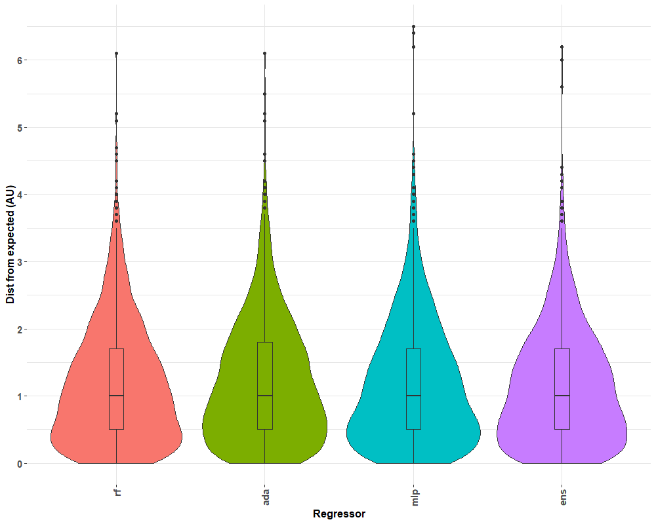

Figure . Distribution of error calculated for the predicted antigenic distance compared to actual antigenic distance as predicted by machine learning models and hemagglutination inhibition assays, respectively. Three regression models were used to predict distances from empirically determined antigens using hemagglutination inhibition titers in a leave-one-out approach: random forest regression (rf), adaBoost decision tree regression (ada), and multilayer perceptron (mlp) regression. All three predictions were combined into an ensemble (ens) to prevent overfitting and to minimize errant predictions by averaging across predictions from all models. Approximately 25% of the data has 0.5 antigenic units (AU) of error or less, 50% of the data has 1 AU of error or less, 75% of the data being less than 2 AU of error. Maximum error for outliers exceeded 6 AU.

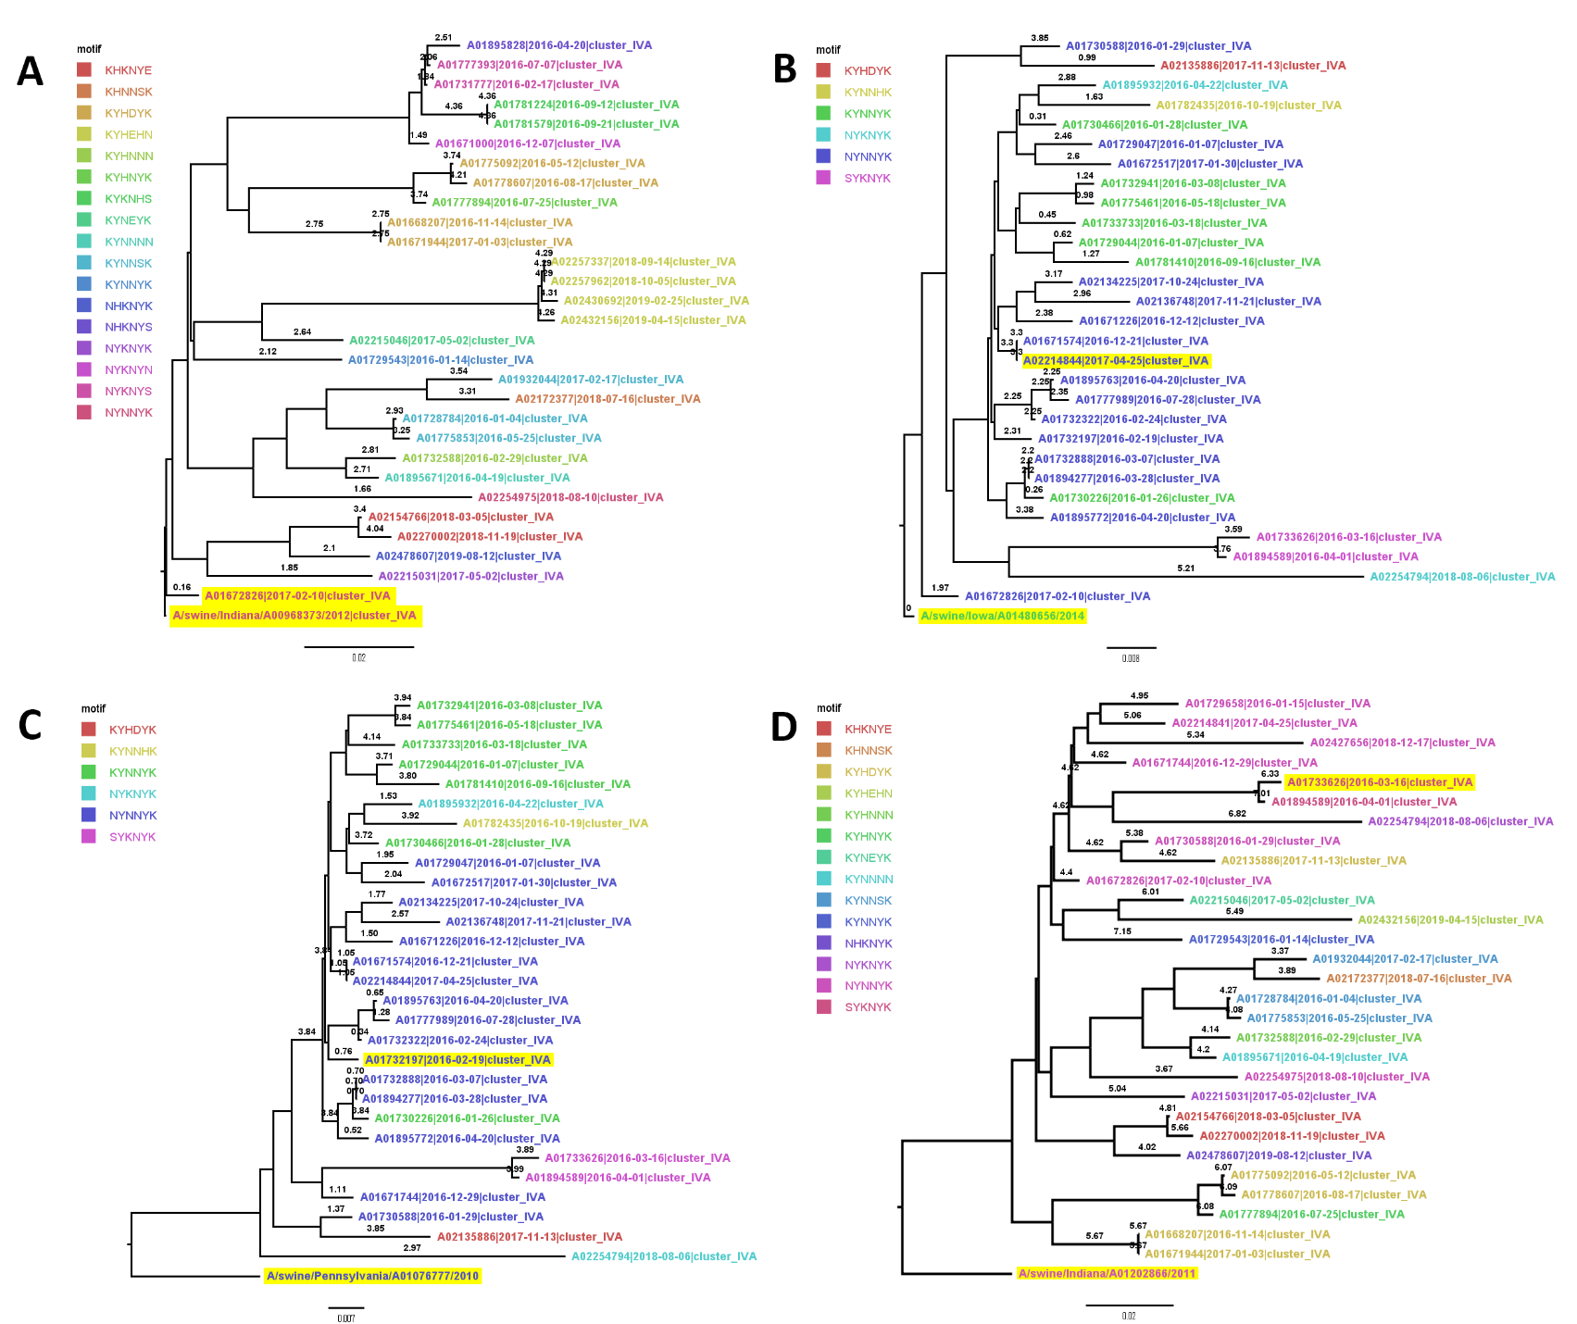

Figure 2. Phylogenetic trees of test antigens rooted to their reference strain. A) Phylogenetic tree of test antigen A/swine/Nebraska/A01672826/2017 and reference strain A/swine/Indiana/A00968373/2012, representing a near predicted antigenic distance prediction (0.16 AU) for two strains of near amino acid identity (99.4%). B) Phylogenetic tree of test antigen A/swine/Indiana/A02214844/2017 and reference strain A/swine/Iowa/A01480656/2014, representing a far predicted antigenic distance prediction (3.3) for two strains of near amino acid identity (98.5%). C) Phylogenetic tree of test antigen A/swine/North_Carolina/A01732197/2016 and reference strain A/swine/Pennsylvania/A01076777/2010, representing a near predicted antigenic distance prediction (0.31) for two strains of far amino acid identity (94.2%). D) Phylogenetic tree of test antigen A/swine/Iowa/A01733626/2016 and reference strain A/swine/Indiana/A01202866/2011, representing a far predicted antigenic distance prediction (6.33) for two strains of far amino acid identity (91.2%). Branches of the phylogenetic tree were annotated with the predicted antigenic distance from the ensemble regression model (both test antigen and reference strain are highlighted). Each tree is pruned to 30 sequences. Influenza strains are colored by the antigenic motif formed by amino acid positions 145, 155, 156, 158, 159, and 189.These positions, located near the ligand binding site of the hemagglutinin protein, have been noted to affect the antigenic interactions of the protein.

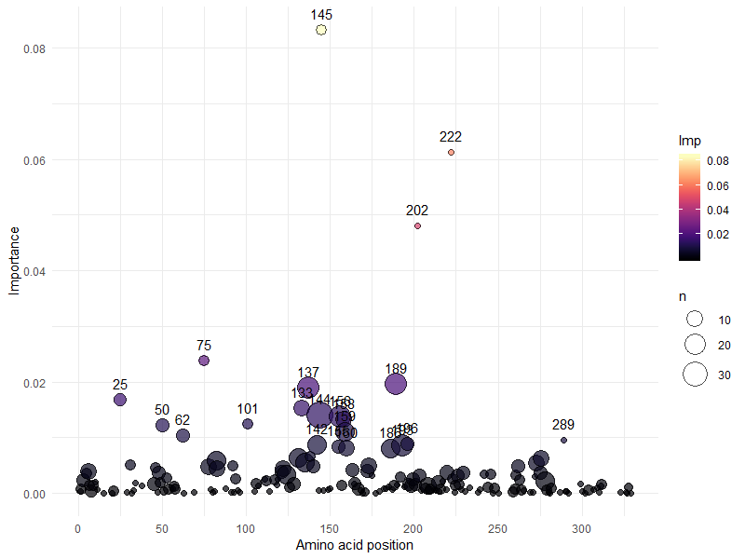

Figure . Rank of amino acid location importance by the cumulative summation of importance per site mutation as determined by random forest regression. Amino acid position using H3 numbering is reported on the x-axis. The importance for each site-specific mutation is summed per site and displayed on the y-axis using a color scale. The size of the circle is relative to the number of mutations observed in the training set per site. Identity was the highest-ranking feature, with an importance of 0.312, but is not displayed on the graph. The top ten amino acid transition features in order of importance are K145N, R222W, I202V, H75Q, I25L, R137Y, D101Y, E62K, P289S, and D133N. The top ten amino acid sites in order of cumulative importance are 145, 222, 202, 75, 189, 137, 25, 133, 144, and 156.

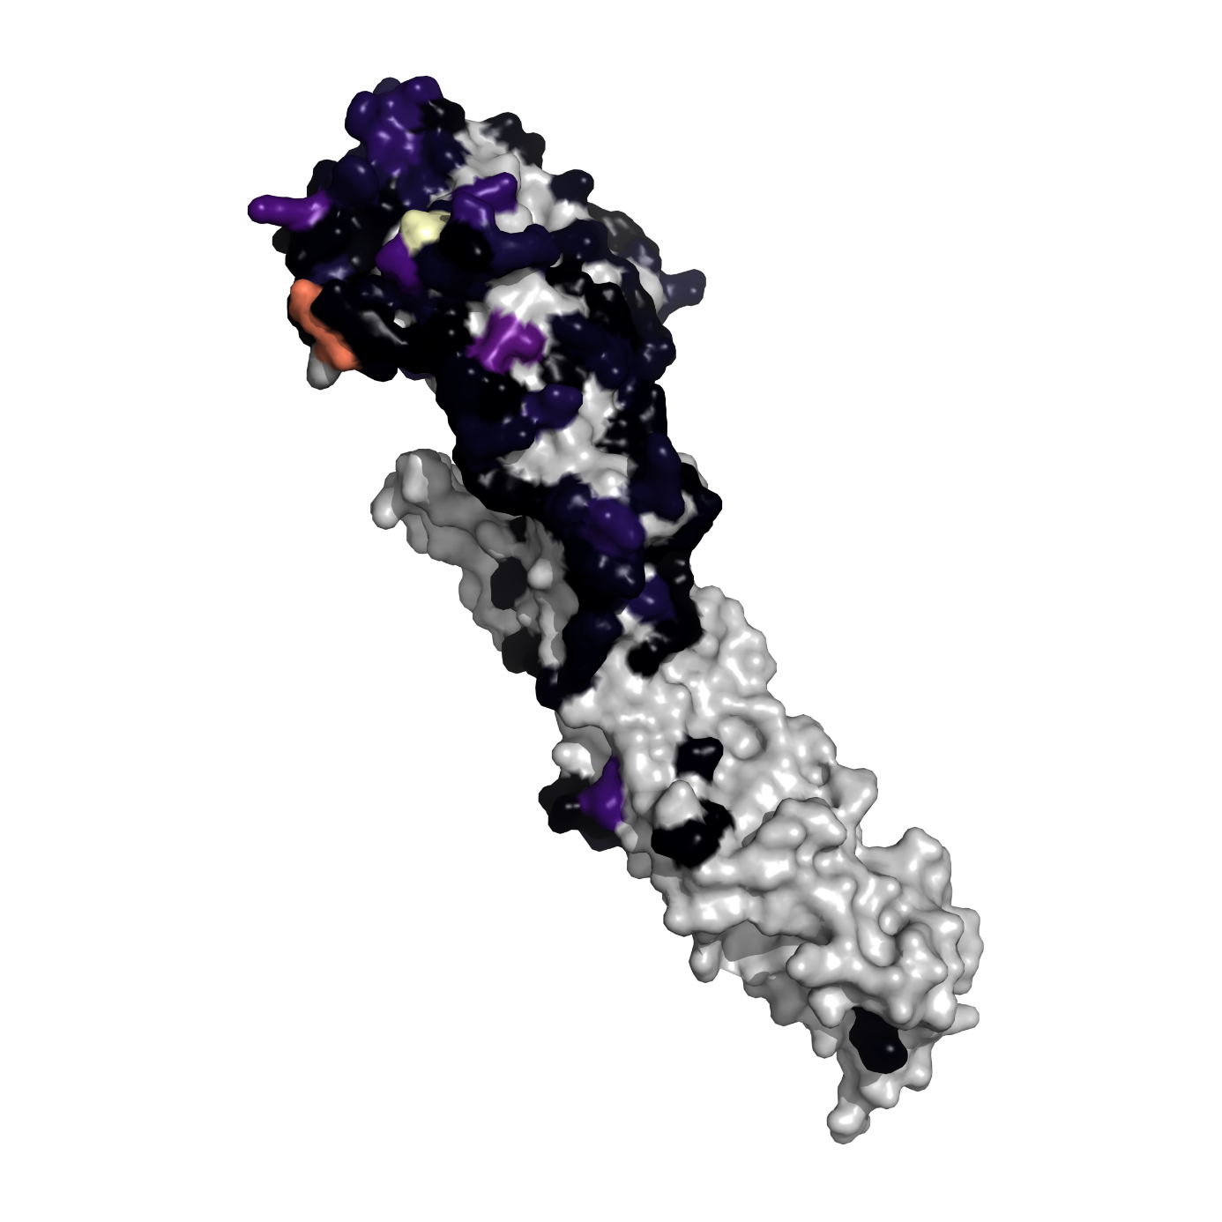

Figure . Projection of feature importance on a monomer of the A/Victoria/361/2011 hemagglutinin (HA) protein (RCSB 4O5N). The significance of each amino acid position in the HA was determined by summing the substitution-based features grouped by the position they represented. Significant positions were projected onto a hemagglutinin protein model of the human H3. The importance for each site-specific mutation is summed per site and projected onto the hemagglutinin protein model of the human H3. Higher color intensity represents a larger calculated importance. Positions with no data were colored gray.